**CALENDAR PLUGIN FOR PHONEGAP**

**Objective:**

This is a basic plugin which creates an event to the user's local calendar.

This plugin is compatible with **PhoneGap 2.8.1.**

**Supported Platforms:**

Android 4.0.3, 4.1.2, 4.2.

**Android Quirks:**

Not supported in Android 2.3.3 because the Calendar API was introduced in Android version 4.0 onwards.

**Methods:**

createEvent:

CalendarPlugin.prototype.createEvent = function(title,location,notes,startDate,endDate, successCallback, errorCallback) {……}

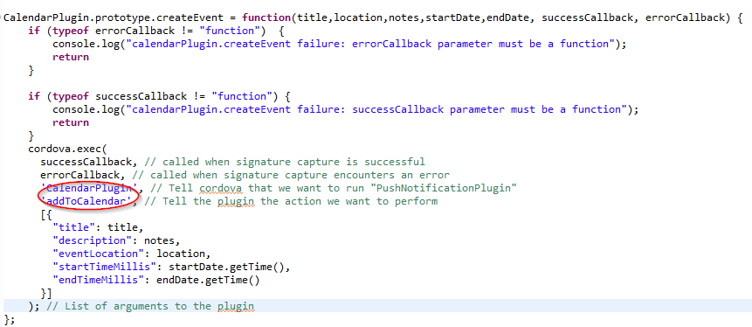

This is basically a js call from calendar.js to the execute method in CalendarPlugin.java file with action specified as *addtoCalendar.*

If the action is *addtoCalendar* then it will launch an androidintent to load the device calendar with some default values specified.

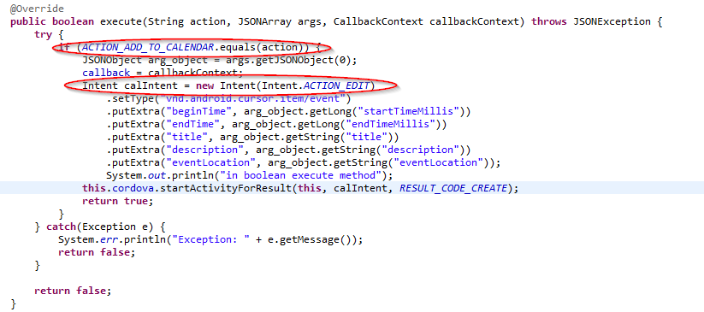

**Adding the plugin to your project:**

1) To install the plugin, add calendar.js to your index.html and to your www folder:

<script type="text/javascript" src="calendar.js"></script>

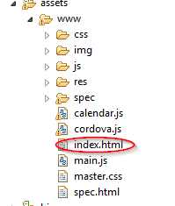

2) Add CalendarPlugin.java to your Android project in com/yourpackagename/CalendarPlugin.java

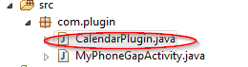

3) Map the plugin in res/xml/config.xml:

<plugin name="CalendarPlugin" value="com.yourpackagename.CalendarPlugin"/>

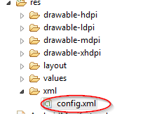

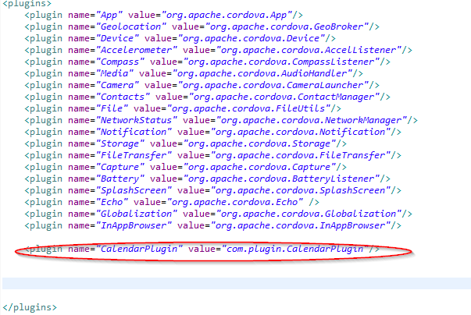

**Usage:**

Create an object to be used to call the defined plugin methods(createEvent) in *index.html* on the event of clicking a button as shown:

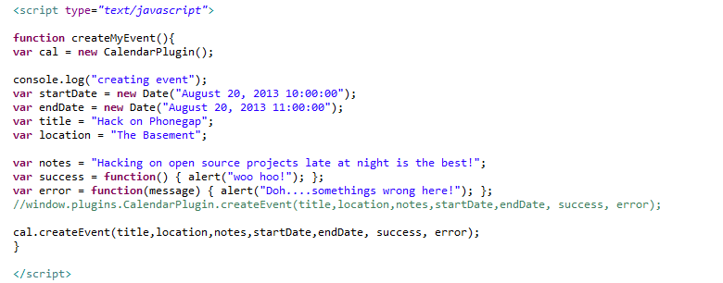

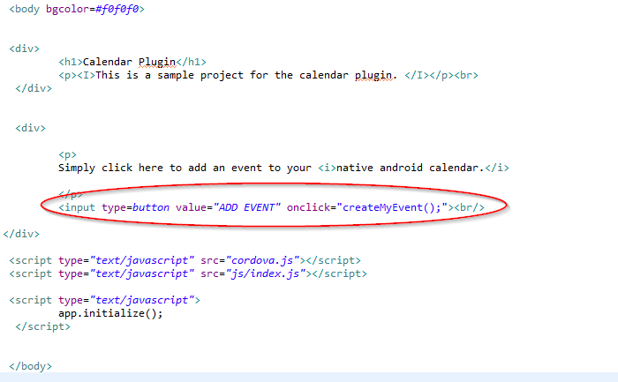

**Output on device :**

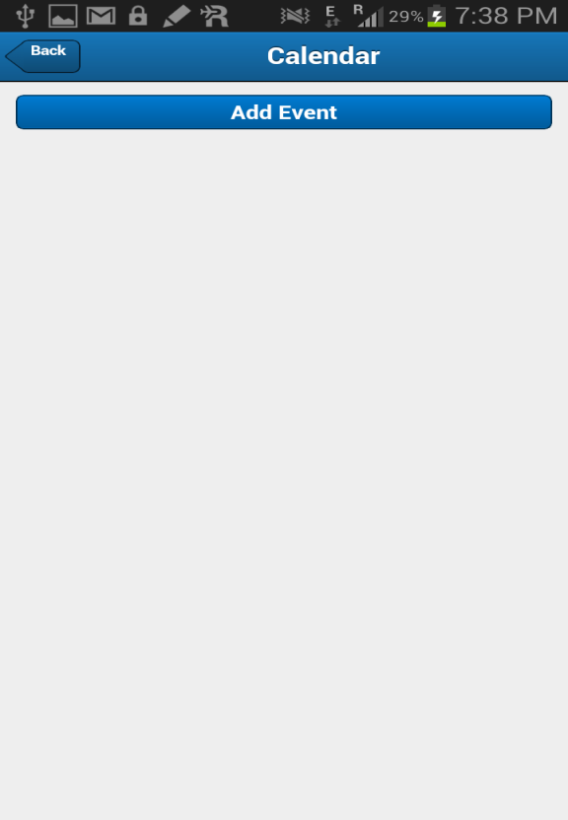

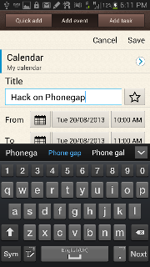

**Part2.**

**Creating Calendar Plugin with sencha and Integrating with eclipse**

**Steps for calendar plugin functionality**

1. **create a new application with the help of following command in cmd:**

**C:\apache-tomcat-7.0.30\webapps\touch>** **sencha generate app <appname> ../<appname>**

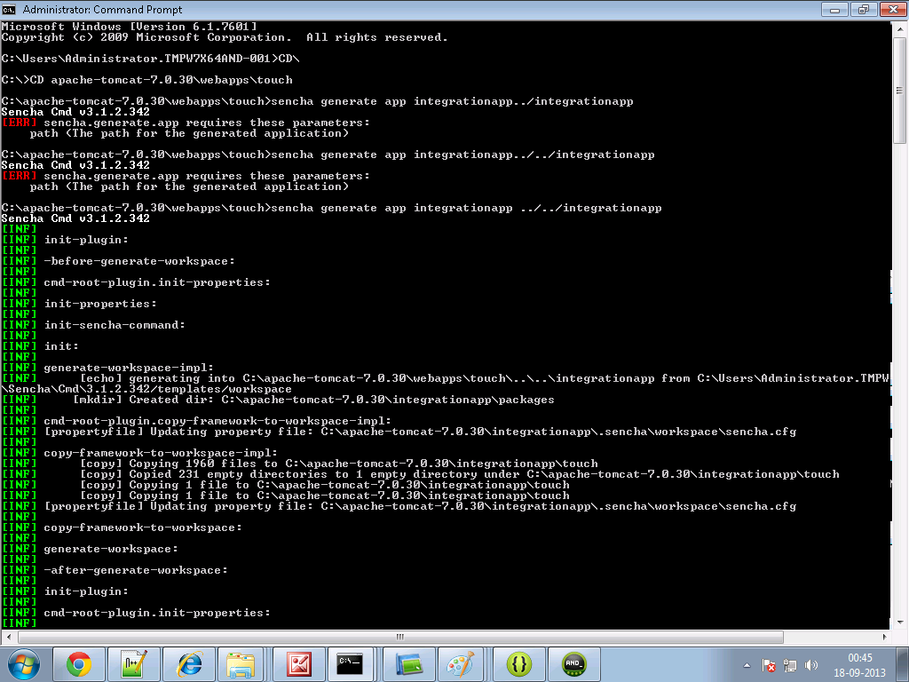

**2.Create a folder and name it as cordova in your sencha <appname> directory. For example**

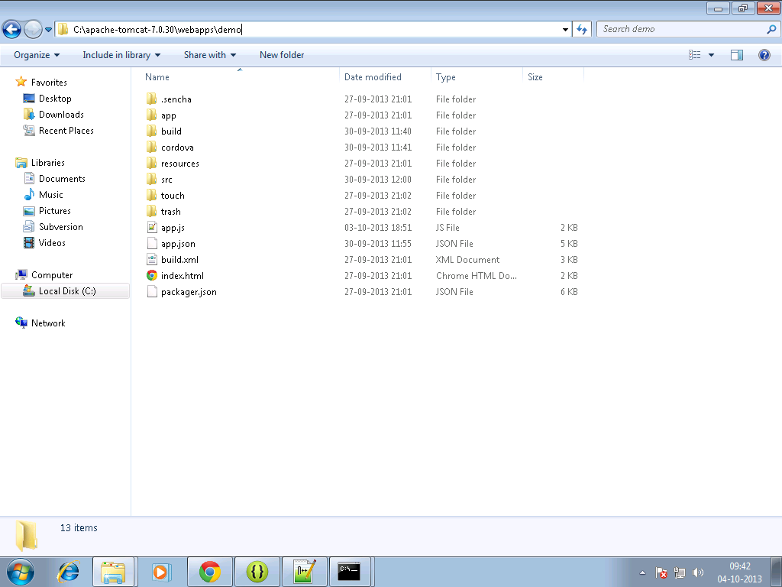

**3.Copy the cordova.js ,cordova.js_android, cordova.js_ios and cordova.js_plugins and calender.js in that folder.**

**4. Make an entry in the js tag of app.json file residing in your<appname> directory as follows:**

js": [  
  {  
            "path": "cordova/cordova.js",  
            "update": "delta"  
        },

{  
            "path": "cordova/calendar.js",  
            "update": "delta"

]

1. **Write the sencha code for view and controller in your sencha <appname>.**

**Calview.js**

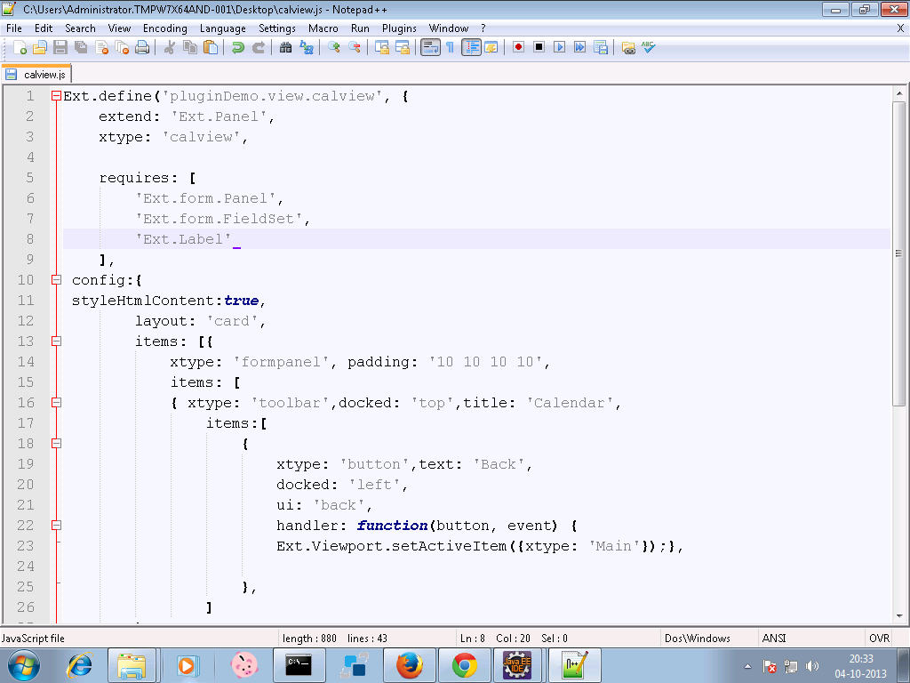

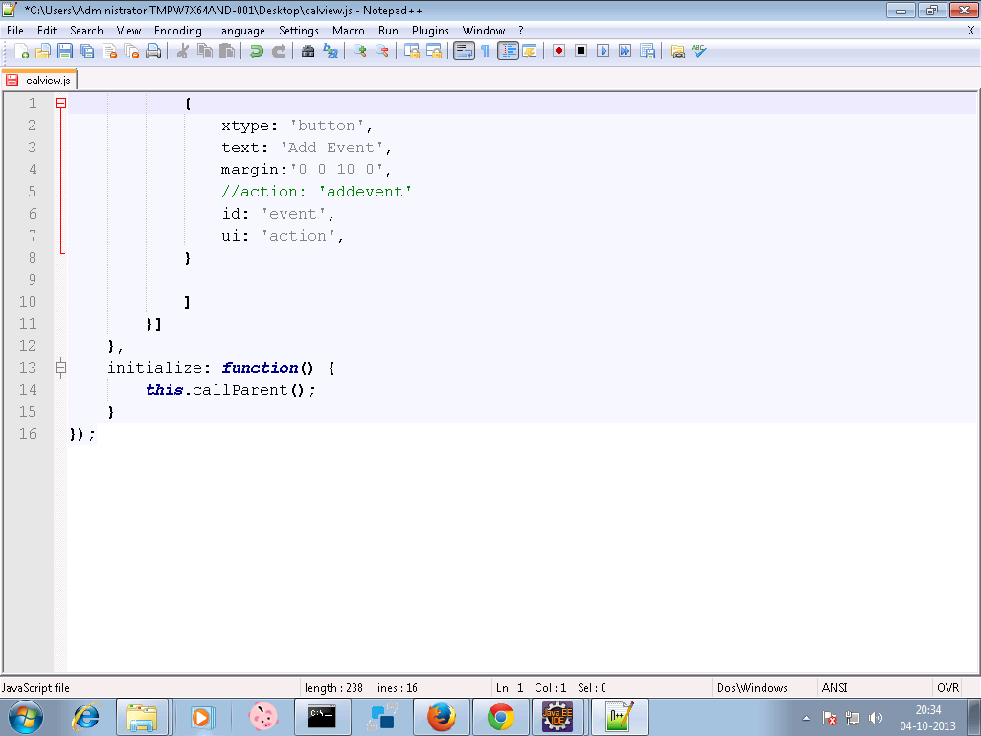

**calcon.js**

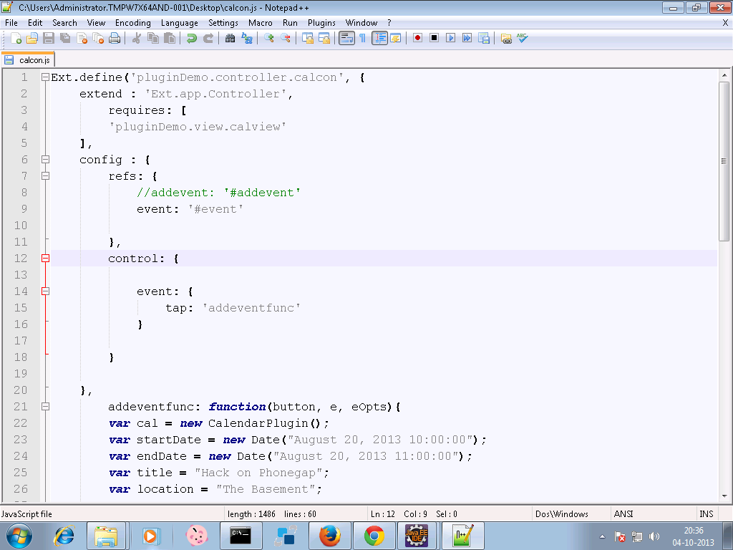

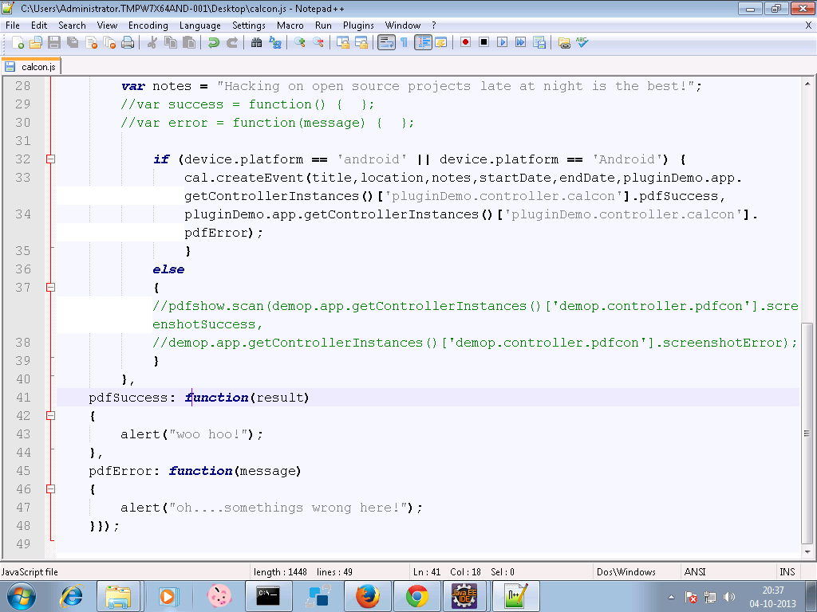

1. **In command prompt go to your sencha <appname> directory first, then Build the package of your sencha app by typing the following command :**
2. **Sencha app build package**

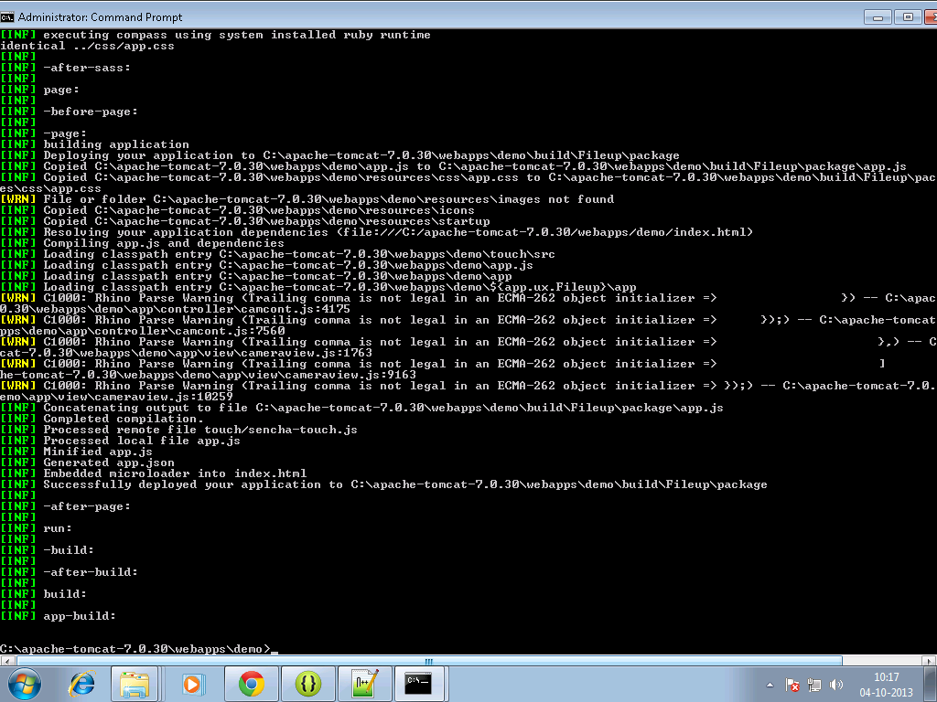

**7. Move to your sench<app> directory ,there a build folder will get created.**

**8. Copy files from package folder under <sencha appname>/build/ sencha < appname> to your www folder of android project for example:**

**C:\temp\TempAndroid\assets\www**

**9. build it - > apk will be in bin folder**



