**Haplorec User Guide**

**Home Page**

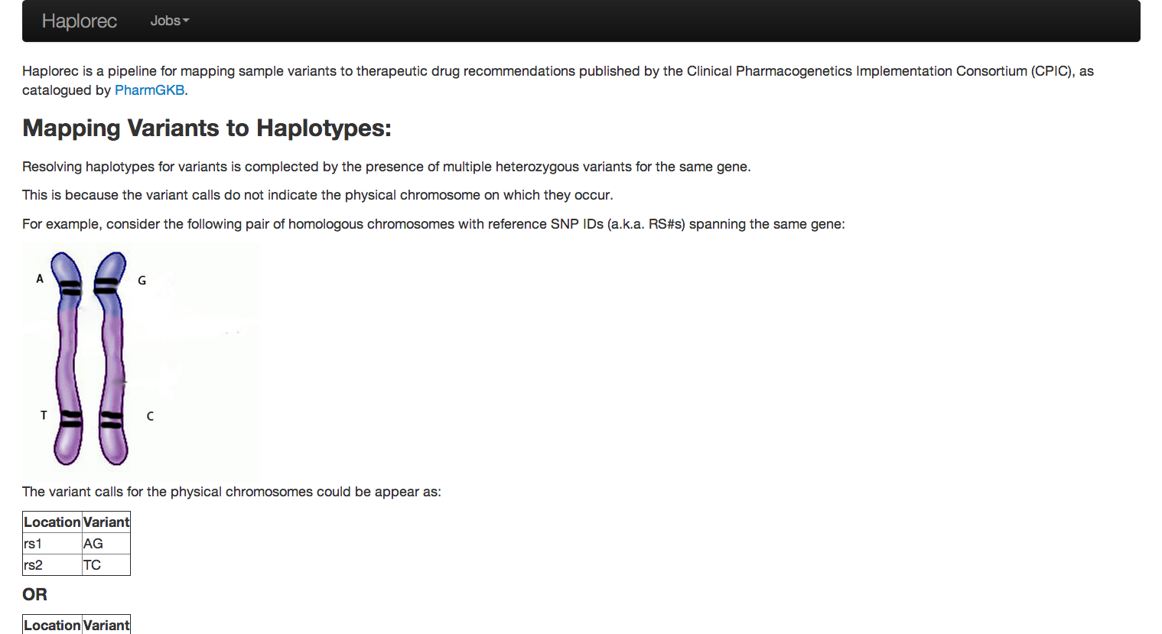￼The Home page explains how the drug recommendations and novel haplotypes are generated form the variants that are inputted.

**The Navigation Bar**

There are two buttons, Haplorec and Jobs.

Click on **Haplorec** to return the Home Page.

Click on **Jobs**, to get the following dropdown menu.

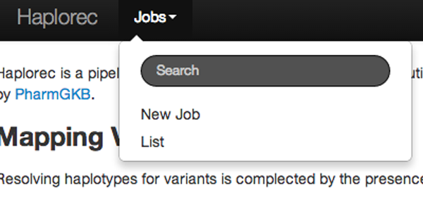

* **Search**, searches through the list of created jobs and displays all the names of jobs that have that letter combination in them
* **New Job**, takes you to the Create Job page
* **List**, takes you to the list of jobs that have already been created

**Create Job Page**

In order to create a new job click on the **Jobs** button in the navigation bar and in the dropdown menu click on **New Job**. This takes you to the Create Page.

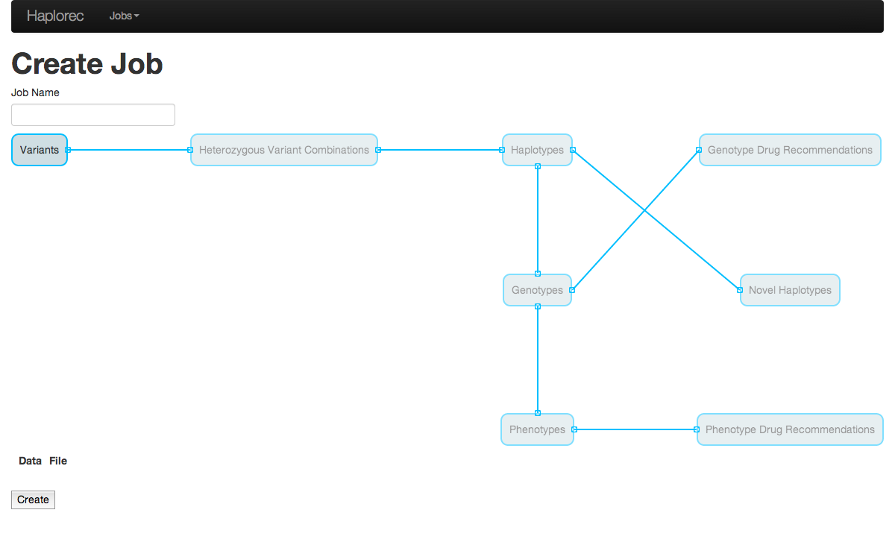

￼￼￼

Scroll over the variant node to display a Sample Input file.

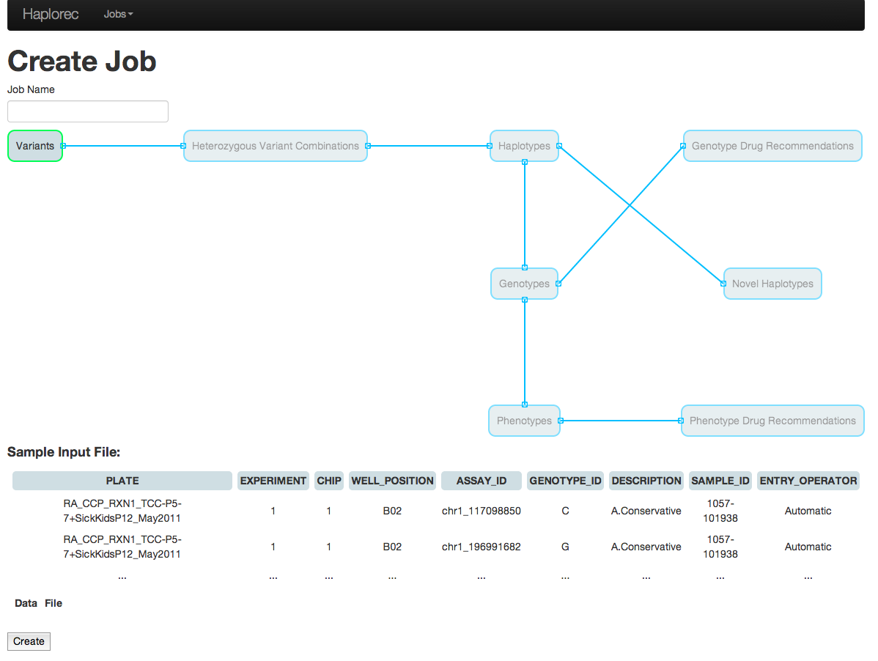

Click on the variant Node to add a file.

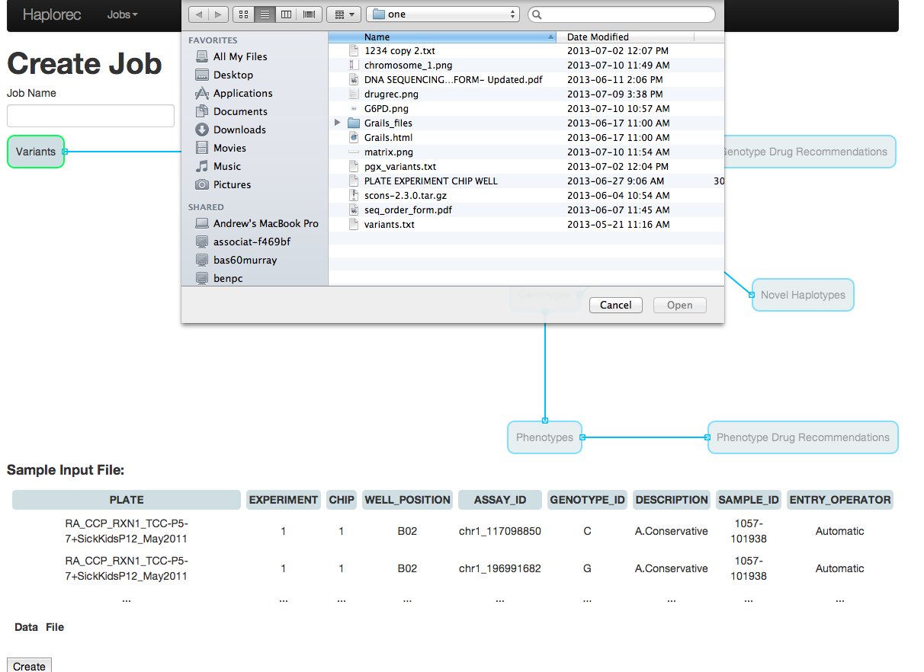

￼￼Make sure you name the job with a unique name before creating it.

It will redirect you to the create page if you try to create a job with no name or with a name that already exists.

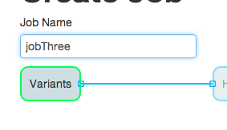

Then click the create button that appears at the bottom of the page.

￼￼

This starts the process of creating the job. The create page will display the progress:

* Nodes with the loading spinner are currently being created
* Nodes that have no loading spinner are complete
* Nodes in red have failed

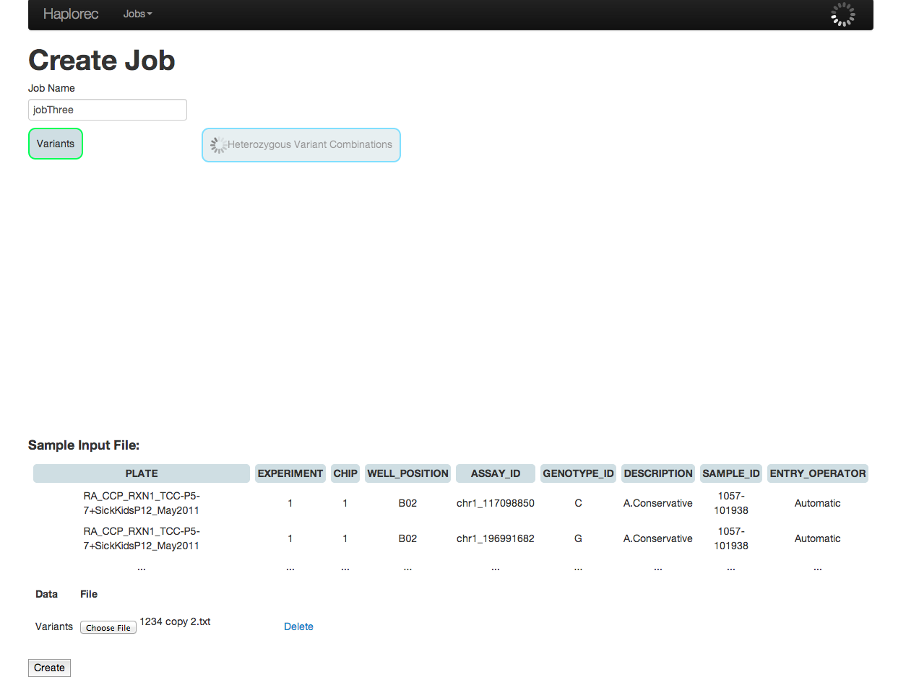

￼￼Once the Job is done being created, it redirects you to the Show job page.

**Note:**

The job will continue to be created if you leave the create page while it is in the process of being created. The progress will also be displayed on the job’s show page.

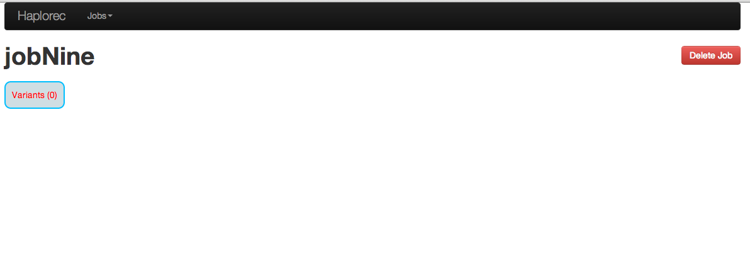Also if a node fails, the job stops being created and you will be redirected to the show page.

**Job List Page**

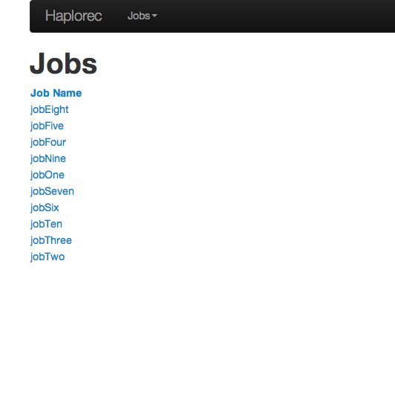The List page displays the list of created jobs in Alphabetical order, click on a job to go to the job’s Show Page.

**Show Job Page**

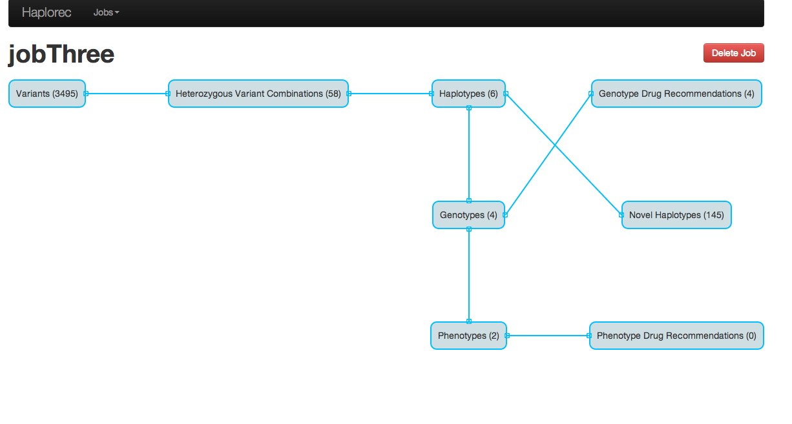

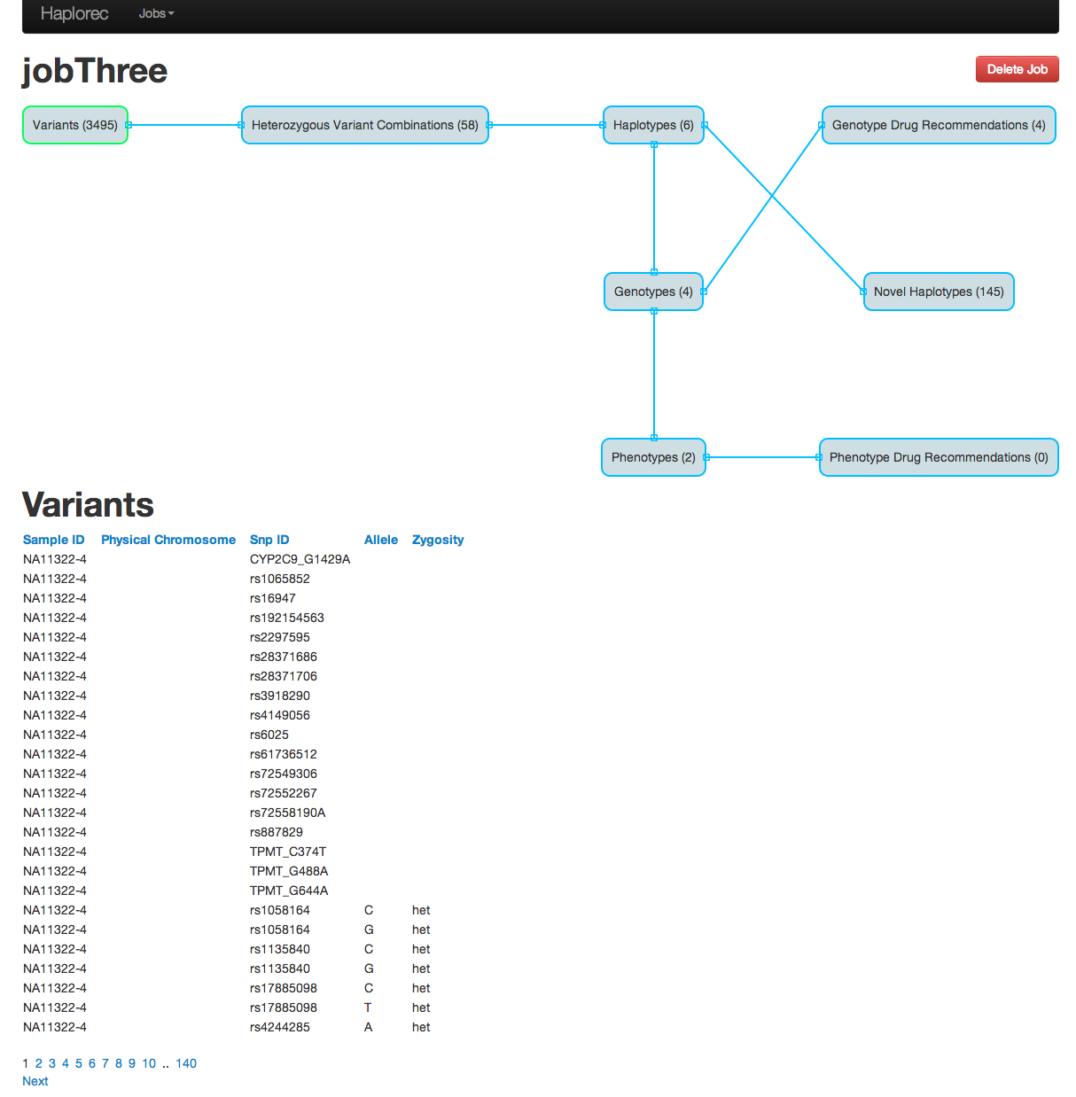Click on a node to display its list.

Click on the table’s headers to sort the table by that column.

Genotype Drug Recommendation, Novel Haplotypes, Phenotype Drug Recommendation have a report button, which when clicked, downloads a text file of the report. Also, click on a drug’s name to get more information about the drug.

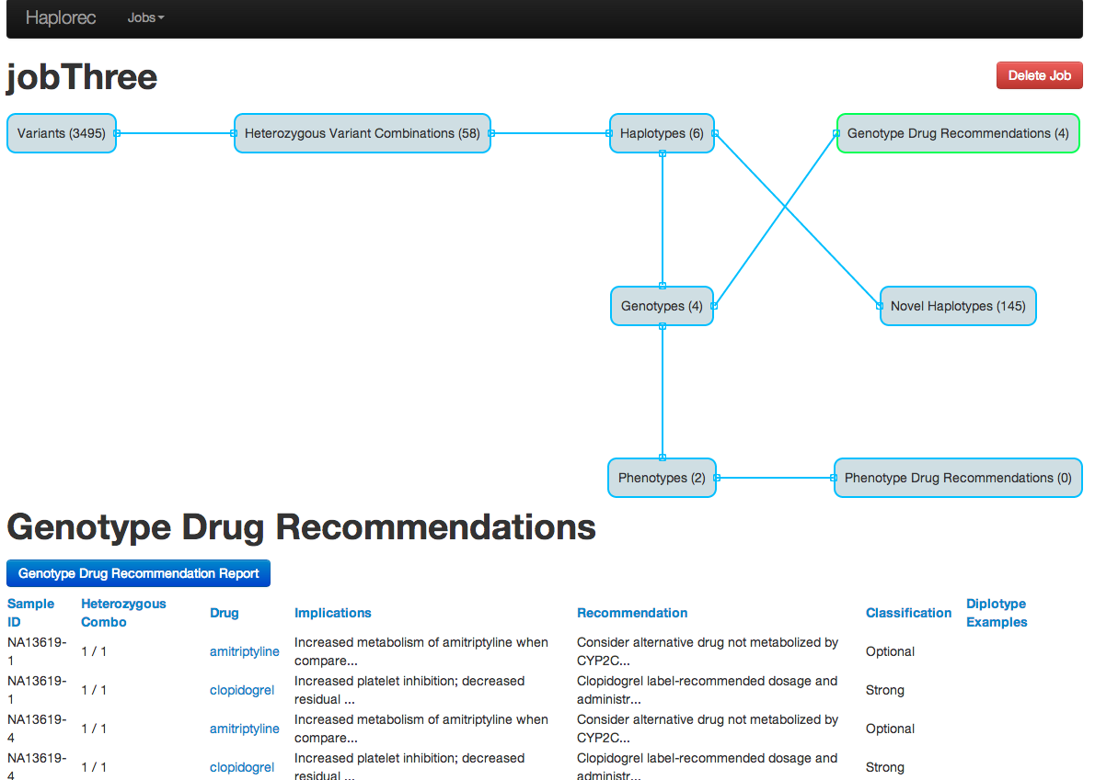

Novel Haplotypes’s list is displayed in a table.

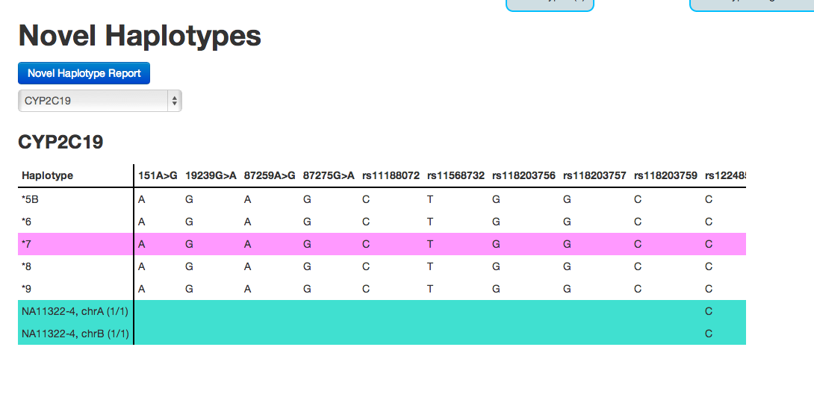

￼￼

If you want to look at another gene, select it from the dropdown list.

To scroll through the matrix make sure the mouse is on the lower right quadrant of the table.