- Home page first image on the right to be changed
- The top left logo doesn’t seem optimised both on mobile and desktop site. Seems very small. Can you see if it can be resized to make it look substantial so branding is clearly visible.
- The yellow capsule which reads – Get the free gut health guide – change that to Connect with me

- 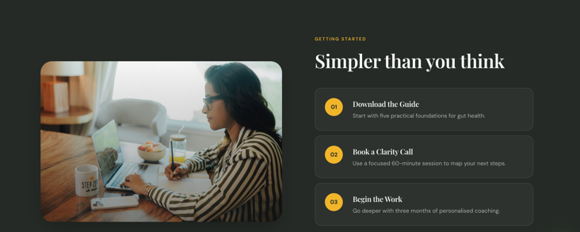 for this section change 01: to Send a WhatsApp message – whatsapp tab to be placed here
Start the Conversation — Send a quick message and tell us what's going on.
For 02 : book a clarity call – it needs to be 30 mins not 60 mins.

So it will be like
01 — Start the Conversation. Send a WhatsApp message and tell us what's going on.
02 — Book a Clarity Call. A 30 min focussed session to understand you and what you are dealing with better and deeper.
03 — Begin the Work. Start your programme

- 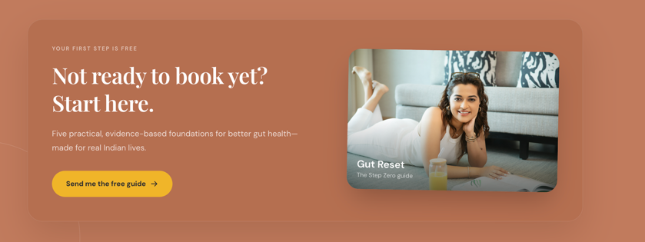
Kicker (small caps label, top-left) — keep as is: "YOUR FIRST STEP IS FREE"
Headline — keep as is: "Not ready to book yet? Start here."
Body text (below headline) — remove: "Five practical, evidence-based foundations for better gut health — made for real Indian lives."
Replace with: "Send a quick message and tell us what's going on. No forms, no pressure — just a real conversation about where to start."
Yellow button — remove: "Send me the free guide →"
Replace with: "Connect with me →"
Also update the button's link/action from whatever downloads the guide to your WhatsApp link (https://wa.aisensy.com/aabkw9).
Image card label (bottom-left text overlaid on the photo) — remove: "Gut Reset" / "The Step Zero guide"
Replace with: "Say Hello" / "Start on WhatsApp"

About section 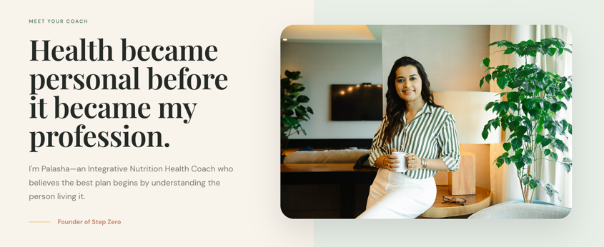
Change image to

Work with me will need to have all the programs and not just 1.

