**Classification –Machine Learning Algorithms**

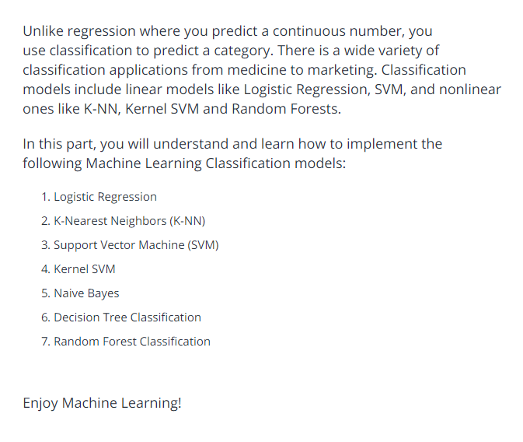

**Logistic Regression:**

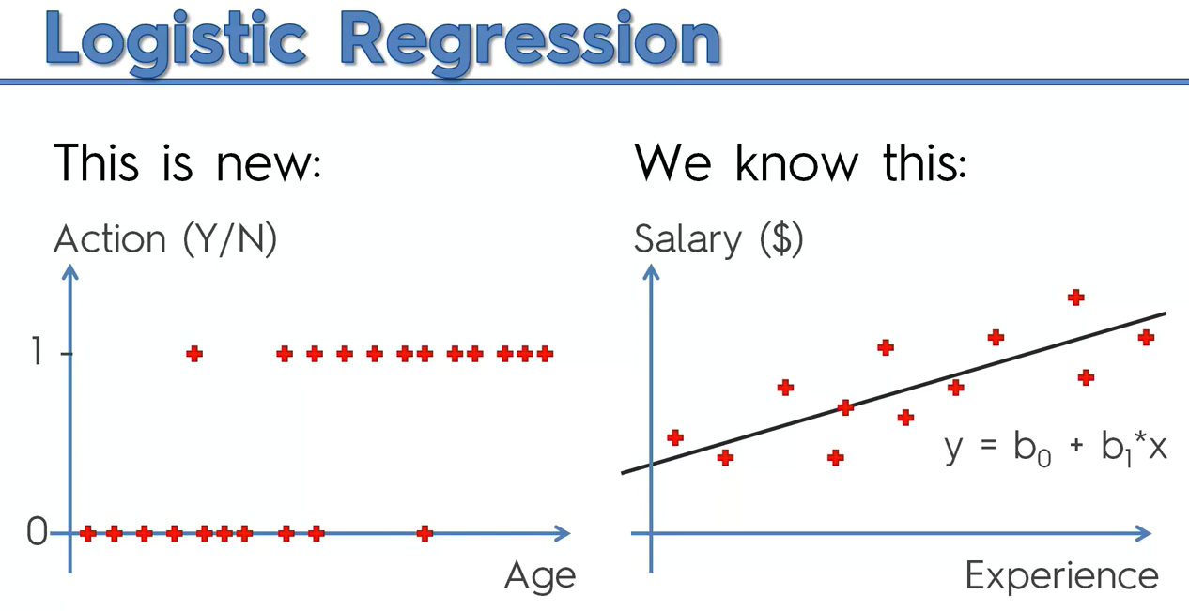

There is some correlation to predict whether customer will buy clothes or not.

If we use linear regression completely, it won’t work.

Take the probability in logistic regression that will help us to solve the problem.

We are modifying linear regression , since there is no >100% and <0%.

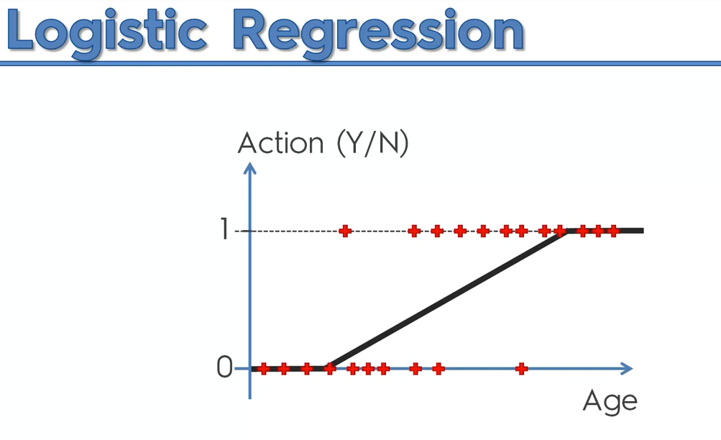

The green box is logistic regression

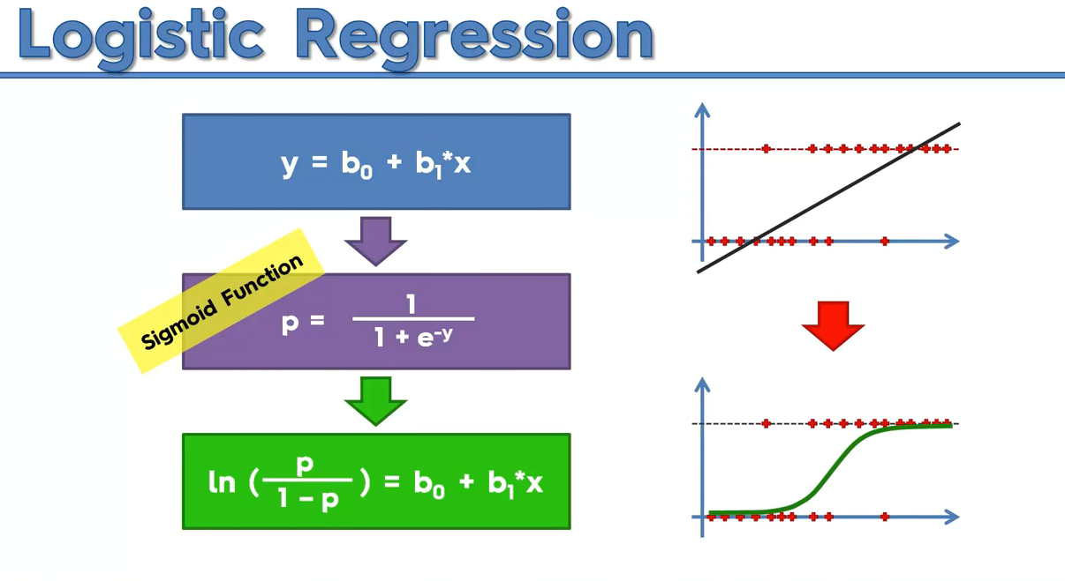

Explanation:

Step 1:

P^ means we are predicting the probability.

Green🡪fitted value

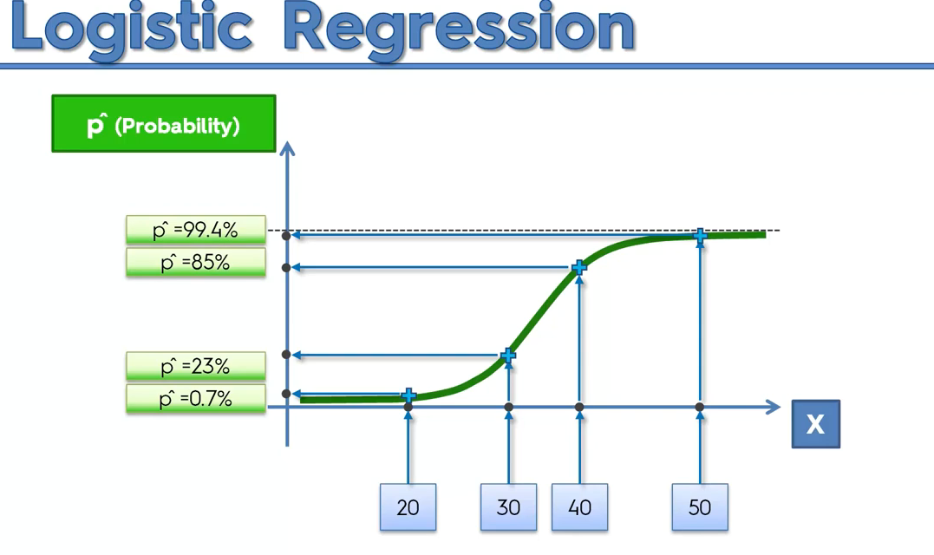

To Predict y^(Predicted Dependent variable),

We will select 50 %, below means 0, greater than 50% then 1.

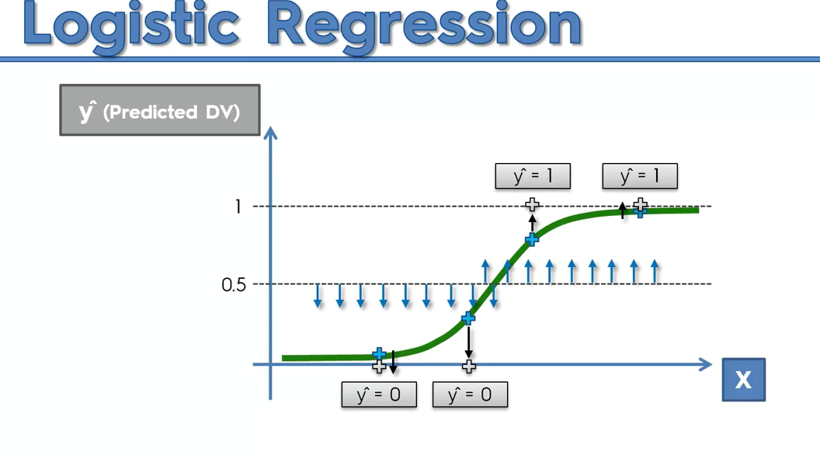

It is also exactly works like linear regression,

* In linear there will be scatter points , we will use slope line
* In classification, we will be predicting binary values, hence we modify the linear regression formula accordingly to predict the probability.
* 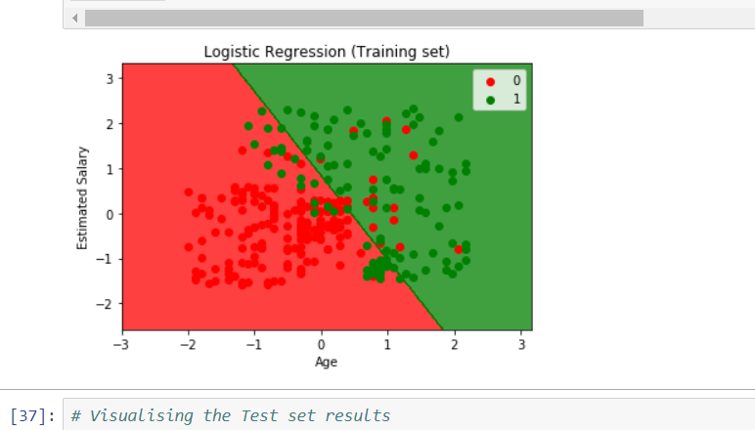

**K-NN**

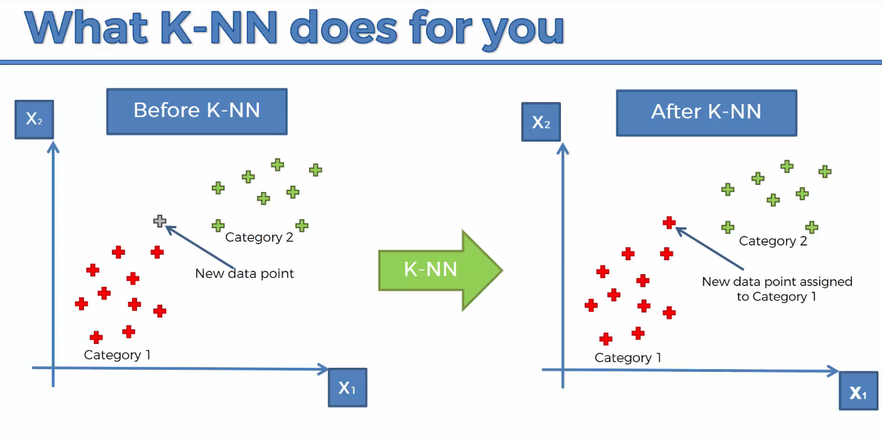

K=5 is default

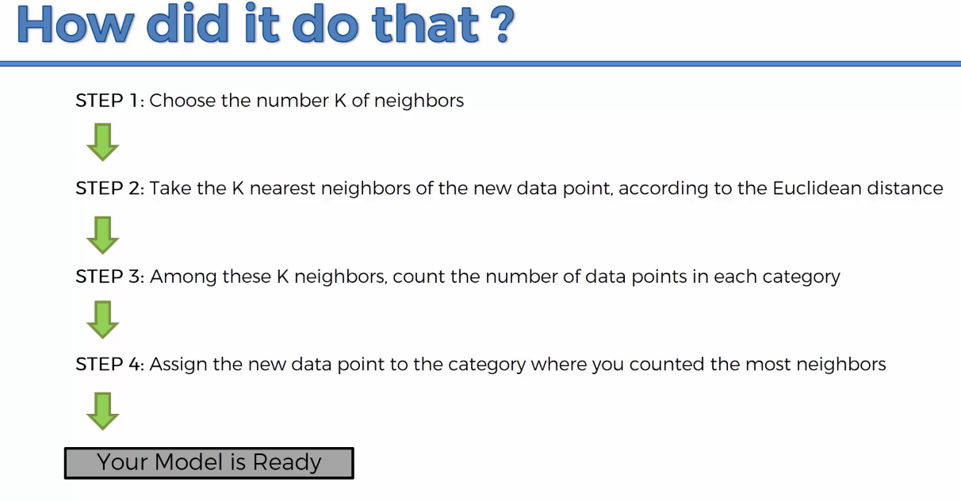

What is Euclidean distance?

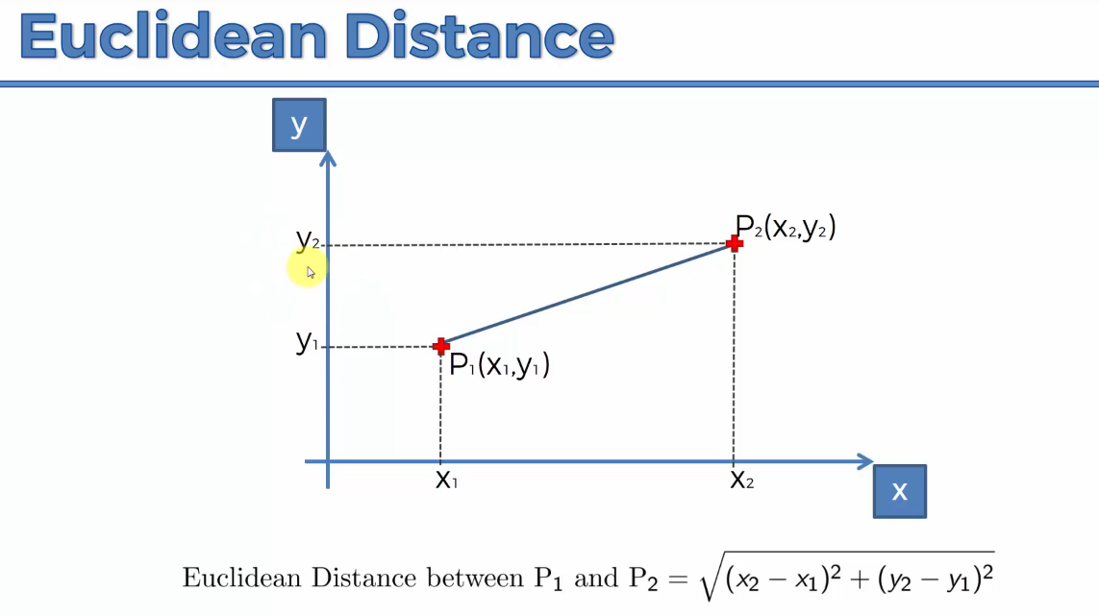

Ie distance between two points.

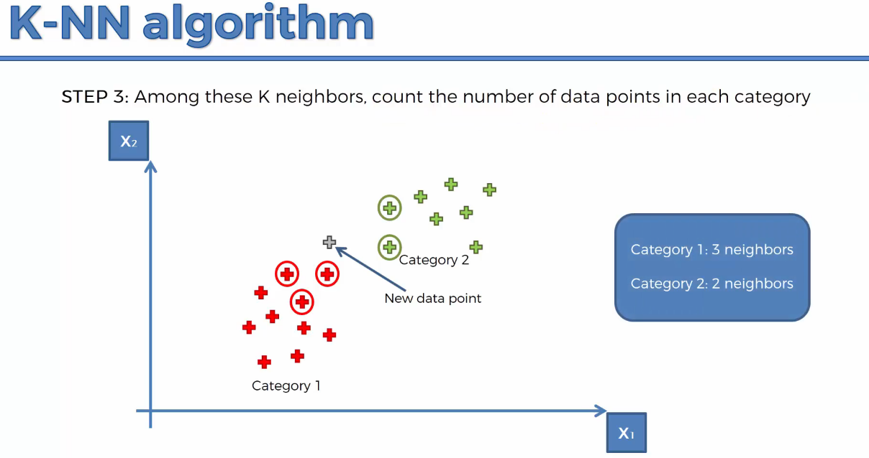

Hence the new data point is assigned as red.

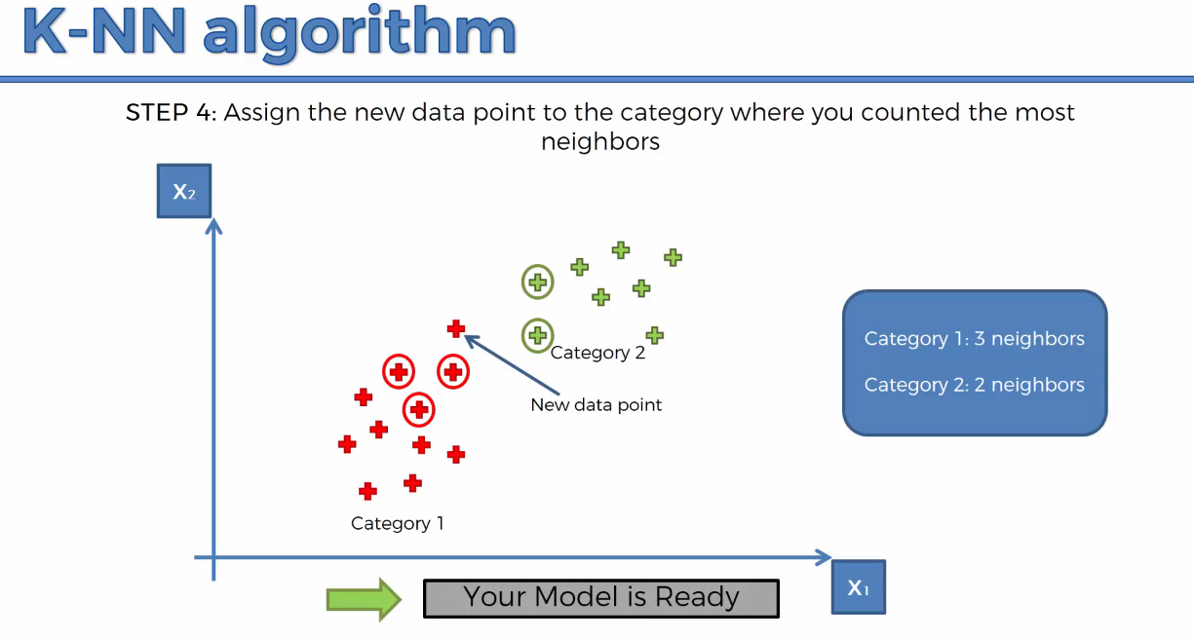

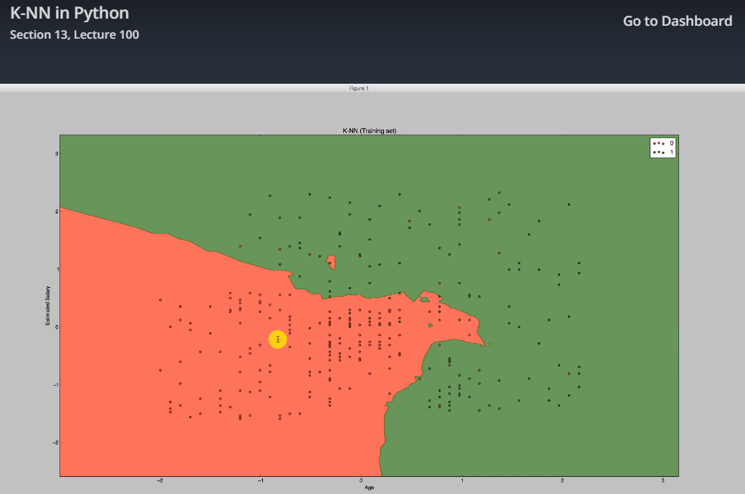

**Support Vector machine-Classifier(linear classifier)**

**kernal can be linear or rbf to make SVM linear or non-linear**

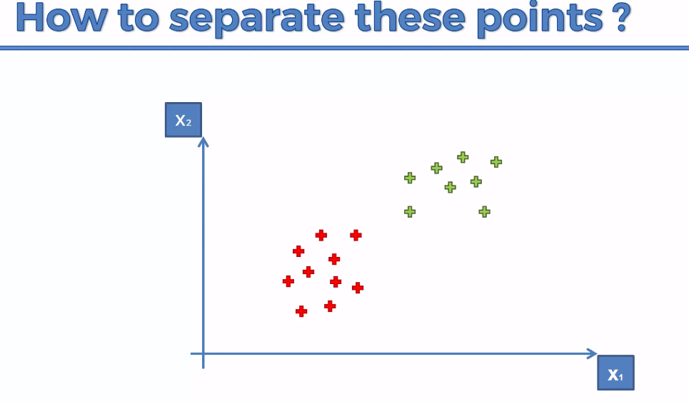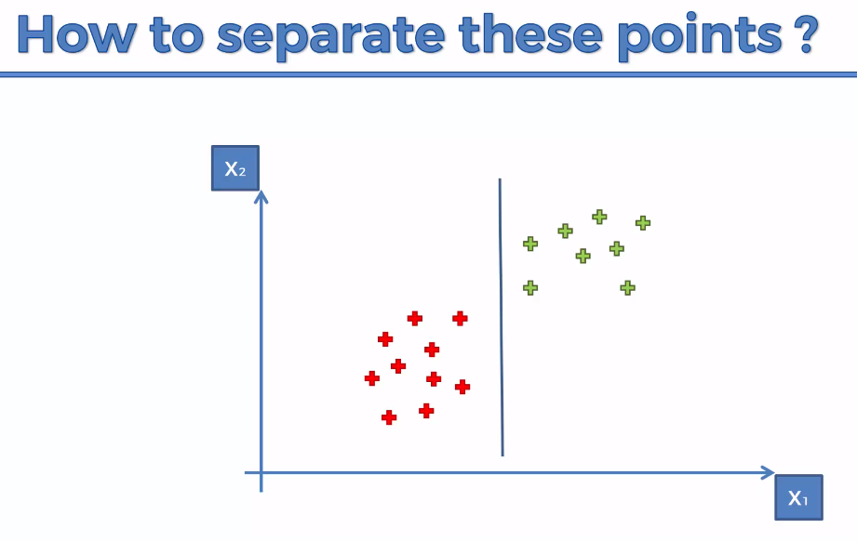

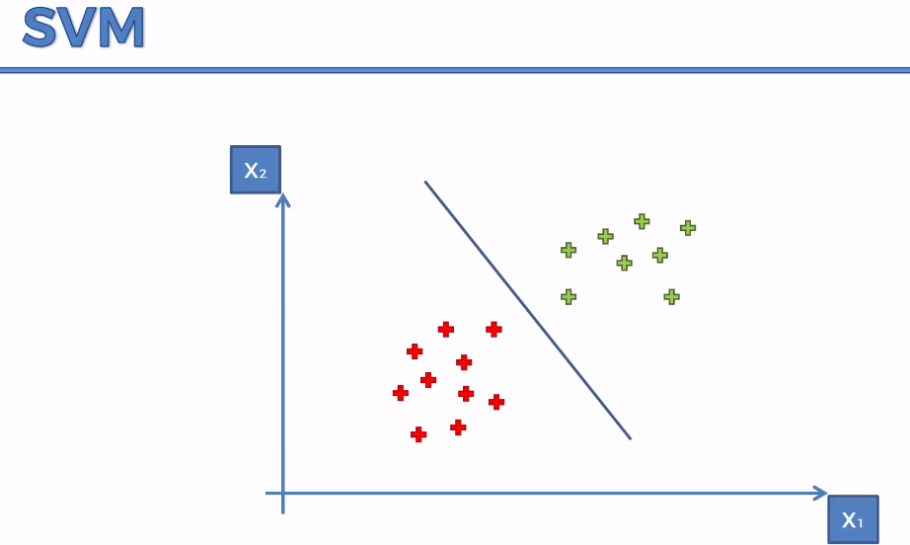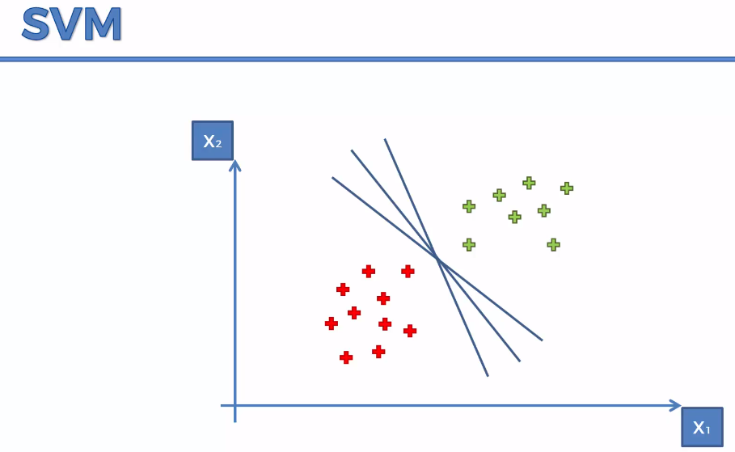

We have to find the optimal line.

Sum of the two line distance should be maximum.

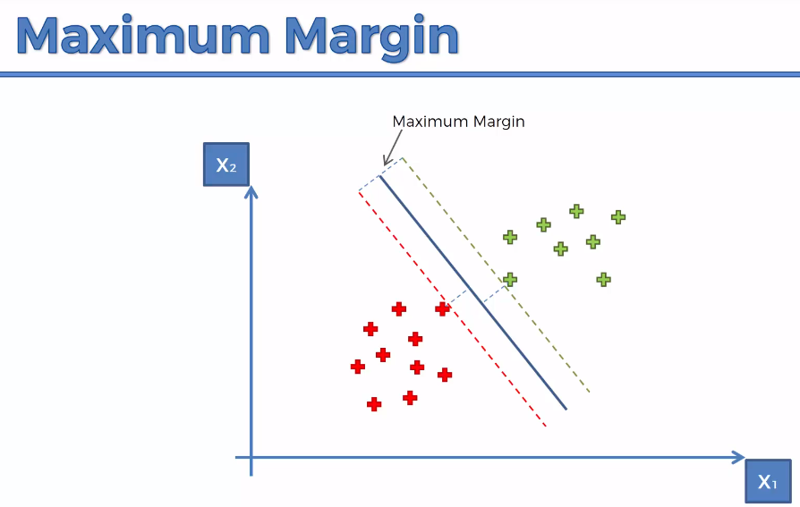 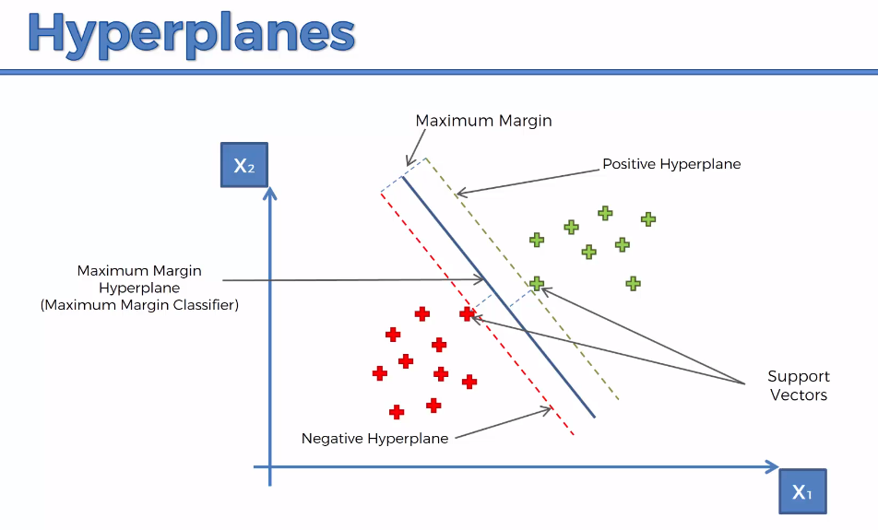

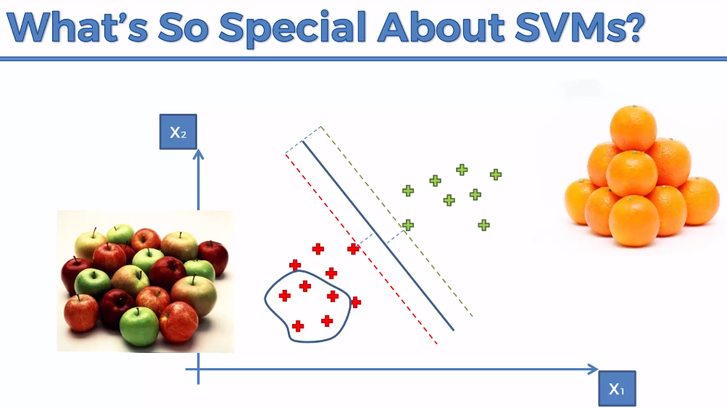

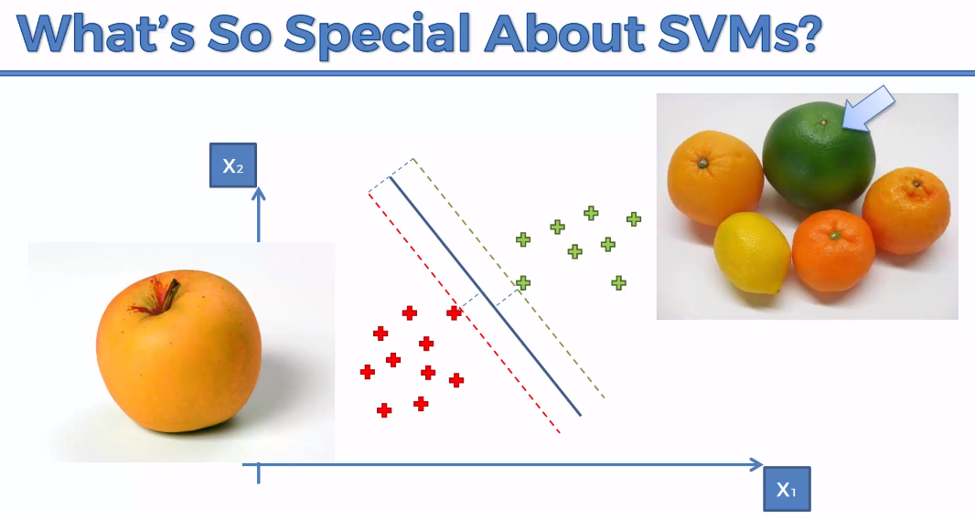

**Result:**

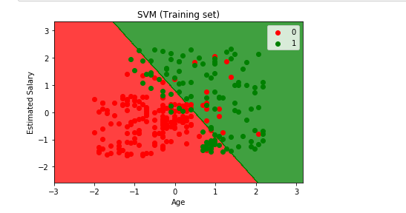

**Kernal SVM**

To handle the below scenario,

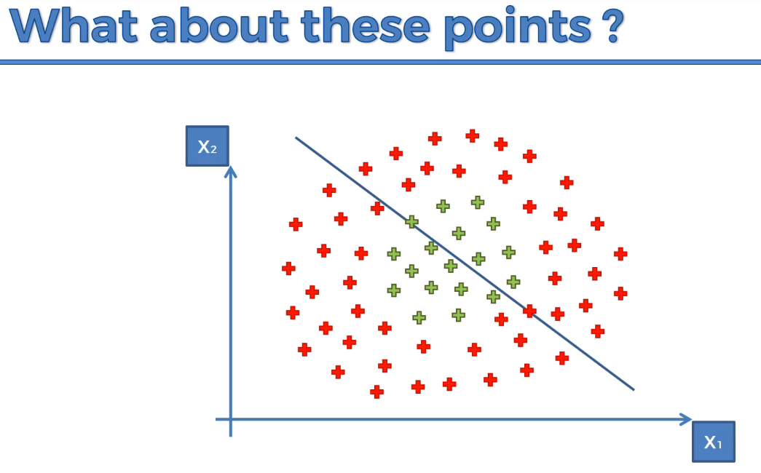

The above approach will fail if we follow linear SVM

