

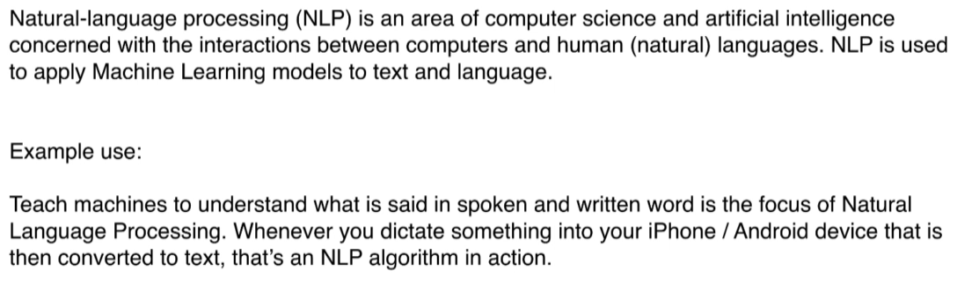

Eg: Siri, Amazon Alexa.

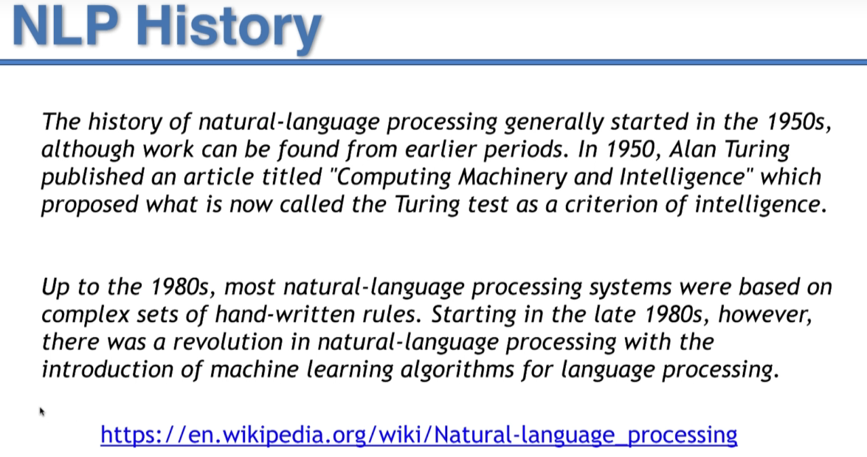

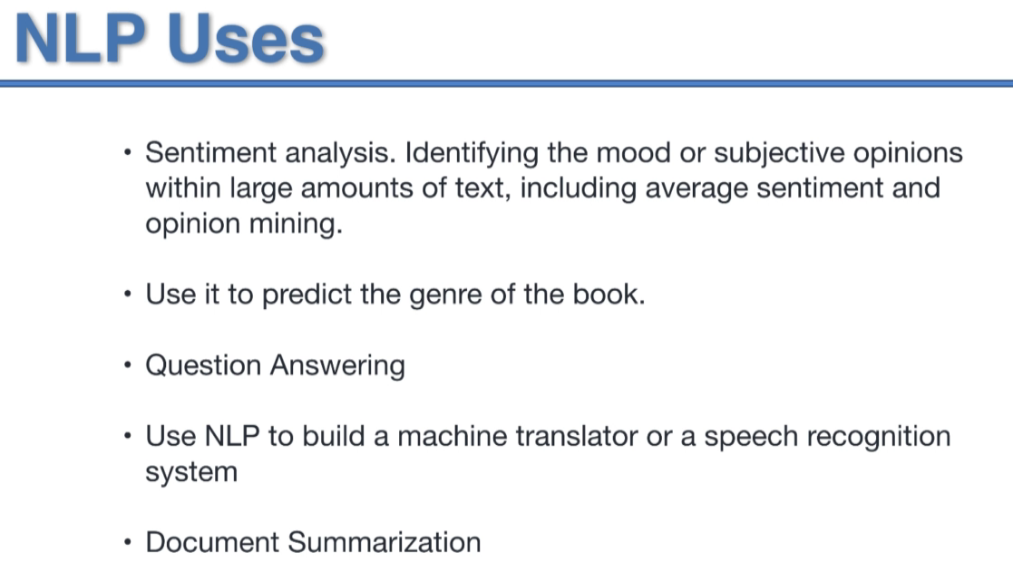

Question Answering🡪Chat Box

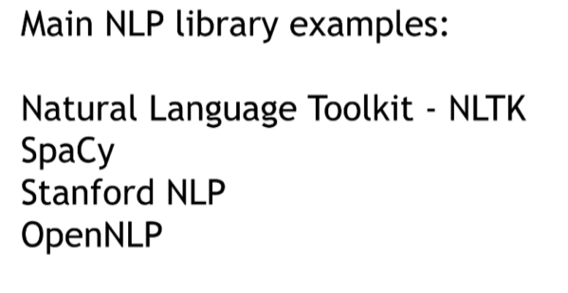

Break down using POS tag

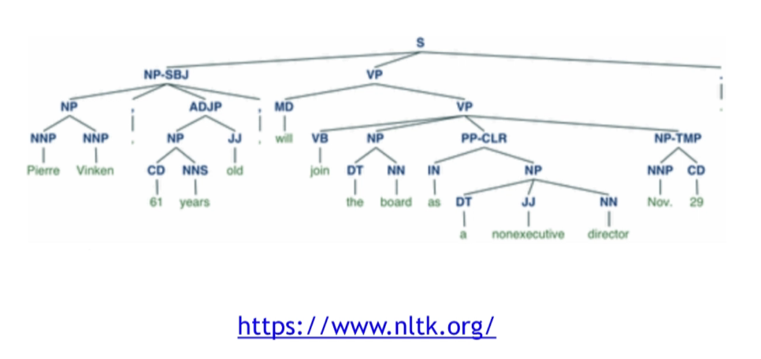

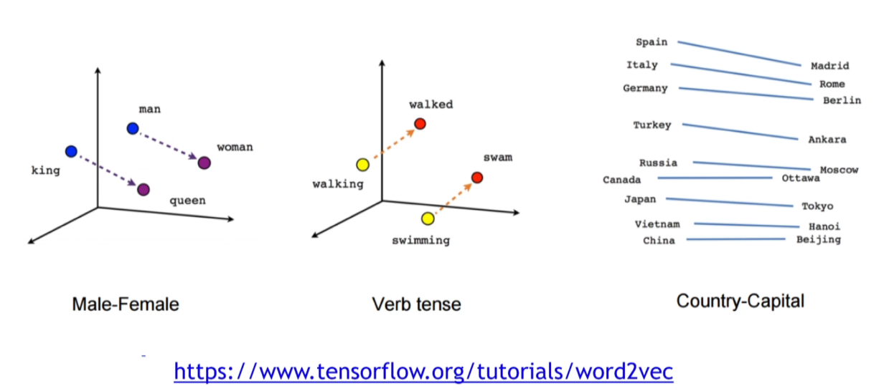

Word-Clustering Visualising:

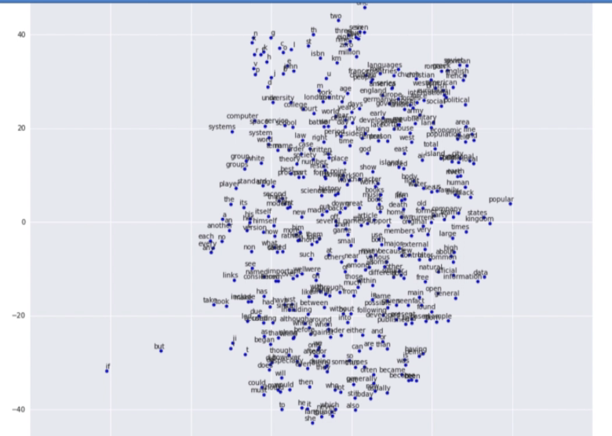

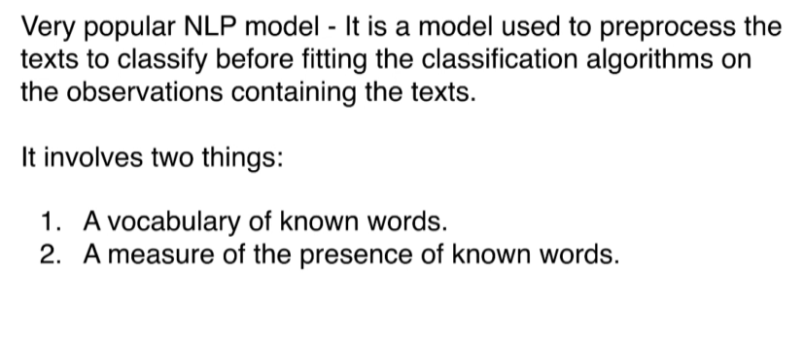

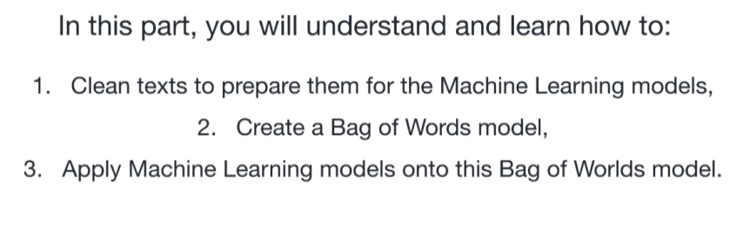

Difference between csv and tsv

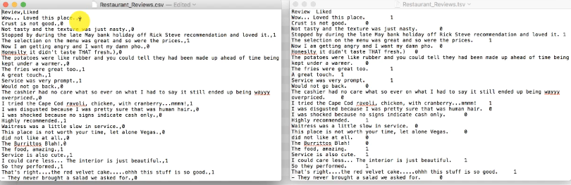

tsv means tab separated value

we Should use tsv for NLP

Because in text there will be comma , that might be confusing.