Regression

**Simple Linear Regression:**

It is like a formula of a slope

Eg scenario: how does a **salary** (Dependent) changes with **years of experience** (Independent Variable)

Coefficient🡪 Unit change in independent Variable (like multiplier🡪connection between x1 and y)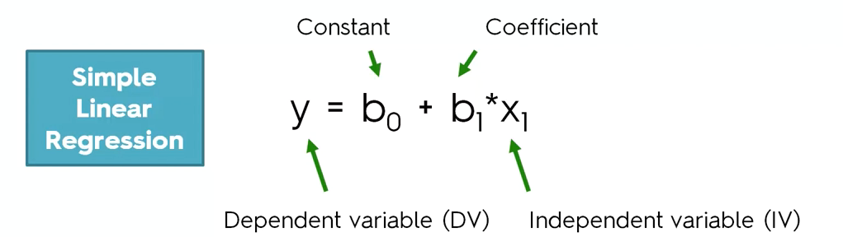

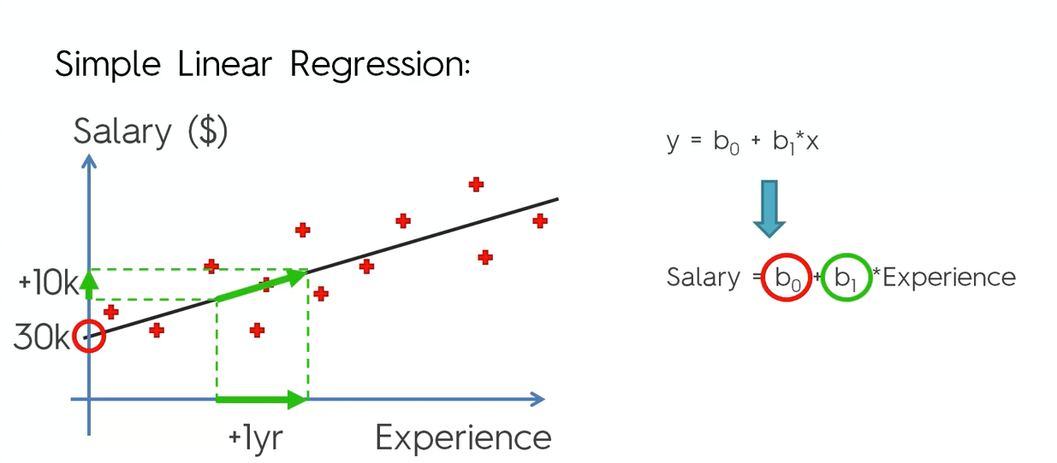

b0🡪Constant (30,000$)

b1🡪Coefficient (+10,000$ for 1 year)

1. How to find the best fitting line(line in the graph)

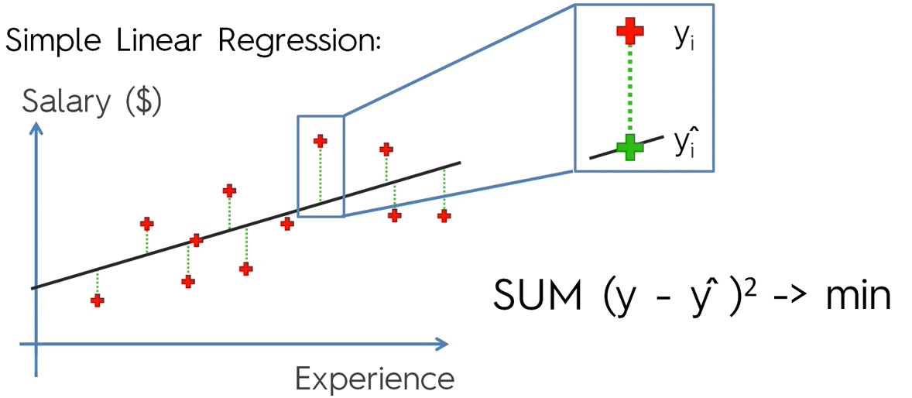

**Example**

