Headboard Wall & Mirror Unit
DIY build plan for use with a bought king bed: Bunnings shopping list, tools, cutting layouts and step-by-step instructions
Bedroom 1 · 4.0 m × 4.9 m · 2.4 m ceiling · light grey carpet (stays untouched)
Store: Bunnings Harrisdale (WA)
Version 2: the king bed (with its own upholstered headboard) is bought ready-made, so the DIY channel headboard has been removed. You build the headboard wall behind it, the hidden plywood sled and the mirror unit.
Prepared 23 October 2026
About aisle numbers and brands. Bunnings’ website could not be reached when this plan was prepared, so stock, exact product names, prices and Harrisdale aisle/bay locations were not checked. The brands listed are ranges Bunnings commonly carries. Before you go: open the Bunnings app, set your store to Harrisdale, search each item and write the aisle and bay into the blank column. Prices are approximate.
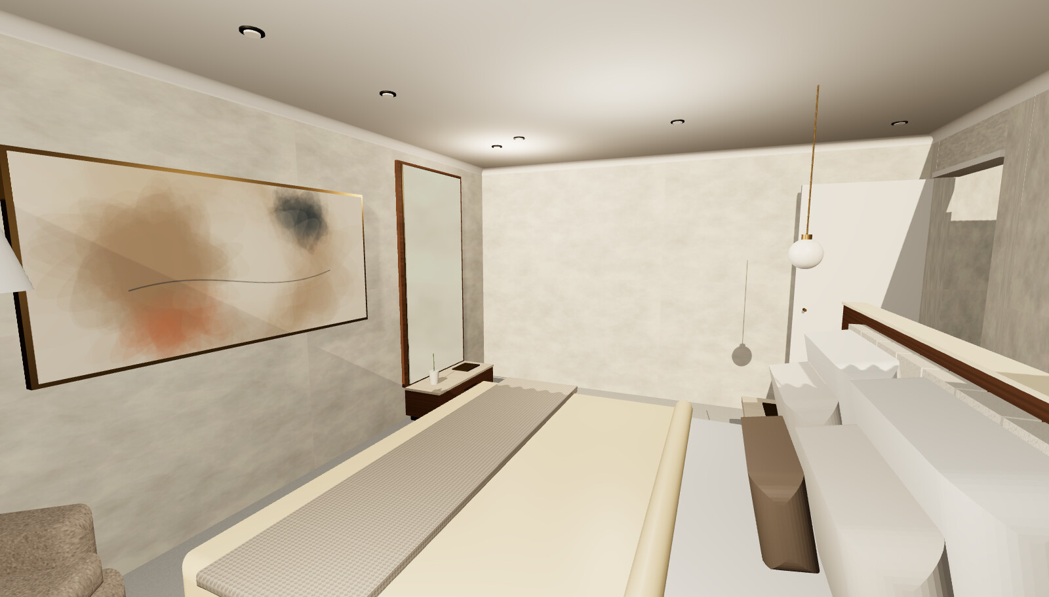
Design reference: tall mirror on a floor-level drawer (left) and the walnut headboard wall behind the bought bed (right)

1. What you are building
Piece | Size | Where it goes | Effort
Bought king bed with headboard | Your chosen model (e.g. Life Interiors Georgia 1975 × 2230, T&W Ellora 1870 × 2085, Harvey Norman Winton 2020 × 2230) | In front of the headboard wall, 20–50 mm off it, standing on the sled tongue | Delivery + assembly
Sled base (hidden) | T-shape: 3.0 m × 0.58 m strip + tongue sized to your bed (example 1915 × 1720), 17–19 mm ply | On the carpet, under the wall, nightstands and the whole bed | Half a day
Headboard wall (backdrop + screen) | 3.0 m long × 1.2 m high × about 0.1 m thick | 0.7 m from the east wall, centred on the robe walkway (1.35 m to 4.35 m from the north wall) | 2 weekends
Mirror + floor drawer unit | 1.0 m wide; drawer plinth 0.35 m deep × 0.3 m high; mirror 0.9 m × 1.9 m | West wall, north end (0.5 m to 1.5 m from the north wall) | 1–2 weekends

Nothing is fixed into the carpet or floor. The headboard wall is screwed only to a plywood sled that runs under the bed, so the bed’s weight holds it upright. The mirror unit’s drawer stands on the carpet and its backing panel hangs on the wall studs.
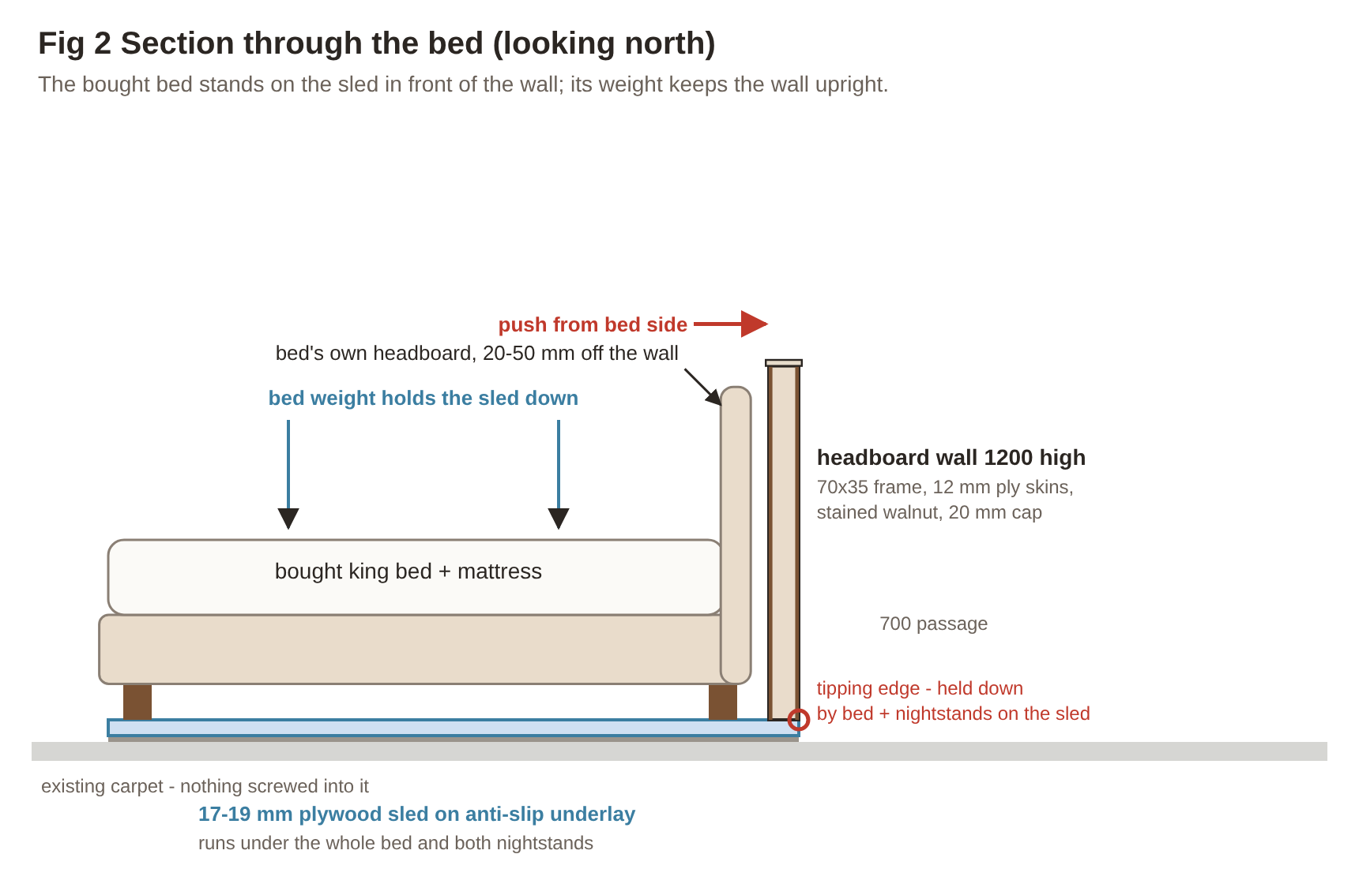
Fig 2 How the headboard wall stands: the bought bed on the sled holds it upright

Check your bed against the wall
The wall is sized for beds up to about 2.0 m wide. Before cutting, confirm these three numbers on the bed you buy:
Check | Rule | If it does not fit
Bed width (incl. headboard) | Bed width + 2 nightstands (450 each) + 2 × 20 mm gaps ≤ 3000 mm wall length | Use narrower (400 mm) nightstands or lengthen the wall to 3.1 m (cut list changes)
Headboard height | Best ≤ 1120 mm so the 20 mm cap and walnut edge show above it, as in the render | Taller headboard (e.g. 1250): raise the wall to 1.35 m (studs 1240 mm) or accept the headboard above the wall
Leg / plinth positions | Every leg must stand on the sled tongue, at least 30 mm in from its edge | Enlarge the tongue; tongue = (bed width − 60) × (bed length − 510)

Two finish routes
Route | What you do | Look
A. All-Bunnings (this plan’s default) | Build skins from 12 mm hoop pine or birch plywood and stain them walnut, then clear-coat. Everything comes from Bunnings. | Warm stained timber; ply grain, not true walnut
B. True walnut | Same build, but use walnut-veneered MDF from a timber/panel merchant for the visible faces (not stocked by Bunnings). | Closest to the renders; costs about A$900–1,500 more

2. Where to start: order of work
Work in this order. Each weekend ends at a safe stopping point.
When | Do this | Ready when
Week 0 (evenings) | Choose the bed and note its width, length, headboard height and leg positions. Measure the room, check north, find wall studs on the west wall, decide finish route, fill aisle/bay column in the Bunnings app, book the electrician, order mirror from a glazier (and stone cap if using travertine). | Shopping list complete
Weekend 1 – Sat | Bunnings trip 1 (sled, frame, fixings, tools). Set out tape lines on the carpet. Cut and lay the sled. | Sled laid and joined
Weekend 1 – Sun | Build the wall frame, stand it on the sled, fix it down, fit brackets. Push-test. | Frame rigid, plumb
Weekend 2 – Sat | Bunnings trip 2 (skins, finishes). Cut and fit skins, close the ends. | Wall clad
Weekend 2 – Sun | Fill, sand, stain, first clear coats. Fit the cap. | Wall finished
Weekend 3 | Bed delivery: assemble the bought bed on the sled tongue, 20–50 mm off the wall. Fix nightstands to the wall and sled. Push-test. | Bed area complete
Weekend 4 – Sat | Mirror unit: hang the backing panel on a cleat; build the drawer plinth. | Panel level on wall
Weekend 4 – Sun | Finish the plinth, fit runners and drawer, fix to the panel. Mirror ledge, then bond the mirror. Trim. | Mirror installed (24 h cure)

3. Bunnings shopping list
Tick each item off in store. Write the Harrisdale aisle and bay from the Bunnings app before you go. Sheet goods: ask the timber yard team to break 2400 × 1200 sheets down on the panel saw so they fit your car; make the accurate cuts at home.

3.1 Sled base and headboard wall frame
✓ | Item | Size / spec | Qty | Bunnings brand / range to look for | Aisle / bay (Harrisdale) | Approx. A$
☐ | Structural plywood | 17–19 mm, 2400 × 1200 (CD or bracing grade) | 3 sheets | Ecoply structural plywood (Carter Holt Harvey) |  | 270–390
☐ | Anti-slip rug underlay / matting | Cut to sled footprint | about 5 m² | Anti-slip matting roll (flooring aisle); else Spotlight / Kmart rug underlay |  | 40–80
☐ | Pine framing (plates) | MGP10, 70 × 35, 3.6 m | 2 lengths | MGP10 structural pine (timber yard) |  | 30–45
☐ | Pine framing (studs + noggins) | MGP10, 70 × 35, 3.0 m | 5 lengths | MGP10 structural pine (timber yard) |  | 55–80
☐ | Timber screws, frame | 10g × 75 mm countersunk | 1 box (100) | Zenith or Buildex |  | 20–30
☐ | Screws, plate to sled | 10g × 45 mm countersunk | 1 box | Zenith or Buildex |  | 15–25
☐ | Short screws into sled | 8g × 12 mm wafer-head (never longer) | 1 box | Zenith |  | 10–15
☐ | Angle brackets | Galvanised, 50–75 mm legs | 20 | Pryda or Zenith |  | 50–100
☐ | Felt pads | Self-adhesive, 25–40 mm | 1 pack | Any (hardware aisle) |  | 5–10
☐ | Flat mending plates | Galvanised, about 100 × 40 mm | 6 | Zenith |  | 15–25
☐ | Construction adhesive | 320 g cartridge | 4 | Selleys Liquid Nails (Original or Fast Grab) |  | 40–60
☐ | Wood glue | Interior PVA, 500 ml | 1 | Selleys Aquadhere Interior |  | 12–18
☐ | Dark grey sample pot | For sled edges | 1 | Dulux or Taubmans sample pot |  | 8–12

3.2 Headboard wall skins, cap and finish (Route A)
✓ | Item | Size / spec | Qty | Bunnings brand / range to look for | Aisle / bay (Harrisdale) | Approx. A$
☐ | Plywood skins | 12 mm hoop pine or birch, good one face, 2400 × 1200 | 3 sheets | Hoop pine plywood BC grade (timber yard) |  | 270–420
☐ | Brad nails | 32–38 mm, to suit your nailer | 1 box | Ozito or Ryobi brads |  | 15–25
☐ | Wood filler | Walnut or jarrah tone | 1 tub | Timbermate |  | 12–18
☐ | Timber stain | Walnut tone, interior | 1 L | Cabot’s or Feast Watson interior stain |  | 35–55
☐ | Clear finish | Water-based, matt | 1 L | Cabot’s Cabothane Clear (matt) |  | 40–60
☐ | Wall cap (Bunnings option) | Tasmanian oak DAR 19 × 140, 3.6 m, cut to 3020 and ripped to 110 mm | 1 | Tasmanian oak DAR (timber yard) |  | 45–70
☐ | Sandpaper | 120, 180, 240 grit, sander discs to suit | 1 pack each | Norton or Flexovit |  | 30–45
☐ | Tack cloths + rags | — | 1 pack | Any |  | 8–12

3.3 Mirror + floor drawer unit
✓ | Item | Size / spec | Qty | Bunnings brand / range to look for | Aisle / bay (Harrisdale) | Approx. A$
☐ | Plywood for backing panel + plinth | 17–18 mm hoop pine or birch, 2400 × 1200 | 2 sheets | Hoop pine plywood (timber yard) |  | 180–280
☐ | Plywood for drawer box | 12 mm sides/back, 6 mm base | offcuts + 1 × 6 mm sheet | Hoop pine / plywood 6 mm |  | 25–40
☐ | Drawer runners | Soft-close, full-extension, 300 mm | 1 pair | Bunnings soft-close runner range (hardware aisle) |  | 25–45
☐ | Pull handle | Long bar, brushed brass, 256–320 mm | 1 | Castella cabinet handles |  | 20–45
☐ | Pine for French cleat | DAR 19 × 90, 1.2 m | 1 | Pine DAR |  | 8–12
☐ | Wall screws into studs | 10g × 65 mm | 1 box | Zenith or Buildex |  | 15–20
☐ | Mirror ledge + trim | Aluminium angle 10 × 10 mm, 1.0 m lengths | 6 | Metal Mate aluminium angle |  | 30–60
☐ | Brass-look finish for trim | Metallic spray | 1 can | Rust-Oleum metallic (brass/gold) |  | 15–25
☐ | Mirror adhesive | Neutral-cure, labelled mirror-safe | 2 cartridges | Check label: “suitable for mirrors” (Selleys / Sika ranges) |  | 25–45
☐ | Clear silicone | For the stone or timber top | 1 | Selleys or Sika neutral-cure |  | 10–18
☐ | Painter’s masking tape | 24–36 mm | 2 rolls | 3M or Scotch |  | 12–20
Not at Bunnings: the mirror 900 × 1900 × 6 mm, copper-free silver, polished edges, safety-film backed (local glazier, about A$250–500); travertine top 1000 × 350 × 20 mm and wall cap 3020 × 110 × 20 mm if you choose stone (stone yard).

4. Tools
Ryobi (One+ 18 V) and Ozito are Bunnings-exclusive battery ranges; staying on one battery platform saves money. Makita, DeWalt and Milwaukee are also sold.
✓ | Tool | Used for | Brands at Bunnings | Aisle / bay
☐ | Drill/driver + impact driver kit | All screws, pilot holes | Ryobi One+, Ozito PXC, Makita
☐ | Circular saw (184 mm) + clamp-on straight edge 2.4 m | Sheet cuts | Ryobi, Ozito; Craftright / Irwin straight edge
☐ | Drop (mitre) saw | Studs, cleats, trims | Ryobi, Ozito
☐ | Jigsaw | Notches | Ryobi, Ozito
☐ | Random orbital sander 125 mm | Sanding | Ryobi, Ozito
☐ | Brad nailer (18 ga) | Fixing skins without visible screws | Ryobi One+ or Ozito
☐ | Bar clamps × 4 (600–1200 mm) | Glue-ups | Irwin Quick-Grip
☐ | Stud finder | West wall studs | Zircon or Ryobi
☐ | 1.2 m spirit level + laser level | Level and plumb | Stanley, Ozito, Ryobi
☐ | Tape, combination square, utility knife, pencils | Marking out | Stanley, Craftright
☐ | Caulking gun | Adhesives | Craftright, Sika
☐ | Brushes, foam applicators, lint-free rags | Stain and clear coat | Uni-Pro, Monarch
☐ | P2 dust masks, safety glasses, ear muffs, gloves | Safety (essential) | ProChoice, 3M
Hiring: a track saw or router is not needed for this plan. If you want one, hire from a tool-hire company rather than buying.

5. Cut lists and cutting layouts
Part | Material | Size (mm) | Qty
Sled strip | 17–19 mm ply | 2400 × 580 and 600 × 580 | 1 + 1
Sled tongue (example bed 1975 × 2230) | 17–19 mm ply | 1720 × 1200 and 1720 × 715 (= (W−60) × (L−510) overall) | 1 + 1
Top + bottom plates | MGP10 70 × 35 | 3000 | 2
Studs | MGP10 70 × 35 | 1090 | 10
Noggins | MGP10 70 × 35 | to fit between studs (about 294) | 9
Skins (each face) | 12 mm ply | 2400 × 1160 + 600 × 1160 | 2 faces
End closers | 12 mm ply | 94 × 1160 | 2
Cap (timber option) | Tas oak 19 × 140 | 3020 × 110 | 1
Mirror backing panel | 17–18 mm ply | 1000 × 1950 | 1
Plinth sides | 17–18 mm ply | 350 × 250 | 2
Plinth top + bottom | 17–18 mm ply | 964 × 350 | 2
Toe-kick board | 17–18 mm ply | 964 × 50 | 1
Drawer front | 17–18 mm ply | 996 × 230 | 1
Drawer box sides / front-back | 12 mm ply | 300 × 170 / 900 × 170 (check runner clearance) | 2 / 2
Drawer base | 6 mm ply | 924 × 300 | 1
French cleat (mirror panel) | Pine 19 × 90, ripped at 45° | 900 | 1 (2 halves)
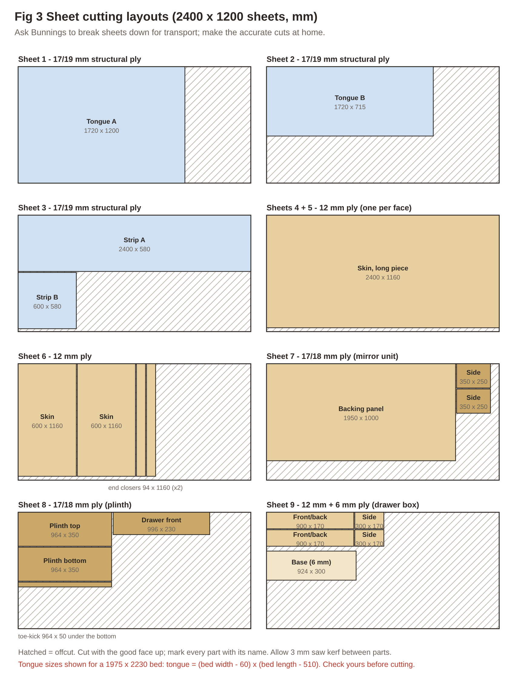
Fig 3 Sheet cutting layouts: label every part as you cut it
Drawer box sizes depend on the runner you buy: most need 12.5–13 mm clearance each side. Read the runner pack and adjust before cutting.

6. Step by step: headboard wall
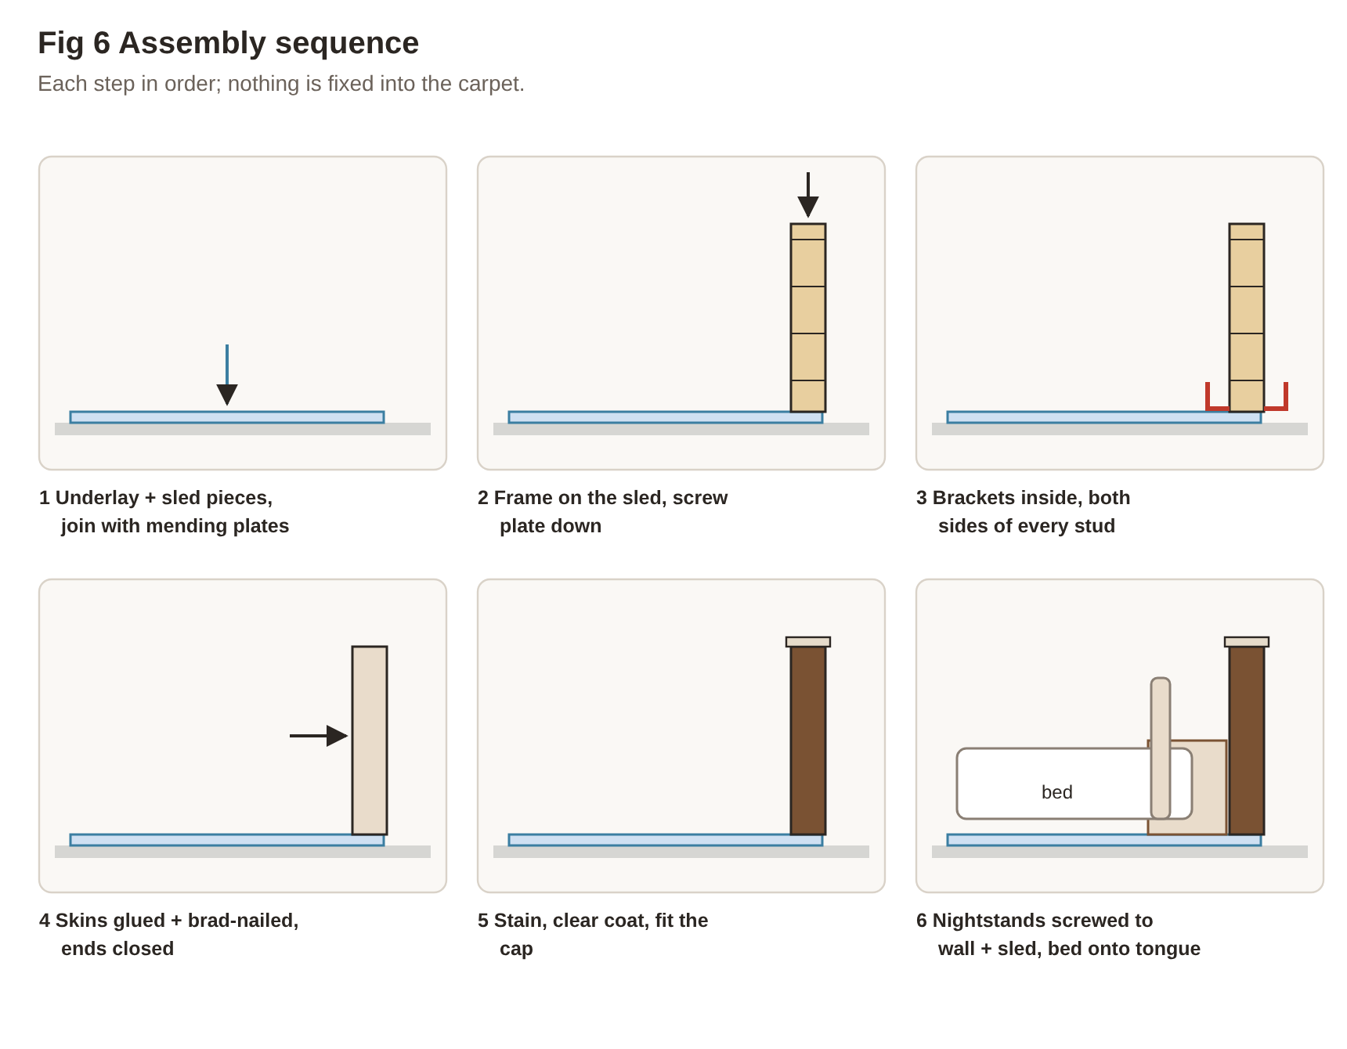
Fig 6 Assembly sequence at a glance

6.1 Set out (Week 0 / Weekend 1 Saturday morning)
- From the bed’s spec sheet, note its overall width (W), length (L) including the headboard, headboard height and where the legs are. Every leg must land on the tongue.
- Mark the wall’s back face on the carpet with painter’s tape: 0.7 m from the east wall, from 1.35 m to 4.35 m from the north wall (3.0 m long, centred on the robe walkway at 2.85 m).
- Tape the sled outline (Fig 1): a 580 mm-deep strip along the full 3.0 m on the bed side of that line, and a tongue (W − 60) wide × (L − 510) long, centred on 2.85 m, running west from the strip.
- Photograph the layout before cutting anything.
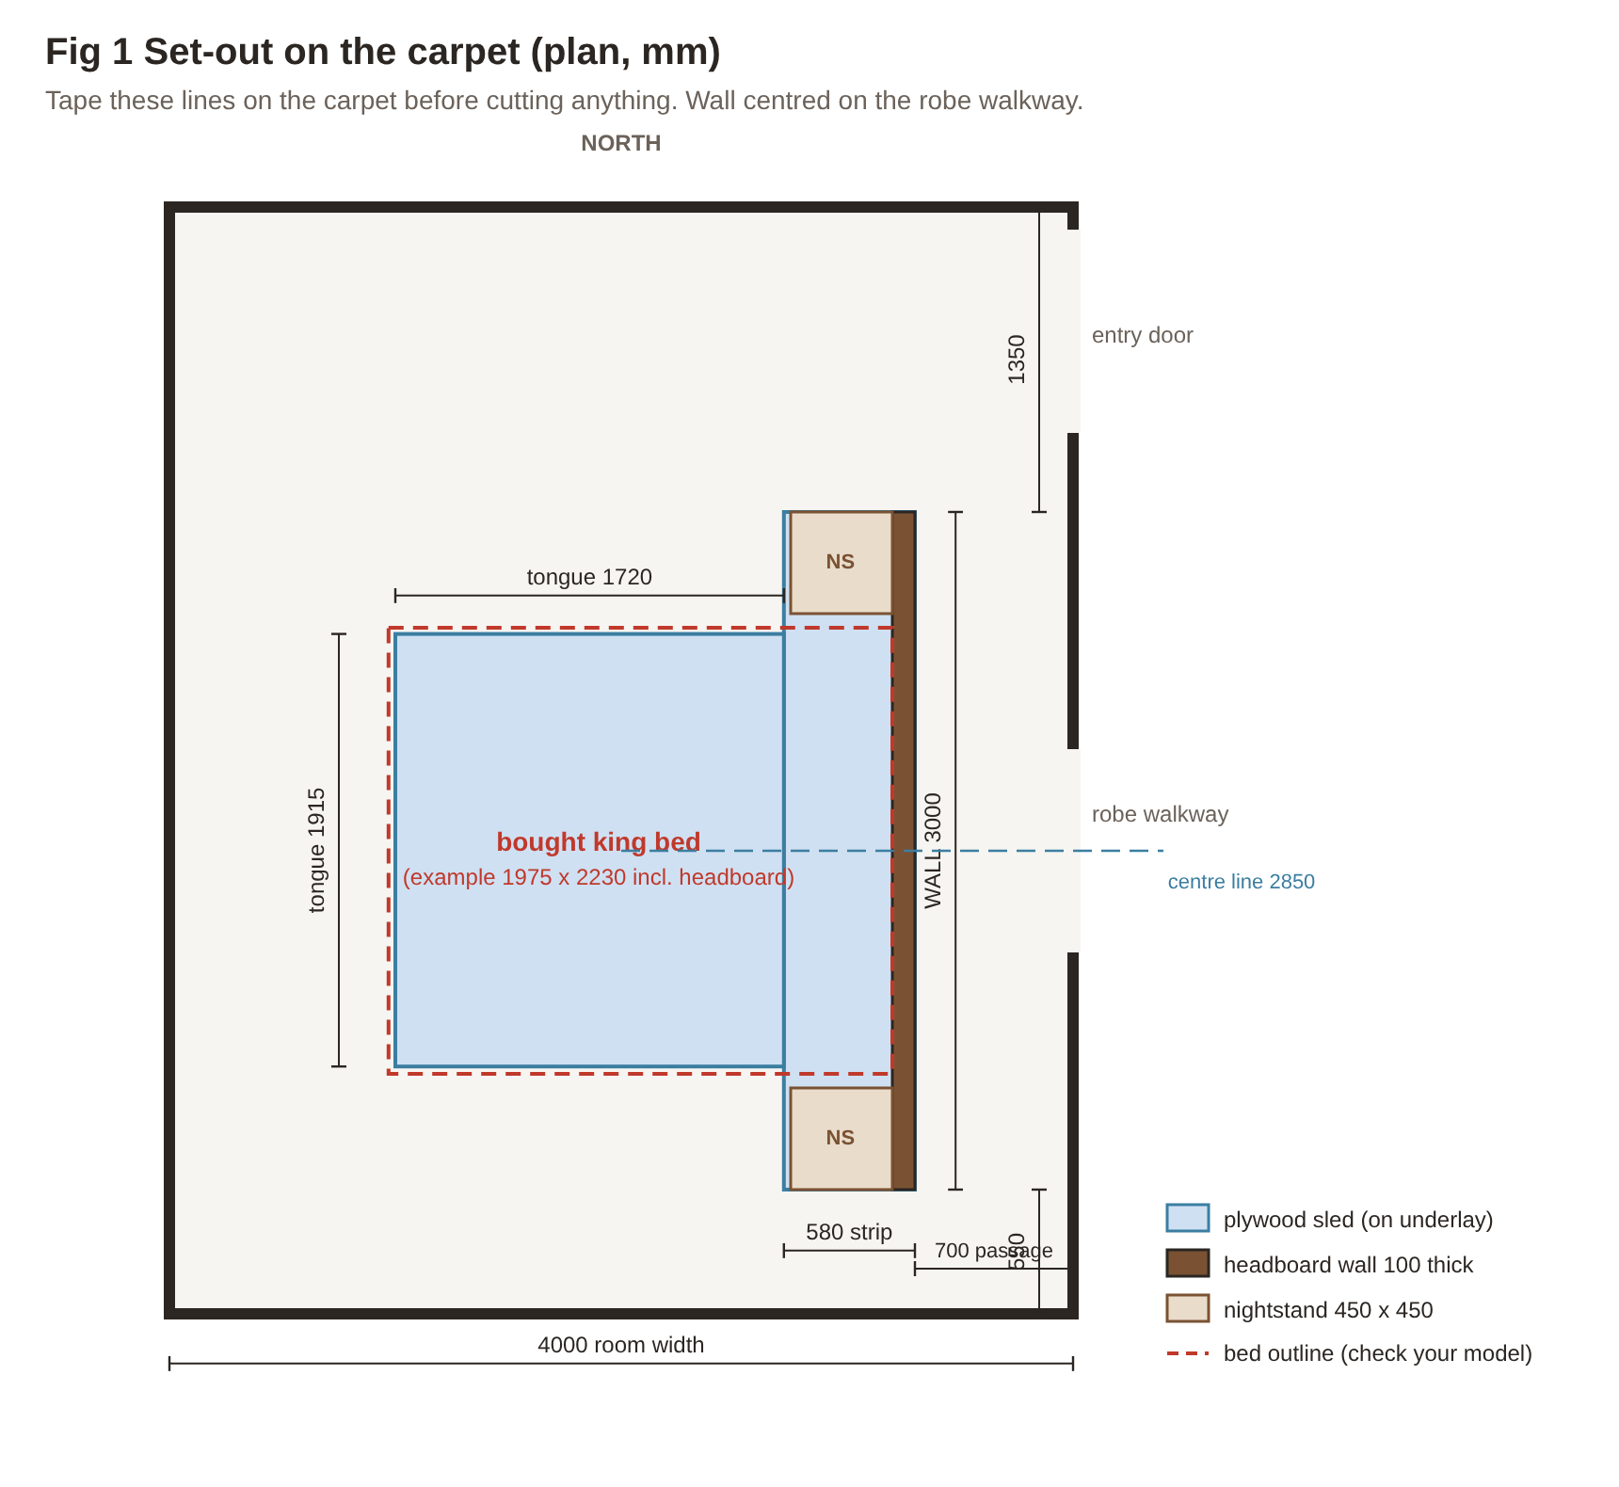
Fig 1 Set-out on the carpet (example bed 1975 × 2230)

6.2 Sled base (Weekend 1 Saturday)
- Cut the strip (2400 × 580 + 600 × 580) and the two tongue pieces (Fig 3) with the circular saw against the straight edge.
- Sand the top edges lightly; paint all exposed edges with the dark grey sample pot.
- Lay the anti-slip underlay inside the tape lines, then the plywood pieces on top, butted tight.
- Join pieces with flat mending plates on the top face, using 8g × 12 mm screws only. Nothing may come through the underside.
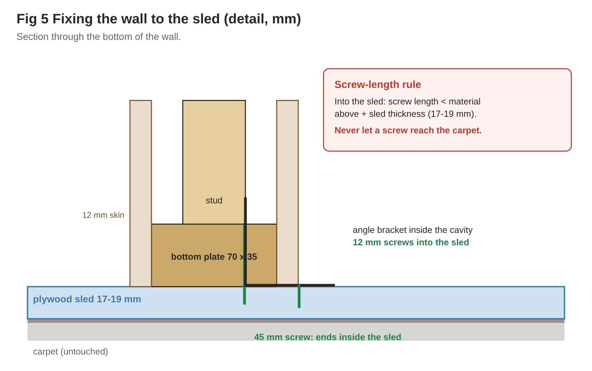
Fig 5 Fixing detail at the bottom of the wall
Golden rule for the whole build: any screw going into the sled must be shorter than the material it passes through plus the sled thickness, so it can never reach the carpet.

6.3 Wall frame (Weekend 1 Sunday)
- Cut two plates at 3000 mm (from the 3.6 m lengths) and ten studs at 1090 mm (frame height ≈ 1200 − sled − cap ≈ 1160 mm). For a 1.35 m wall, studs are 1240 mm.
- Lay the plates on edge, mark stud positions at about 329 mm centres (Fig 4); glue (Aquadhere) and screw each stud with two 75 mm screws through the plates.
- Fit a noggin row 600 mm up, staggered so you can screw through the studs.
- Check the frame is square: the two diagonals must match within 3 mm.
- Stand the frame on the sled with its back face on the tape line, flush with the strip’s back edge. Check plumb both ways with the level.
- Screw the bottom plate into the sled with 45 mm screws at 300 mm centres (35 mm plate + sled = 52–54 mm, so 45 mm never pokes through).
- Inside the frame, fit an angle bracket each side of every stud to the sled: 12 mm screws into the sled, 30–45 mm screws into the stud.
- Push hard at the top from both sides. It may flex slightly until the skins and bed go on, but the base must not lift.
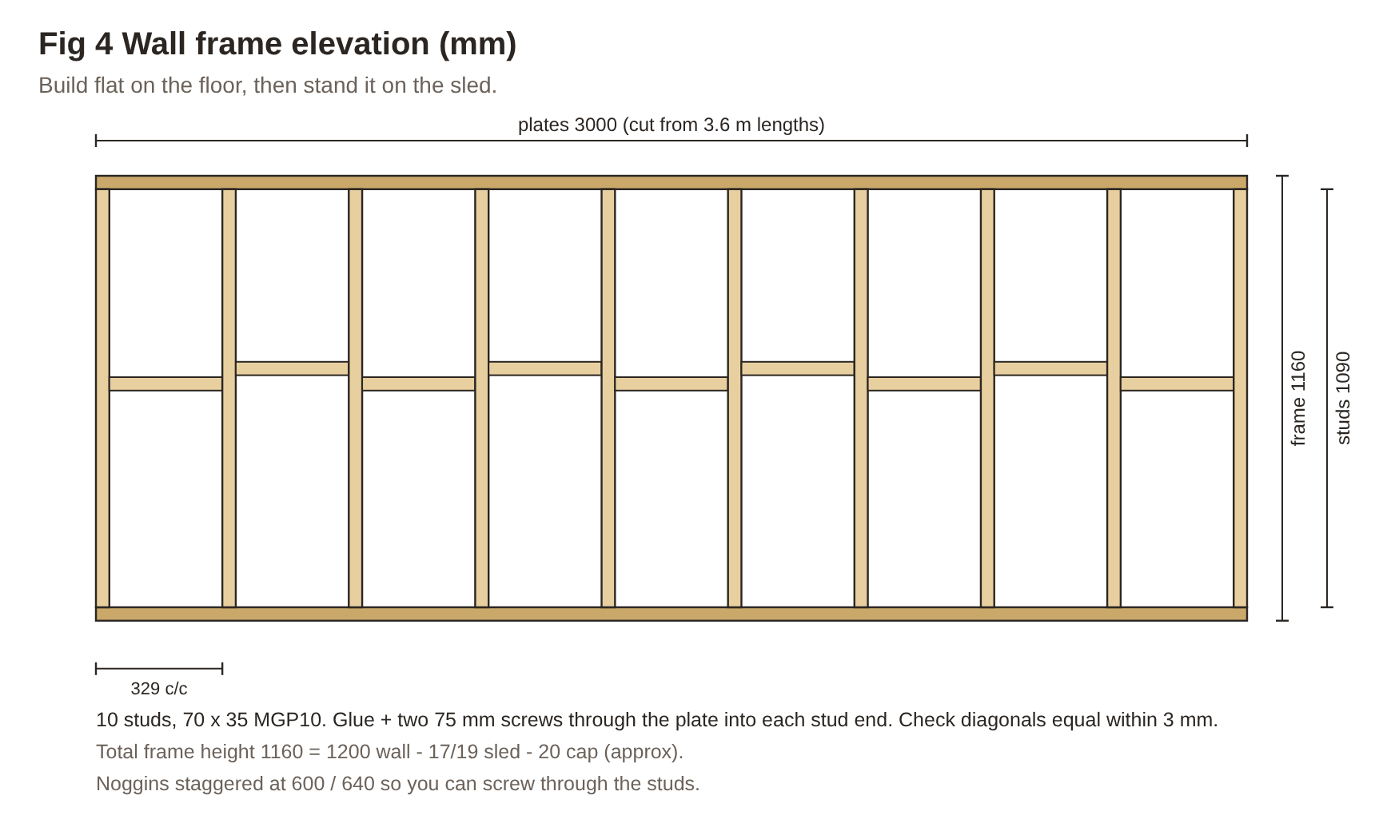
Fig 4 Wall frame elevation
Electrical: with the recommended wireless option there is no wiring in the wall. If your electrician will fit plug-in furniture power units in the nightstands, nothing is needed inside the wall either.

6.4 Skins (Weekend 2 Saturday)
- Cut the skins: per face, one 2400 × 1160 and one 600 × 1160 piece, good face out. Put the joint on a stud.
- On the bed side, place the joint so the bed’s headboard covers it; on the passage side, offset it to a different stud.
- Run beads of Liquid Nails on every stud and plate, press the skin on, then fix with 32–38 mm brads every 200 mm.
- Repeat on the passage side. Close the two 94 mm ends with the end-closer strips.
- Fill brad holes with Timbermate; let dry; sand flush.

6.5 Finish and cap (Weekend 2 Sunday)
- Sand all faces with 180 then 240 grit; wipe with a tack cloth.
- Test the walnut stain on an offcut first; adjust with a second coat if you want it darker.
- Stain the wall with a rag or foam applicator, working with the grain; wipe off excess; leave as long as the tin says.
- Apply 3 coats of Cabothane Clear matt, light sand with 240 between coats.
- Cap: cut the Tas oak to 3020 mm and rip it to 110 mm, round the edges lightly, stain and coat to match; fix with Liquid Nails and brads from above, filled. (Stone cap: bed it on neutral-cure silicone instead.)

6.6 Nightstands and the bought bed (Weekend 3)
- Place each nightstand on the sled strip against the wall, one each side of the bed position.
- Screw through each nightstand back into two studs, and through its base into the sled with 12 mm screws.
- Assemble the bought bed (per the maker’s instructions) directly on the tongue, so you don’t drag it across the sled.
- Position it centred on 2.85 m with its headboard 20–50 mm off the wall; check every leg is on the tongue, at least 30 mm in from the edge.
- Stick felt pads on the back of the bed’s headboard where it could touch the wall, so it never knocks or marks the finish.
- Do the push test (section 8) with the bed and mattress in place.

7. Step by step: mirror + floor drawer unit
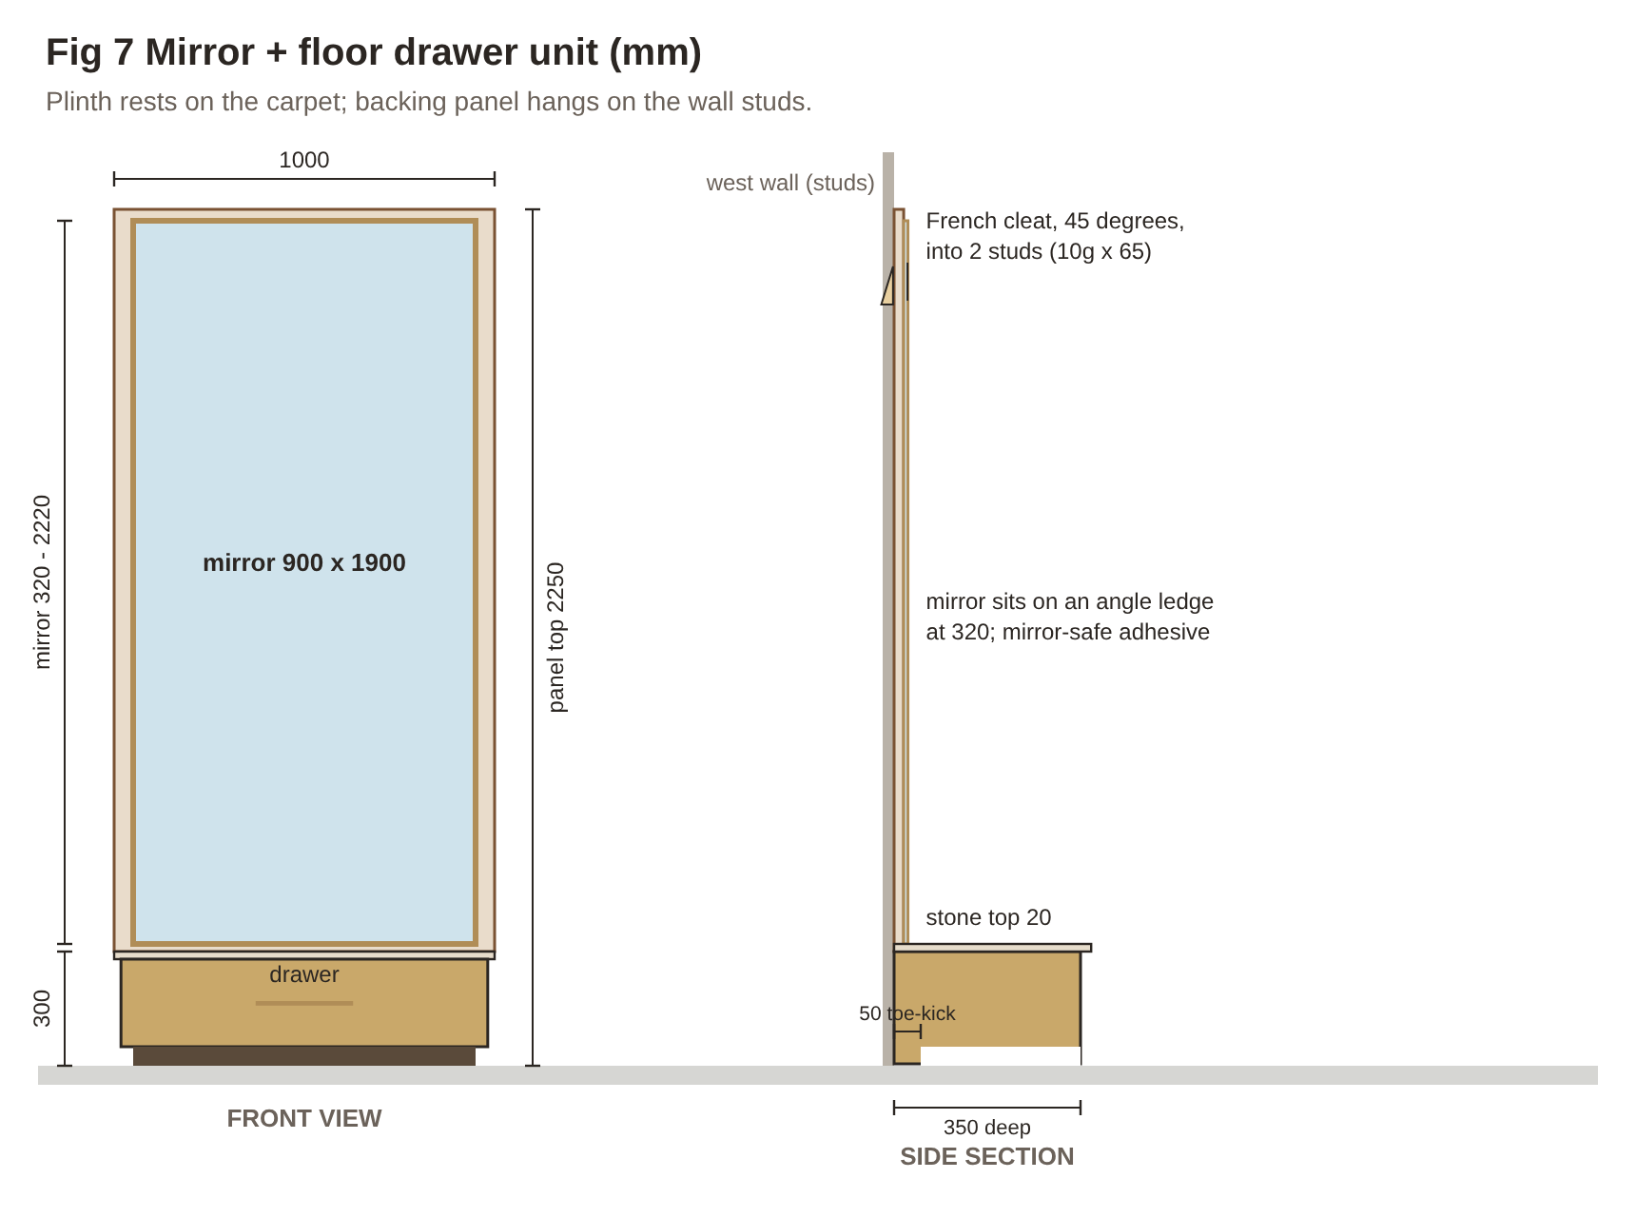
Fig 7 Mirror unit: front view and side section

7.1 Backing panel (Weekend 4 Saturday)
- On the west wall, between 0.5 m and 1.5 m from the north wall, find and mark at least two studs with the stud finder; confirm with a small nail in a spot the panel will cover.
- Cut the backing panel 1000 × 1950 from 17–18 mm ply. Sand, stain and clear-coat it to match the headboard wall.
- Rip a 900 mm pine cleat at 45°. Screw one half across the back of the panel about 150 mm from its top (bevel down).
- Screw the other half to the wall studs with 10g × 65 mm screws (bevel up), level, at the height that puts the panel’s bottom edge 300 mm above the carpet.
- Hang the panel. Check level and plumb; add two screws through the panel’s lower area into the studs (they will be hidden behind the mirror).

7.2 Floor drawer plinth (Weekend 4 Saturday–Sunday)
- Cut the plinth parts: two sides 350 × 250, top and bottom 964 × 350, toe-kick 964 × 50.
- Glue and screw the box together; fit the toe-kick 50 mm back from the front edge at floor level.
- Fit the 300 mm soft-close runners inside the sides following the pack’s instructions.
- Build the drawer box to the runner’s clearance; 6 mm base in a groove or glued and pinned underneath.
- Fix the 996 × 230 drawer front: double-sided tape first, open the drawer and screw from inside; then fit the Castella pull centred.
- Stain and clear-coat the plinth to match.
- Push the plinth under the backing panel and screw through its back into the panel from inside (not into the carpet).
- Top it with the travertine piece on neutral-cure silicone, or a stained timber top.

7.3 Mirror (Weekend 4 Sunday)
- Spray the aluminium angles with the brass-look metallic paint; let dry.
- Screw one angle across the panel as a ledge at 320 mm above the floor; the mirror’s weight sits on this, not on the glue.
- With a helper, dry-fit the mirror on the ledge, centred; mark its outline in pencil.
- Apply mirror-safe adhesive in vertical beads about 150 mm apart (no solvent adhesive: it damages the silver).
- Set the mirror on the ledge, press it on, and tape it to the panel for 24 hours.
- Fix the side and top angles to the panel (not glued to the glass), mitred at the corners.

8. Safety and final checks
☐ Every leg of the bought bed is on the sled tongue; nightstands are screwed to the wall and the sled.
☐ With the bed empty, a firm push at the top of the wall from both sides causes no rocking or lifting.
☐ No screw anywhere reaches the carpet.
☐ Cap is fully bedded; nothing rocks.
☐ Mirror sits on its ledge; tape removed after 24 h; trims fixed to the panel.
☐ Re-check every screw and bracket after 1 month, then every 6 months.
☐ Nobody climbs on or sits on top of the headboard wall; supervise small children.
☐ All wiring and light fittings are done by a licensed electrician.
If a push test shows any movement, extend the sled tongue further under the bed or screw concrete pavers onto the sled under the bed (hidden) before use. If in doubt, ask a carpenter to check it.
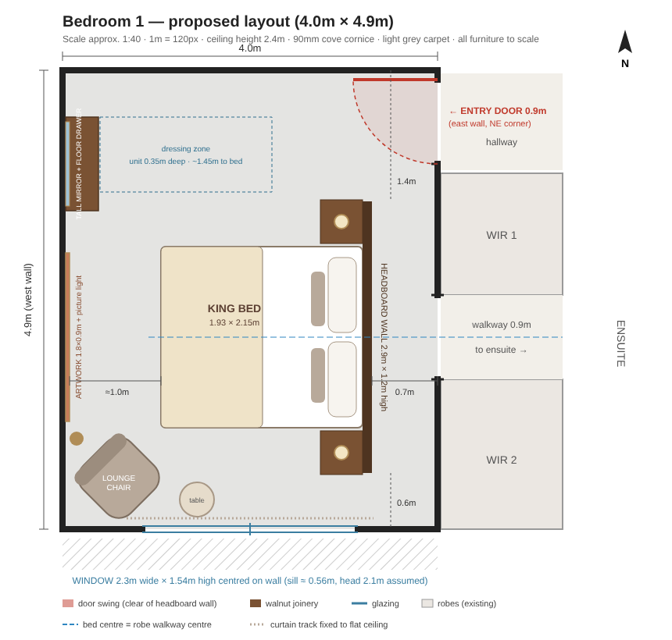
Floor plan: headboard wall position and mirror unit on the west wall (north end)

