Introduction to React A workshop for COMP 523   
Aaron Smith   
Monday, Feb. 10, 2020

What is React?

|  |  |  |
| --- | --- | --- |
| • | React is a **JavaScript framework** |  |
| • |
| Used for **front end web development** |
| • | Think of jQuery, but more structured |

|  |  |  |
| --- | --- | --- |
| • | Created and used by **Facebook** |  |
| • | Famous for implementing a **virtual dom** |

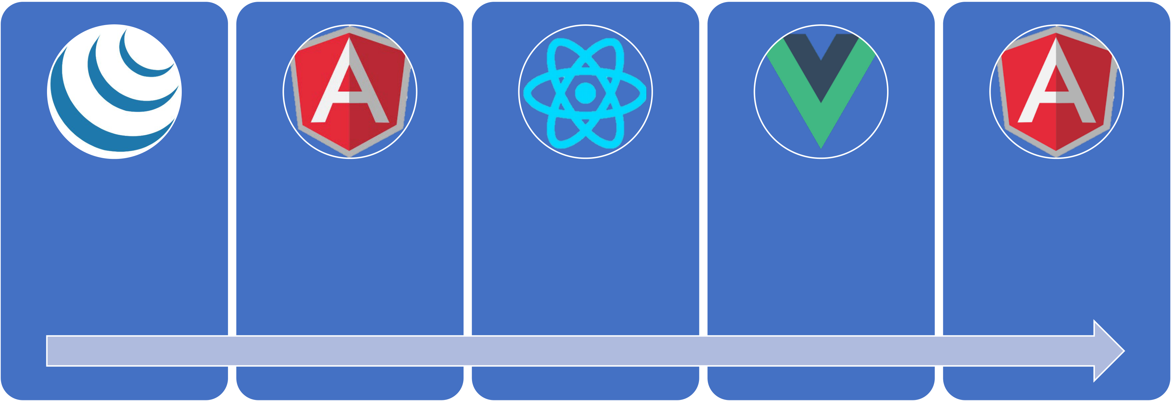

Timeline of front-end JavaScript frameworks

|  |  |  |  |  |
| --- | --- | --- | --- | --- |
| jQuery* | AngularJS | React | Vue | Angular |

|  |  |  |  |  |
| --- | --- | --- | --- | --- |
| (2006) | (2010) | (2013) | (2014) | (2014) |

* jQuery is more often considered a **library** than a **framework**

Common tasks in front-end development

|  |  |
| --- | --- |
| App state | Data definition, organization, and storage |

|  |  |
| --- | --- |
| User actions | Event handlers respond to user actions |
| Templates | Design and render HTML templates |
| Routing | Resolve URLs |
| Data fetching | Interact with server(s) through APIs and AJAX |

Fundamentals of React

1. JavaScript and HTML in the same file (JSX)

2. Embrace functional programming

3. Components everywhere

JavaScript and HTML *in the same file*

|  |  |  |  |  |
| --- | --- | --- | --- | --- |
| **HTML** | **CSS** | **JS** | **JSX** | **CSS or JSS** |

|  |  |  |
| --- | --- | --- |
| Traditional  approach |  |  |
| React  approach | |

JSX: the React programming language

|  |
| --- |
| const first = "Aaron"; |

|  |  |
| --- | --- |
| const last | = "Smith"; |

|  |  |
| --- | --- |
| const name = <span>{first} {last}</span>;  const list = (   <ul>   <li>Dr. David Stotts</li> <li>{name}</li>   </ul>  ); | const listWithTitle = (   <>   <h1>COMP 523</h1>   <ul>   <li>Dr. David Stotts</li> <li>{name}</li> |

</ul>

</>

|  |
| --- |
| ); |

“React is just JavaScript”

Functional programming

1. Functions are “first class citizens”

2. Variables are immutable

3. Functions have no side effects

Functional programming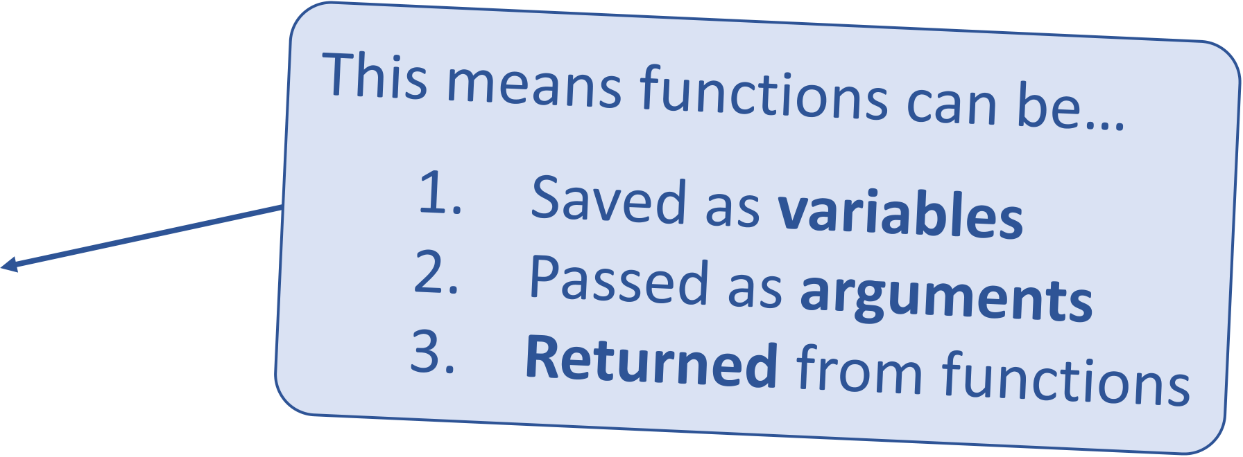

Functions are “first class citizens”

|  |
| --- |
| let add = function() { |

|  |  |
| --- | --- |
| console.log('Now adding numbers'); const five = 3 + 2;  }; | function foo() {   return function() { |

|  |  |  |
| --- | --- | --- |
| function performTask(task) { | } | console.log('What gets printed?'); |
| }; |
| task(); |

|  |  |  |
| --- | --- | --- |
| } | console.log('Task performed!'); | foo |

|  |  |
| --- | --- |
| performTask(add); | foo();  foo()(); |

Functional programming

Variables are immutable

|  |
| --- |
| let a = 4; |

|  |
| --- |
| a = 2; // Mutates `a` |

|  |
| --- |
| let b = [1, 2, 3]; |

|  |
| --- |
| b.push(4); // Mutates `b` |

|  |
| --- |
| let c = [...b, 4]; // Does not mutate `b` |

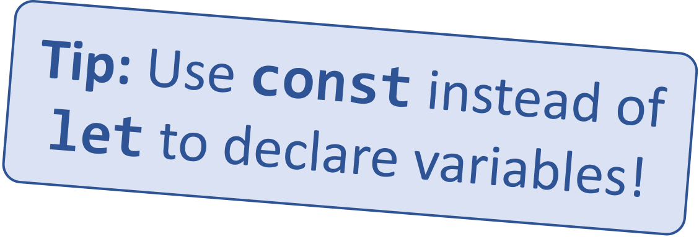

Functional programming

Functions have no side effects

|  |
| --- |
| const b = []; |

|  |
| --- |
| function hasSideEffects() { |

|  |
| --- |
| b = [0]; |

|  |
| --- |
| } |

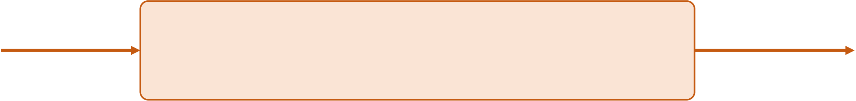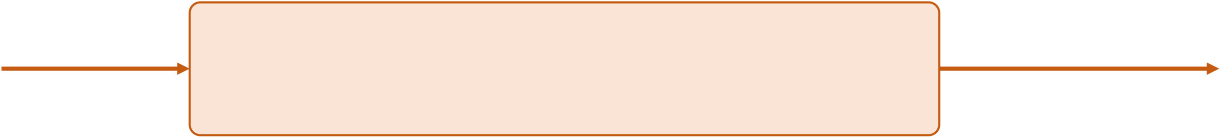

Components   
Components are functions for user interfaces

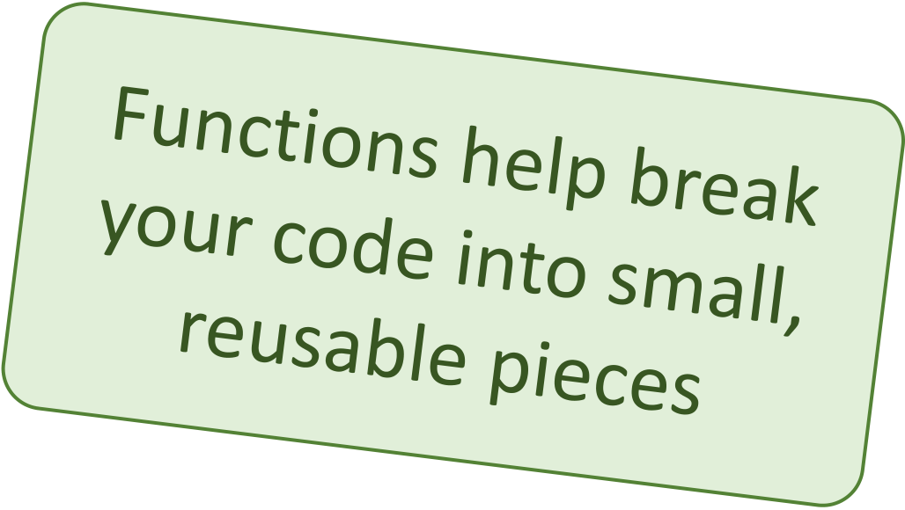

|  |  |  |  |
| --- | --- | --- | --- |
| Math function: | Input **x** | let y = f(x); | Output **number** |
| Input **x** | let y = <FancyDiv value={x} />; | Output **HTML** |
| Component function: |

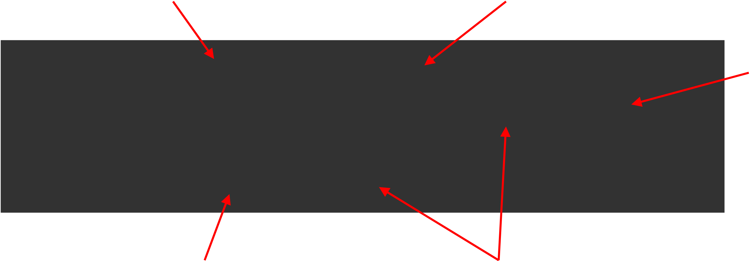

Anatomy of a React component

The component is just

Inputs are passed through a

a function single argument called “props”

The function

|  |  |
| --- | --- |
| export default function MyComponent(props) {   return <div>Hello, world! My name is {props.name}</div>; | outputs HTML |

}

const html = <MyComponent name="aaron" />;

The function is **executed** as if Parameters are passed in

it was an HTML tag as HTML attributes

Component rendering

|  |  |
| --- | --- |
| • | When a component function **executes**, we say it “**renders**” |

|  |  |
| --- | --- |
| • | Assume components may re-render at any time |

Our job is to ensure that   
every time the component re-renders,   
the correct output is produced

“In React, everything is a component”

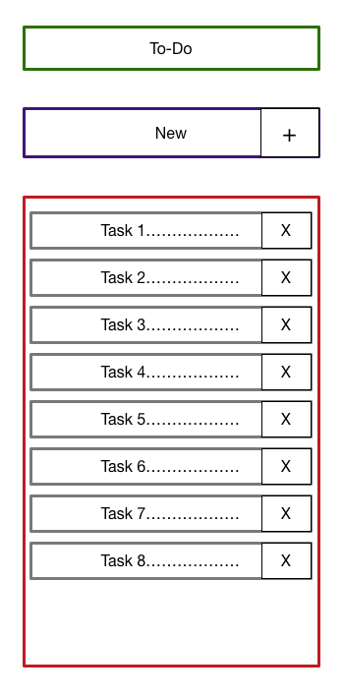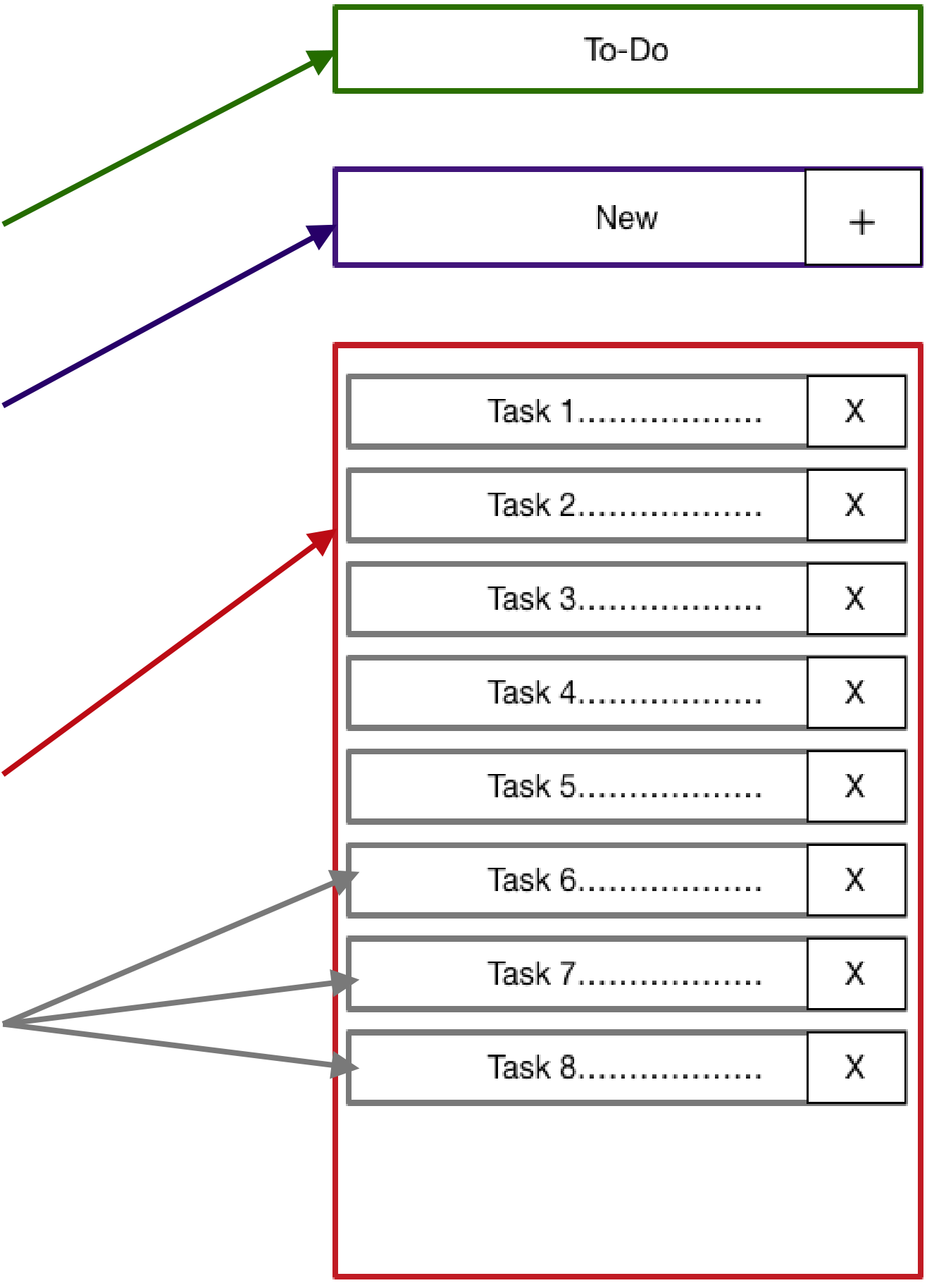

Todo application   
 **Title** Big idea:

|  |  |  |
| --- | --- | --- |
| ▪ | A digital to-do list | **TodoForm** |

First step:  
 ▪ mockup / wireframe

**TodoList**

**Todo**

Creating a new React app

Creating a new React app is simple!

1. Install Node.js   
2. Run: **npx create-react-app app-name**

|  |  |
| --- | --- |
| 3. New app created in folder: | **./app-name** |

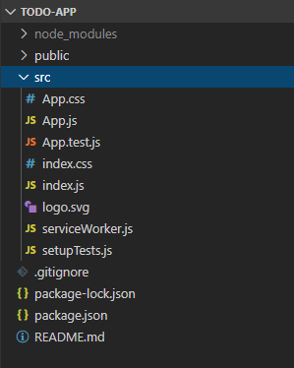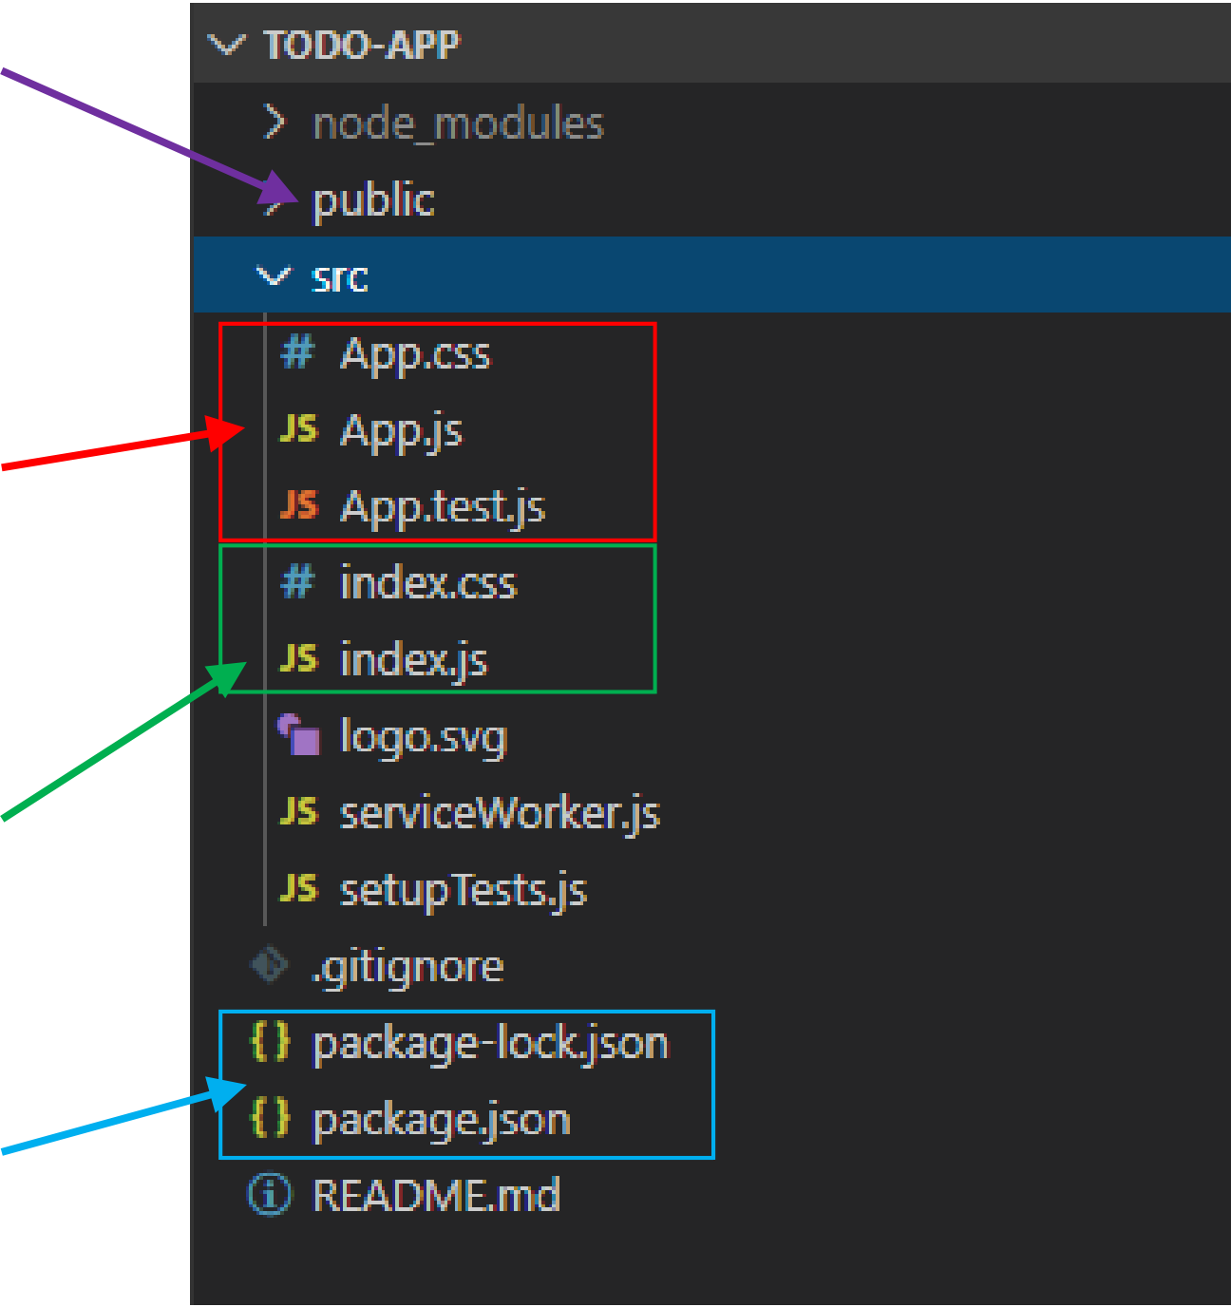

Anatomy of a new React app

**public** holds the initial html   
document and other static assets

**App** is a boilerplate   
starter component

**index.js** binds   
React to the DOM

**package.json** configures   
 npm dependencies

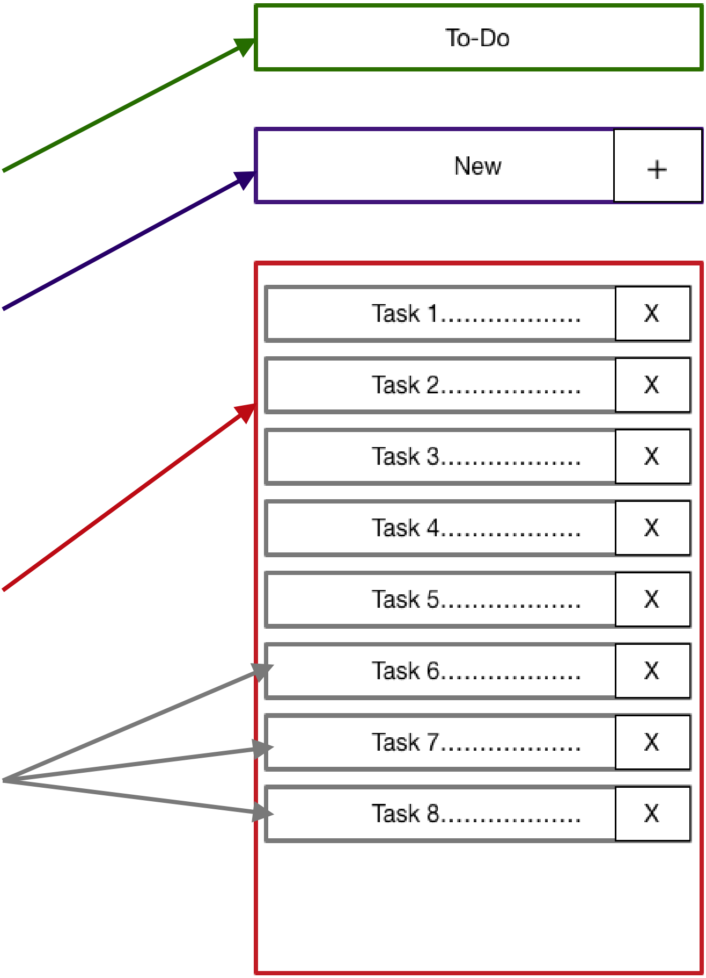

Component Hierarchy   
 **Title**

**TodoForm**   
**App**



|  |  |  |  |
| --- | --- | --- | --- |
| **Title** | **TodoList** | **TodoForm** | **TodoList**  **Todo** |
|  | | |
| **Todo** | **Todo** | **Todo** |

Special list key property

|  |  |
| --- | --- |
| • | **Situation:** Display a **dynamic array of elements** |

|  |  |
| --- | --- |
| • • • • | Must specify a special “**key**” property for each element The key of an item **uniquely identifies it**  Used by React internally for **render optimization**  Can be any unique value (string or number) |

What are hooks?

**Hooks:** Special functions that allow developers to hook into **state** and

Built-in hooks:

|  |  |  |  |
| --- | --- | --- | --- |
| **lifecycle** of React components. | We will cover |  | useState |
| **State:** One or more data values | these today | useEffect |
| associated with a React component | We will **not** cover |  | useReducer |
| instance. |
| useMemo |
| **Lifecycle:** The events associated with a | these today | useRef |
| useCallback |
| React component instance (create, |
| render, destroy, etc). |



First React hook: useState

Purpose:   
1. Remember values internally when the component re-renders 2. Tell React to re-render the component when the value changes

Syntax:

const [val, setVal] = useState(100);

|  |  |  |
| --- | --- | --- |
| The current value | A setter function to | The initial |

change the value value to use

Predicting component re-rendering A component will only re-render when…

1. A value inside **props** changes

**– or –**

2. A **useState** setter is called

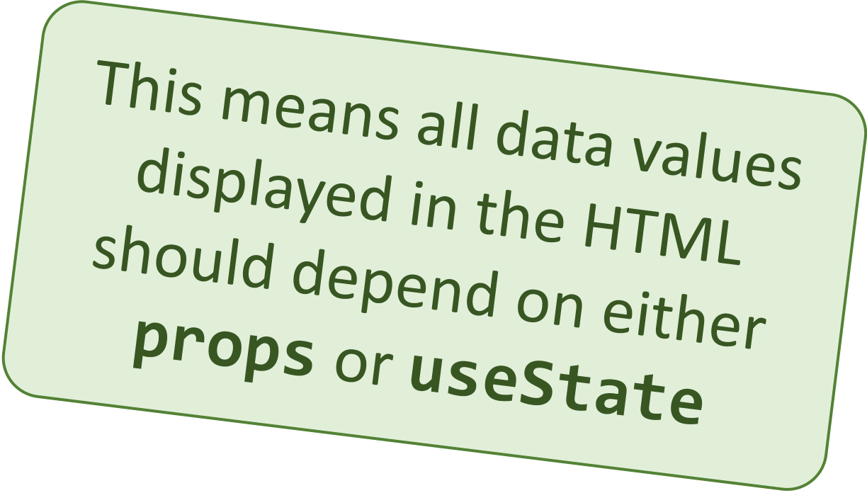



Second React hook: useEffect

Purpose:

Act as an **observer**, running code in response to value changes

Syntax:

useEffect(() => {   
 console.log(`myValue was changed! New value: ${myValue}`); }, [myValue]);

A list of values such that changes

The code to run when

should trigger this code to run values change

Building a React project

|  |  |
| --- | --- |
| • | When you’re ready to launch your app, run this command: |

**npm run build**

|  |  |
| --- | --- |
| • | This bundles your app into CSS/JS/HTML files and puts them in the |

**/build** folder

|  |  |
| --- | --- |
| • | These files can be served from an AWS S3 bucket |

3rdparty components and libraries

|  |  |
| --- | --- |
| • • • • • • | React-Router  Redux  Material-UI  Bootstrap  Font-Awesome  SWR |