Git Push:

1. install git in eclipse help > install software

2.paste this command:

https://download.eclipse.org/egit/updates

select all and finish.

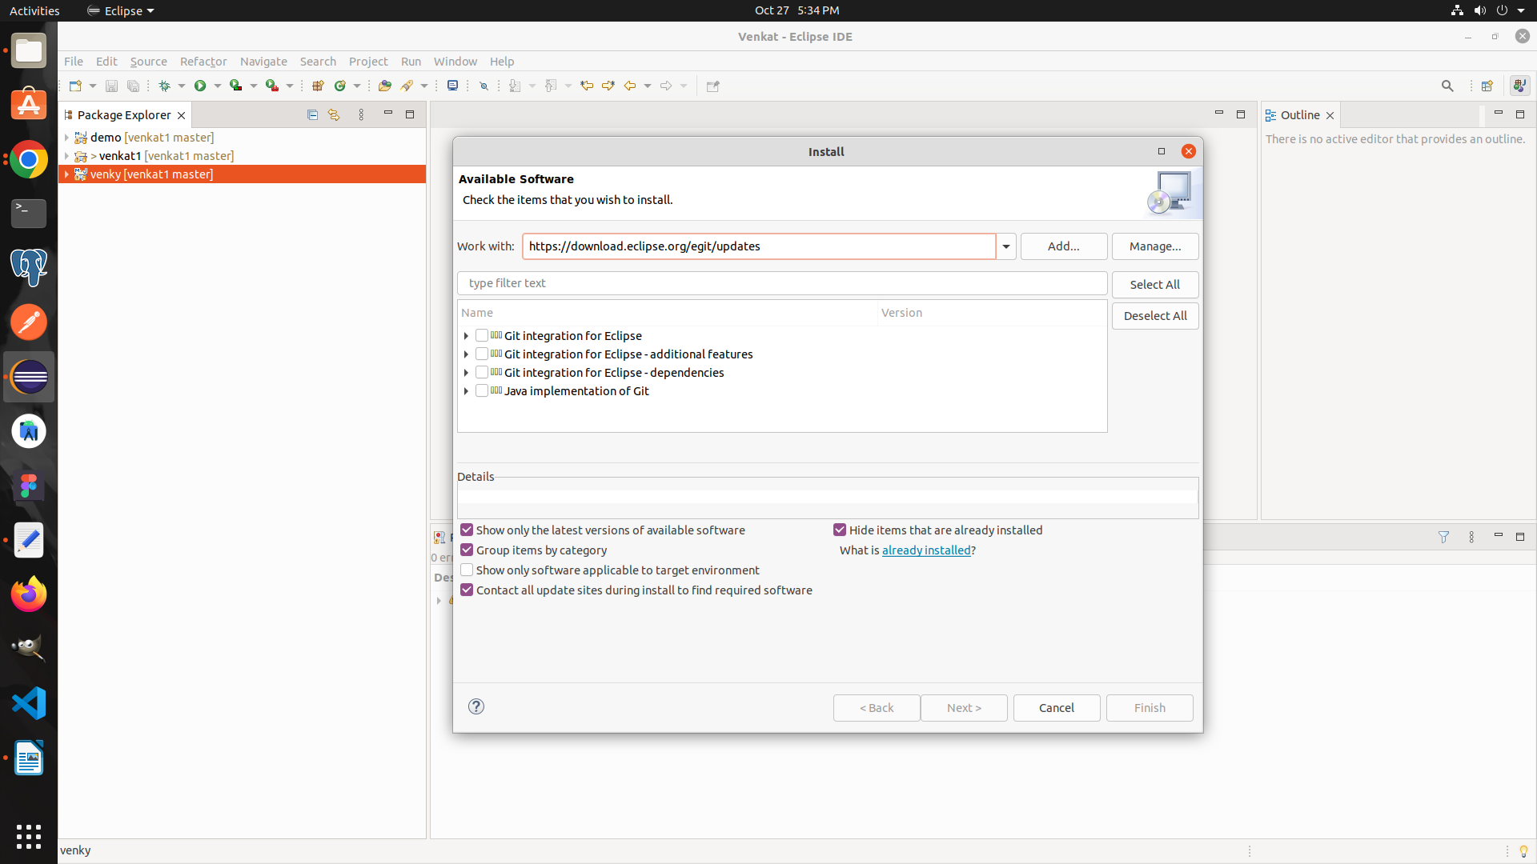
Then,

we push the project to the git hub:

1. select project and left click then team > share project.

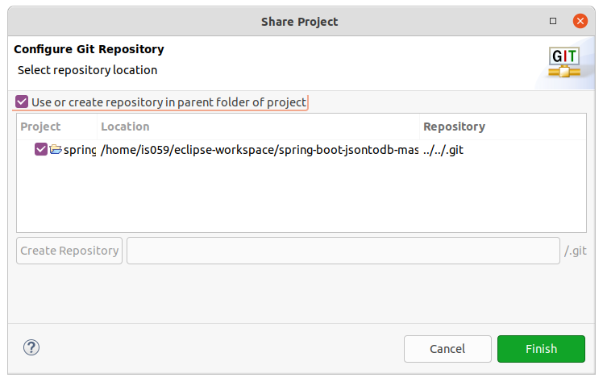

3.uncheck the use Or create repository in parent folder of project
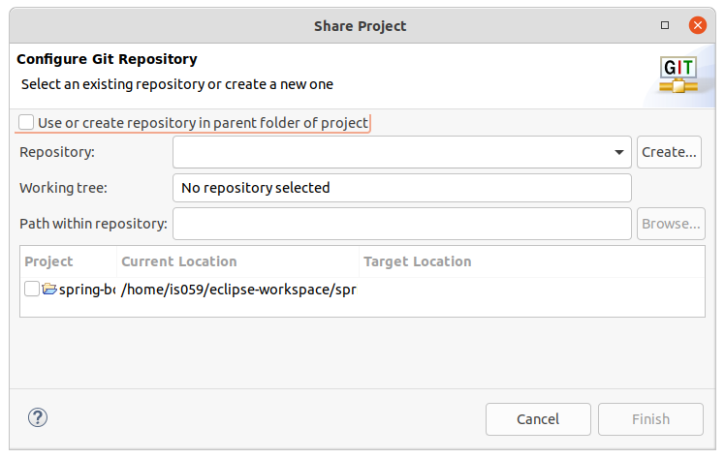
4. select the repository but it automatically allocate the repository

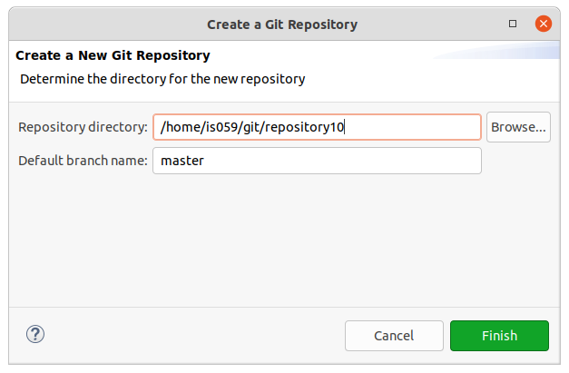

maintain the same repository path because or else it will create another master and branches so main the same repository.

And then change name according to ur naming in branch name ie,. Myself its “main”.

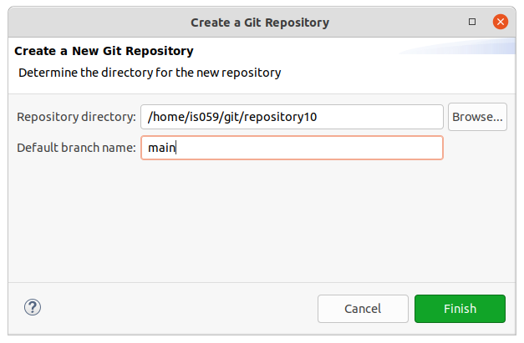

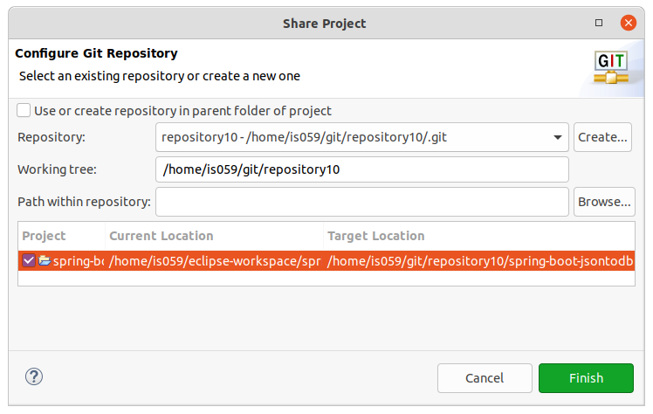
and select the locations and finish.

Then left click the project:

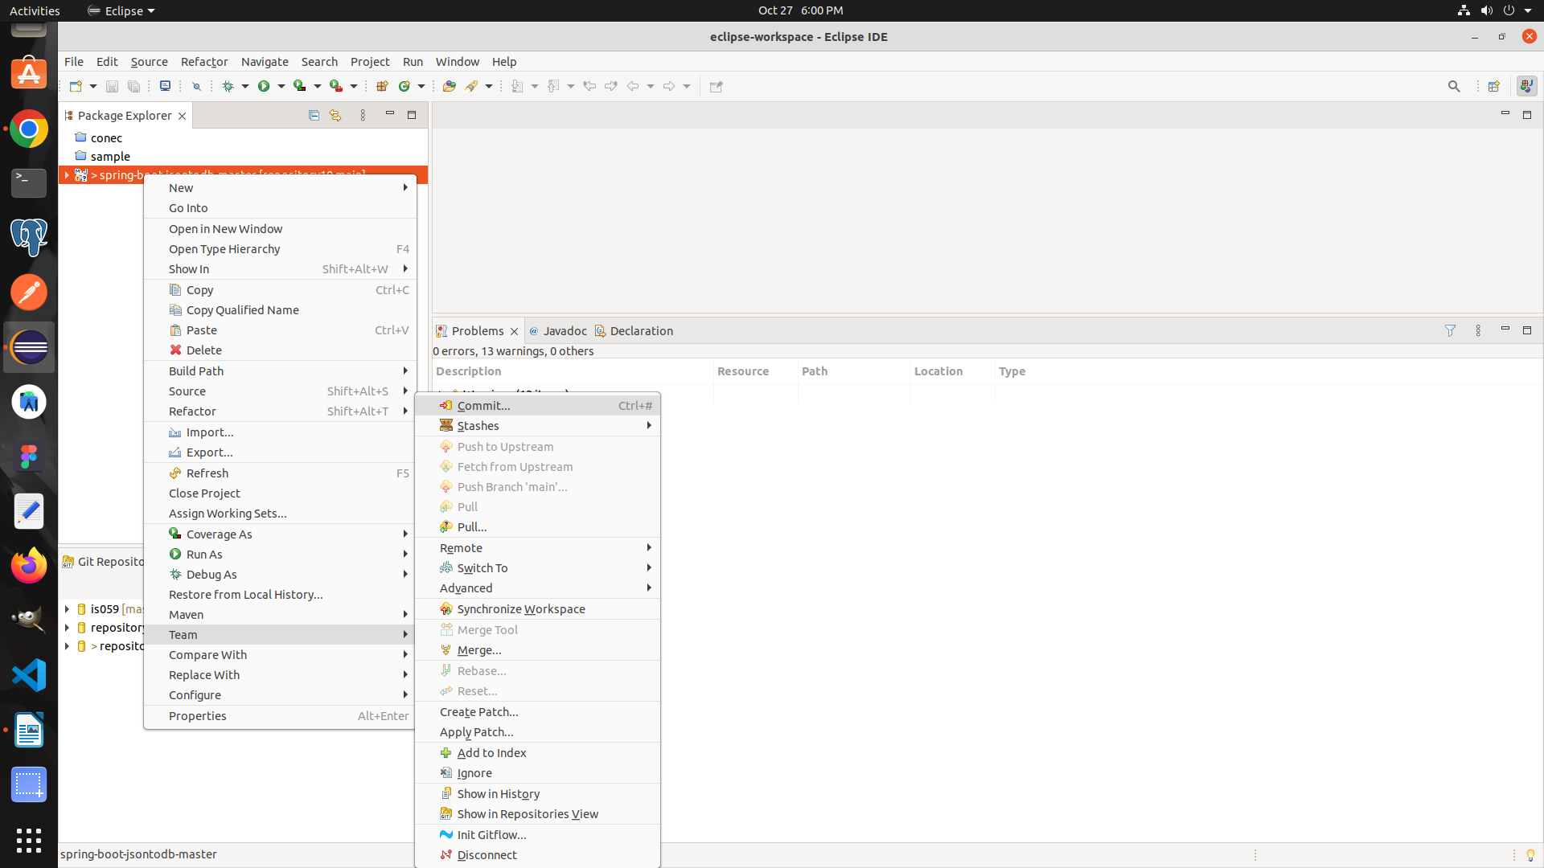
then commit the project.

Then click the double add button on the top then following will be transfer to stored changes.
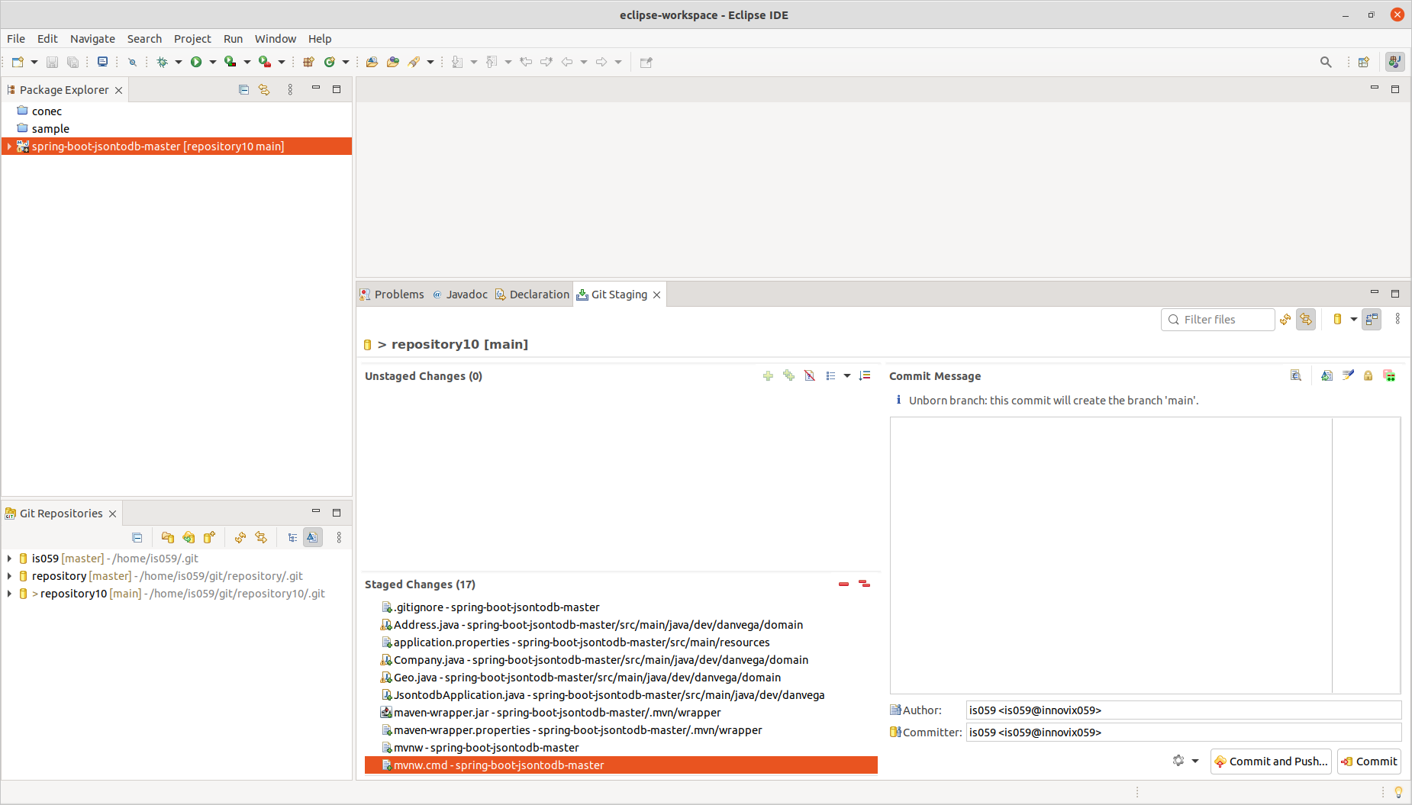
then commit and push and dont forget to write the comment.

Part -2 :

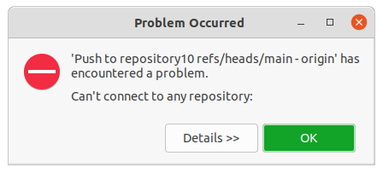

this message is due to user and password is not connected to github so we need to connect.

Then after clicking ok , click push and commit then following will be display:

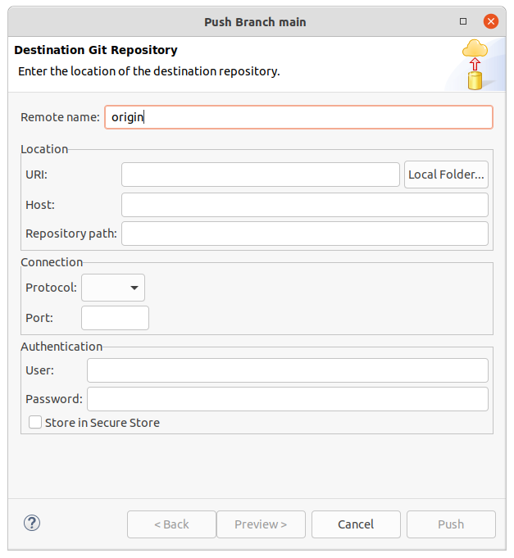

fill the information from the git hub url link

password need to be tokenized from the github side
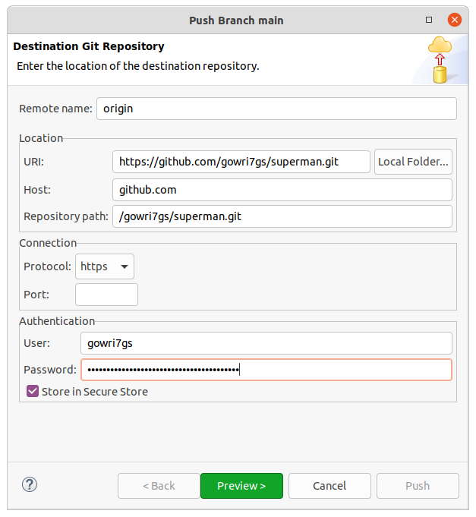

then in preview

push branch manager will display:

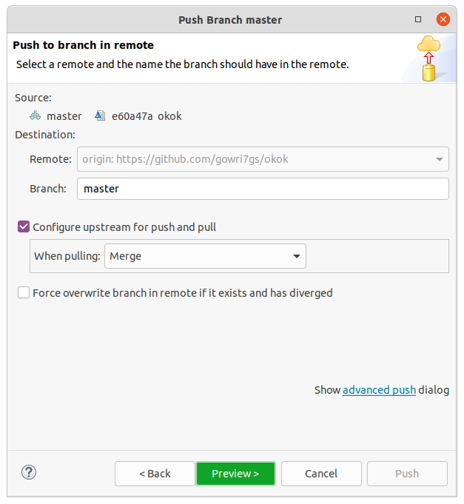

click preview then preview display everything is fine.

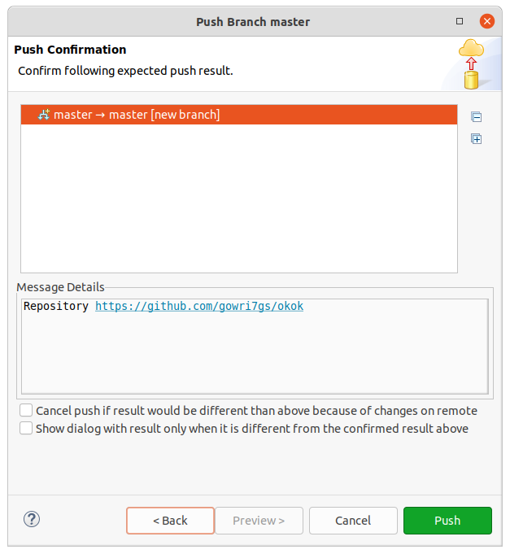
The click push.

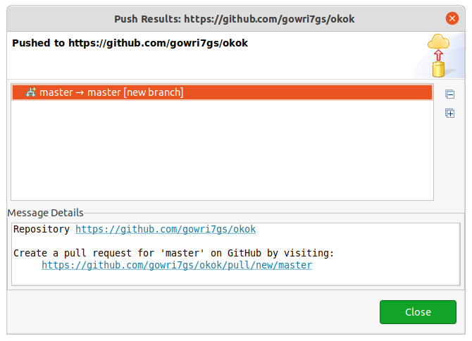
Successfully pushed the project into git hub. For adding project same repo path is needed.
Pull git:

click on the new space the FILE > IMPORT then select git:

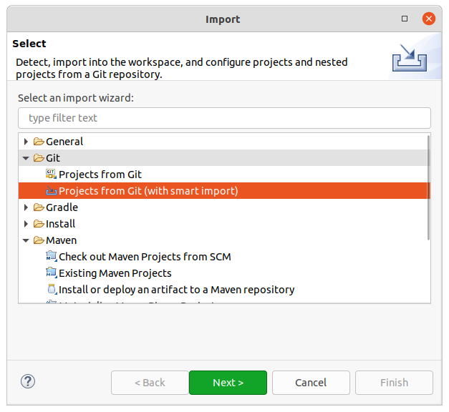

click next

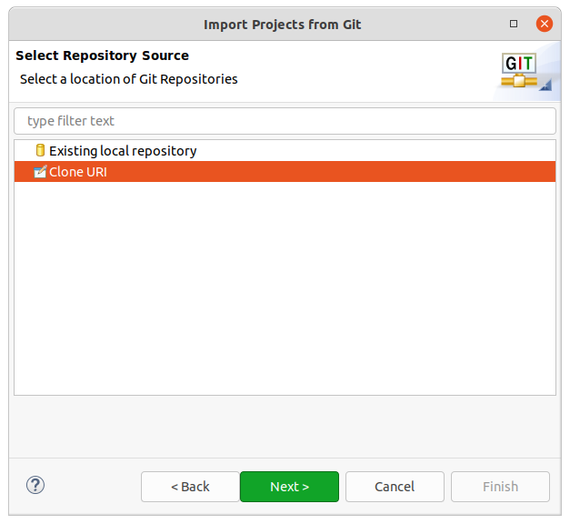

then click next

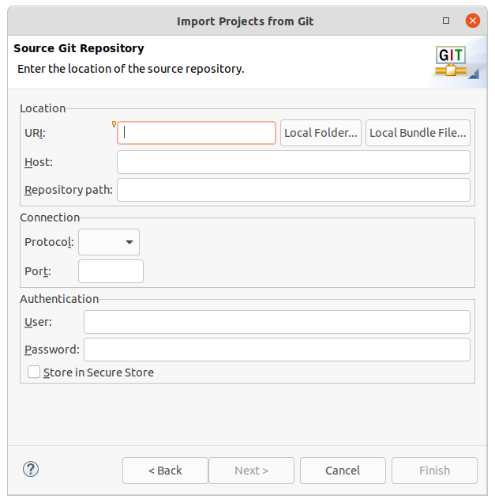

fill the details

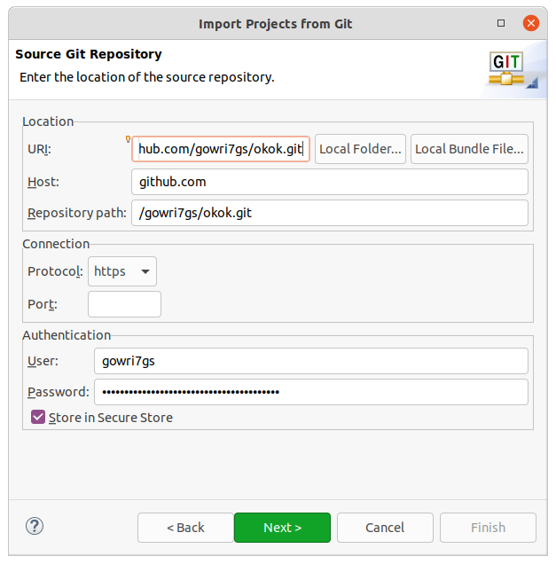
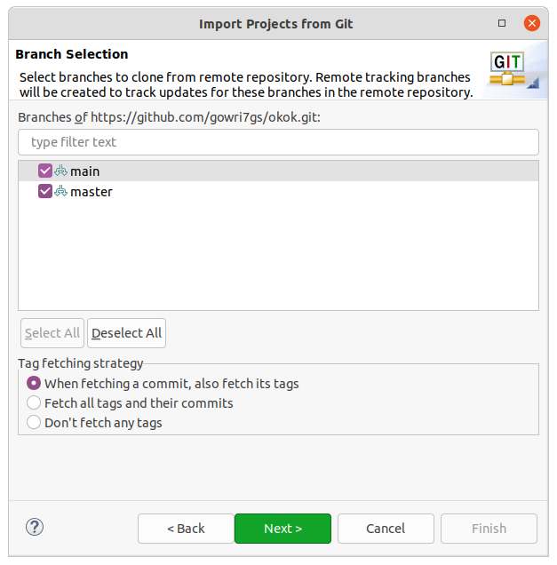

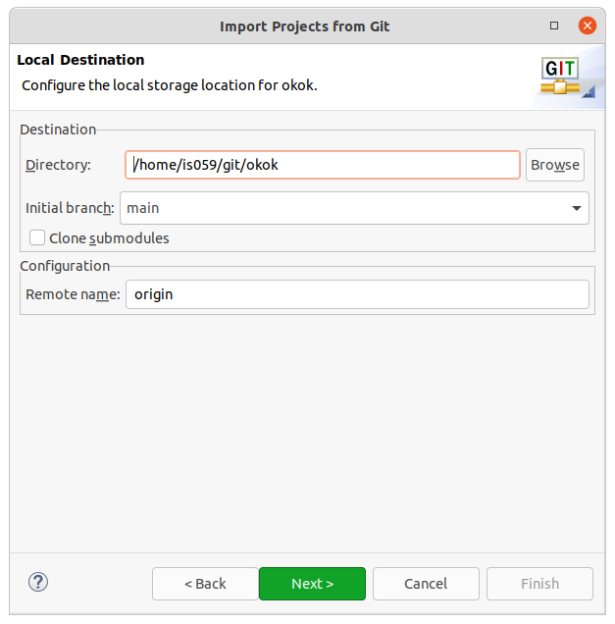

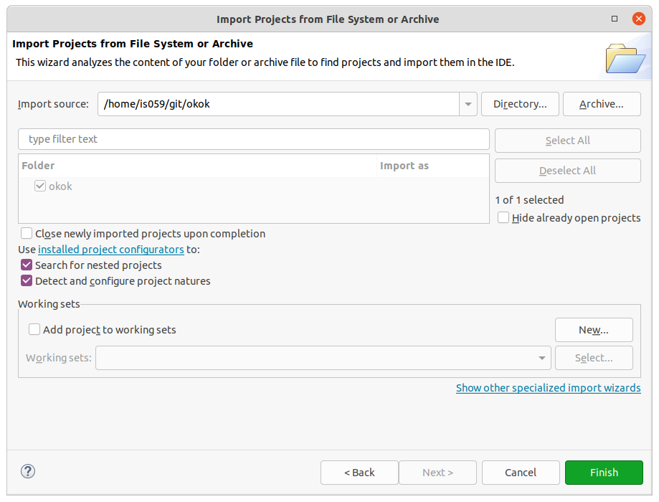
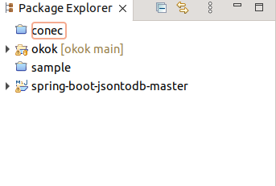

successfully pulled the project from the github repository.

