Mini SPL2

A Report Submitted to:
Mridha Md. Nafis Fuad
Lecturer, Institute of Information Technology
University of Dhaka
Dhaka, Bangladesh.
In Partial Fulfillment of the Requirements for the Course
Design Pattern
Course Code: SE 2215
Submitted By:
Fahmida Munni
Roll: BSSE 1604
Irin Sultana
Roll: BSSE 1642

Institute of Information Technology (IIT), University of Dhaka.
Submission Date: 10 September, 2026

Table of Contents
Table of Contents 2
1. Overview 3
2. Architecture 4
3. Design Patterns 5
4. Database Design 14
5. Version Control and Team Collaboration 16
6. Testing and Validation 17
7. Requirement Compliance and Remaining Work 18

QueryLens Project Documentation
GitHub Repository: https://github.com/innu-M/QueryLenss.git

1. Overview
QueryLens is a JavaFX desktop application that helps a developer understand and improve the performance of SQLite queries. A user connects to a database, runs a query, and immediately sees an analysis of its complexity and risk, along with concrete recommendations for improving it.
- Automatically generates safe alternative forms of a query and verifies that each alternative returns identical results to the original.
- Benchmarks the original and its alternatives under configurable conditions and ranks the results, turning a manual, error-prone optimization process into something the application does for the user.
- Saves past comparisons so they can be revisited, searched, and re-run later, rather than losing the value of a benchmarking session once the window closes.

1.1 Technology Stack
The implementation uses the following required technologies and supporting tools:
Technology | Use in QueryLens
Java 21 | Application and business-logic implementation
JavaFX 21 | Desktop user interface and data visualization
Maven | Dependency management, compilation, testing, and JavaFX execution through pom.xml
SQLite | User-selected databases and a separate persistent QueryLens history database
JDBC | Database connectivity, statement execution, EXPLAIN QUERY PLAN, and PRAGMA access
JUnit 5 | Automated unit and integration tests for business logic and persistence
Git and GitHub | Branching, pull requests, reviews, merge history, and team collaboration

1.2 Major Screens and Operations
QueryLens contains seven major screens, staying within the required four-to-eight-screen scope:
Screen | Primary responsibility
Connections | Create and select SQLite database connections
Query Workspace | Validate, execute, analyze, and record SQL statements
Recommendations | Review optimization advice and update recommendation state
Alternative Competition | Generate, verify, benchmark, rank, and explain safe SELECT alternatives
Benchmark Controls | Configure runs, timeout, ranking metric, progress, and cancellation
Plan Trees | Visualize and compare parent-child EXPLAIN QUERY PLAN structures
Comparison History | Search, inspect, delete, and rerun saved comparison sessions
The two principal analytical workflows are query analysis with recommendation generation, and alternative-plan competition with equivalence verification, benchmarking, ranking, explanation, and persistence.

2. Architecture
QueryLens is organized into three layers that are consistently applied across every feature area:
- Persistence layer — responsible for all SQLite and JDBC access.
- Service / facade layer — contains business logic and coordinates persistence.
- JavaFX view layer — responsible only for presentation.
This separation exists because the alternative is a familiar failure mode in small JavaFX projects: business logic ends up embedded directly in controller classes, where it cannot be tested without a running UI and cannot be reused across screens. By keeping persistence behind repository interfaces and business logic behind services, classes such as the recommendation engine or the query workspace service can be exercised directly in unit tests, with no JavaFX runtime and no live database connection required.
The codebase is organized by feature rather than by technical layer. Instead of grouping all repositories together, all services together, and all views together, each feature area — workspace, recommendation, alternative, benchmark, plan, history, sandbox, persistence, and ui — contains the classes relevant to that concern. This was a deliberate choice: a change to how recommendations work touches the recommendation package and nothing else, rather than requiring coordinated edits across a models, services, and controllers package. It also keeps each pattern's supporting classes physically close to one another, which makes the design easier to explain and easier to navigate during review.

2.1 Application Data Flow
- A user opens or creates a connection to a SQLite database through the Connections screen.
- Queries are written and executed in the Query Workspace; each execution is recorded and immediately analyzed for complexity and risk.
- That analysis feeds the Recommendations screen, surfacing suggestions such as avoiding SELECT * or adding an index for a filtered column.
- For a SELECT query, a user can send it into the Alternative Competition screen, where safe alternatives are generated, verified for equivalence, and benchmarked under settings configured on the Benchmark Controls screen.
- The Plan Trees screen visualizes the underlying EXPLAIN QUERY PLAN output as a real parent-child structure, so the difference between a table scan and an indexed search is visible rather than inferred from raw text.
- Every completed comparison is persisted and made available through the Comparison History screen, where it can be searched, reviewed in detail, or re-run.

2.2 Project Scope and Limitations
• QueryLens is a developer-support and learning tool for SQLite; it is not a replacement for SQLite's optimizer or database engine.
• Alternative generation is intentionally rule-based and restricted to supported, single-statement SELECT forms. Write statements are available in the normal workspace but are excluded from alternative competition for safety.
• Result equivalence is verified by executing candidates and comparing deterministic result fingerprints. This is empirical verification for the selected database state, not a formal proof for every possible future dataset.
• Performance percentiles are local to the candidates measured in one comparison session. They do not claim to represent other users or a global population.
• Proposed indexes are tested only on a temporary database copy, and the user's original database is not modified by the sandbox workflow.

3. Design Patterns

3.1 Recommendation Engine — Strategy, Factory, State
- Problem: the recommendation rules applied to a query — flagging SELECT *, suggesting an index for a join column, suggesting an index for a filtered column, and suggesting an index to support sorting or grouping — needed to be independently addable and testable without modifying the code that runs the analysis itself.
- Alternative considered and rejected: a single method containing an if/else chain for every rule. Every new rule would require editing that shared method, increasing the risk of breaking an existing rule, and individual rules could not be unit-tested in isolation from one another.
- Pattern applied — Strategy: each rule is implemented as its own class conforming to the RecommendationStrategy interface — SelectStarRecommendationStrategy, JoinIndexRecommendationStrategy, FilteredColumnIndexStrategy, and SortGroupIndexStrategy.
- Pattern applied — Factory: a RecommendationStrategyFactory is responsible for selecting which strategies apply to a given analysis, keeping that selection logic out of RecommendationEngine entirely.
- Future benefit: adding a new recommendation rule — for example, detecting an index that is no longer used — requires only a new class implementing RecommendationStrategy, with no change required to RecommendationEngine or to any existing strategy.
- Problem (lifecycle): a recommendation can be applied or dismissed by the user, and once in either state it should not silently revert.
- Alternative considered and rejected: a plain status field checked by conditionals throughout the codebase. The rules governing which transitions are valid would end up duplicated wherever the status is checked.
- Pattern applied — State: RecommendationState is implemented by PendingRecommendationState, AppliedRecommendationState, and DismissedRecommendationState, with RecommendationStateFactory restoring the correct object from persisted status. Pending accepts apply or dismiss; terminal states reject invalid transitions by throwing an exception, so behavior—not only a label—is encapsulated in each state.
- Future benefit: a future rule change — for example, allowing a dismissed recommendation to be reopened — is implemented as a change to one state class's transition logic, rather than a search-and-replace across every place recommendation status is referenced.
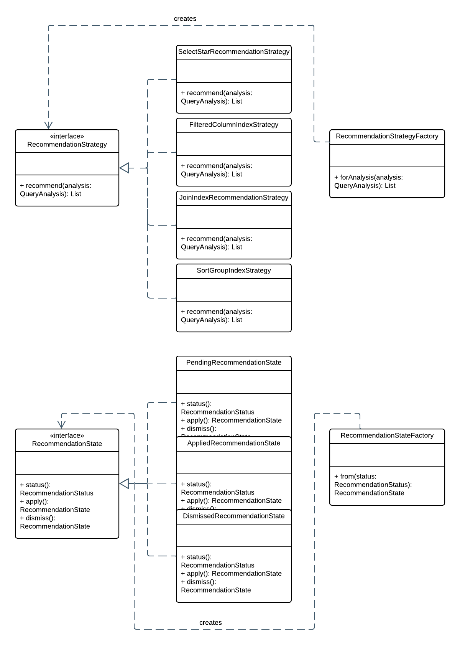
Figure 1: Recommendation Engine — Strategy, Factory, and State pattern relationships

3.2 Alternative Query Competition — Strategy, Factory, Adapter
- Problem: generating alternative forms of a query — forcing an existing index, forcing no index, or rewriting an OR expression into an IN clause — is the same underlying problem as the recommendation rules above: several independent, swappable approaches to the same task.
- Pattern applied — Strategy and Factory: AlternativeQueryStrategy is implemented by ExistingIndexStrategy, NotIndexedStrategy, and OrToInStrategy, with an AlternativeQueryStrategyFactory producing the applicable set for a given query. The same reasoning that led to Strategy for recommendations applies here, and a shared design vocabulary between the two features was intentional rather than incidental.
- Future benefit: a new rewrite technique can be added as a new strategy class without altering how existing alternatives are generated, verified, or benchmarked.
- Problem (SQLite access): reading SQLite's index catalog and executing a query in a safe, read-only context both depend on SQLite-specific behavior that the rest of the application should not need to know about directly.
- Pattern applied — Adapter: the competition workflow expects the IndexCatalogProvider target interface, while SQLite exposes index metadata through JDBC and SQLite-specific PRAGMA statements. SQLiteIndexCatalogProvider translates those database-specific rows into the list of index names expected by the strategy layer. SQLiteBenchmarkExecutor separately owns read-only benchmark execution and fingerprinting.
- Future benefit: index discovery for another database engine can be added through a new IndexCatalogProvider adapter without changing the generation strategies. Benchmark execution is SQLite-specific in the present scope and would require its own abstraction before multi-engine support.
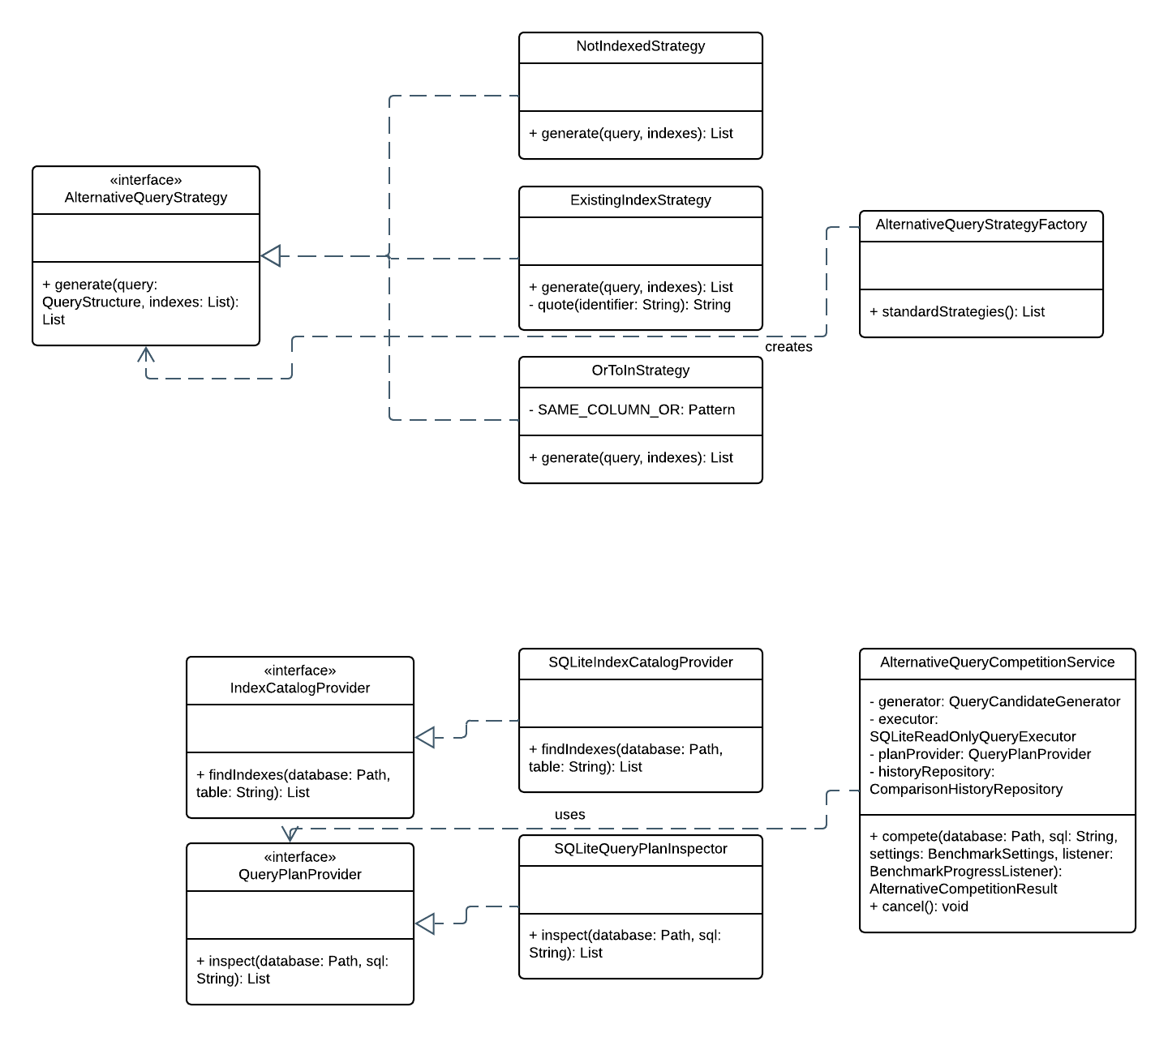
Figure 2: Alternative Query Competition — Strategy, Factory, and Adapter relationships. The current executor class is SQLiteBenchmarkExecutor.

3.3 Plan Tree Visualization — Composite, Visitor, Builder, Adapter
- Problem: SQLite's EXPLAIN QUERY PLAN output is a flat list of rows, but the information it represents — which operation is a child of which — is inherently a tree.
- Alternative considered and rejected: displaying the plan as a flat list, since it discards the parent-child relationship that actually explains why a plan performs the way it does.
- Pattern applied — Composite: QueryPlanComponent is the shared interface implemented by QueryPlanNode. Every node exposes the same operation and owns an immutable view of its children, so a single operator and a nested subtree can be traversed uniformly.
- Problem (explanations): explaining what a given plan node means — whether it is a full table scan, an indexed search, or a temporary B-tree — differs by operation type.
- Alternative considered and rejected: encoding this as a type check on every node.
- Pattern applied — Visitor: QueryPlanVisitor is implemented by PlanExplanationVisitor, which walks the tree and produces explanations without the tree structure itself needing to know how to explain its own nodes.
- Future benefit: a future explanation type, such as a visitor that compares two plan trees and highlights only their differences, can be added as a new QueryPlanVisitor implementation without changing QueryPlanNode or QueryPlanComponent at all.
- Pattern applied — Builder: QueryPlanTreeBuilder assembles a validated QueryPlanTree from unordered rows identified by id and parent id. It links children, preserves orphan rows as roots, and rejects invalid structures such as duplicate identifiers and cycles.
- Pattern applied — Adapter: the plan feature consumes the QueryPlanProvider target interface. SQLiteQueryPlanInspector adapts SQLite's EXPLAIN QUERY PLAN result columns into QueryPlanStep records, keeping JDBC and SQLite-specific details outside the builder and visitors.
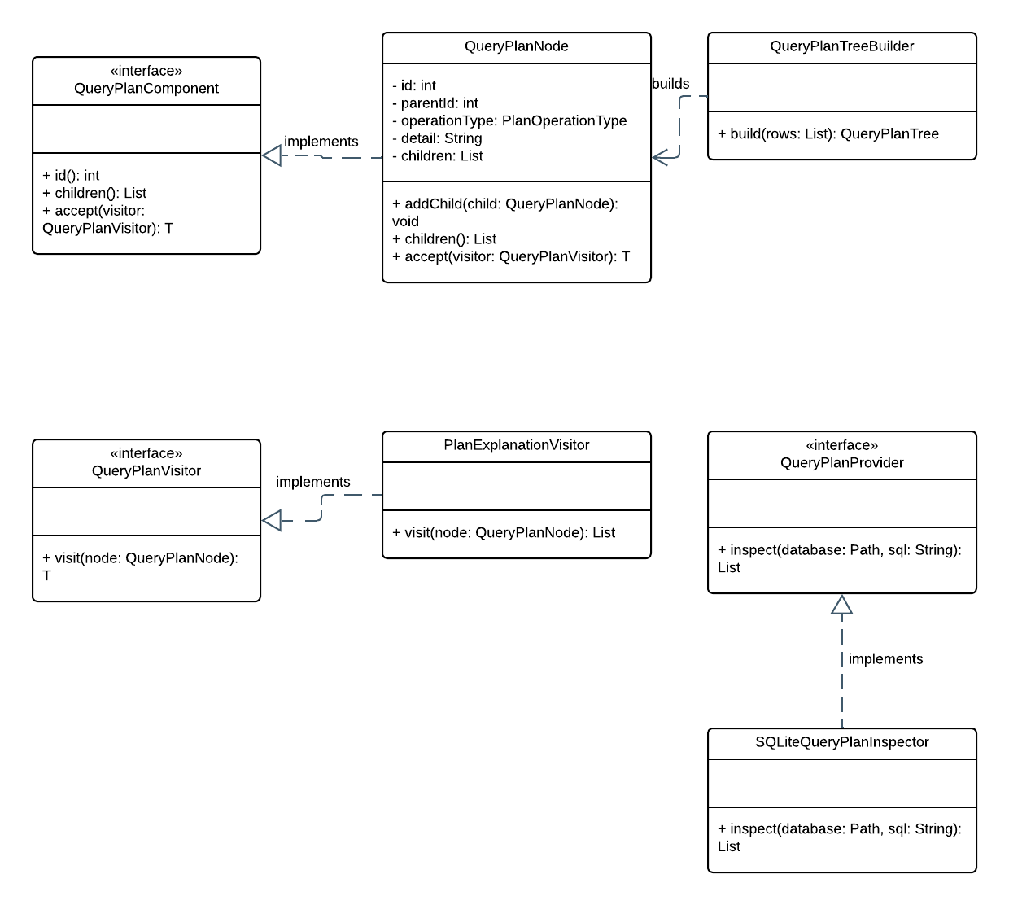
Figure 3: Plan Tree Visualization — Composite, Visitor, Builder, and Adapter pattern relationships

3.4 Query Workspace Core — Chain of Responsibility, Template Method, Facade
- Problem: before a query is executed, it must pass several independent safety checks, each with a distinct failure reason.
- Alternative considered and rejected: combining these checks into a single validation method, which would prevent the checks from being run, tested, and extended independently of one another.
- Pattern applied — Chain of Responsibility: SqlValidationChain runs a series of SqlValidationRule implementations in sequence, so a new safety check can be added as a new rule without modifying the chain itself or any existing rule.
- Problem (execution algorithm): JDBC query execution repeatedly requires the same connection, statement, timing, and result-reading sequence, while the concrete database connection policy may vary.
- Alternative considered and rejected: duplicating JDBC setup, timing, execution, and cleanup in each concrete executor, which would allow resource handling and measurement behavior to drift.
- Pattern applied — Template Method: AbstractQueryExecutor defines the fixed execute algorithm for opening a connection, running the statement, timing it, and reading either rows or an update count. SQLiteQueryExecutor supplies the SQLite connection step. QueryExecutionWorkflow then coordinates validation, analysis, recommendation generation, and persistence at the service level.
- Problem (coordination): the Query Workspace screen depends on validation, execution, analysis, and history recording together.
- Alternative considered and rejected: having the view coordinate all of them directly, which is both hard to test and hard to reuse.
- Pattern applied — Facade: QueryWorkspaceService gives the view a single coordinating entry point and keeps the orchestration logic testable independently of JavaFX.
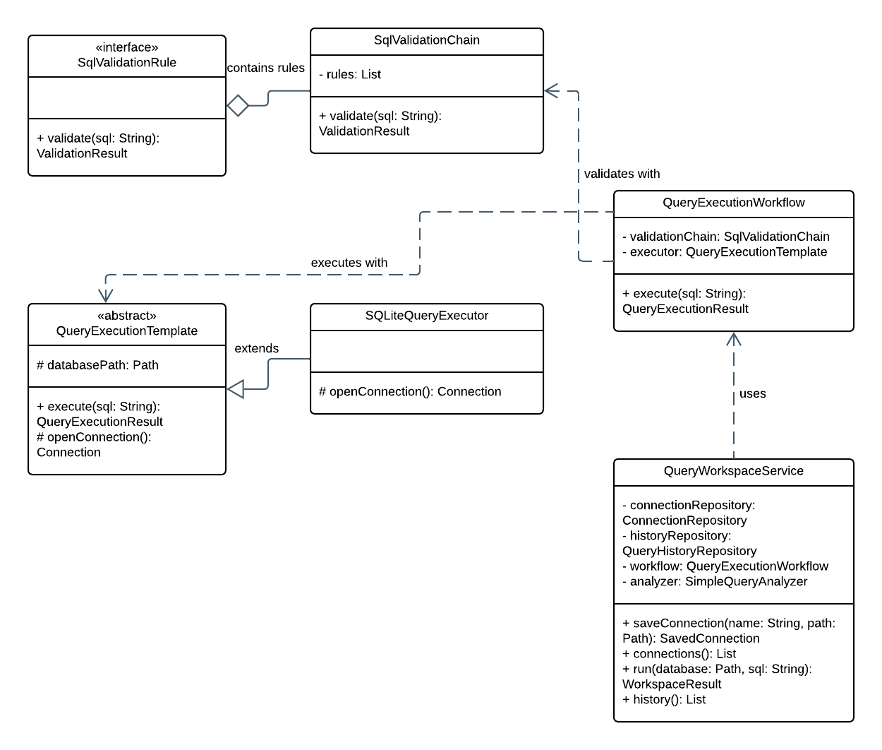
Figure 4: Query Workspace Core — Chain of Responsibility, Template Method, and Facade relationships. QueryExecutionTemplate is now named AbstractQueryExecutor.

3.5 Persistence & Benchmarking — Repository, Observer
- Problem: every feature area in QueryLens needs to access SQLite, and embedding SQL directly in service classes would make those services untestable without a live database and scatter SQL statements throughout the codebase.
- Pattern applied — Repository: each feature accesses SQLite through a dedicated repository — ConnectionRepository, QueryHistoryRepository, QueryAnalysisRepository, RecommendationRepository, and ComparisonHistoryRepository — rather than through direct JDBC calls inside services.
- Future benefit: if QueryLens's persistence needs changed in the future — for example, adding a caching layer in front of query history — that change would be contained entirely within the relevant repository class.
- Problem (progress reporting): a benchmark run takes measurable time to complete, and the user interface needs to reflect its progress without the benchmarking logic itself depending on JavaFX.
- Alternative considered and rejected: having the benchmark code call UI update methods directly, which would couple business logic to the presentation layer.
- Pattern applied — Observer: BenchmarkProgressListener allows the UI to subscribe to progress updates — including cancellation — without the underlying benchmark execution logic knowing anything about how that progress is displayed.
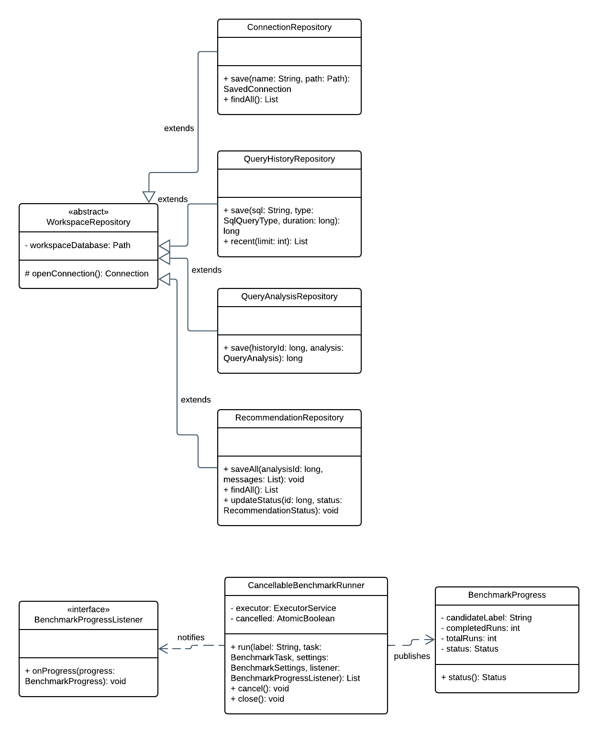
Figure 5: Persistence and Benchmarking — Repository and Observer pattern relationships

4. Database Design
QueryLens's schema is organized into two related but independently manageable groups of tables:
- Core workflow — database_connections, query_history, query_analyses, and recommendations. Records every query a user runs and the analysis and recommendations generated from it.
- Comparison workflow — comparison_sessions, comparison_candidates, and benchmark_runs. Records the results of alternative-query competitions independently of the core workflow.
These two groups are deliberately separate rather than merged into a single schema:
- A comparison session and everything beneath it can be deleted as a unit through a cascading foreign key without any risk of affecting a user's underlying query history — the guarantee ComparisonHistoryRepository's delete operation depends on.
- Within the core workflow, a query's analysis is removed if its originating history entry is removed (cascading delete).
- A history entry's connection reference is only cleared, not deleted, if the connection itself is removed — preserving the historical record of a query even after the connection used to run it no longer exists.
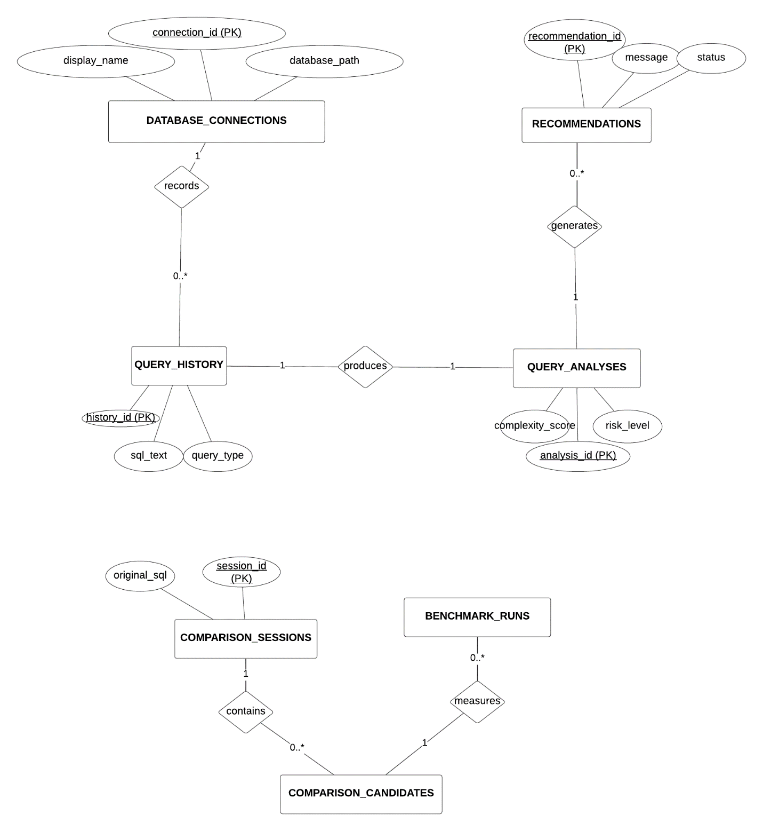
Figure 6: QueryLens Entity-Relationship Diagram

4.1 Keys, Relationships, and Constraints
The implemented schema contains seven meaningful entities. Primary keys, foreign keys, cardinalities, and important constraints are summarized below.
Entity | Primary key | Relationship and constraint evidence
database_connections | id | database_path is UNIQUE; one connection may reference many history rows
query_history | id | connection_id is optional and uses ON DELETE SET NULL
query_analyses | id | history_id is UNIQUE and NOT NULL; one-to-one with history; ON DELETE CASCADE
recommendations | id | analysis_id is NOT NULL; one analysis to many recommendations; status defaults to PENDING
comparison_sessions | id | Owns zero or more comparison candidates
comparison_candidates | id | comparison_id is NOT NULL with ON DELETE CASCADE; equivalent is constrained to 0 or 1
benchmark_runs | id | candidate_id is NOT NULL with ON DELETE CASCADE; duration must be non-negative; candidate and run number are UNIQUE

4.2 CRUD Coverage
The repository layer currently exposes the following persisted operations. This matrix reports implemented behavior rather than assuming full CRUD from the presence of a table.
Important entity | Create | Read | Update | Delete
Database Connection | Yes | Yes | Not yet | Not yet
Query History | Yes | Yes | Not applicable | Not yet
Recommendation | Yes | Yes | Status | Not yet
Comparison Session | Yes | Yes | Rerun creates new | Yes, cascades
Current compliance note: persistence is meaningful and tested, but the rubric's requirement for complete CRUD on at least three important entities is not yet fully satisfied. Connection update/delete, history delete, and recommendation delete are the clearest remaining operations to implement before final submission.

4.3 Database Initialization and Seeding
DatabaseInitializer automatically creates the QueryLens history database directory, opens SQLite with foreign keys enabled, reads src/main/resources/database/schema.sql, and executes every schema statement. Automated tests create temporary fixture records for repeatable repository verification.
Current compliance note: the initializer creates tables but does not yet load reusable demonstration records into the application history database. The course guideline's data-seeder requirement therefore remains open. A dedicated, idempotent demo-data seeder should be added before submission; the report intentionally does not claim that unimplemented behavior.

5. Version Control and Team Collaboration
Repository: https://github.com/innu-M/QueryLenss

5.1 Branching and Review Workflow
• master is the stable submission/release branch, while develop is the integration branch.
• Significant work is isolated on descriptive feature, chore, test, or refactor branches created from the latest develop branch.
• A completed branch is pushed to GitHub and opened as a pull request into develop. Maven tests and the PR checklist provide pre-merge evidence.
• The teammate reviews the pull request, requested changes are added as new commits, and the approved PR is merged through GitHub. develop is merged into master only for a stable release or submission point.
• The repository history contains feature branches and GitHub pull-request merge commits for project foundation, UI, workspace, recommendations, comparison history, alternative generation, benchmark controls, plan trees, sandbox index testing, persistence tests, and package refactoring.

5.2 Verified Team Contributions
The contribution summary below is based on authored commits and feature branches visible in the repository history.
Member | Verified major contributions
Fahmida Munni (BSSE 1604) | Project foundation and CI; JavaFX theme/layout; connections and query workspace; recommendation engine and state tests; benchmark controls, progress, cancellation and timeout; sandbox index testing; persistence tests and workspace refactoring
Irin Sultana (BSSE 1642) | Comparison-history schema, repositories and report screen; alternative SELECT generation, equivalence checks, benchmarking, ranking, persistence and percentile display; plan-tree construction, comparison and visualization; pattern-oriented package refactoring and documentation
Both members appear as authors in the Git history and review one another's pull requests, providing traceable evidence of collaborative development.

6. Testing and Validation
Business-logic and persistence tests were executed with Maven using mvn test on 10 September 2026. Result: 38 tests run, 0 failures, 0 errors, and 0 skipped (BUILD SUCCESS).
ID | Area | Input or scenario | Expected and actual result | Status
TC-01 | Workspace | Supported SELECT and update statements | Results/history or affected rows are produced as expected | PASS
TC-02 | Validation | Multiple or schema-changing statements | Rejected before execution | PASS
TC-03 | Recommendation | SELECT *, filters, joins, and sorting | Applicable strategies generate advice | PASS
TC-04 | State | Pending to Applied/Dismissed; terminal transition | Valid transitions succeed; invalid transition is rejected | PASS
TC-05 | Alternatives | Writes, joins, aliases, multiple statements | Unsafe/unsupported competition input is rejected | PASS
TC-06 | Equivalence | Candidate returns different result fingerprint | Candidate is rejected and not ranked as equivalent | PASS
TC-07 | Benchmark | Cancellation and timeout | Runner stops safely and publishes terminal state | PASS
TC-08 | Plan tree | Nested, orphan, duplicate-id, and cyclic plan rows | Valid tree is built; invalid structures are rejected | PASS
TC-09 | Sandbox | Proposed index on temporary copy | Copy changes; source database remains unchanged | PASS
TC-10 | Persistence | Save/load/search comparison session | Session, candidates, plans, and samples are restored | PASS
TC-11 | Cascade delete | Delete comparison session | Candidates and benchmark runs are also removed | PASS
TC-12 | Schema | Initialize a new history database | All seven required tables are created | PASS
The suite covers common validation and error conditions as well as success paths. JavaFX presentation is intentionally kept thin; the most important business rules are tested without launching the desktop interface.

7. Requirement Compliance and Remaining Work
The following summary distinguishes verified compliance from work that remains before final submission.
Requirement | Evidence in current project | Status
JavaFX desktop application | Seven major JavaFX screens | Met
Maven configuration | pom.xml manages JavaFX, SQLite JDBC, and JUnit | Met
SQLite persistence | Seven related entities with keys and constraints | Met
Two non-trivial workflows | Analysis/recommendation and alternative competition | Met
Analytical/reporting operations | Plan analysis, rankings, percentiles, history search | Met
Meaningful design patterns | Twelve patterns tied to explicit design problems | Met
Automated business tests | 38 passing Maven tests | Met
Git branching and collaboration | Feature branches, PR merges, two authors | Met
Full CRUD for three entities | Current repositories provide partial CRUD coverage | Remaining
Schema and data seeder | Schema initializer exists; demo-data loading is not implemented | Remaining

