Site Name: Sole Society – It was all about shoes

Site Purpose: The purpose of this page is to inform the people about the trending shoes

Scenarios: What shoes is the latest trend?  
 What is basketball good for basketball?

Color Schema: #E9DCBE, #aaa, #666

Color Schema Use in Document: Black

Typography Named and Used: Roboto, san serif

Wireframe:

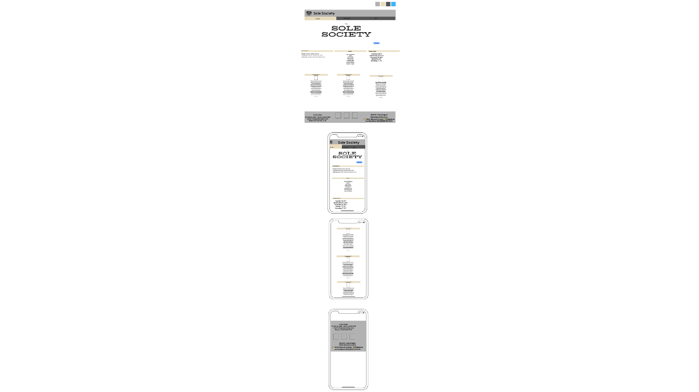

Valid HTML and CSS: Folder Name: Project

HTML Name: home.html, directory.html, join.html

CSS Name: home.css, mobile.css, wide.css