GL Calendar
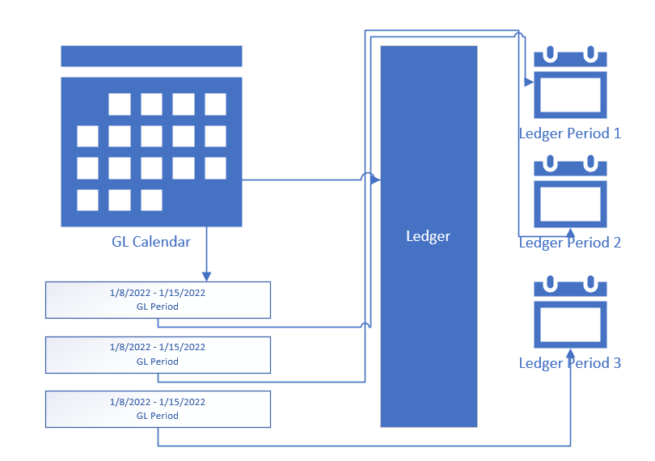
Each GL Calendar has several periods
GL calendar is assigned to the ledger
The ledger period shows all available periods on the GL calendar
When you open a period. The system creates a new period for that ledger
You can have multiple open periods but the system always uses the newest open period to post journals.
You can manually select periods only on manual journals.

- Define calendar
- Define the calendar periods. Each GL Calendar has several periods
- Assign calendar to a ledger
- All calendar periods are available as Ledger GL period (Available period)
- Open an available period to make it an active period
When you open a period. The system creates a new period for that ledger

- The latest open period is the current open period that system uses for journals
You can have multiple open periods but the system always uses the newest open period to post journals.
You can manually select periods only on manual journals.

Calendar Period : A specfic duration of time in a calendar. Ex: Mar-25 (01.Mar.2025 to 31.Mar.2025)
Available Periods: Calendar periods that are available for a ledger i.e.
List of all defined calendar periods.
You can open/close a period from the available period
Active Periods: All Ledger periods i.e. All calendar periods assigned to a ledger or ever opened for a ledger
Current Open Period/Latest Open Period: The current active open period for a ledger. The system creates all the journals in this period.

