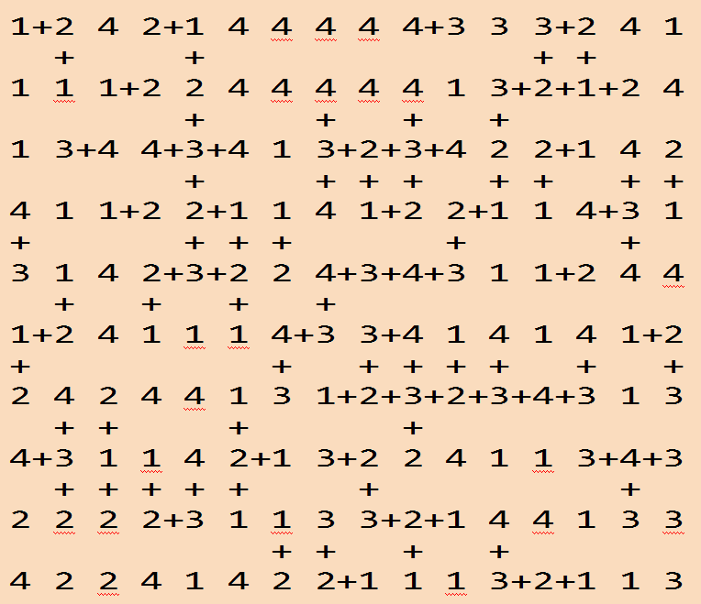
Code / Project : CME1252 / 3
Year / Semester : 2022-2023 Spring Semester
Duration : 3.5 weeks

Project: Chain

The aim of the project is to develop a number game.

General Information

The game is played in a board with 10*16 area of numbers. Game elements are numbers (1-4) and plus signs. The aim of the game is reaching the highest score by constructing number chains.

Game Elements

Board
- Consist of 10*16 area of numbers

Numbers
- Number set: 1, 2, 3, 4

+
- Player constructs chains by inserting + into the suitable places.
  - Cursor keys: To move cursor on the board
  - Space: Insert/remove +
  - Enter: End of the round and calculate the chain
  - E: End of the game

Chain
- A chain is number squares joined with plus signs in 4 directions.
- Difference must be 1 between numbers of neighbor squares in the chain.

Table
- In each round, constructed chains are accumulated in the table.

Game Initialization

Number area of the board (10*16) is filled with 1, 2, 3 or 4 numbers with equal probability. Player can set the random number seed.

Game Playing Information

In each round;
- Player constructs a single chain by inserting + into the suitable places.
- Chain rules:
  - There must be only one chain in each round. Chain with more than one part, broken chains, wrong positioned plus signs are prohibited.
  - Difference between neighbor squares in the chain must be 1 (+1 or -1).
  - The number of squares in the chain must be at least 4.
  - The score of the chain is n² (n: The number of elements in the chain)
- When the chain is constructed, the player presses the enter key.
  - Then the chain is checked.
    - If the chain has errors or insufficient elements, game is over with the current score of the player.
    - If the chain is correct:
      - The chain is added to the table.
      - The chain disappears from the board.
      - The score of the chain is calculated and added to the player's score.
      - Next round starts.
Sample Game Screens

1 2 4 2 1 4 4 4 4 4 3 3 3 2 4 1 Board Seed : 4523
Round : 1
1 1 1 2 2 4 4 4 4 4 1 3 2 1 2 4 Score : 0
-----------------------------------------------------
1 3 4 4 3 4 1 3 2 3 4 2 2 1 4 2 Table:

4 1 1 2 2 1 1 4 1 2 2 1 1 4 3 1

3 1 4 2 3 2 2 4 3 4 3 1 1 2 4 4

1 2 4 1 1 1 4 3 3 4 1 4 1 4 1 2

2 4 2 4 4 1 3 1 2 3 2 3 4 3 1 3

4 3 1 1 4 2 1 3 2 2 4 1 1 3 4 3

2 2 2 2 3 1 1 3 3 2 1 4 4 1 3 3

4 2 2 4 1 4 2 2 1 1 1 3 2 1 1 3

1 2 4 2 1 4 4 4 4 4 3 3 3 2 4 1 Board Seed : 4523
Round : 1
1 1 1 2 2 4 4 4 4 4 1 3 2 1 2 4 Score : 0
-----------------------------------------------------
1 3 4 4 3 4 1 3 2 3 4 2 2 1 4 2 Table:

4 1 1 2 2 1 1 4 1 2 2 1 1 4 3 1
+
3 1 4 2 3 2 2 4+3+4+3 1 1 2 4 4
+
1 2 4 1 1 1 4+3 3 4 1 4 1 4 1 2
+
2 4 2 4 4 1 3 1 2 3 2 3 4 3 1 3

4 3 1 1 4 2 1 3 2 2 4 1 1 3 4 3

2 2 2 2 3 1 1 3 3 2 1 4 4 1 3 3

4 2 2 4 1 4 2 2 1 1 1 3 2 1 1 3

1 2 4 2 1 4 4 4 4 4 3 3 3 2 4 1 Board Seed : 4523
Round : 1
1 1 1 2 2 4 4 4 4 4 1 3 2 1 2 4 Score : 64
-----------------------------------------------------
1 3 4 4 3 4 1 3 2 3 4 2 2 1 4 2 Table:
2+3+4+3+4+3+4+3
4 1 1 2 2 1 1 4 1 2 . 1 1 4 3 1

3 1 4 2 3 2 2 . . . . 1 1 2 4 4

1 2 4 1 1 1 . . 3 4 1 4 1 4 1 2

2 4 2 4 4 1 . 1 2 3 2 3 4 3 1 3

4 3 1 1 4 2 1 3 2 2 4 1 1 3 4 3

2 2 2 2 3 1 1 3 3 2 1 4 4 1 3 3

4 2 2 4 1 4 2 2 1 1 1 3 2 1 1 3

1 2 4 2 1 4 4 4 4 4 3 3 3 2 4 1 Board Seed : 4523
Round : 2
1 1 1 2 2 4 4 4 4 4 1 3 2 1 2 4 Score : 100
-----------------------------------------------------
1 3 4 4+3 4 1 3 2 3 4 2 2 1 4 2 Table:
+ 2+3+4+3+4+3+4+3
4 1 1 2 2 1 1 4 1 2 . 1 1 4 3 1 +
+ + 4+3+2+3+2+1
3 1 4 2 3+2 2 . . . . 1 1 2 4 4

1 2 4 1 1 1 . . 3 4 1 4 1 4 1 2

2 4 2 4 4 1 . 1 2 3 2 3 4 3 1 3

4 3 1 1 4 2 1 3 2 2 4 1 1 3 4 3

2 2 2 2 3 1 1 3 3 2 1 4 4 1 3 3

4 2 2 4 1 4 2 2 1 1 1 3 2 1 1 3

1 2 4 2 1 4 4 4 4 4 3 3 3 2 4 1 Board Seed : 4523
Round : 3
1 1 1 2 2 4 4 4 4 4 1 3 2 1 2 4 Score : 125
-----------------------------------------------------
1 3 4 . . 4 1 3 2 3 4 2 2 1 4 2 Table:
2+3+4+3+4+3+4+3
4 1 1 2 . . 1 4 1 2 . 1 1 4 3 1 +
4+3+2+3+2+1
3 1 4 2 . . 2 . . . . 1 1 2 4 4 +
1+2+3+4+3
1 2 4 1 1 1 . . 3 4 1 4 1 4 1 2
+
2 4 2 4 4 1 . 1 2 3 2+3+4+3 1 3

4 3 1 1 4 2 1 3 2 2 4 1 1 3 4 3

2 2 2 2 3 1 1 3 3 2 1 4 4 1 3 3

4 2 2 4 1 4 2 2 1 1 1 3 2 1 1 3

1 2 4 2 1 4 4 4 4 4 3 3 3+2+4 1 Board Seed : 4523
+ Round : 4
1 1 1 2 2 4 4 4 4 4 1 3 2+1 2 4 Score : 125
-----------------------------------------------------
1 3 4 . . 4 1 3 2 3 4 2 2 1 4 2 Table:
2+3+4+3+4+3+4+3
4 1 1 2 . . 1 4 1 2 . 1 1 4 3 1 +
4+3+2+3+2+1
3 1 4 2 . . 2 . . . . 1 1 2 4 4 +
1+2+3+4+3
1 2 4 1 1 1 . . 3 4 . 4 1 4 1 2

2 4 2 4 4 1 . 1 2 3 . . . . 1 3

4 3 1 1 4 2 1 3 2 2 4 1 1 3 4 3

2 2 2 2 3 1 1 3 3 2 1 4 4 1 3 3 Error in chain
- Game Over -
4 2 2 4 1 4 2 2 1 1 1 3 2 1 1 3

End of the Game and High Score Table

Player can exit the game by pressing the E key.

After the game finishes, High Score Table is displayed in descending order.
Default High Score Table for the game (in the following order in "highscore.txt" file):
- Sema Fırat 200
- Tarık Deniz 525
- Ali Vadi 16
- Seda Rüzgar 90

Structures

Board : 2D Array
Chain : Singly Linked List (SLL)
Table : Multi Linked List (MLL)
High Score Table : Doubly Linked List (DLL)

Suggested Weekly Program

1. Design of classes, data structures. Screen. Menu. Board initialization.
2. Chain constructing. Chain control. Scoring. Updating board.
3. Table. High Score Table. Remaining parts of the game, debugging/testing.

First Evaluation: 22.5.2023  Report: 22.5.2023 | Final Evaluation: 29.5.2023 (presentation in English: powerpoint+poster)  Report: 29.5.2023

