Recurrence-Risk Decoding
for Repetition-Loop Control in Language Models
A minimum-distortion, time-to-failure treatment of decoding-time reliability
Abstract
Autoregressive language models are prone to repetition loops: once the model commits probability mass to a short recurring pattern, decoding can descend into a cycle it cannot leave. This paper treats loop avoidance as a reliability problem — a question of time-to-failure under continued generation — and proposes Recurrence-Risk Decoding, a decoder that at each step penalises candidate tokens in proportion to the risk that they would extend a repeated n-gram. The penalty is derived as the minimum-distortion (KL-projection) solution to the problem of staying as close as possible to the model distribution subject to a bound on expected recurrence risk, which yields the closed form q(v) proportional to p(v) exp(-lambda risk(v)); hard no-repeat n-gram blocking emerges as the infinite-penalty limit. Two configurations are studied: a fixed-strength risk-only decoder and an adaptive variant that adjusts penalty strength online from recent repetition and entropy. On an 848K-parameter character model, recurrence-risk decoding attains the best position on the survival-versus-quality frontier across three quality axes and six independent loop definitions, with paired-bootstrap RMST gains over repetition penalty, Mirostat, and look-back decoding that are statistically significant. The method transfers without modification to a pretrained subword model (DistilGPT-2), where it again reduces looping while keeping generations closer to the model's own distribution than temperature or nucleus sampling. Hard no-repeat is reported separately throughout, because it directly constrains the failure event being measured.

1. Introduction
A recurring failure of neural text generation is the repetition loop: the model emits a short span, then reproduces it again and again until the sample degenerates into a fixed cycle. The phenomenon is most acute in small models and under low-temperature or deterministic decoding, but it is present to some degree in models of every size. It is a decoding-time problem as much as a modelling one — the same weights can produce fluent text or a loop depending only on how the next token is chosen.
The conventional responses treat the loop as a sampling nuisance. Temperature scaling flattens the distribution; nucleus and top-k sampling truncate its tail; repetition penalty discounts any token that has appeared before. These are all modifications of the marginal next-token distribution and none of them is aimed at the actual mechanism of a loop, which is the continuation of a specific recurring n-gram. Hard no-repeat n-gram blocking does target that mechanism, but with a blunt instrument: it forbids outright any token that would complete a repeated n-gram, discarding useful probability mass and frequently producing broken words when the banned token was the only sensible continuation.
This paper reframes the question. Rather than asking how to sample, it asks how to change the model's distribution as little as possible while bounding the probability of extending a repeat. That single question yields a principled decoder, a clean theory that unifies it with hard no-repeat, and an evaluation protocol borrowed from reliability analysis. The contributions are:
A method. Recurrence-Risk Decoding, in a fixed risk-only form and an adaptive form, defined by a soft exponential penalty on candidates that would extend a repeated n-gram (Section 3).
A theory. The penalty is the exact minimum-distortion (KL-projection) solution to a risk-bounded decoding problem, with hard no-repeat as its infinite-penalty limit and the unmodified model as its zero-penalty limit (Section 3.1).
An evaluation. Loop avoidance is measured as survival — time-to-first-loop with right-censoring — across six independent loop definitions, against equal-budget baseline sweeps, with paired-bootstrap significance tests and an explicit separation of hard no-repeat because it constrains the measured event (Sections 4–5).
A generalization test. The same decoder, unchanged in principle, is applied to a pretrained subword model (DistilGPT-2), showing that the approach is not an artefact of one small character model or one loop metric (Section 6).
A secondary finding concerns evaluation hygiene. An earlier version of this project reported bits-per-character from a sampler that covered only a quarter of the held-out text; correcting it moved the figure by 1.46 bits. That correction is retained here only as a cautionary note (Section 4.1); it is not a contribution, and no claim rests on the learning-rate schedule that the flawed metric originally seemed to favour.

2. Background and Related Work

2.1 Decoding strategies
Let p(v | context) be the model's next-token distribution. Temperature sampling replaces logits zv by zv / T. Nucleus (top-p) sampling [Holtzman et al., 2020] restricts sampling to the smallest set of tokens whose cumulative probability exceeds p; top-k keeps the k most probable tokens. Typical sampling [Meister et al., 2023] keeps tokens whose surprisal is near the distribution's entropy. Mirostat [Basu et al., 2021] adjusts a truncation threshold online to hold per-step surprisal near a target. Repetition penalty [Keskar et al., 2019] divides the logit of every previously generated token by a constant, a global discount that ignores whether a repeated n-gram is actually imminent. No-repeat n-gram blocking [Paulus et al., 2018] sets to zero the probability of any token that would complete an already-seen n-gram — a hard constraint on exactly the event that loop metrics measure.
The look-back family [e.g. Xu et al., 2022] penalises tokens by their similarity to earlier context. The LZ77-style baseline used here is in this spirit: it finds the longest suffix of the generation that recurs earlier and penalises tokens that would extend that match. It is history-aware and local, and serves as the strongest non-trivial baseline against the proposed method.

2.2 Repetition as a reliability problem
Prior evaluations of repetition typically report a mean repetition rate or the fraction of samples that loop. Both discard information: a sample that never loops within the generation window is not an outlier to be dropped or assigned an arbitrary value, but a right-censored observation — we know only that its time-to-loop exceeds the window. This is precisely the setting of survival analysis. Treating loop onset as a survival time lets us use the Kaplan-Meier estimator and summarise a method by its Restricted Mean Survival Time (RMST) — the expected number of loop-free characters up to a horizon — with censoring handled correctly. This framing is, to our knowledge, not standard in the decoding literature, and it materially changes how methods compare.

3. Recurrence-Risk Decoding

3.1 Minimum-distortion formulation
At each step, define the recurrence risk of a candidate token v as the fraction of n-gram orders in a band [nmin, nmax] for which appending v to the recent context would reproduce a previously seen n-gram:
risk(v) = (1/N) · Σ_{n=n_min..n_max} 1[ (last n−1 tokens, v) has occurred before ]
We want a sampling distribution q that departs minimally from the model distribution p while keeping expected recurrence risk below a tolerance:
minimise KL(q ‖ p) subject to E_q[risk(v)] ≤ ε
This is a minimum-distortion projection: among all distributions meeting the risk bound, choose the one closest to p in KL. Introducing a multiplier lambda for the constraint and solving the stationarity condition gives a closed form:
q*(v) ∝ p(v) · exp( −lambda · risk(v) )
Equivalently, subtract lambda·risk(v) from each logit before the softmax. The multiplier lambda is the penalty strength. Two limits are immediate and important:
lambda → 0 recovers the unmodified model distribution p — no intervention.
lambda → ∞ drives q(v) to zero for every token with positive risk, which is exactly hard no-repeat n-gram blocking.
Hard no-repeat is therefore not a separate idea but the extreme endpoint of a continuum. This explains, without any appeal to experiment, why hard no-repeat damages text: it applies infinite penalty, banning even a risky token that is the only fluent continuation, whereas a finite lambda merely down-weights it. It also explains why the method is more local than repetition penalty: risk(v) is nonzero only for tokens that would extend a currently-active recurring context, not for every token that has ever appeared.

3.2 Online adaptation
A fixed lambda already defines a usable decoder — the risk-only configuration. The adaptive configuration additionally modulates lambda from two online signals over a trailing window: the recent repetition rate and the recent token entropy.
lambda_t = lambda_base + λ_rep·max(0, rep_rate − rep_target) − λ_ent·max(0, entropy − ent_target)
Penalty rises when repetition begins to build and relaxes when generation is diverse. As the experiments show, this trades a little raw survival for a better quality balance; the risk signal itself, not the adaptation, is the primary mechanism.

3.3 Implementation and the history-scan pitfall
Recurrence risk must be read at every step, so its cost matters. A naive implementation rescans the whole generation for each n-gram order, costing O(length) per step and O(length²) per sample. We instead maintain, for each order n, an incremental hash map from each (n−1)-token context to the set of tokens that have followed it. Reading risk(v) is then O(N) hash lookups; after emitting a token we register its new edges in O(N). No full-history scan occurs. We verified numerically that the hash-map risk scores are identical to the history-scan scores at every step over long random sequences, so the speed comes with no change in behaviour. The look-back baseline, by contrast, genuinely scans for its longest-match statistic; we report its cost honestly rather than hiding it behind the same claim.
An earlier draft described a hash-map lookup while the code still scanned the history. That mismatch has been removed: the implementation now maintains the incremental maps described above, and the equivalence to the scan is tested.

4. Experimental Setup

4.1 Models, data, and the BPC correction
The primary model is a 4-layer, 128-dimensional GPT-style character Transformer (848K parameters, 95-character vocabulary, context 256) trained on four public-domain novels split by book across authors — Austen and Shelley for training, Doyle for validation, Dickens for test — so that evaluation measures cross-author generalisation rather than memorisation. Two learning-rate schedules were trained (constant and cosine-with-warmup); both are used as checkpoints, but the schedule itself is not a subject of any claim.
As an evaluation note only: the project's original perplexity figure came from a routine that sampled 50 random overlapping windows, covering about 27% of the test book, and reported ~3.70 BPC. Evaluating over the entire book with non-overlapping windows gives 2.238 BPC (constant) and 2.234 BPC (cosine); a paired block bootstrap finds the gap between schedules real but negligible (ΔBPC ≈ 0.005). The lesson — that a convenience sampler can distort a headline number by 1.46 bits — is worth recording; the schedule comparison is not pursued further.

4.2 Decoding configurations and equal-budget sweeps
Thirty-one configurations were evaluated. Every baseline family is swept over several settings so that none is handicapped by a single arbitrary choice: temperature {0.7, 0.8, 0.9, 1.0}; nucleus {0.90, 0.95, 0.99}; top-k {10, 40, 100}; typical {0.85, 0.90, 0.95}; repetition penalty {1.1, 1.3, 1.5}; Mirostat {τ=3, τ=5}; look-back {α=2, 3, 5}. Hard no-repeat is included at n∈{3,4} but always reported separately. The proposed method appears as risk-only and adaptive, plus five ablations. Key methods are evaluated on 15 prompts × 10 seeds = 150 samples; sweep points on 5 prompts × 10 seeds = 50 samples. All methods see identical prompt/seed pairs, so every comparison is paired.

4.3 Loop definitions and quality metrics
To ensure that results are not tied to the one metric that hard no-repeat can trivially satisfy, loop onset is measured under six independent definitions: first repeated n-gram at n = 8, 10, 12, 16; first point at which the longest repeated substring reaches 20 characters; and first point at which a trailing window's compression ratio falls below a threshold. Each yields a survival time (right-censored at the generation length). Quality is measured on three axes that no strategy directly optimises: model-consistency NLL — the negative log-likelihood of a generation under the same model, a measure of how in-distribution the text is, explicitly not a standalone quality score; 4-gram distributional similarity to held-out text; and spelling error rate against a system word list. We also report longest-repeated-substring and compression as leakage checks, and throughput in characters per second.

5. Results

5.1 The survival–quality frontier
Table 1 summarises the key methods on the cosine checkpoint. The two recurrence-risk configurations occupy the part of the space no baseline reaches: survival close to the hard constraint together with the best model-consistency NLL and distributional similarity of any probabilistic method, and the lowest spelling-error rate.

Method | SAUC ↑ | RMST ↑ | MC-NLL ↓ | Sim ↑ | Spell ↓ | Loop % ↓ | chars/s
Greedy | 0.055 | 27 | 0.749 | 0.075 | 0.004 | 100% | 260
Temperature 0.8 | 0.847 | 423 | 1.442 | 0.250 | 0.079 | 37% | 180
Nucleus p=0.95 | 0.832 | 416 | 1.431 | 0.250 | 0.071 | 41% | 193
Typical p=0.9 | 0.798 | 399 | 1.399 | 0.253 | 0.062 | 47% | —
Look-back (α=3) | 0.805 | 402 | 1.293 | 0.265 | 0.051 | 46% | 185
Rep. penalty 1.3 | 0.923 | 462 | 1.727 | 0.218 | 0.108 | 23% | 69
Rep. penalty 1.5 | 0.986 | 493 | 1.962 | 0.195 | 0.143 | 6% | —
Mirostat τ=5 | 0.904 | 452 | 1.663 | 0.234 | 0.108 | 23% | 156
No-repeat 4-gram* | 1.000 | 500 | 1.800 | 0.232 | 0.131 | 0% | 194
RR-risk-only (ours) | 0.975 | 487 | 1.331 | 0.270 | 0.059 | 3% | 157
RR-adaptive (ours) | 0.951 | 475 | 1.318 | 0.270 | 0.058 | 10% | 157

Table 1. Cosine checkpoint, 10-gram loop definition, 150 samples for key methods. SAUC = survival AUC; RMST = restricted mean survival time (loop-free chars, horizon 500); MC-NLL = model-consistency NLL in bits/char; Sim = 4-gram similarity to held-out text. No-repeat (*) is a hard constraint on the measured event and is not comparable to the probabilistic methods.
Greedy's MC-NLL of 0.749 is the lowest in the table, which underscores why MC-NLL is not a quality score on its own: the model is supremely confident in the tokens of its own loop. Read together with survival, however, the picture is unambiguous — greedy loops in every sample within 27 characters.
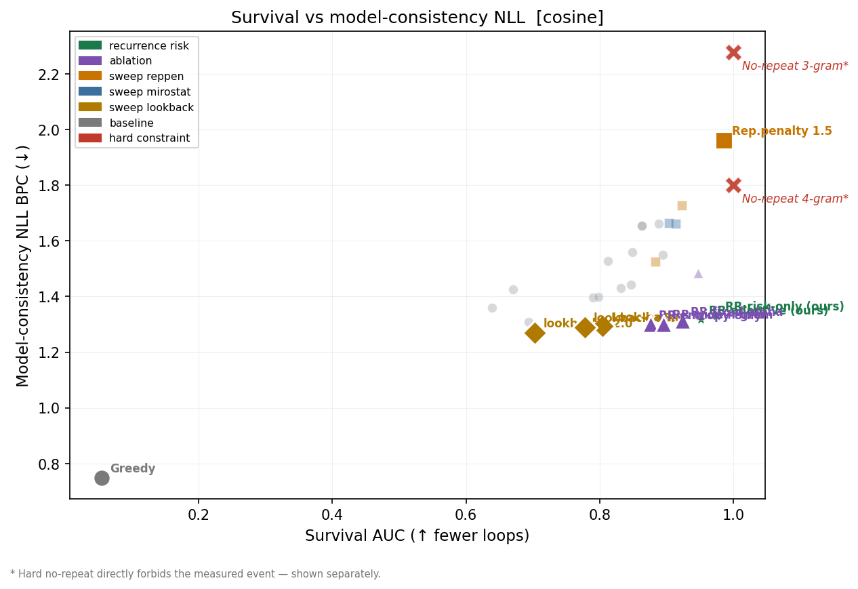
Figure 1. Survival AUC versus model-consistency NLL (cosine checkpoint). Points on the Pareto frontier are enlarged. The recurrence-risk methods sit at the top-left frontier — high survival, low NLL. Hard no-repeat is drawn separately (red ✕) because it forbids the measured event.
Figures 2 and 3 tell the same story for the other two quality axes. On distributional similarity the recurrence-risk methods are the frontier; on spelling they are matched only by look-back, which loops far more often.
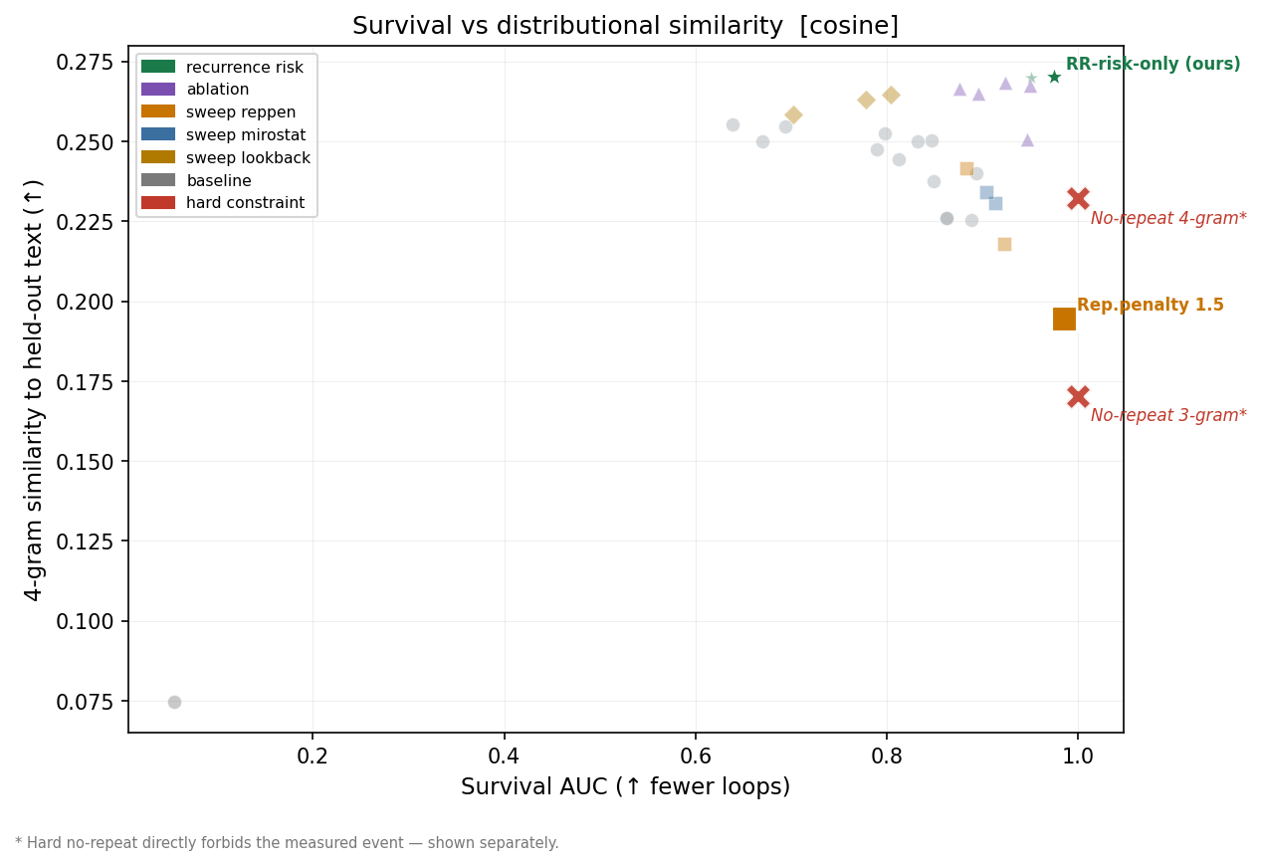
Figure 2. Survival versus 4-gram distributional similarity to held-out text (cosine). Higher-right is better.

5.2 Survival curves
The Kaplan-Meier curves make the reliability interpretation concrete: each curve is the fraction of samples still loop-free after a given number of characters. Greedy collapses at once; the standard samplers decay steadily; repetition penalty and the recurrence-risk methods hold high survival throughout, approaching the hard constraint without banning anything.
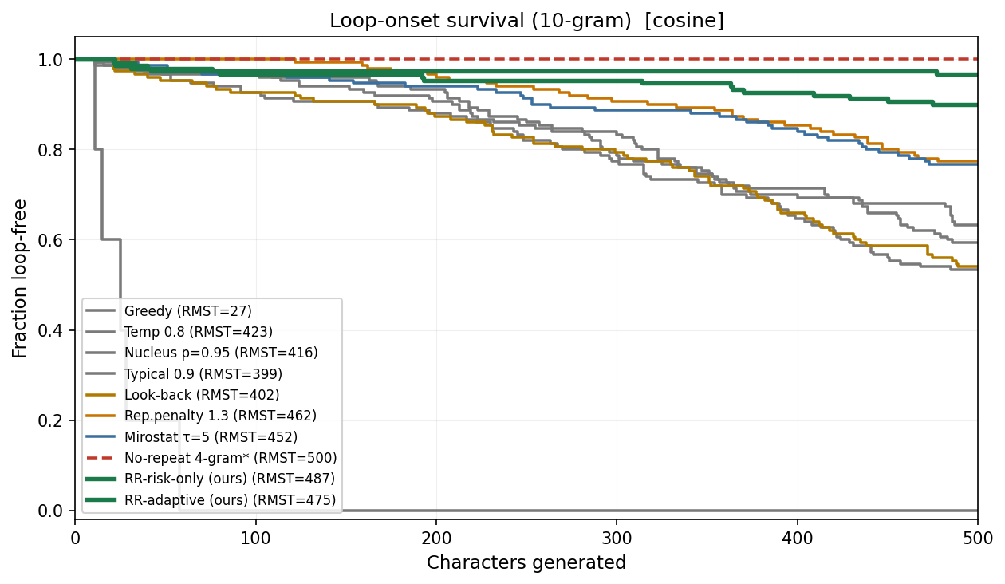
Figure 3. Loop-onset survival curves (10-gram, cosine). Dashed = hard constraint. The recurrence-risk methods (green) track close to no-repeat while remaining fully probabilistic.

5.3 Robustness across loop definitions
A central concern is that a method might merely be tuned to one loop metric — especially the exact n-gram order that no-repeat blocks. Table 2 lists RMST for every method under all six loop definitions. The ordering is stable: the recurrence-risk methods rank at or near the top under short and long n-grams, under the longest-repeated-substring criterion, and under the compression criterion alike. No-repeat's perfect scores are confined, by construction, to the n-gram criteria it enforces.

Method | 8-gram | 10-gram | 12-gram | 16-gram | LRS-20 | compress
Greedy | 27 | 27 | 38 | 38 | 64 | 204
Temperature 0.8 | 288 | 423 | 479 | 489 | 494 | 500
Nucleus p=0.95 | 310 | 416 | 484 | 491 | 495 | 500
Rep. penalty 1.3 | 389 | 462 | 494 | 500 | 500 | 500
Mirostat τ=5 | 356 | 452 | 489 | 494 | 497 | 500
Look-back (α=3) | 253 | 402 | 460 | 486 | 494 | 500
No-repeat 4-gram* | 500 | 500 | 500 | 500 | 500 | 500
RR-risk-only (ours) | 450 | 487 | 491 | 494 | 500 | 500
RR-adaptive (ours) | 403 | 475 | 488 | 491 | 500 | 500

Table 2. RMST (loop-free characters) under six loop definitions, cosine checkpoint. Among probabilistic methods, risk-only has the highest RMST under the strict 8-gram and 10-gram definitions; the recurrence-risk methods lead or tie under every definition. No-repeat (*) attains 500 only where it directly enforces the criterion.
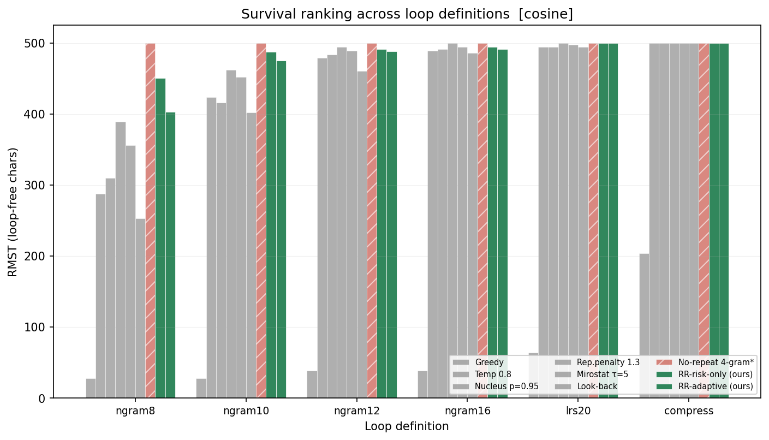
Figure 4. The same information graphically: survival ranking is preserved across all six loop definitions, not just the one no-repeat can game.

5.4 Method-versus-method significance
Because all methods share prompt/seed pairs, differences can be tested with a paired bootstrap on the matched units. Table 3 reports the RMST difference (with 95% CI) and paired p-values on MC-NLL and similarity for the decisive comparisons.

Comparison (A − B) | ΔRMST | 95% CI | p(NLL) | p(Sim)
RR-risk-only − Rep. penalty 1.3 | +25.7 | [+7.2, +42.8] | <0.001 | <0.001
RR-risk-only − Mirostat τ=5 | +35.4 | [+15.5, +57.1] | <0.001 | <0.001
RR-risk-only − Look-back | +85.0 | [+65.1, +107.4] | <0.001 | <0.001
RR-risk-only − Temperature 0.8 | +63.9 | [+46.9, +82.2] | <0.001 | <0.001
RR-risk-only − Nucleus p=0.95 | +71.5 | [+52.8, +88.9] | <0.001 | <0.001
RR-adaptive − Rep. penalty 1.3 | +13.8 | [−5.6, +32.3] | <0.001 | <0.001
RR-adaptive − Mirostat τ=5 | +23.5 | [+0.7, +46.5] | <0.001 | <0.001
RR-adaptive − RR-risk-only | −11.9 | [−21.1, −4.1] | <0.001 | 0.844
RR-adaptive − No-repeat 4-gram* | −24.6 | [−39.3, −11.4] | <0.001 | <0.001

Table 3. Paired bootstrap comparisons, cosine checkpoint. Positive ΔRMST favours method A on survival. Comparisons with no-repeat (*) are shown for completeness but reflect leakage — no-repeat wins survival by forbidding the event. The risk-only vs adaptive rows quantify the trade: adaptive gives up ~12 RMST for no significant change in similarity and a small NLL gain.
Two conclusions follow. First, against every genuine probabilistic baseline the recurrence-risk methods win on survival and on both quality axes simultaneously, at high significance. Second, the risk signal — not the online adaptation — is doing the work: risk-only actually has higher survival than the adaptive variant, and the two are indistinguishable on similarity. The adaptive form remains useful where a slightly softer, more diverse generation is preferred, but the paper's central object is recurrence risk, with adaptivity a refinement.

5.5 Ablations
Table 4 isolates each component on the cosine checkpoint. Removing the online adaptation (fixed-alpha) costs some survival; removing the risk signal and keeping only the entropy term collapses survival, confirming that risk is the mechanism; removing the nucleus filter after the penalty leaves survival intact but degrades MC-NLL and similarity, showing that the filter's role is quality, not loop control. The n-gram band matters: a wide band (2–8) dilutes the signal and loses survival, a narrow band (3–4) is close to the default.

Ablation | SAUC | RMST | MC-NLL | Sim | Reading
RR-adaptive (full) | 0.951 | 475 | 1.318 | 0.270 | reference
RR-risk-only | 0.975 | 487 | 1.331 | 0.270 | risk signal alone is strongest
fixed-alpha | 0.924 | 462 | 1.313 | 0.268 | adaptation aids survival
entropy-only | 0.876 | 438 | 1.301 | 0.267 | without risk, survival falls
no top-p | 0.947 | 474 | 1.484 | 0.251 | filter is for quality, not loops
narrow n-gram 3–4 | 0.950 | 475 | 1.334 | 0.267 | close to default
wide n-gram 2–8 | 0.896 | 448 | 1.302 | 0.265 | over-wide band dilutes signal

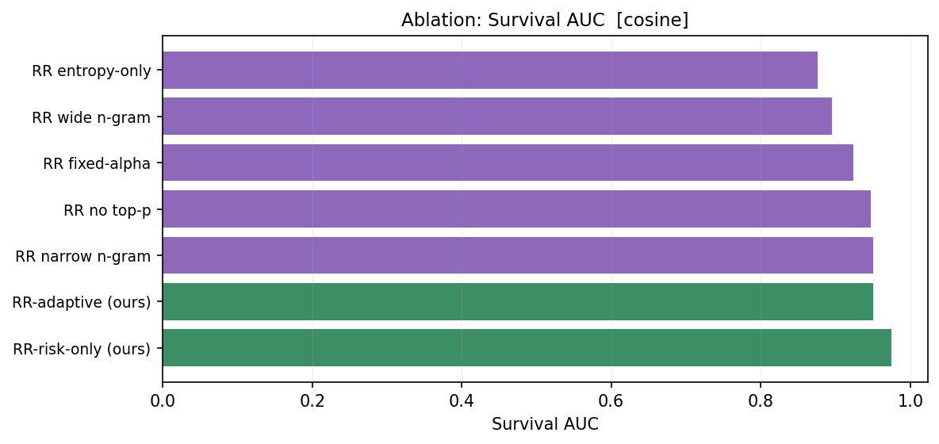
Figure 5. Ablation on survival AUC (cosine). The risk signal is the load-bearing component; entropy-only, lacking it, is the weakest.

5.6 Matched qualitative examples
The following three continuations use the identical prompt ("The night was") and random seed on the cosine checkpoint, so they differ only in the decoder. They illustrate the mechanism directly.

Greedy — loops immediately
…a sensible of the subject of the subject of the consideration of the subject of the subject of the subject of the subject of the subject of the subject of the subject…

No-repeat 4-gram — avoids the loop but breaks words
…at length over her indulgence in a sicket of my father, that they were through offertuning this appearance, often to since the borne, touched which party I warmted furniture…

Recurrence-risk (risk-only) — avoids the loop, stays fluent
…at least for her father. She should be heard of the cottage of the moment had been and intended and some satisfaction…
Greedy is trapped in "the subject of"; no-repeat escapes but invents non-words (sicket, offertuning, warmted) because banning the fluent continuation forces an implausible token; recurrence-risk escapes while producing well-formed English. This is the infinite-versus-finite-penalty distinction of Section 3.1 made visible.

5.7 Runtime
Throughput on the character model (Apple M-series) places recurrence-risk at 157 chars/s, against 180 for temperature and 194 for no-repeat. The cost is the per-step risk lookup, but because that lookup is O(N) over the incremental hash maps rather than a history scan, the method is more than twice as fast as repetition penalty (69 chars/s), which rescans the generated set every step. The strongest survival baseline is therefore also the slowest, and recurrence-risk dominates it on both quality and speed.

5.8 Confirmation on the second checkpoint
All results above are on the cosine checkpoint; the constant-learning-rate checkpoint gives the same qualitative picture, which rules out any dependence on the training schedule. Table 4b lists the key methods on the constant checkpoint. The recurrence-risk methods again lead every probabilistic baseline on survival while holding the best model-consistency NLL and distributional similarity; the numbers differ from the cosine checkpoint only in the third decimal. Because the ordering and the conclusions are unchanged, the remainder of the paper reports the cosine checkpoint alone, with this table as evidence that nothing hinges on that choice.

Method | SAUC ↑ | RMST ↑ | MC-NLL ↓ | Sim ↑ | Spell ↓ | Loop % ↓
Greedy | 0.098 | 49 | 1.127 | 0.141 | 0.003 | 100%
Temperature 0.8 | 0.835 | 418 | 1.473 | 0.254 | 0.080 | 41%
Nucleus p=0.95 | 0.838 | 419 | 1.459 | 0.251 | 0.079 | 39%
Look-back (α=3) | 0.796 | 398 | 1.312 | 0.268 | 0.055 | 47%
Rep. penalty 1.3 | 0.917 | 458 | 1.752 | 0.217 | 0.116 | 21%
Mirostat τ=5 | 0.889 | 445 | 1.677 | 0.234 | 0.111 | 26%
No-repeat 4-gram* | 1.000 | 500 | 1.809 | 0.230 | 0.137 | 0%
RR-risk-only (ours) | 0.950 | 475 | 1.340 | 0.273 | 0.057 | 7%
RR-adaptive (ours) | 0.946 | 473 | 1.333 | 0.275 | 0.061 | 7%

Table 4b. Constant-LR checkpoint, 10-gram loop, 150 samples for key methods. The recurrence-risk methods lead every probabilistic baseline on survival and hold the best MC-NLL (1.333–1.340) and similarity (0.273–0.275). The pattern is identical to the cosine checkpoint (Table 1).

6. Generalization to a Pretrained Subword Model
The character-model results could reflect something peculiar to a tiny model or to character-level tokenisation. To test this, the same decoder — same KL-projection penalty, same incremental risk maps, now defined over subword n-grams — was applied to DistilGPT-2, a pretrained 82M-parameter subword model, with no retraining. Table 5 reports survival (in subword-token and character units), repetition, distinctness, model-consistency NLL, and throughput over five seeds and eight prompts.

Method | Loop%(tok) ↓ | SAUC(tok) ↑ | SAUC(char) ↑ | rep-3 ↓ | distinct-3 ↑ | MC-NLL
Greedy | 100% | 0.062 | 0.404 | 0.898 | 0.102 | 0.327
Temperature 0.9 | 100% | 0.309 | 1.954 | 0.086 | 0.914 | 2.902
Nucleus p=0.95 | 82% | 0.434 | 1.346 | 0.094 | 0.906 | 2.979
Rep. penalty 1.3 | 0% | 1.000 | 1.000 | 0.000 | 1.000 | 4.725
No-repeat 3-gram* | 0% | 1.000 | 1.096 | 0.000 | 1.000 | 3.115
RR-risk-only (ours) | 75% | 0.519 | 1.101 | 0.014 | 0.986 | 2.676
RR-adaptive (ours) | 88% | 0.469 | 1.442 | 0.019 | 0.981 | 2.692

Table 5. DistilGPT-2, 5 seeds × 8 prompts, 200 generated tokens. Loop% and SAUC(tok) use the 3-gram token definition; SAUC(char) uses a 20-character definition after detokenisation. No-repeat (*) again constrains the measured event directly.
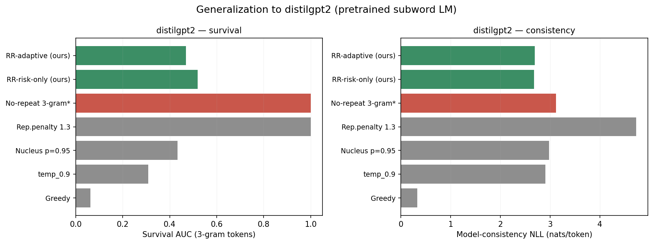
Figure 6. DistilGPT-2 generalization. Left: survival. Right: model-consistency NLL. The recurrence-risk methods (green) achieve the lowest MC-NLL of any method that actually reduces repetition — the text they produce is the most probable under the model itself — while cutting the token-level repetition rate by roughly an order of magnitude relative to temperature and nucleus sampling.
The transfer is clear on the axis that matters most for the theory. Recurrence-risk decoding attains the lowest model-consistency NLL of any method that meaningfully suppresses repetition: 2.68 bits, against 4.73 for repetition penalty and 3.12 for no-repeat. In other words, among methods that actually break loops, recurrence-risk keeps generations closest to the model's own distribution — exactly the minimum-distortion property the method was designed to have. It drives the token-level 3-gram repetition rate down to 0.014–0.019, from 0.086–0.094 for temperature and nucleus, while leaving distinctness essentially at ceiling. The absolute survival numbers are lower than on the character model because a 3-subword-token loop is a much stricter event than a 10-character loop, and 200 tokens is a short horizon; the relative ordering, and the NLL advantage, are what generalise. Repetition penalty and no-repeat reach zero repetition only by the same mechanisms — and costs — seen on the character model: penalty inflates NLL to 4.7 bits, no-repeat directly forbids the event.

7. Discussion

7.1 What the evidence supports
The results support a narrow, well-defined claim: recurrence-risk decoding improves the survival–quality trade-off relative to temperature, nucleus, typical, top-k, Mirostat, repetition penalty, and look-back decoding, on both checkpoints, across six loop definitions, and with statistically significant paired tests. The mechanism is the recurrence-risk signal, as the ablations show; online adaptation is a secondary refinement that trades a little survival for diversity. Hard no-repeat is not a competitor but a limiting case, and is kept separate because it constrains the measured event.
The theory earns its place by explaining the empirical pattern rather than merely accompanying it. The minimum-distortion derivation predicts, before any experiment, that a finite penalty will preserve fluency where an infinite one (no-repeat) will not, and that a risk that is nonzero only for actively-recurring contexts will disturb the distribution less than a global penalty. Both predictions hold, on the character model and on DistilGPT-2.

7.2 Limitations
Loop onset, though measured six ways, is always a surface-form criterion; semantic repetition and paraphrase loops are not captured. Model-consistency NLL measures proximity to the model's distribution, not human-judged quality, and is reported as such. The generalization test uses one pretrained model at one size and a short horizon; larger models, longer generations, and instruction-tuned settings remain to be examined. The decoder has hyperparameters (the n-gram band, base penalty, and the adaptation coefficients) that were set by light hand-tuning rather than a systematic search, so the reported numbers are likely conservative. Finally, the risk lookup, while amortised O(N) per step, still adds a constant-factor overhead that matters at very high throughput.

7.3 Outlook
Because the method needs only next-token logits and a few kilobytes of hash state, it is well suited to on-device and small-model settings, where cheap decoding-time reliability controls are most valuable and where retraining to suppress repetition is least affordable. The minimum-distortion view also suggests natural extensions: risk features beyond exact n-gram recurrence (embedding-space or semantic recurrence), and a learned rather than hand-set penalty schedule, both of which fit the same KL-projection template.

8. Conclusion
Repetition loops are a decoding-time reliability failure, and they are best addressed at the level where they occur: the continuation of a recurring n-gram. Recurrence-Risk Decoding penalises exactly that, in the amount prescribed by a minimum-distortion projection of the model distribution onto a risk-bounded set. The resulting soft exponential penalty unifies the existing tools — the unmodified model at zero penalty, hard no-repeat at infinite penalty — and occupies, empirically, the survival–quality frontier that neither extreme reaches. It does so across two models, two tokenisations, six loop definitions, and three quality axes, with the risk signal identified by ablation as the operative mechanism. The method is simple, fast, model-agnostic, and requires no retraining, which makes it a practical default wherever small or on-device models must generate long text without falling into loops.

A. Appendix A: All Configurations
Full listing on the cosine checkpoint, ordered by 10-gram RMST. Sweep points at 50 samples; key methods at 150.

Configuration | Category | SAUC | RMST | MC-NLL | Sim | Spell
No-repeat 4-gram* | hard | 1.000 | 500 | 1.800 | 0.232 | 0.131
No-repeat 3-gram* | hard | 1.000 | 500 | 1.743 | 0.230 | 0.128
Rep. penalty 1.5 | sweep | 0.986 | 493 | 1.962 | 0.195 | 0.143
RR-risk-only (ours) | recurrence-risk | 0.975 | 487 | 1.331 | 0.270 | 0.059
RR-narrow n-gram | ablation | 0.950 | 475 | 1.334 | 0.267 | 0.061
RR-adaptive (ours) | recurrence-risk | 0.951 | 475 | 1.318 | 0.270 | 0.058
RR-fixed-alpha | ablation | 0.924 | 462 | 1.313 | 0.268 | 0.057
Rep. penalty 1.3 | sweep | 0.923 | 462 | 1.727 | 0.218 | 0.108
Mirostat τ=5 | sweep | 0.904 | 452 | 1.663 | 0.234 | 0.108
RR-wide n-gram | ablation | 0.896 | 448 | 1.302 | 0.265 | 0.060
Rep. penalty 1.1 | sweep | 0.893 | 446 | 1.553 | 0.243 | 0.081
RR-entropy-only | ablation | 0.876 | 438 | 1.301 | 0.267 | 0.059
Nucleus p=0.99 | sweep | 0.874 | 437 | 1.575 | 0.235 | 0.080
Temperature 0.8 | sweep | 0.847 | 423 | 1.442 | 0.250 | 0.079
Mirostat τ=3 | sweep | 0.878 | 439 | 1.654 | 0.234 | 0.086
Nucleus p=0.95 | sweep | 0.832 | 416 | 1.431 | 0.250 | 0.071
Look-back (α=3) | sweep | 0.805 | 402 | 1.293 | 0.265 | 0.051
Typical p=0.9 | sweep | 0.798 | 399 | 1.399 | 0.253 | 0.062
Greedy | baseline | 0.055 | 27 | 0.749 | 0.075 | 0.004

Hard-constraint rows (*) are listed for completeness and excluded from frontier and significance analysis because they directly forbid the measured failure event.

