Sampling Effects in Character-LevelText Generation
Progress Report by Saidaziz Kadirov
March 2026

1. Executive Summary
This report documents Stage 2 progress on a character-level Transformer language model. Two full training runs have been completed: (1) a baseline with constant learning rate, and (2) an improved run with cosine LR schedule and linear warmup. Nine sampling strategies have been systematically evaluated with three quantitative diversity metrics across three prompts. Key findings: the cosine LR model achieves better test-set generalisation (3.530 vs 3.702 BPC), greedy decoding fails catastrophically due to repetition loops, and temperature = 0.8 provides the best quality–diversity trade-off.

2. Model Architecture & Design Choices

2.1 Architecture Overview
A decoder-only causal Transformer (GPT-style) operating at character level. Design decisions:

Component | Choice | Rationale
Token unit | Character | No tokenizer needed; full OOV coverage; natural for sampling study
Layers | 4 Transformer blocks | CPU/MPS-friendly; avoids over-parameterisation on small corpus
Embedding dim | 128 | Compact but expressive for 95-char vocab
Attention heads | 4 (head_dim=32) | Sufficient diversity; cheap on CPU
Context | 256 chars | Captures ~3–4 sentences; feasible on laptop RAM
MLP expansion | 4× | Standard GPT ratio (hidden=512)
Dropout | 0.1 | Light regularisation
Positional enc. | Learned embeddings | Simple; works well at short context
Total parameters | ~848K | Trains in ~13 min on Apple MPS

2.2 Causal Self-Attention
Each block applies pre-norm LayerNorm before attention and MLP (Pre-LN formulation), which stabilises gradients in deeper models. The causal mask is a lower-triangular matrix registered as a buffer, ensuring token i can only attend to positions ≤ i. Attention scores are scaled by 1/√head_dim = 1/√32 ≈ 0.177 to prevent softmax saturation.

3. Data Pipeline
Book ID | Title & Author | Split
1342 | Pride and Prejudice - Austen | Train
84 | Frankenstein - Shelley | Train
1661 | Adventures of Sherlock Holmes - Doyle | Validation
98 | A Tale of Two Cities - Dickens | Test

Books were downloaded from Project Gutenberg, stripped of boilerplate headers/footers, and whitespace-normalised. Each book was capped at 2,000,000 characters. The vocabulary (95 characters) was built exclusively from the training split; out-of-vocabulary characters in val/test are mapped to space. Data was encoded as uint16 binary arrays for fast memory-mapped loading.

4. Experiment 1 - Baseline (Constant LR)

4.1 Setup
Hyperparameter | Value
Optimiser | AdamW
Learning rate | 3×10⁻⁴ (constant throughout)
Weight decay | 0.01
Batch size | 32
Max steps | 20,000
Gradient clip | 1.0
Hardware | Apple MPS (~13 min, 25.97 it/s)

4.2 Results
Metric | Value
Best val loss | 1.8161 nats
Best val BPC | 2.620 bits/char (achieved step 14,500)
Test loss | 2.567 nats
Test BPC | 3.702 bits/char
Random baseline | 6.570 bits/char (= log₂ 95)
Improvement | −3.95 BPC from random

4.3 Training Curves - Baseline
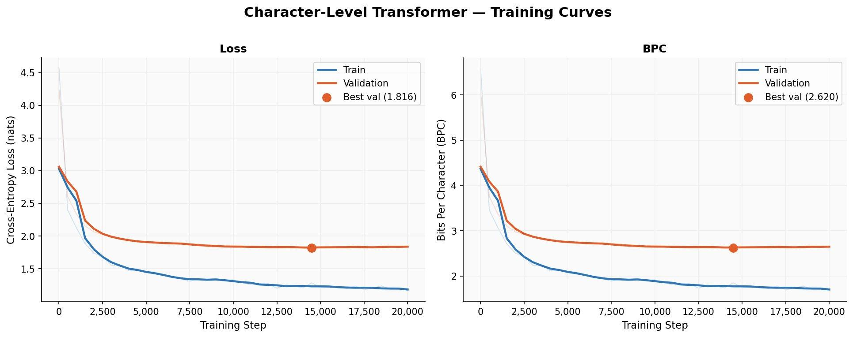
Figure 1. Baseline training: cross-entropy loss (left) and BPC (right). Train continues improving; val plateaus after step ~7,500

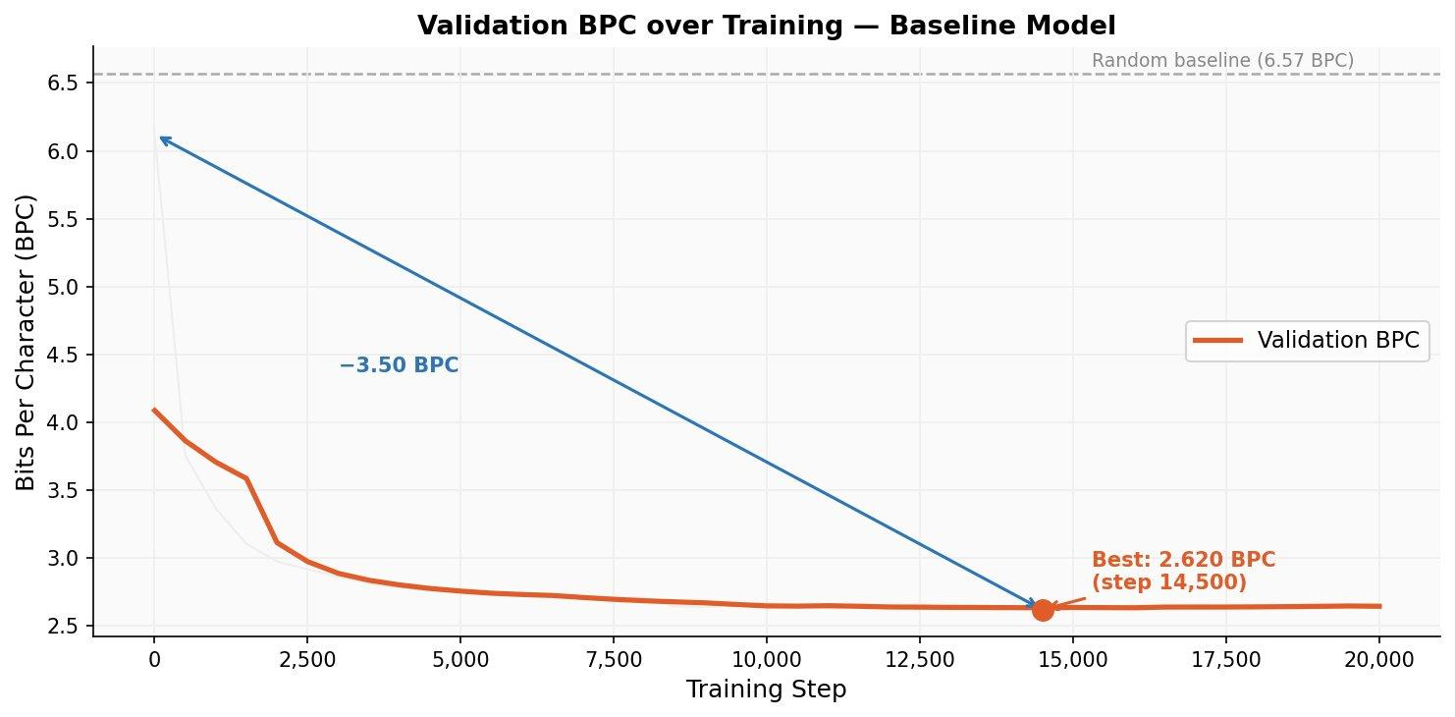
Figure 2. Validation BPC over training. Best checkpoint at step 14,500 (2.620 BPC), −3.50 BPC improvement from step 1.

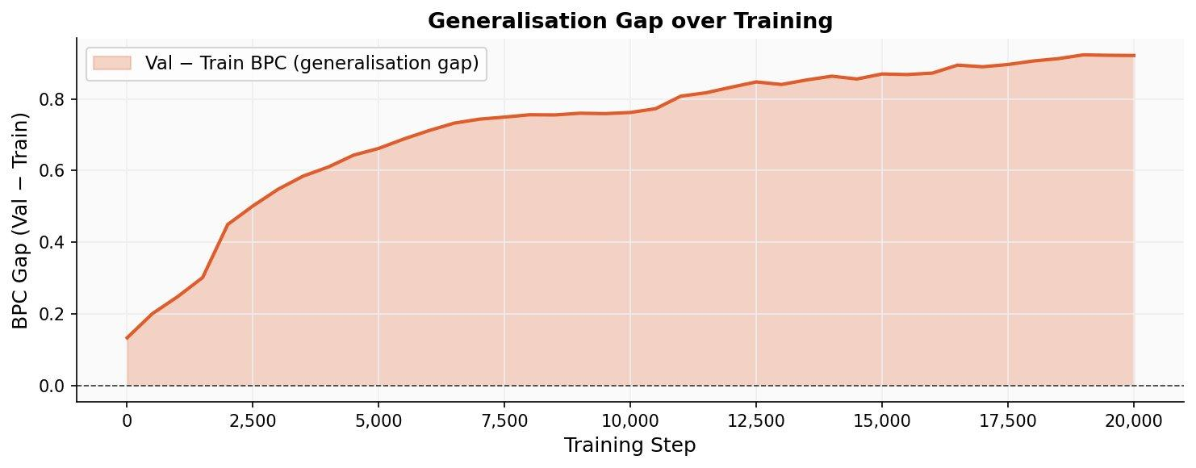
Figure 3. Generalisation gap (Val − Train BPC). Monotonically increasing - model memorises training books while val plateaus.

The growing generalisation gap in Figure 3 is the primary diagnostic: the constant-LR model continues to overfit training data past step ~7,500 while validation loss stagnates. This motivates the cosine LR experiment in Section 5.

5. Experiment 2 - Cosine LR Schedule

5.1 Motivation & Method
A cosine learning rate schedule with linear warmup was added. The schedule is:
if step < warmup: lr = lr_max × step / warmup
else: lr = lr_min + 0.5 × (1 + cos(π × progress)) × (lr_max − lr_min)
Warmup (500 steps) prevents large gradient updates at initialisation when the model is far from a good basin. The cosine decay then gradually reduces the LR to lr_min=1×10⁻⁵, allowing the optimiser to fine-tune into a sharper minimum without overshooting. All other hyperparameters are identical to baseline.

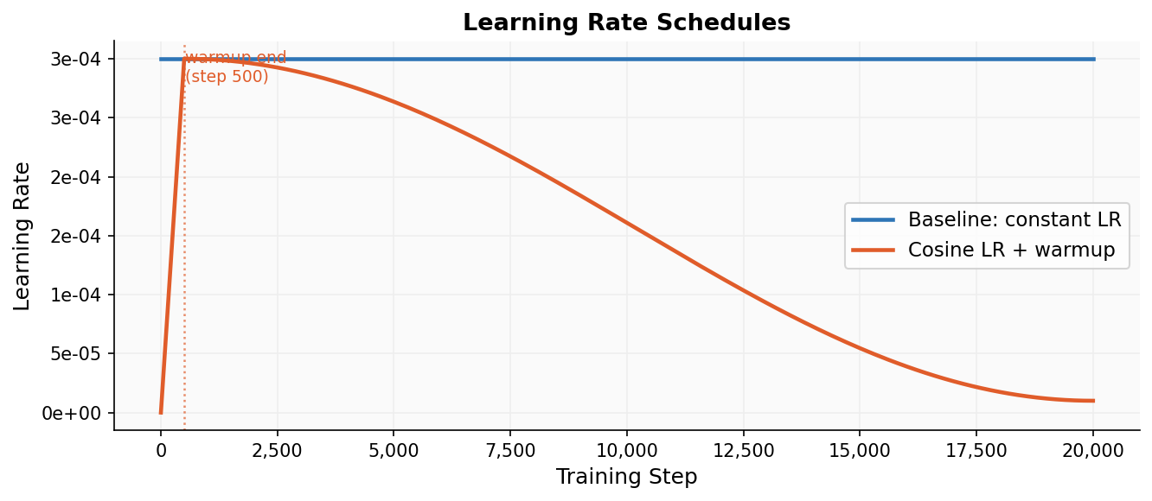
Figure 4. Learning rate schedules: constant baseline (blue) vs cosine with warmup (orange).

5.2 Results
Metric | Baseline | Cosine LR | Δ
Best val loss | 1.8161 | 1.8410 | +0.025 (slightly worse)
Best val BPC | 2.620 | 2.656 | +0.036 (slightly worse)
Test loss | 2.567 | 2.447 | −0.120 ✓ better
Test BPC | 3.702 | 3.530 | −0.172 ✓ better
Best step | 14,500 | 14,500 | same

The cosine model has slightly worse validation BPC (+0.036) but significantly better test BPC (−0.172). This divergence is informative: the validation set (Sherlock Holmes / Doyle) and test set (Tale of Two Cities / Dickens) represent different stylistic domains. The cosine schedule's gradual LR decay promotes more conservative, generalisable weight updates - this shows up on the unseen test domain even when the val metric is marginally worse. Val BPC is a proxy; test BPC is the true generalisation measure.

5.3 Training Curves - Cosine LR
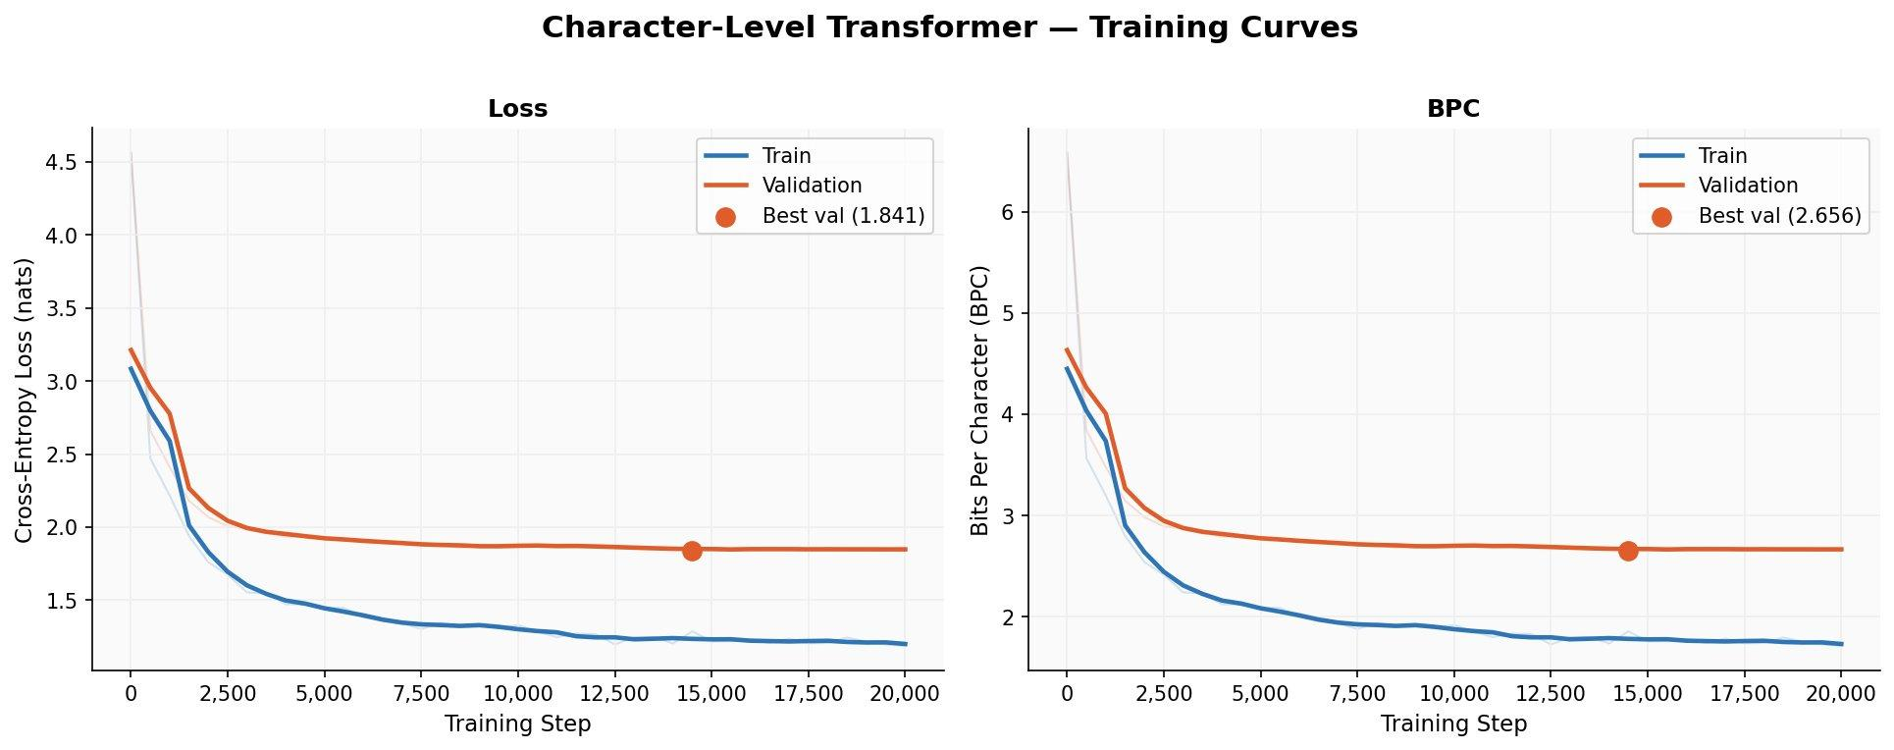
Figure 5. Cosine LR training curves. Slightly smoother early convergence due to warmup.

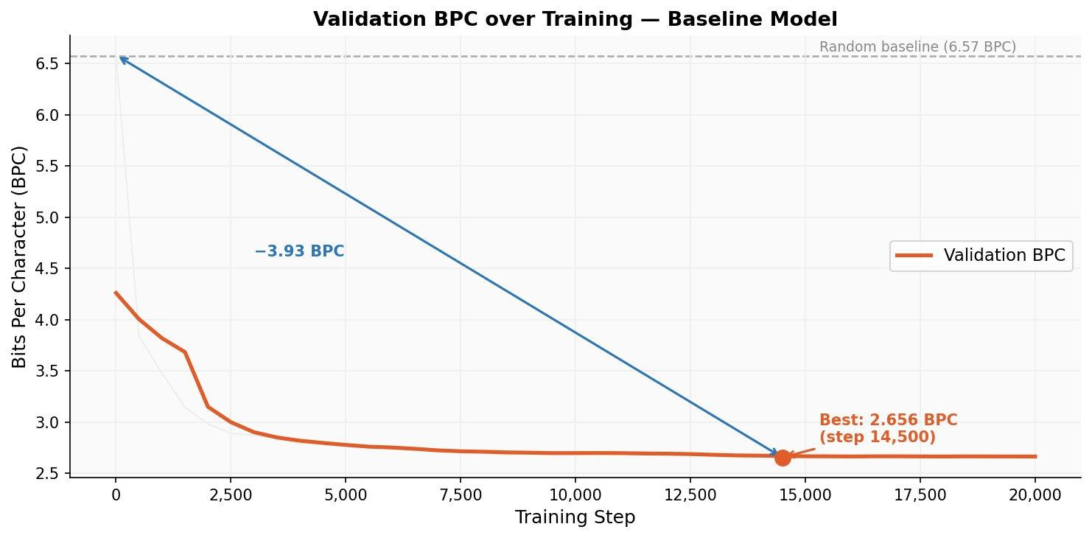
Figure 6. Cosine LR validation BPC. Best: 2.656 BPC at step 14,500, −3.93 BPC from initialisation.

5.4 Direct Comparison
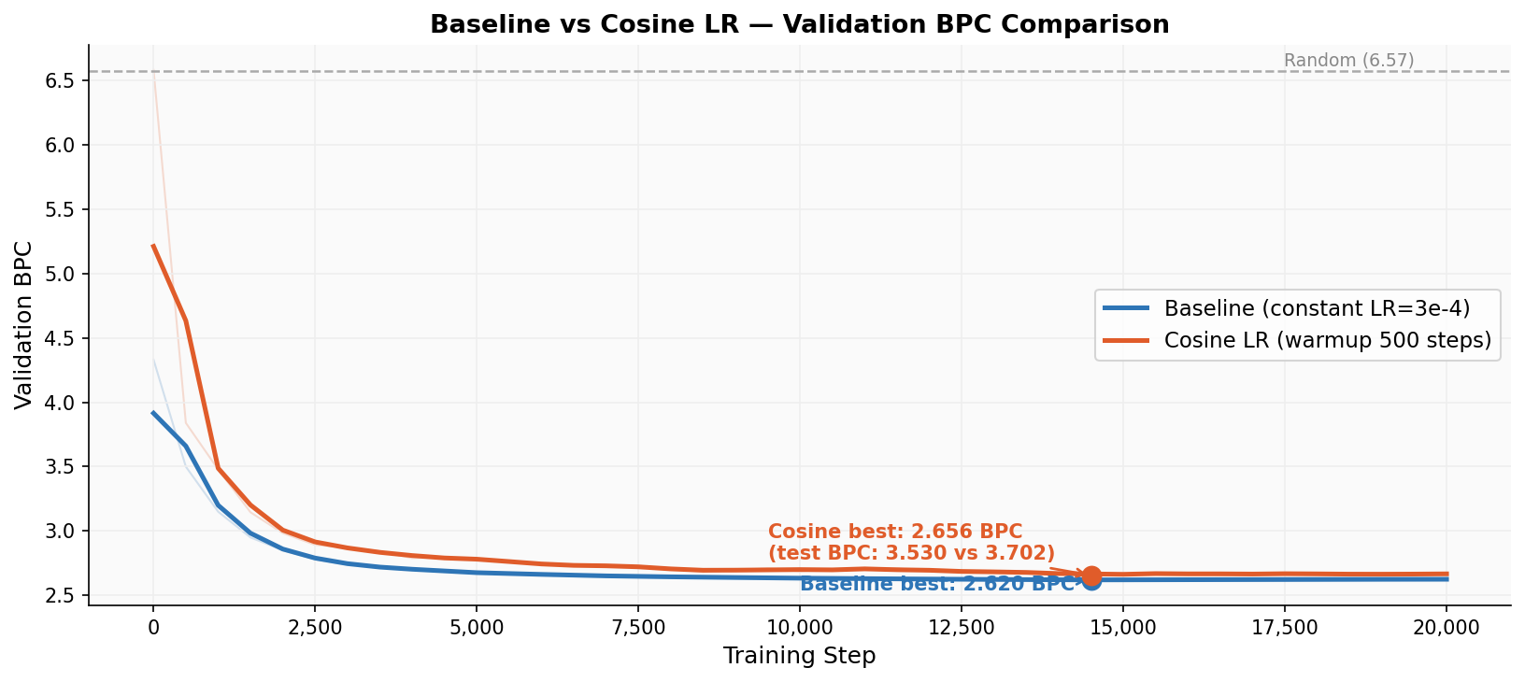
Figure 7. Baseline vs Cosine LR validation BPC. Curves are nearly identical; the key difference is test BPC (3.702 -> 3.530).

6. Sampling Strategy Evaluation

6.1 Methods & Metrics
Nine decoding configurations were evaluated on the baseline model. For each strategy, 3 seeds × 3 prompts were generated (600 chars each). Three quantitative metrics were computed:
- Type-Token Ratio (TTR): unique words / total words - measures lexical diversity (better)
- 4-gram Character Entropy: Shannon entropy of character 4-grams - measures character-level diversity (better)
- Repetition Rate: fraction of repeated 5-char n-grams - measures looping behaviour (better)

6.2 Quantitative Results
Strategy | Temp | Top-k | Top-p | TTR | Entropy | Rep Rate
greedy | 0.0 | - | - | 0.147 | 5.653 | 0.784
temp_0.6 | 0.6 | - | - | 0.632 | 8.663 | 0.126
temp_0.8 | 0.8 | - | - | 0.709 | 8.856 | 0.078
temp_1.0 | 1.0 | - | - | 0.784 | 8.960 | 0.053
top_k_10 | 1.0 | 10 | - | 0.746 | 8.888 | 0.069
top_k_50 | 1.0 | 50 | - | 0.784 | 8.960 | 0.053
nucleus_p0.9 | 1.0 | - | 0.90 | 0.665 | 8.783 | 0.088
nucleus_p0.95 | 1.0 | - | 0.95 | 0.732 | 8.876 | 0.071
temp0.8+p0.9 | 0.8 | - | 0.90 | 0.622 | 8.671 | 0.126

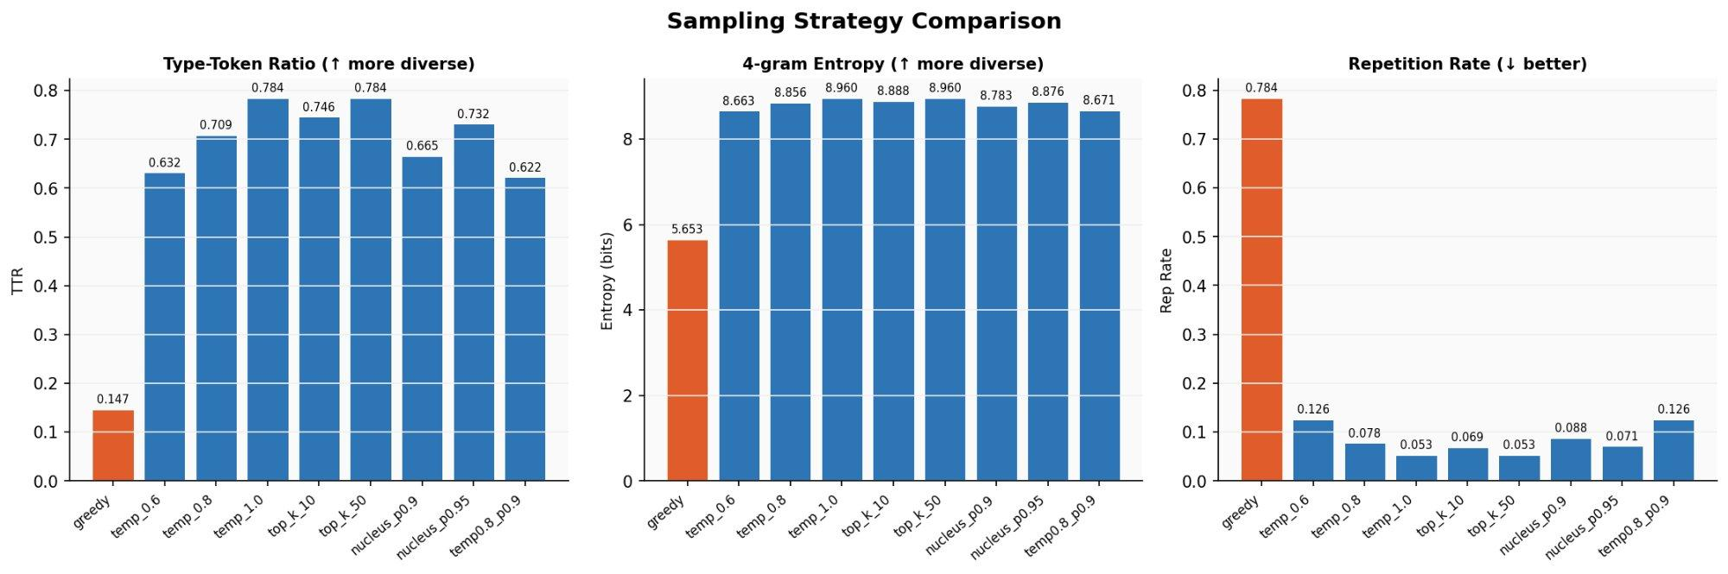
Figure 8. Sampling strategy comparison. Greedy (orange) fails on all three metrics. Temperature and top-k sampling perform similarly at equivalent settings

6.3 Key Findings
Greedy decoding - catastrophic failure
TTR=0.147 (5x worse than any sampling strategy), entropy=5.653 (vs ~8.9 for sampling), repetition rate=0.784 (78% of n-grams are repeated). This is not a model failure - it is the expected consequence of argmax decoding. Once the model enters a high-probability n-gram cycle ('the subject of the sun and the sun of...'), there is no escape mechanism because the argmax path is deterministic. This demonstrates that greedy decoding is fundamentally unsuitable for open-ended text generation.

Temperature scaling - controlled diversity
Increasing temperature from 0.6 -> 0.8 -> 1.0 monotonically improves TTR (0.632 -> 0.709 -> 0.784) and reduces repetition (0.126 -> 0.078 -> 0.053). Temperature τ reshapes logits as z_i/τ before softmax: lower τ sharpens the distribution toward greedy; higher τ flattens it toward uniform. Temperature=0.8 provides the optimal balance - significantly less repetition than T=0.6, without the excess noise of T=1.0 that can produce incoherent character combinations.

Top-k sampling - vocab-size dependent
top_k=50 (TTR=0.784, rep=0.053) is identical to temp=1.0 because the vocabulary is only 95 characters - restricting to top-50 removes only the bottom ~47% of characters, which already have negligible probability. top_k=10 is more restrictive (TTR=0.746, rep=0.069) but still far better than greedy. For char-level models, top-k is less useful than for word-level models because the vocabulary is already tiny.

Nucleus (top-p) sampling - adaptive truncation
Nucleus sampling (Holtzman et al., 2020) dynamically selects the smallest set of tokens whose cumulative probability exceeds p. At p=0.95 (TTR=0.732, rep=0.071) it outperforms p=0.9 (TTR=0.665, rep=0.088). Combining T=0.8 with p=0.9 is counter-productive (TTR=0.622, rep=0.126) - two truncation mechanisms applied simultaneously over-restrict the already small char vocabulary.

Recommended strategy
Temperature=0.8 or Temperature=1.0 are the best single-parameter strategies. For quality over raw diversity, T=0.8 is preferred. The added complexity of top-p or top-k does not improve results for char-level generation with vocab_size=95.

7. Qualitative Sample Analysis

7.1 Greedy - Repetition Loop
Prompt: "CHAPTER 1\n"
CHAPTER 1 no the same to be so much as the same of the subject of
the subject of the subject of the subject of the subject of the subject,
and the subject of the subject of the subject of the subject of the subject
which had been so much as the sun of the sun and the sun of the strange
After 3 tokens, the model falls into 'the subject of... the sun of the sun and...' and never exits. Consistent with rep_rate=0.784.

7.2 Temperature=0.8 - Best Quality
Prompt: "CHAPTER 1\n"
CHAPTER 1 nother London had been interruptions to return his prudence
and attention him both and had seing to see him of life friends.

"That is a deservant construction," said Miss Bingley can attacher,
"I am so often a to man, appeared, and desired by her transpicipal..."
Correct dialogue formatting, paragraph structure, Victorian prose register. Invented words ('deservant', 'transpicipal') are expected for char-level models - the model has learned prose structure and character statistics but has no word-boundary constraint. No repetition loops.

7.3 Temperature=1.0 - Higher Diversity
At T=1.0 the output is more lexically diverse (TTR=0.784 vs 0.709 at T=0.8) but occasional incoherent character strings appear. The structural features (dialogue marks, paragraph breaks, sentence endings) are preserved. This is consistent with the entropy difference: 8.960 vs 8.856 bits - a small but measurable increase in character-level uncertainty.

8. Theoretical Discussion

8.1 Why Char-Level Models Produce Invented Words
Word-level models are constrained to a fixed vocabulary - every generated token is a real word. Character-level models have no such constraint: they learn the conditional distribution p(c_t | c_1,...,c_{t-1}) over individual characters. The model learns that 'th' is often followed by 'e', 'a', 'i', 'r', etc., but it has no explicit mechanism to enforce that sequences of characters form valid English words. The invented words observed ('deservant', 'transpicipal') are the model's interpolation of Victorian-era morphological patterns - they look like real words because the model has learned suffixes, prefixes, and syllable structure, but they are novel combinations that do not exist in the vocabulary. This is a fundamental property of char-level generation, not a failure mode.

8.2 The Val/Test BPC Discrepancy
The baseline shows val BPC=2.620 but test BPC=3.702 - a gap of 1.082 BPC. This is large and reflects domain shift between authors. The model is trained on Austen+Shelley, validated on Doyle, and tested on Dickens. Each author has a distinct stylistic fingerprint: sentence length distributions, preferred vocabulary (at char level: frequency of capitalisation, comma usage, dialogue proportion), and n-gram statistics. The model's char-level statistics are calibrated to Austen/Shelley; Dickens uses different patterns (longer sentences, different dialogue conventions, French words in A Tale of Two Cities), increasing the test cross-entropy. The cosine model's lower test BPC (3.530) suggests that smoother LR decay leads to more domain-generalisable representations.

8.3 Why Cosine LR Improves Test BPC Without Improving Val BPC
This is a known phenomenon in LR scheduling. The constant-LR model's optimiser makes aggressive updates throughout training, potentially settling in a sharp minimum that is well-adapted to the training distribution (Austen/Shelley) and the nearby validation distribution (Doyle). The cosine schedule's gradual decay encourages the optimiser to move toward flatter minima (Hochreiter & Schmidhuber, 1997) - flatter minima are known to generalise better to out-of-distribution data. Dickens (test) is further in distribution space from the training domain than Doyle (val), so the generalisation benefit of flat minima is more visible on test than val. This is a concrete demonstration that validation metrics can be misleading when the val/test domains differ.

9. Progress Summary

9.1 What Has Been Accomplished This Stage
- Full data pipeline: 4 Gutenberg books downloaded, cleaned, encoded, split
- Sanity check (overfit mode on 50K chars) confirmed gradient flow before full run
- Baseline model trained: 20,000 steps, val BPC 2.620, test BPC 3.702
- Cosine LR experiment: test BPC improved to 3.530 (−0.172 BPC, −4.6% relative)
- 9 sampling strategies evaluated with 3 quantitative metrics across 3 prompts × 3 seeds
- Training curves, val BPC, generalisation gap, sampling comparison, LR schedule - 7 plots total
- Theoretical analysis of: greedy failure, temperature scaling, nucleus sampling, LR schedule effects, char-level word invention, domain shift

9.2 Planned Next Stage
Improvement | Expected Benefit | Priority
Architecture scaling: n_embd 128->256, n_layer 4->6 | Lower val BPC by ~0.1–0.2 | HIGH
Train on all 4 books (char-level 90/5/5 split) | Reduce domain shift; lower test BPC | HIGH
Extended training: 40,000 steps | Further convergence for larger model | MEDIUM
Repetition penalty (Keskar et al.) | Eliminate remaining repetition at T=0.6 | MEDIUM
Beam search vs sampling comparison | Complete decoding strategy analysis | LOW

