FLOW-OTOMATIS — STEP 04 FINAL UI REFERENCE
Repository-Optimized Source of Truth • Biography Sync • UIB v1.2
This repository copy preserves all 30 approved UI compositions in compressed form. Written rules and Implementation Overrides are authoritative for text/semantics. High-resolution originals are archived outside this compact repository copy and identified by their original SHA-256 manifest.
- Global sidebar: Beranda, Workspace, Hasil, Profil Google, Gemini Keys, Diagnostik, Pengaturan.
- Windows 11 light desktop UI; compact professional white/light-gray + blue #2563EB.
- Primary biography input: episode package / FLOW_OTOMATIS_IMPORT.json.
- Canonical Scene key: SCENE_### across storyboard, approved image, prompt, job, result and edit handoff.
- Approved reference image is required and normally auto-mapped. Manual file selection is fallback only.
- Production lock: Omni Flash 1.1 • 720p • 16:9.
- Target comes from Audio/SRT. Flow duration choices: 4/6/8/10. App recommends; user confirms. Shorter-than-target choices are disabled.
- Target >10.00s is INVALID and must return upstream for scene split.
- Generate and Download are separate states.
- AI Agent material actions require preview + approval. No CAPTCHA/MFA bypass or quota/rate-limit evasion.
- FLOW_OTOMATIS_RESULT.json contains operational result data but no password/cookie/session secret/token/raw API key.
UI-IMG-001A
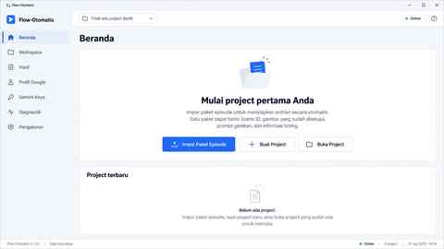
Review: PASS
UI-IMG-001B
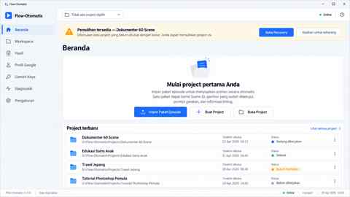
Review: PASS
UI-IMG-001C
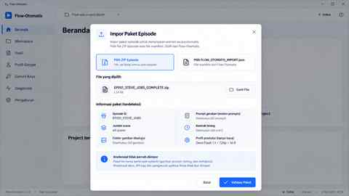
Review: PASS
Implementation Note: Import never imports password, cookie, session secret, API key or token.
UI-IMG-002A
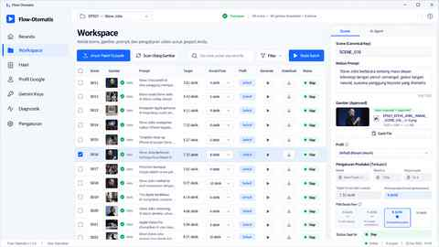
Review: PASS
Implementation Note: Normal image path is SCENE_### auto-mapping; Change File is recovery/fallback.
UI-IMG-002B
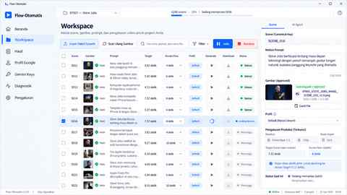
Review: PASS
Implementation Note: Generate and Download are distinct stages.
UI-IMG-002C
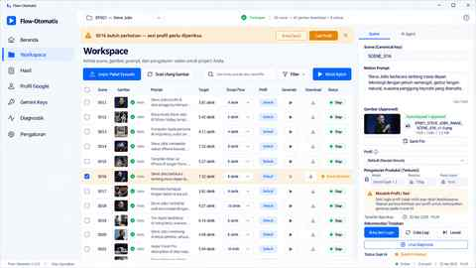
Review: PASS
Implementation Note: Session issue -> pause/Needs Attention; no auto account switch to evade limits.
UI-IMG-002D
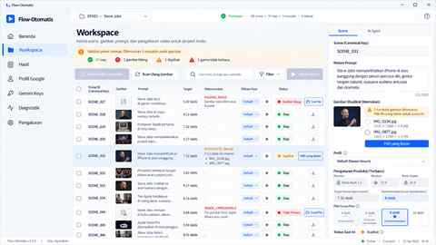
Review: PASS + IMPLEMENTATION OVERRIDE
Implementation Override: Artwork resolution typo: implementation is 720p; production lock is Omni Flash 1.1 • 720p • 16:9.
UI-IMG-003A
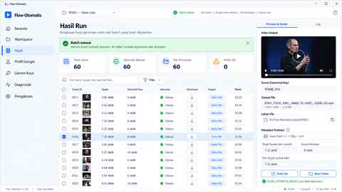
Review: PASS
Implementation Note: Example Target 7.32s stays master timing; generated 8s source is trimmed to 7.32s downstream.
UI-IMG-003B
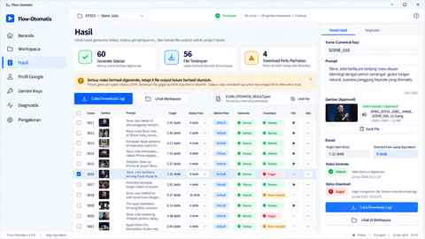
Review: PASS
Implementation Note: Generate success + download failure does not imply regeneration.
UI-IMG-003C
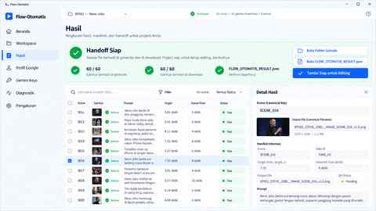
Review: PASS + IMPLEMENTATION OVERRIDE
Implementation Override: Handoff output is VIDEO (.mp4 or official video format), not PNG. Summary wording must be video generated/downloaded.
UI-IMG-004A
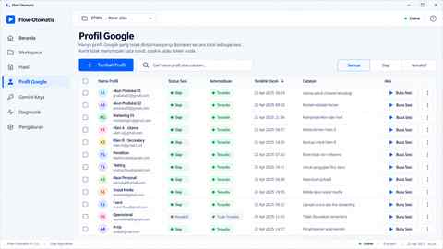
Review: PASS
UI-IMG-004B
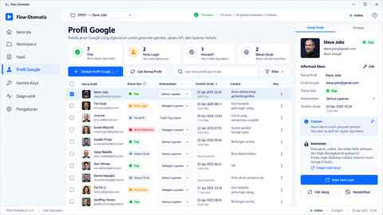
Review: PASS + IMPLEMENTATION OVERRIDE
Implementation Override: Public-person names/avatar/email are illustrative only; runtime uses user-owned profile labels/data.
UI-IMG-005A
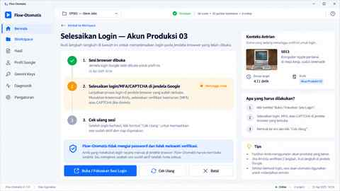
Review: PASS
Implementation Note: Login/MFA/CAPTCHA is completed by the user on official pages.
UI-IMG-005B
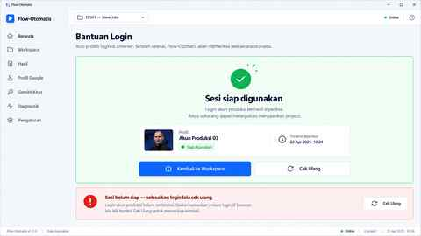
Review: PASS
UI-IMG-006A
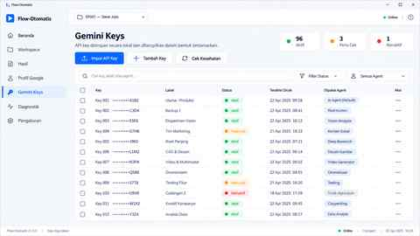
Review: PASS
Implementation Note: Raw API key is never displayed again; masked/suffix only.
UI-IMG-006B
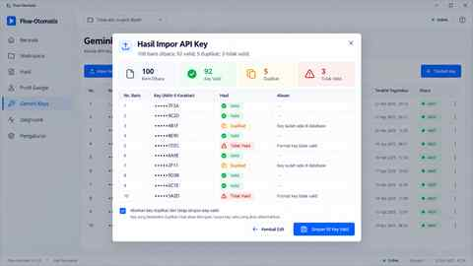
Review: PASS
UI-IMG-007A
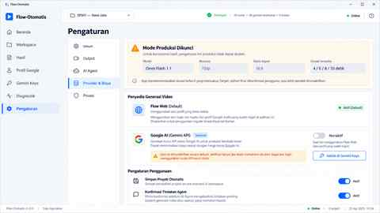
Review: PASS
Implementation Note: Omni Flash 1.1 • 720p • 16:9 is locked for this biography workflow.
UI-IMG-008A
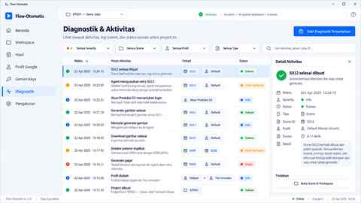
Review: PASS + IMPLEMENTATION OVERRIDE
Implementation Override: No automatic AI retry. Agent proposes retry; material retry requires preview + approval. Diagnostics generation/download refers to video output.
UI-IMG-008B
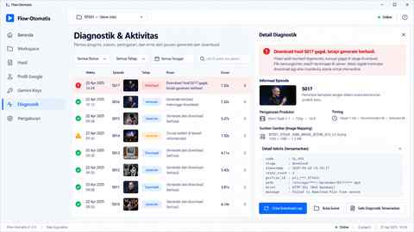
Review: PASS + IMPLEMENTATION OVERRIDE
Implementation Override: S017 diagnostic maps to SCENE_017. SCENE_016 shown in artwork is an artifact. Sensitive paths/IDs remain redacted.
UI-IMG-009A
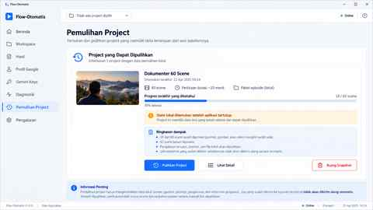
Review: PASS + IMPLEMENTATION OVERRIDE
Implementation Override: Recovery Center is not a permanent sidebar item; open it through recovery banner/prompt/temporary route.
UI-IMG-009B
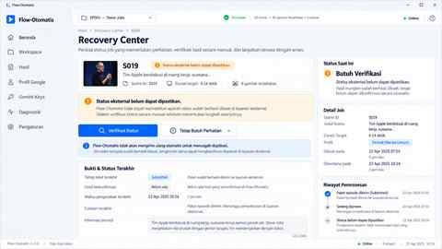
Review: PASS
Implementation Note: Ambiguous external job is verified, never auto-resubmitted.
UI-IMG-010A
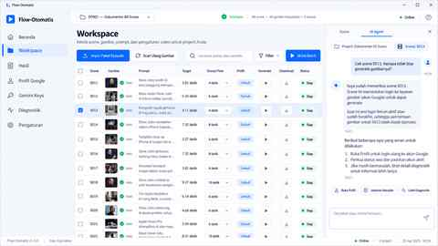
Review: PASS
UI-IMG-010B
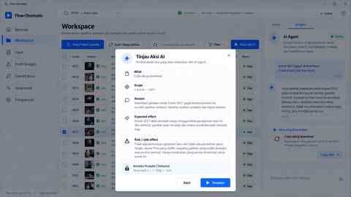
Review: PASS
Implementation Note: AI action applies only after What/Scope/Reason/Expected effect/Risk review.
UI-IMG-010C
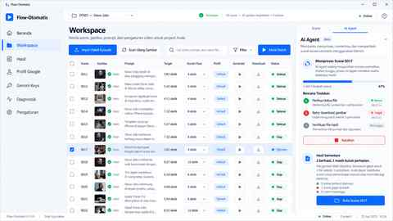
Review: PASS + IMPLEMENTATION OVERRIDE
Implementation Override: Retry/download wording refers to VIDEO output. Agent may not silently change Target, Selected Flow duration, approved image mapping, prompt or profile.
UI-IMG-011A
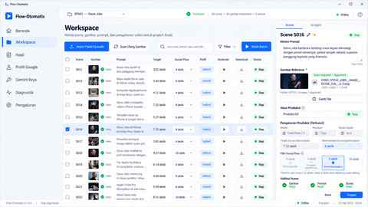
Review: PASS
Implementation Note: Target 7.32s: 4s/6s disabled, 8s/10s valid, 8s recommended.
UI-IMG-012A
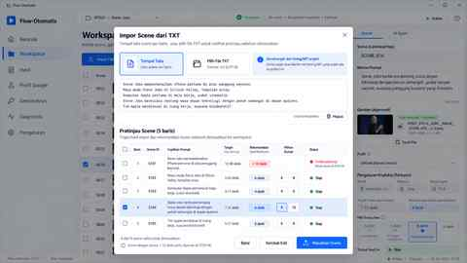
Review: PASS
Implementation Note: Bulk TXT is manual fallback; main biography path is episode package/FLOW_OTOMATIS_IMPORT.json.
UI-IMG-012B
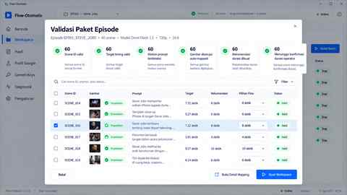
Review: PASS
Implementation Note: Recommended duration is not final until operator confirms valid selection.
UI-IMG-013A
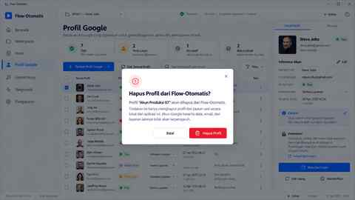
Review: PASS
Implementation Note: Remove Profile removes local app association, not the Google account.
UI-IMG-014A
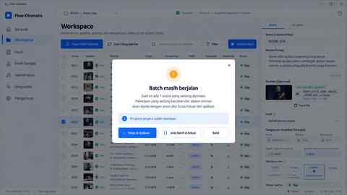
Review: PASS
Implementation Note: App does not promise background batch processing after exit.
UI-IMG-015A
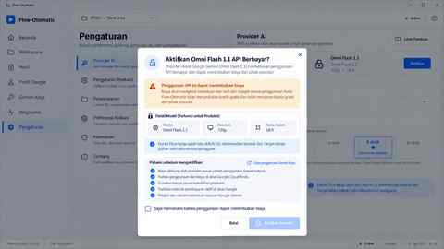
Review: PASS
Implementation Note: Paid provider is enabled only after explicit cost consent.

STEP 04 Final Gate
- 30 UI prompts completed — PASS
- 30 UI images completed — PASS
- All images reviewed — PASS
- Implementation Overrides pinned — PASS
- Final UI Reference consolidated — PASS
- Production lock consistent — PASS
- Biography sync consistent — PASS
STEP 04 STATUS: PASS

