LAGU FULL ALBUM
FINAL UI REFERENCE v1.1 - REPOSITORY COMPACT COPY
Authority: All 29 approved UI states are preserved. Images are compressed for repository storage only. Canonical behavior/copy remains Product Definition + STEP 03/04 revised + STEP 05 UI Freeze. Original full-resolution SHA is stored in SOURCE_OF_TRUTH_MANIFEST.md.

01. UI-IMG-001A - Project Hub - default
APPROVED visual reference.
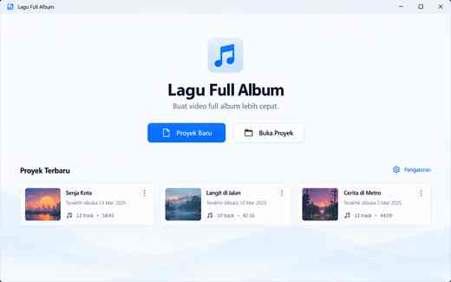

02. UI-IMG-001B - Project Hub - recovery available
APPROVED visual reference.
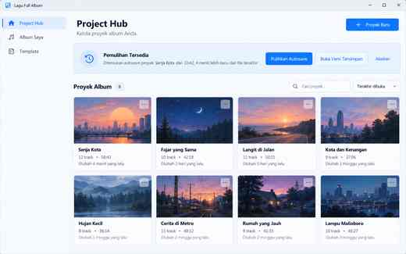

03. UI-IMG-002A - Album Editor - empty project
APPROVED visual reference.
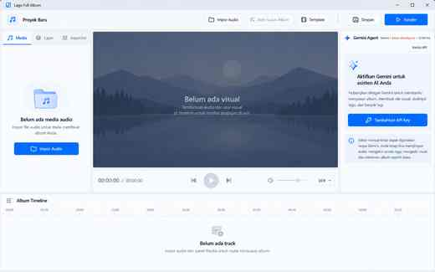

04. UI-IMG-002B - Album Editor - album ready
APPROVED visual reference.
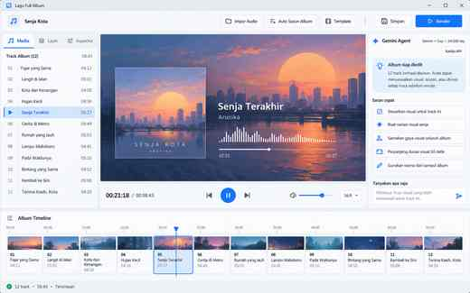

05. UI-IMG-002C - Album Editor - visual layer selected
APPROVED visual reference.
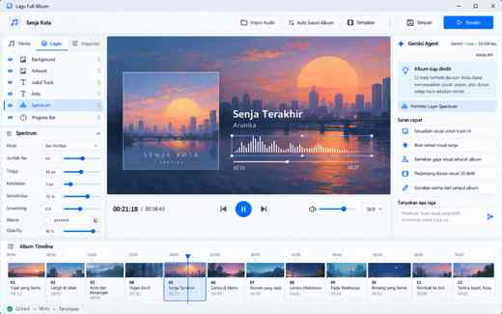

06. UI-IMG-002D - Album Editor - track boundary selected
APPROVED visual reference.
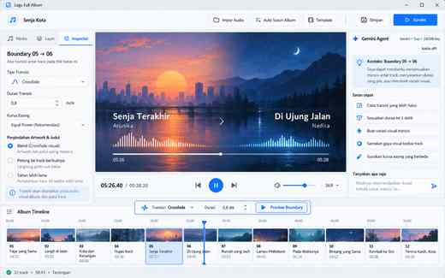

07. UI-IMG-002E - Album Editor - Gemini low-risk result
APPROVED visual reference.
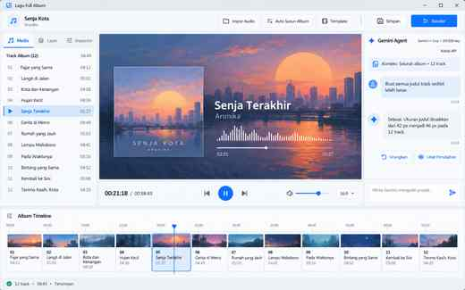

08. UI-IMG-002F - Album Editor - missing media warning
APPROVED visual reference.
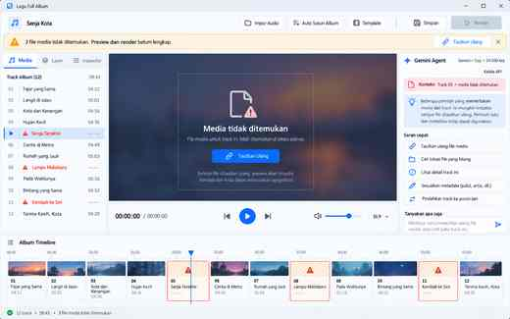

09. UI-IMG-003A - Template Browser - selected
APPROVED visual reference.
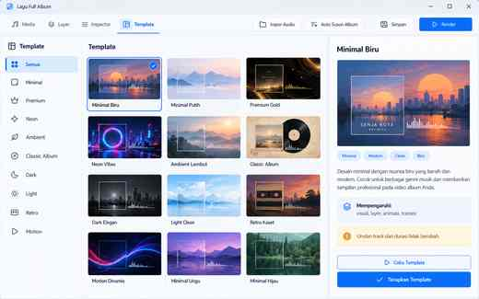

10. UI-IMG-003B - Template Browser - try/applied preview
APPROVED visual reference.
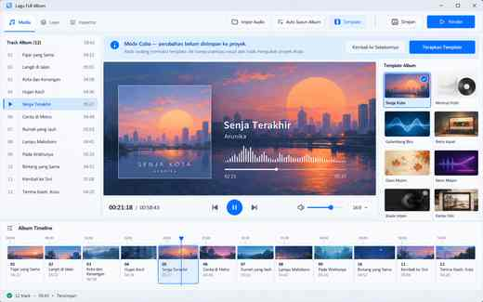

11. UI-IMG-004A - Gemini Manager - empty
APPROVED visual reference.
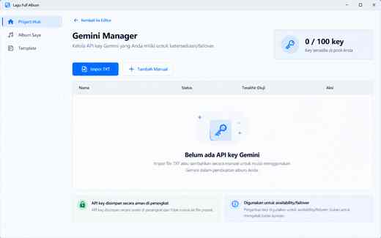

12. UI-IMG-004B - Gemini Manager - populated
APPROVED visual reference.
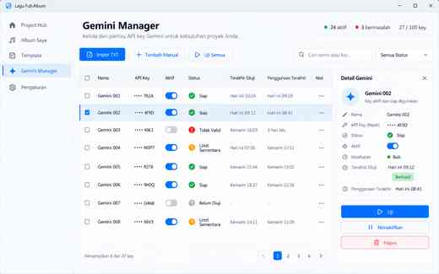

13. UI-IMG-004C - Gemini TXT Import Summary
APPROVED visual reference.
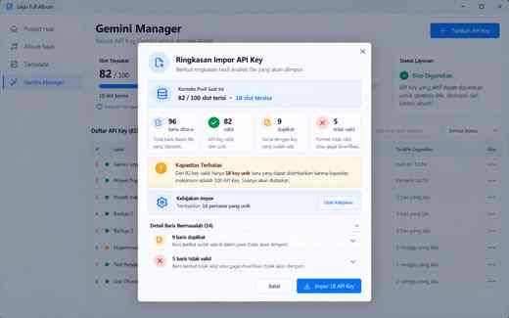

14. UI-IMG-005A - Render Center - preflight pass
APPROVED visual reference.
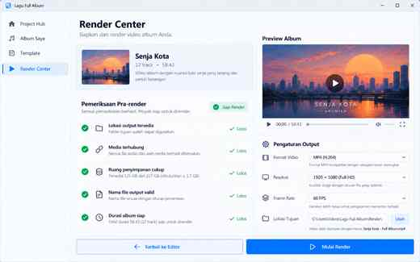

15. UI-IMG-005B - Render Center - preflight blocked
APPROVED visual reference.
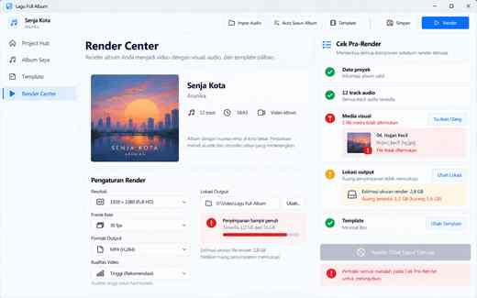

16. UI-IMG-005C - Render Center - rendering
APPROVED LAYOUT ONLY: MP3/audio-only wording is generator drift; final output is VIDEO MP4.
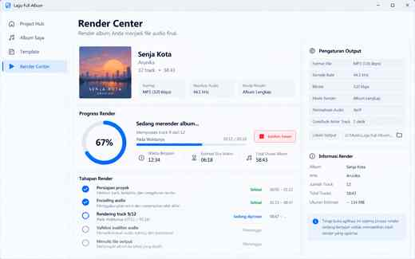

17. UI-IMG-005D - Render Center - error
APPROVED visual reference.
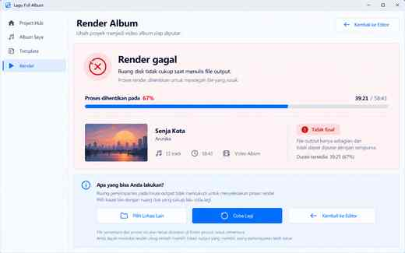

18. UI-IMG-005E - Render Center - success
APPROVED visual reference.
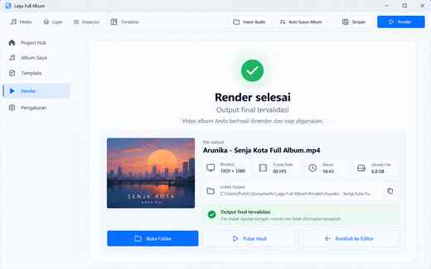

19. UI-IMG-006A - Settings - ready
APPROVED visual reference.
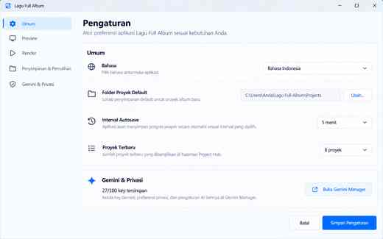

20. UI-IMG-007 - New Project
APPROVED visual reference.
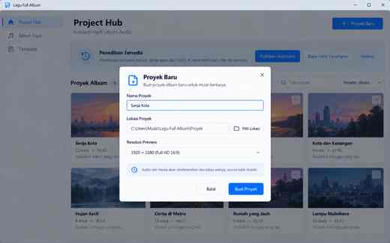

21. UI-IMG-008 - Unsaved Changes
APPROVED: Simpan & Lanjutkan / Jangan Simpan / Batal.
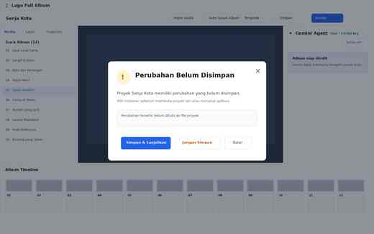

22. UI-IMG-009A - Missing Media - unresolved
APPROVED visual reference.
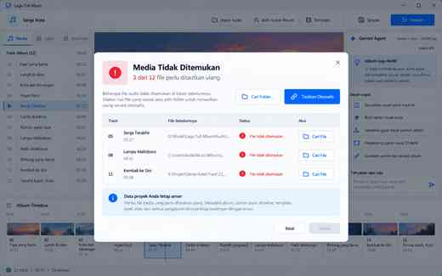

23. UI-IMG-009B - Missing Media - relink scan/partial
APPROVED visual reference.
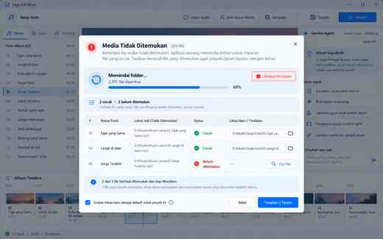

24. UI-IMG-010 - Gemini Plan Preview
APPROVED visual reference.
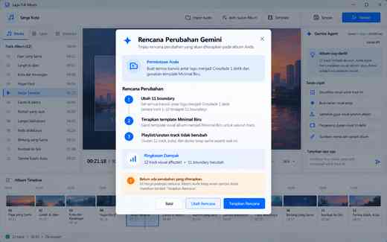

25. UI-IMG-011 - Gemini Destructive Confirmation
APPROVED visual reference.
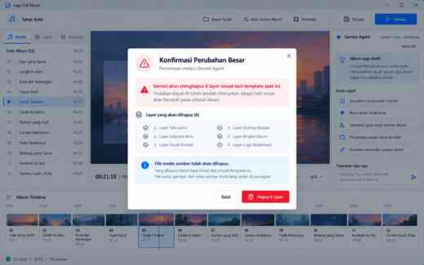

26. UI-IMG-012 - Save Template
APPROVED visual reference.
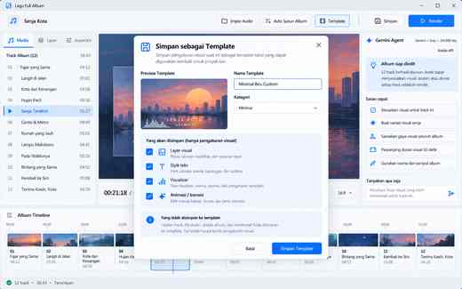

27. UI-IMG-013 - Output Collision
APPROVED visual reference.
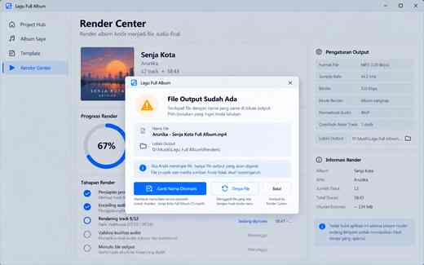

28. UI-IMG-014 - Cancel Render
APPROVED visual reference.
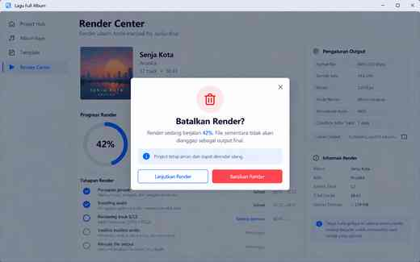

29. UI-IMG-015 - Corrupt/Incompatible Project
APPROVED visual reference.
