ALPS CL Machine Set Up Guide

- Enviroment Prepare
Windows Server 2008 R2

- Software Prepare
Office 2010 (32 bits)
Sybase 12.5.2 driver

- CL Setup File Guide
  - Install Office 2010 (32 bits)
  - Install Sybase 12.5.2 driver
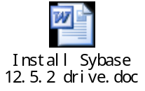
  - Setup(Copy SETUP folder into disk C of OS2008) Run as administrator

将SETUP文件夹复制到安装2008操作系统的服务器的C盘根目录下，以管理员权限进行安装。

    - Install 3rdPartSetup

3.3.1.1 Install sombrero

(C:\SETUP\3rdPartSetup\sombrero\install.exe)
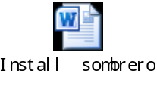
    - Install FE
      - Install Core_FE

(C:\SETUP\FE\1-ore_FE\S3CoreFE_G04.10C.00\setup.exe)
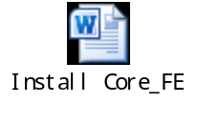
      - Install S3 Global

(C:\SETUP\FE\2-S3 Global\S3_G04.01.00\Setup.exe)
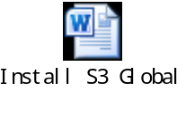
      - Install CRE S3(C:\SETUP\FE\3-CRE S3\SETUP.exe)
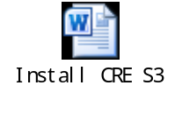
      - Install CRE TP

(C:\SETUP\FE\4-CRE TP\CRE_TP\G04.09.00\G04.09.00\SETUP.exe)
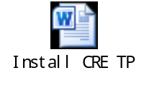
      - Install RI FE

(C:\SETUP\FE\5-RI FE\SETUP.exe)
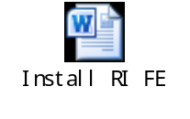
      - Install EXE
将alps.exe复制到windows server 2008对应的目录下

- Register OCX and DLL and LICENSE

4.1 Copy all the files from C:\ SETUP \OCX\
Into C:\Windows\System32 and C:\Windows\SysWOW64

4.2 Copy all the files from C:\ SETUP \DLL\
Into C:\Windows\System32 and C:\Windows\SysWOW64

4.4 Copy all the files from C:\ SETUP \LICENSE\
Into C:\Windows\System32 and C:\Windows\SysWOW64

4.5 Run C:\ SETUP \LICENSE\ VBCTRLS .REG

4.6 Run C:\ SETUP \ Reg.bat
If have any error info, please ignore it

- Setting Region and Language


- Sstoolbar (designer widgets2.0) license setting
6.1 registry Sstoolbar editor
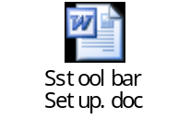

- User Accounts setting
Control Panel->All Control Panel Items->User Accounts->change user account control settings
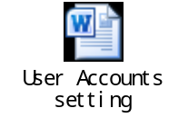

- Copy s3.ini

Copy s3.ini file to environment(OS2008): “C:\Windows\”

- Copy sql.ini
Copy sql.ini file to environment (OS2008): “C:\sybase\ini\”

- Copy sri.ini
Copy sri.ini file to environment(OS2008): “C:\Windows\”

- Setup Microsoft Visual Basic 6.0

- Restart OS 重启

