

RELEASE NOTICE
CHINA EMMA G4

Version E2.CHI.G4.131.000.00

2019/07/26

Requires: EMMA2 Ver E2.CHI.G4.125.000.00
Requires EMMA2 Current Production Database

Table of Contents

1.0 Installation Plan: 3
2.0 Synopsis of new functionality and major fixes: 3
3.0 Special Considerations: 3
4.0 EMMA Installation 3
4.1 EMMA2 Installation 3
4.2 DB Server Installation 3
4.3 Document Installation 3
5.0 Report File Installation 3
6.0 CRE Setup 4
7.0 Orbix Setup 4
8.0 Workstation Setup 4
9.0 Product Setup 4
10.0 Contact List 4
11.0 Rollback Procedure 4
Appendix A: List of PCRs or PIRs fixed in EMMA E2.CHI.G4.131.000.00 4
Item No 4
CQ # 4
Module 4
PIR/PCR Description 4
Remarks 4
Appendix B: List of the Build Components 4
Appendix C: Proc.bat 5
Appendix D: PROCS.OUT 5
Limitations and anticipated problems 5

Installation Plan:
Installation Targets: Chartis China

Installation Schedule: ASAP

Synopsis of new functionality and major fixes:

See Appendix A for synopsis of change.

Special Considerations:

  - This build should be applied to DM and VEB Production environments.

EMMA Installation

EMMA2 Installation

- Create a back-up folder, with name “Backup E2.CHI.G4.131.000.00”.
- Unzip the attached file, FRE_ E2.CHI.G4.131.000.00.zip, into a temporary folder.
- Setup EMMA with the installation guide
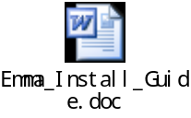

DB Server Installation

- Backup the database.
- Unzip the file DBS_E2.CHI.G4.131.000.00.zip in the destination folder.
- Execute Proc.bat. in the tsysprof folder refer to Appendix C on how to execute PROC.BAT.
a. If there exists folder “schema”
If there exists proc_WEAP.bat, execute proc_WEAP.bat at VEB Database. If there exists proc_DM.bat, execute proc_DM.bat at DM Database
b. If there exists folder “sp”, execute Proc.bat in this folder.
c. If there exists folder “reference data”, execute Proc.bat in this folder.
d. If there exists folder “transaction data”, execute Proc.bat in this folder.
e. If there exists folder “tsysprof”, execute Proc.bat in this folder.
4. Execute the sp in the sp folder in the DBArtisan environment.

Document Installation
Not Applicable

Report File Installation

Not Applicable

CRE Setup

Not Applicable

Orbix Setup

Not Applicable

Workstation Setup

Not Applicable

Product Setup

Not Applicable

Contact List

For assistance, contact:

Name | Location | Phone
Elizabeth.Huang | Mphasis, Shanghai | +(8621) 50807366 – 3823
TINA.TIAN | Mphasis, Shanghai | +(8621) 50807366 – 3013

Rollback Procedure

If there is an error caused by this build, the following rollback procedure should be followed.

- Copy all Localprt.mdb from the folder “Backup E2.CHI.G4.131.000.00” to the directory where the Localprt.mdb are residing.
- Copy all executables from the folder “Backup E2.CHI.G4.131.000.00” to the directory where all Emma executables are residing.
- Restore the backup database.
- Please take note that this procedure should only be executed when there is an error encountered during/after application of the builds.

Appendix A: List of PCRs or PIRs fixed in EMMA E2.CHI.G4.131.000.00

- China PCR

Item No | CQ # | Module | PIR/PCR Description | Remarks
1 | ITSR013622 | Others | VB upgrade to OS 2016 | Passed
2 | ITSR013528 | Others | Userall group add authority | Passed

Appendix B: List of the Build Components
This build contains the following components:

Screenshots
FRE_E2.CHI.G4.131.000.00.zip
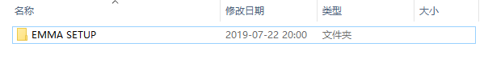

DBS_E2.CHI.G4.131.000.00.zip
schema
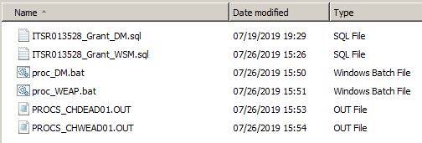

Tsysprof
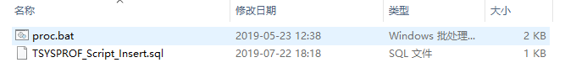

Appendix C: Proc.bat

To run the batch file follow the steps listed below:

- Open an “MS DOS Prompt” using the “Start Menu”
- On the “MS DOS” console, change your current working directory to the directory where you have previously extracted the component.
- Navigate to the component directories and run the batch file using the following command parameters:

[Batch File Name] [user name] [password] [server name] [db name]

Example to run the data script in the production Emma db:
PROC.bat SA PASSWORD CHNPSYX1 CHWEAP01

The batch file will result to an OUT file where you can verify if the components were successfully applied. The output file will be found on each subdirectory where the batch files are executed.

Appendix D: PROCS.OUT
Compare result of PROCS_SIT_XX.OUT file

Limitations and anticipated problems

None

