PLAYER GUIDE | COURSEWORK DRAFT

BallDarkEcho
  - Listen. Reveal. Survive.
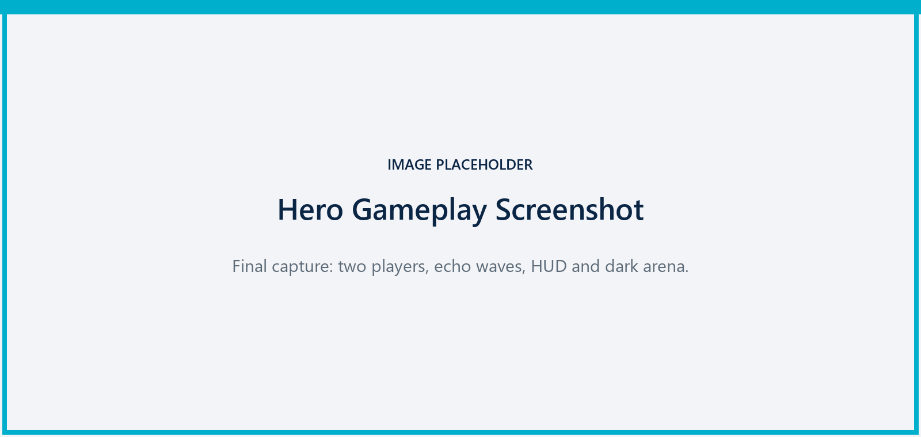
Sound is information. Sound is exposure.
Windows 64-bit | LAN multiplayer | Keyboard and mouse
Prepared by Zhu Yuhan (u5750655) | July 2026

1. Quick Start
Recommended setup Use stereo headphones. Direction, distance and action identity are gameplay information, not decorative audio.

What you are trying to do
BallDarkEcho is a LAN deathmatch played in a low-light arena. Locate opponents by reading temporary echo waves and spatial sound, then reach the kill target before the other players. The current default is 10 kills. A defeated player respawns after approximately 3 seconds while the match is active.

Start a LAN match
- Launch the final Windows package. Draft note: replace this line with the confirmed executable name and folder once packaging is complete.
- Enter a player name and continue to the multiplayer room screen.
- Host: create a LAN room, choose a map and skill, and set the maximum player count.
- Client: refresh the room list and join the host. If discovery fails, use the build's direct-address option when available.
- Non-host players select READY UP. The host can start only when the lobby is ready.
- Host selects START. All players should travel from MenuLobby to the selected battle map.
- Fight until a player reaches the target score. The HUD displays VICTORY or DEFEAT when the match ends.
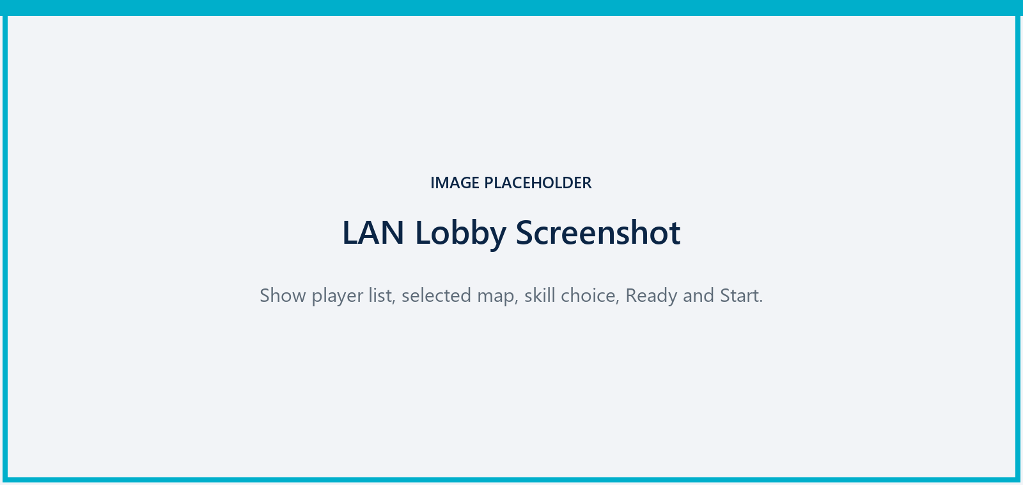
Figure 1. Replace with the final LAN lobby showing room settings and player readiness.

2. Controls
Draft verification R and Tab are bound directly in C++. The remaining gameplay keys reflect the current player Blueprint and design records and must be confirmed in the final packaged build.

Key | Action | Effect | Status
W A S D | Move | Navigate the arena. | Verify
Mouse | Look / aim | Direct the camera, weapon and targeted skill. | Verify
Space | Jump | Cross low obstacles and change vertical position. | Verify
Left Mouse | Fire | Fire the currently selected weapon mode. | Verify
Shift (hold) | Sprint | Move faster; create larger, clearer exposure waves. | Verify
Ctrl (hold) | Silent walk | Move slowly; reduce wave and audible range, but remain detectable nearby. | Verify
Q | Cycle weapon | Standard → Rapid → Snipe → Standard. | Verify
1 / 2 / 3 | Select weapon | Directly select Standard, Rapid or Snipe. | Verify
R | Use skill | Activate the skill selected in the lobby. Hold/release for Resonance Beam. | Current
Tab (hold) | Large map | Show the expanded exploration map while held. | Current

3. Reading the Echo
Every important action trades information for exposure. Visual waves reveal surfaces and action origins for a short time; audio usually carries beyond the clearest visual feedback. Do not treat the arena as permanently visible.
State | Speed | Exposure | Best use
Normal | Balanced | Medium | Default navigation. Readable without dominating combat.
Sprint | Fast | High | Easy to track. Use for escapes, pressure and fast rotations.
Silent walk | Slow | Low | Reduces range and clarity. It is risk reduction, not invisibility.

Visual language
- Cyan / blue waves: movement, scans and most impact or navigation information.
- Red waves: weapon fire and attack exposure; the centre indicates the muzzle origin.
- Temporary reveal: information fades. Re-check assumptions instead of relying on old positions.
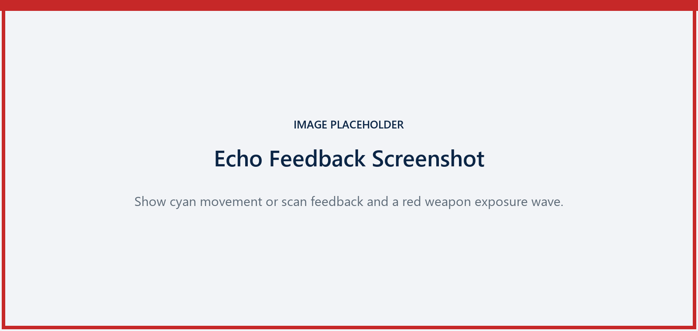
Figure 2. Replace with a clean gameplay capture that demonstrates the colour language.

4. Weapons
Weapon fire and projectile impact are separate information sources. Listen for the shot to estimate the attacker, then read the impact to understand where the projectile landed.
Mode | Profile | Exposure | Use
1 Standard | Balanced | Medium | Reliable general-purpose pressure.
2 Rapid | Fast fire; short effective range | Lower per shot | Close-range pressure and finishing.
3 Snipe | Slow; long range; high damage | Very high | Long sightlines and decisive shots.
Combat habit Change position after loud shots. The Snipe mode is powerful, but its long-range signature makes the shooter easier to locate.

5. Skills
Choose one skill in the lobby. Press R to activate it; the current C++ baseline uses a shared 12-second cooldown. Final visual and multiplayer tuning should be confirmed before release.
Skill | Player-facing purpose
Wide Echo Scan | Emits a large scan wave and temporarily reveals nearby combat targets. Useful for breaking uncertainty, but highly visible.
Noise Decoy | Places a false sound source toward the aimed location. Use it to redirect attention or create hesitation.
Resonance Beam | Hold R to maintain a long-range beam-style attack; release R to stop it. Strong pressure also creates strong exposure.
Stealth Run | Temporarily suppresses movement echo and increases movement speed. It reduces exposure but does not remove every combat cue.

6. HUD and Match Flow
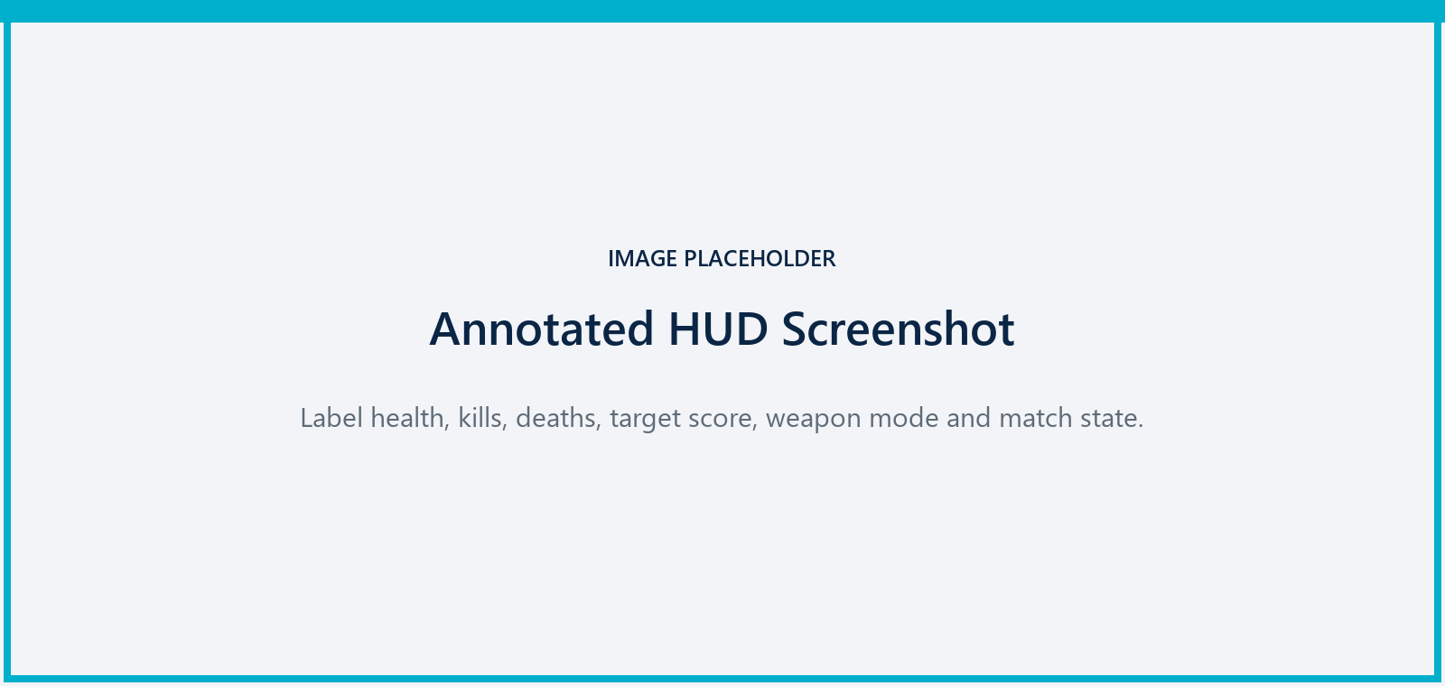
Figure 3. Replace with the final HUD and label each visible element.
- Health: current and maximum HP. Reaching zero triggers death and respawn when the match is still active.
- Score: K is kills, D is deaths, and Target is the number of kills required to win.
- Weapon: displays 1 Standard, 2 Rapid or 3 Snipe.
- State: displays RESPAWNING, VICTORY or DEFEAT when applicable.
- Large map: hold Tab to inspect accumulated exploration information.

After death
The defeated pawn is hidden and collision is disabled. The player respawns after the configured delay unless the match has already ended. Re-orient immediately: the battlefield may have changed while the player was inactive.

7. Spatial Audio
Headphone check Before recording or playtesting, confirm that the operating system and capture software are receiving stereo game audio.

BallDarkEcho uses Wwise 2025.1.8 for gameplay event routing and spatial playback. The current Main_Gameplay bank includes normal, sprint and silent movement; Standard, Rapid and Snipe fire; projectile impact; scan; decoy; player hit; and death. These cues should help distinguish action type, direction and distance.
- Direct sound should be clearer than sound heard behind a wall.
- Sprint should be easier to locate than normal movement.
- Silent walk should remain audible at close range.
- Weapon fire and impact should sound different so that shooter and hit locations are not confused.
- The DM_EchoAtrium prototype includes a restrained central-atrium reverb treatment; it is not a complete Rooms/Portals implementation.
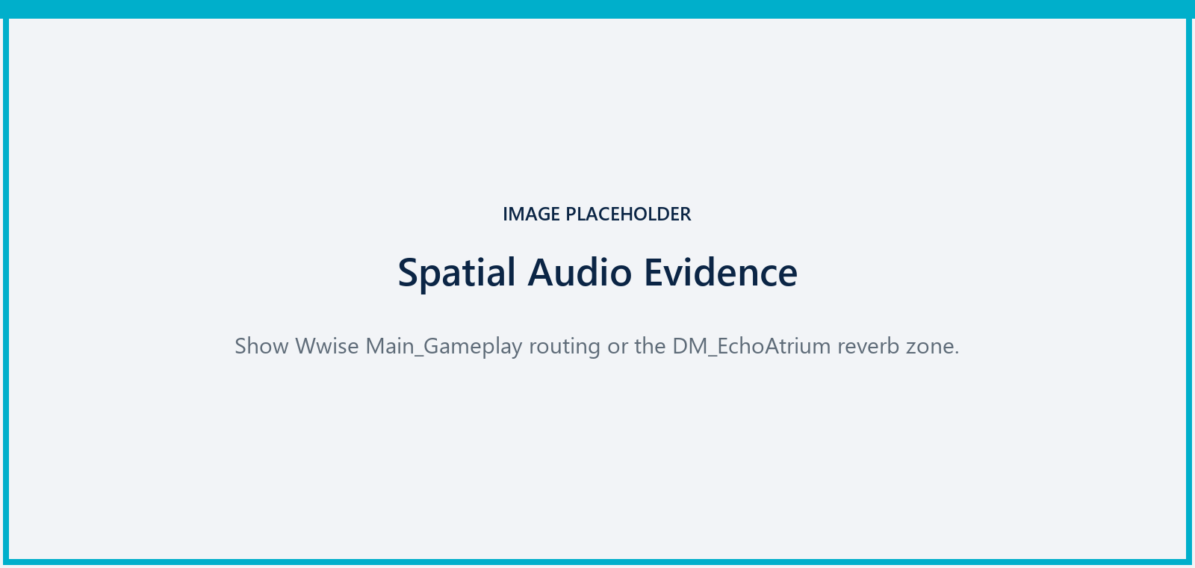
Figure 4. Replace with final spatial-audio authoring evidence.

8. Troubleshooting
Problem | Suggested action
No LAN room appears | Confirm both computers are on the same network, allow the game through Windows Firewall, refresh again, then use direct address if the final build exposes it.
Host cannot start | Every non-host player must be ready. Only the host can change the map, maximum players and match start.
No game audio | Check the Windows output device, application volume and stereo capture route. Restart the final package if the SoundBank failed to initialise.
Travel returns to menu | Record the selected map and package version. This may indicate that the battle map was not included in the Cook.
Skill does not activate | Wait for the cooldown, confirm the player is alive, and verify that the selected skill is displayed in the lobby before starting.
Performance instability | Use DM_Tian as the stable validation map. Reduce graphics or disable hardware ray tracing in the final settings if DM_EchoAtrium is unstable.

9. Draft Limitations and Credits
Remove or update before submission Confirm every control in the packaged build; add the executable name; replace all image placeholders; verify scan replication, exact-once Wwise playback and Cooked map travel; then remove all Draft labels.

Current scope boundaries
- The final Win64 packaged build and clean-machine LAN test are still pending.
- Charged scan, pickup/Buff systems and full Spatial Audio Rooms/Portals are not documented as completed features.
- DM_EchoAtrium requires a fresh two-client stability test after the latest reverb change.
- The settings sliders are interface placeholders until their Wwise bus connection is verified.

Credits and technical information
Item | Detail
Developer | Zhu Yuhan (u5750655)
Engine | Unreal Engine 5.7
Audio middleware | Audiokinetic Wwise 2025.1.8
Target | Windows 64-bit; LAN multiplayer
Source | https://github.com/inovamenz-code/DarkEcho
Asset licensing | Final release must include the completed AudioSource/_licenses/sources.md record and external visual-asset credits.

Author completion checklist
- Replace four screenshots and check every caption.
- Verify controls on the final Win64 package.
- Add final package name, version and minimum system requirements.
- Complete credits and audio licences.
- Run two-client packaged LAN and Wwise exact-once tests.
- Remove yellow draft callouts before submission.

