**Clean View**

Clean View reduces noise and interference, while enhancing colour and contrast for the crystal clear view. Enjoy everything with refined image quality.

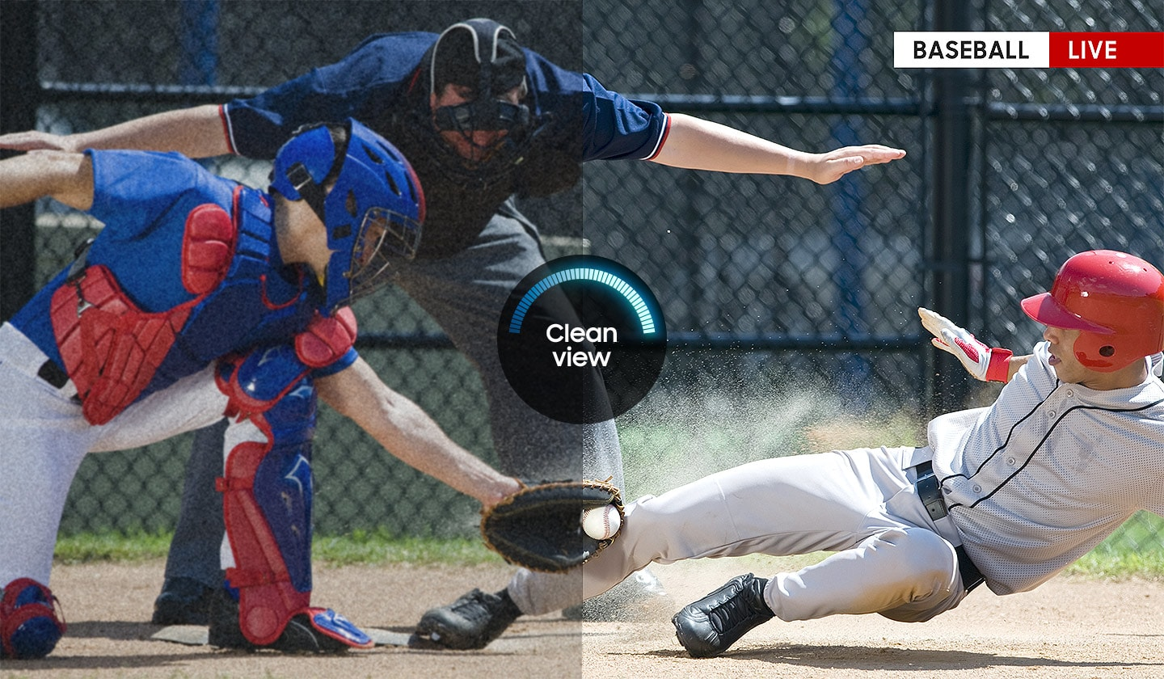

**Wide Colour Enhancer**

Bright, rich colours await. Wide Colour Enhancer improves your image quality and uncovers details with colours as they were meant to be seen.

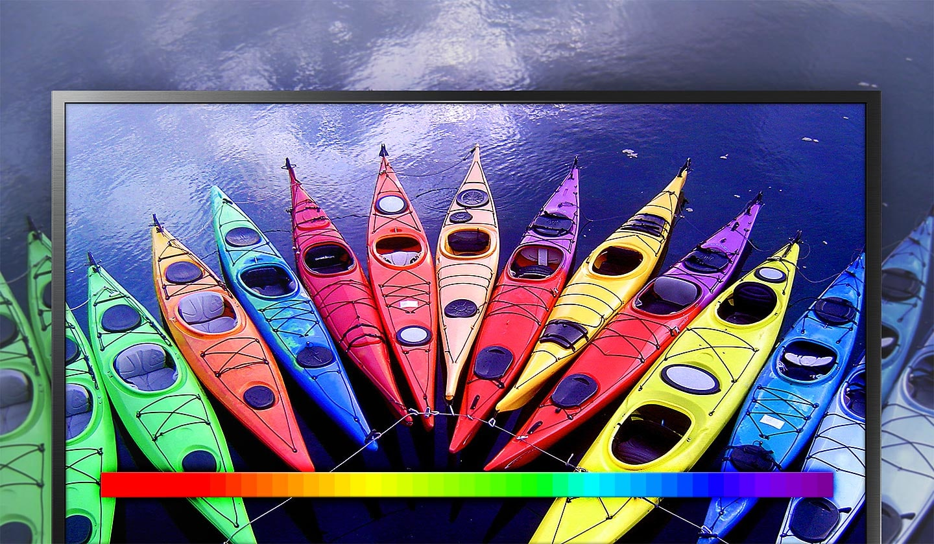

**HD picture quality**

Enjoy HD TV in Digital era. Once you see high definition of TV with vivid and crisp details, you’ll never look back to standard definition or analog TVs.

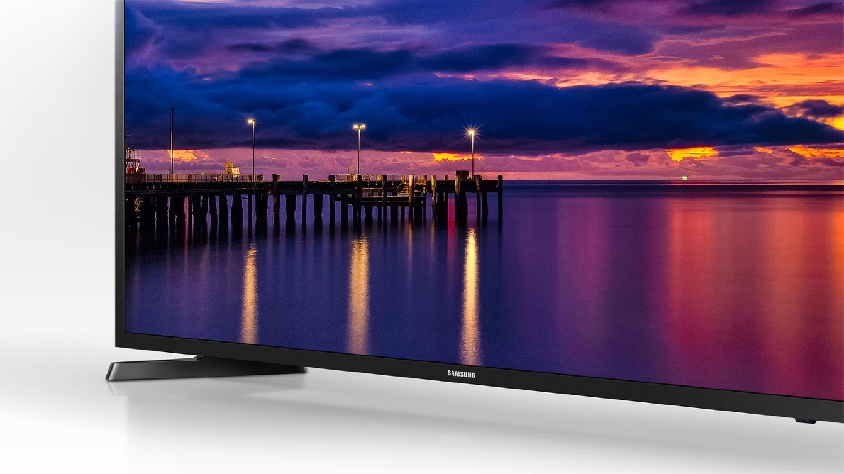

* Pixel representations on TV screen are simulated scene to help consumers understand.

**Connect share movie**

Plug your favourite entertainment and media into your TV – watch videos, play music, or view photos through a USB connection.

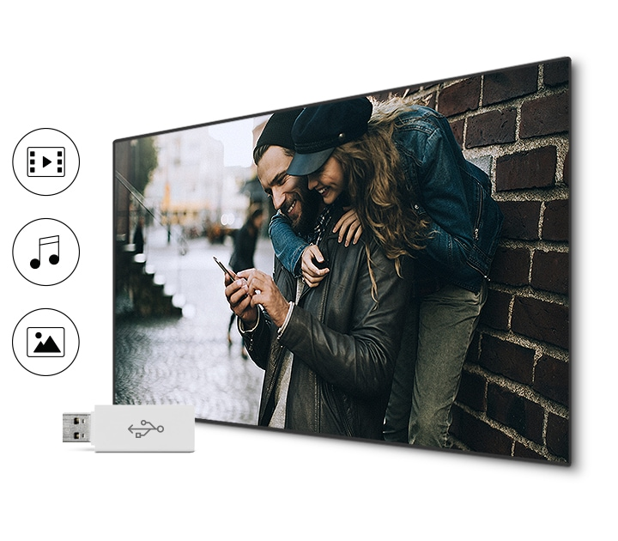

* **SPECIFICATION**
* **Display**
  + **Screen Size** 32"
  + **Resolution** 1,366 x 768
  + **Moth Eye** N/A
  + **Screen Curvature** N/A
* **Video**
  + **Picture Engine** Hyper Real
  + **Motion Rate** 60
  + **PQI (Picture Quality Index)** 200
  + **HDR (High Dynamic Range)** N/A
  + **HDR 10+**N/A
  + **HLG (Hybrid Log Gamma)** N/A
  + **Contrast** Mega Contrast
  + **Color** Wide Color Enhancer
  + **Viewing Angle** N/A
  + **Micro Dimming** N/A
  + **Auto Depth Enhancer** N/A
  + **Contrast Enhancer** N/A
  + **Auto Motion Plus** N/A
  + **Film Mode** Yes
  + **Natural Mode Support** N/A
* **Audio**
  + **Dolby Digital Plus** Yes
  + **DTS Codec** N/A
  + **Sound Output (RMS)** 10W
  + **Speaker Type** 2CH
  + **Woofer** N/A
  + **Multiroom Link** N/A
  + **Blutooth Audio** N/A
  + **Smart Service**
  + **Voice Interaction** N/A
  + **Samsung SMART TV** N/A
  + **TV Plus** N/A
  + **Web Browser** N/A
  + **SmartThings App Support** N/A
  + **SmartThings** N/A
  + **Universal Guide** N/A
* **Convergence**
  + **TV to Mobile – Mirroring** N/A
  + **Mobile to TV - Mirroring, DLNA** N/A
  + **360 Video Player** N/A
  + **360 Camera Support** N/A
  + **Bluetooth Low Energy** N/A
  + **WiFi Direct** N/A
  + **TV Sound to Mobile** N/A
  + **Sound Mirroring** N/A
* **Differentiation**
  + **S-Share**N/A
  + **Dongle Compatibility (3G / LTE / WiFi)** N/A
  + **Analog Clean View** N/A
  + **Senior Mode** N/A
  + **Triple Protection** N/A
  + **Image Booster** Yes
  + **Family TV 2.0** N/A
  + **Local Cinema Mode** N/A
* **Tuner/Broadcasting**
  + **Digital Broadcasting** DVB-T2
  + **Analog Tuner** Yes
  + **2 Tuner** N/A
  + **CI (Common Interface** N/A
  + **Data Broadcasting** N/A
  + **TV Key Support** N/A
* **Konektivitas**
  + **HDMI** 2
  + **USB** 1
  + **Component In (Y/Pb/Pr)** 1
  + **Composite In (AV)** 1
  + **Ethernet (LAN)** N/A
  + **Audio Out (Mini Jack** N/A
  + **Digital Audio Out (Optical** 1
  + **RF In (Terrestrial / Cable input)** 1/0/0
  + **Ex-Link ( RS-232C )** N/A
  + **CI Slot** N/A
  + **HDMI A / Return Ch. Support** N/A
  + **HDMI Quick Switch** N/A
  + **Wireless LAN Adapter Support** N/A
  + **Wireless LAN Built-in** N/A
  + **Anynet+ (HDMI-CEC)** N/A
* **Design**
  + **Design** Mold
  + **Bezel Type** VNB
  + **Slim Type** Semi Slim
  + **Front Color** Glossy Black
  + **Light Effect (Deco)** N/A
  + **Stand Type** Mini Arc
  + **Swivel (Left/Right** N/A
* **Additional Feature**
  + **Décor Mode** N/A
  + **Motion Detection (Frame)** N/A
  + **Ambience** N/A
  + **Prosesor** N/A
  + **Accessibility** N/A
  + **Digital Clean View** Yes
  + **Auto Channel Search** Yes
  + **Auto Power Off** Yes
  + **Caption (Subtitle)** Yes
  + **Connect Share™ (HDD** N/A
  + **ConnectShare™ (USB 2.0)** Yes
  + **EPG** Yes
  + **Extended PVR** N/A
  + **Game Mode** Yes (Basic)
  + **OSD Language** Local
  + **Picture-In-Picture** N/A
  + **BT HID Built-in** N/A
  + **USB HID Support** N/A
  + **Teletext (TTX)** Yes
  + **Time Shift** N/A
  + **V-Chip** N/A
  + **IPv6 Support** N/A
  + **MBR Support** N/A
  + **Ultra Clean View** N/A
* **Eco Feature**
  + **Eco Sensor** N/A
  + **Energy Efficiency Class** N/A
* **Power**
  + **Power Supply** AC100-240V 50/60Hz
  + **Power Consumption (Max)** 48 W
  + **Power Consumption (Stand-by)** N/A W
  + **Power Consumption (Energy Saving Mode)** N/A W
  + **Power Consumption (Typical)** N/A W
  + **Peak Luminance Ratio** N/A %
  + **Yearly Power Consumption (EU standard)** N/A kWh
* **Dimension**
  + **Package Size (WxHxD)** 806.0 x 141.0 x 531.0 mm
  + **Set Size with Stand (WxHxD)** 732.9 x 462.8 x 163.7 mm
  + **Set Size without Stand (WxHxD)** 732.9 x 440.3 x 78.5 mm
* **Weight**
  + **Package Weight** 5.8 ±0.5 kg
  + **Set Weight with Stand** 4.3±0.3 kg
  + **Set Weight without Stand** 4.2±0.3 kg
* **Accessory**
  + **Voice Agent Support** N/A
  + **Remote Controller Mode l**TM1240A
  + **Batteries (for Remote Control)** Yes
  + **Samsung Smart Control (Included)** N/A
  + **No Gap Wall-mount** N/A
  + **Optional Stand Support** N/A
  + **Mini Wall Mount Support** N/A
  + **Vesa Wall Mount Support** Yes
  + **TV Key Dongle (Included)** N/A
  + **User Manual**Yes
  + **E-Manual**N/A
  + **ANT-Cable**N/A
  + **Power Cable**Yes
  + **Slim Gender Cable**N/A