Imani Palmer - ipalmer2

Tom Chen -ychen360

**CS 438 - MP4 - Report**

By default, assume the following parameters: N=25, L=20, R=8 16 32 64 128, M=6, T=50,000. Now, plot graphs for the following scenarios where certain parameters are varying.

1. **Plot how channel utilization (in percentage) varies with increasing number of nodes (i.e., N varying from 5 to 100). Channel utilization is defined as the ratio of clock ticks that were used up for correct communication to the total number of clock ticks, T.**

As the number of nodes increases the channel utilization decreases, this happens because as there are more nodes with higher chances of collision.

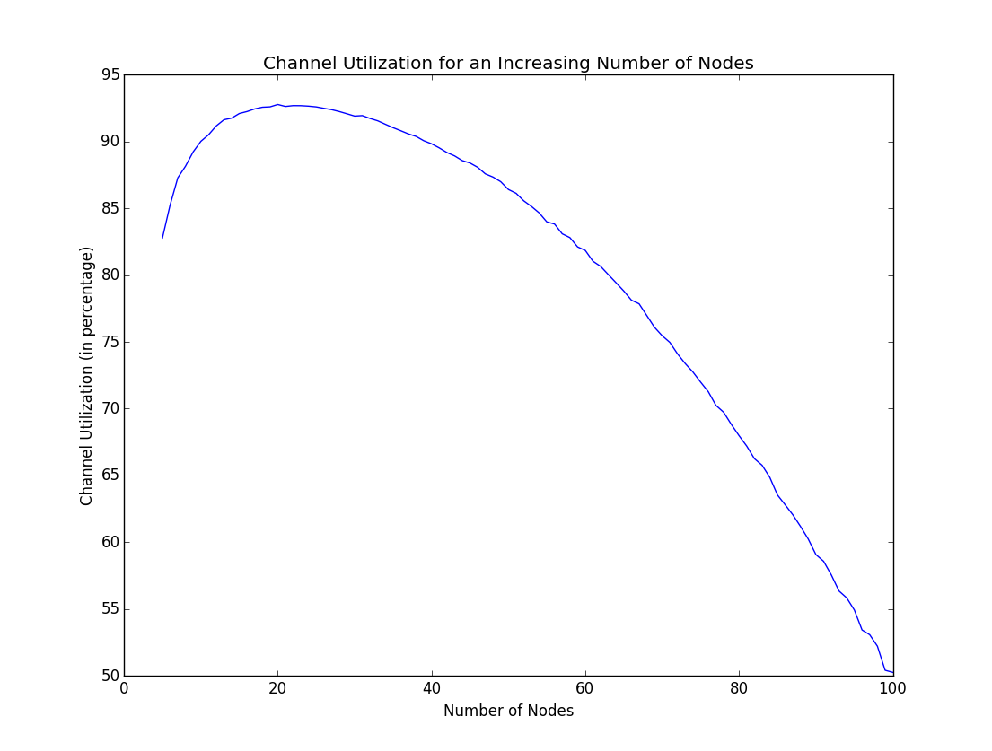

1. **Plot how the channel idle fraction (in percentage) varies with increasing number of nodes (i.e., N varying from 5 to 100). Channel idle fraction is defined as the ratio of unused clock ticks to the total number of clock ticks, T. Note that unused clock ticks do not include collisions.**

The channel is idle for smaller amount of time as we increase the number of nodes, because there is a greater chance of transmission when there are more nodes.

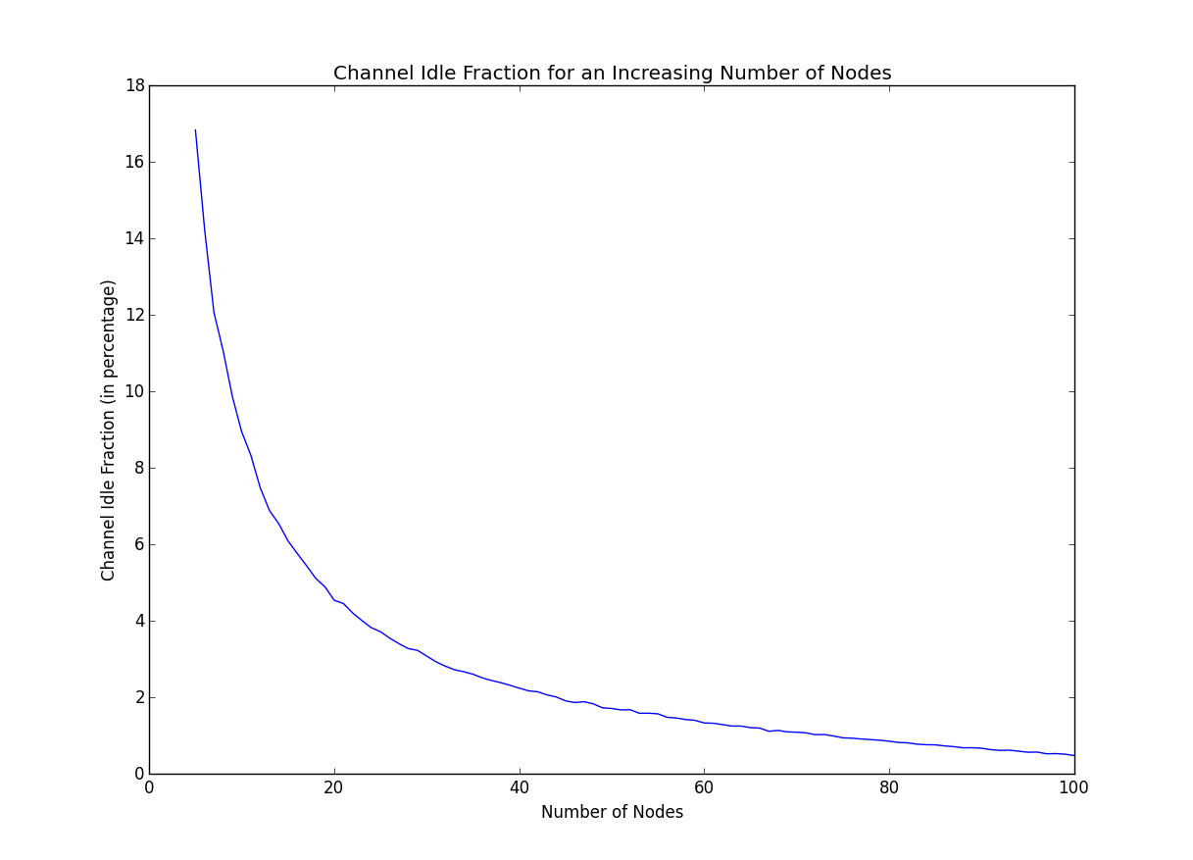

1. **Plot the total number of collisions with increasing number of nodes (i.e., N varying from 5 to 100).**

As the number of nodes increase the chance of collision also increases, this happens because as there are more nodes there are higher chances of collision among nodes.

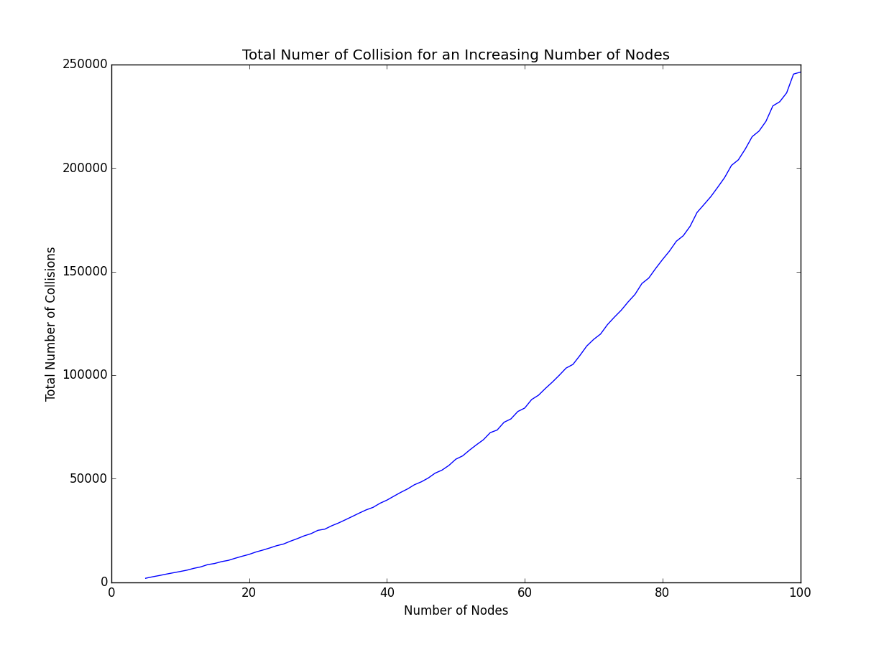

1. **Repeat part (a) but plot 5 curves on the same graph, each curve corresponding to different initial values of R: 1, 2, 4, 8 16. For each of the 5 cases, let R double upon collisions.**

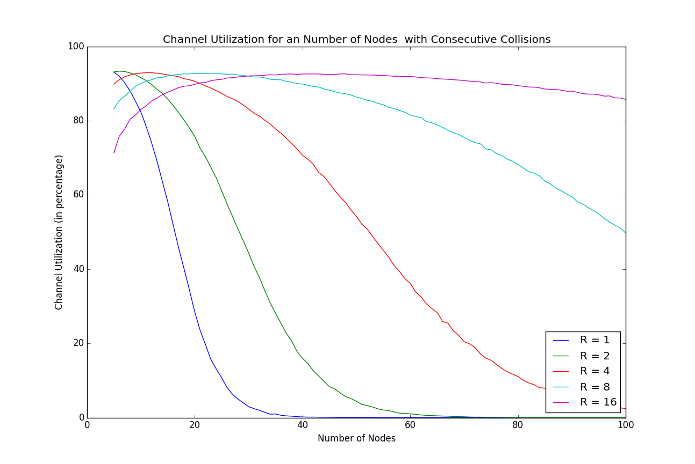

1. **Repeat part (a) but plot 5 curves on the same graph, each curve corresponding to different packet lengths L: 20, 40, 60, 80, 100.**

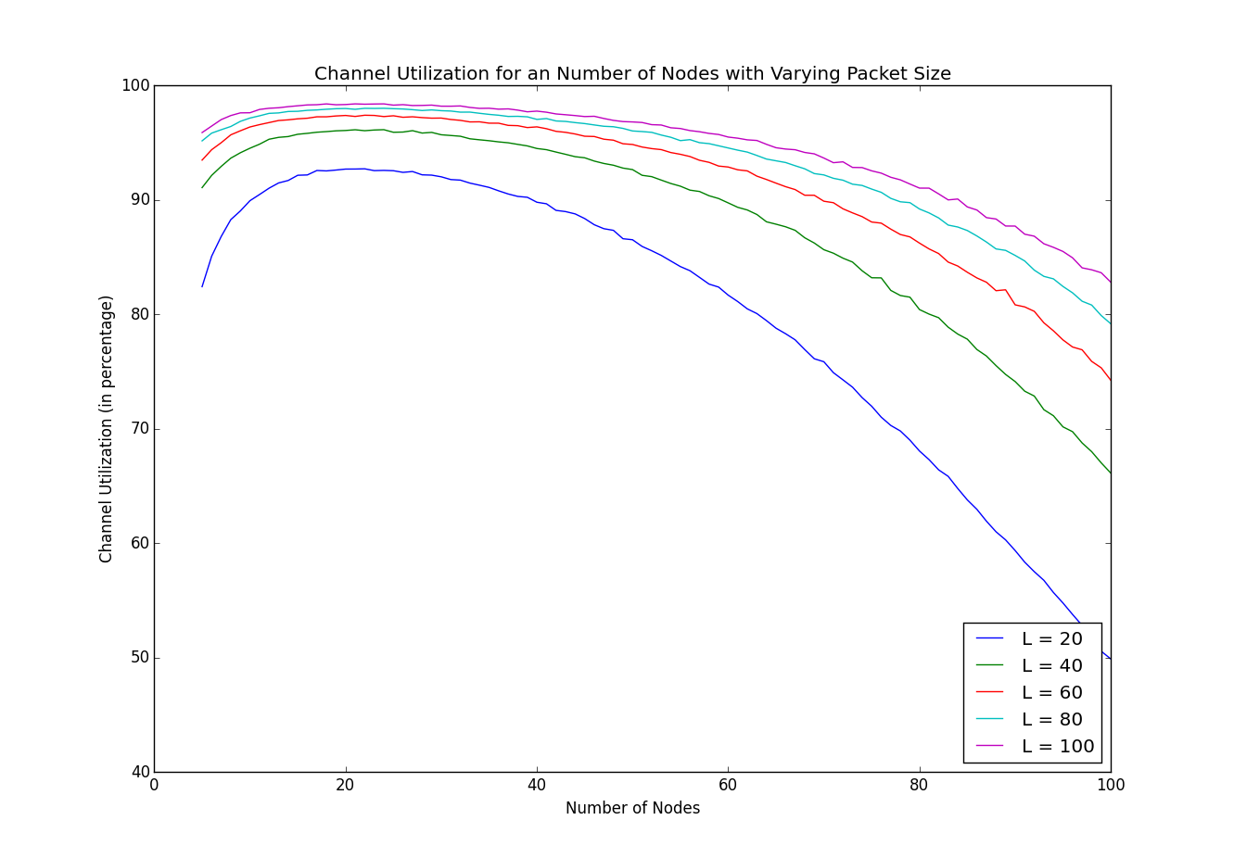

1. **Explain the shape of the curves in (d) and (e) by elaborating on how/why increasing value of N, R, and L impact channel utilization.**

An increase the number of nodes (N) that are using a specific channel then the utilization will decrease because there is a higher chance of collision among nodes. An decrease in the chance of collision (R) increases the over utilization because it allows for the channel to be in constant use and not concerned with the troubles of collision. An increase in packet size (L) also increases the channel utilization because the channel is able to be sensed by other nodes and not cause a collision by trying to send a packet. Also the larger the packet the longer the channel is in use.