**Project Evidence**

|  |  |
| --- | --- |
| **Learner Name** | Anton Watson |
| **Course Date** |  |
| **Trainer** | Craig Thompson |

**Day 1**

I decided that for my web form project I wanted to make a sign up form for a fictional online game. The user would fill in their account details like name and email address, and then have the chance to fill in details of the character they will play as in the game. I wanted to include as many different input types as possible so I tried to think of ways to include the lesser used inputs such as the colour picker and the drop down menu.

I started off by working through the process of what I wanted to include in the final project on paper. From that list I made up a basic outline in pseudocode that I could work from. I used a previous form project to add comments and then removed the previous code so that I could start fresh.

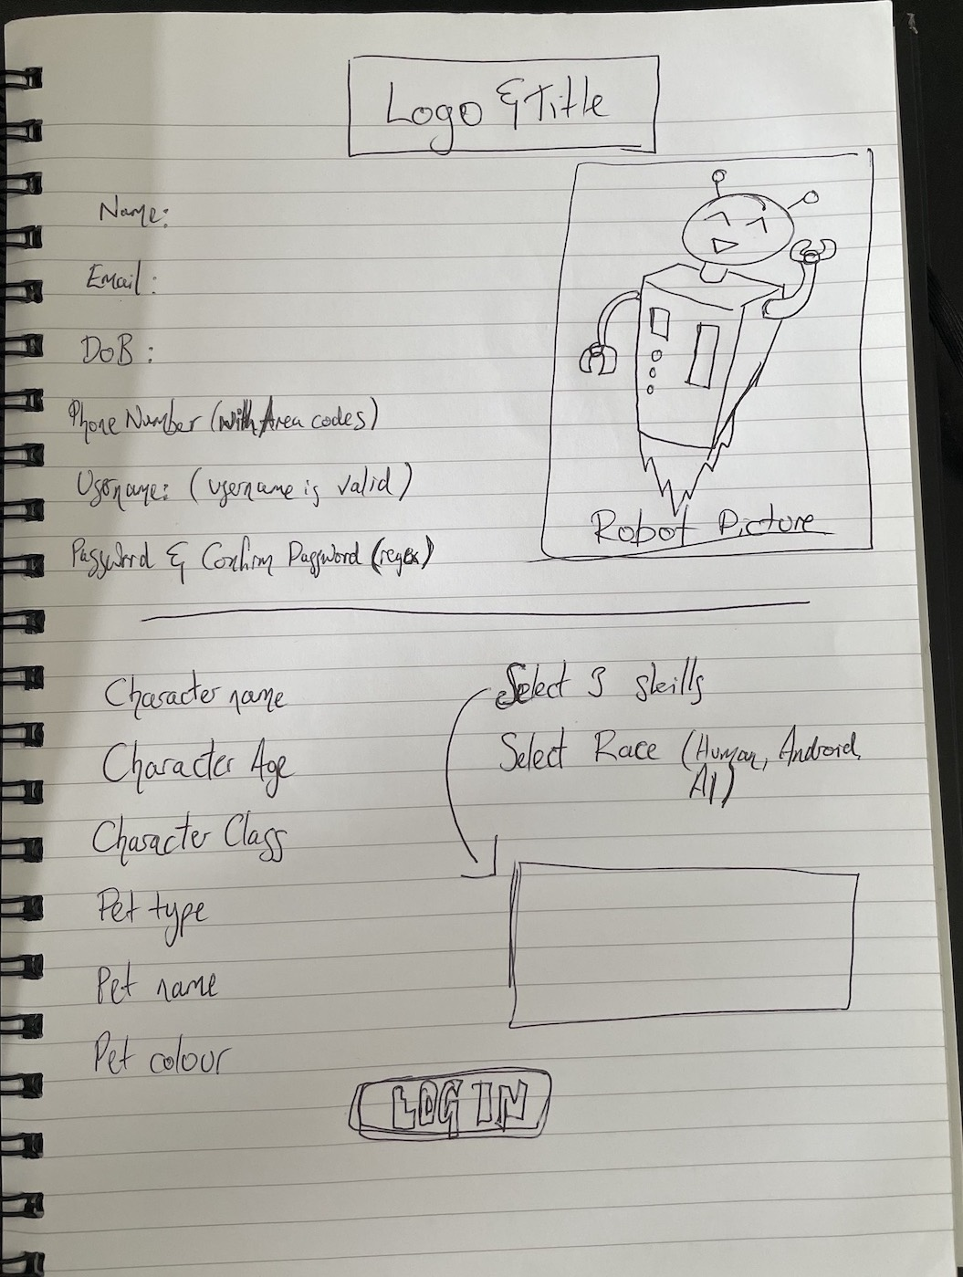

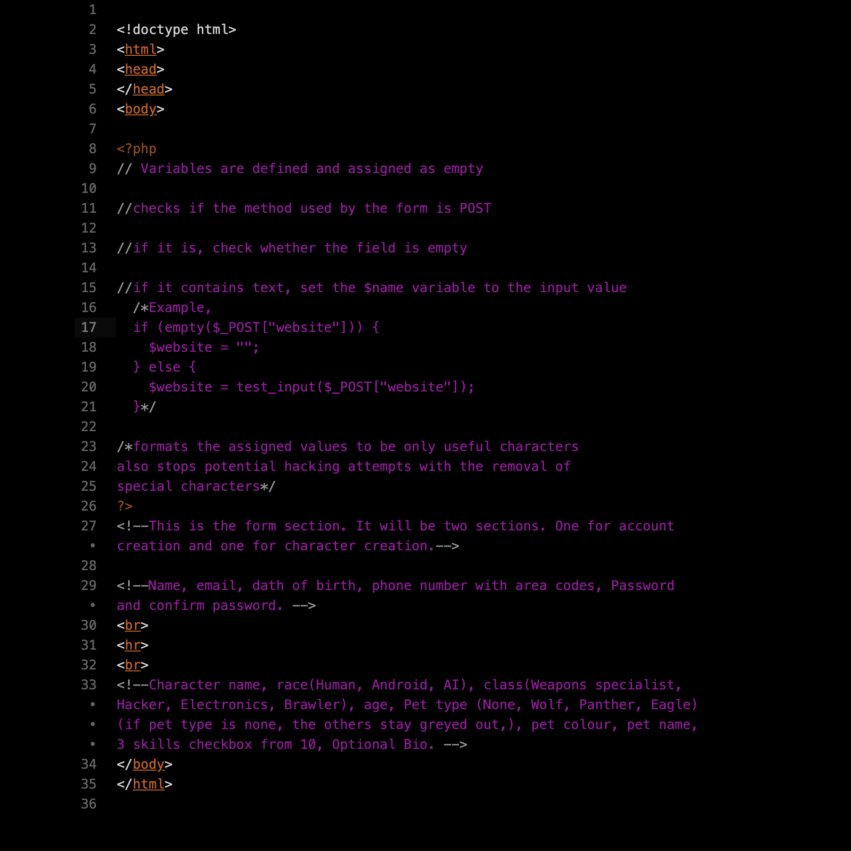

**Day 2**

**Day 3**

**Day 4**

**Day 5**