# QV 10/11 System Monitor v4 Overview/Instructions

## What’s New:

* **Changed naming convention of Windows logs** (csv files) to include an underscore (_), so be sure to read the new instructions
* Easier setup
* Added tracing
* Added button in Setup tab for Win Server 2008 defaults
* Performance log visibility in Log Analyzer tab
* Machine Names and System Architecture self-populate
* Added new chart “Concurrent Sessions” to Trends tab
* Added IIS HTTP Error logging
* See what users have selected in the Audit tab and also the Log Analyzer tab (hover over msg)
* Please see load script for more changes/change log

## Requirements:

* **You must have QVS Events logs**. Tell the app to point to them via the QVS Log Folder input on the Setup tab.
* **If you do not have 2 underscores in your QVS logfile names, you will need to add the second one manually**. *Example:* ***“Events_Testlog”*** *would need to be changed to* ***“Events_Testlog_Modified”*** *or similar. If you do not do this, do not expect the information to populate properly in the application.*
* IIS logs are found in the default location. If adding load balanced nodes, point the application to the corresponding file paths. If using a non-default format, you could run into problems and might need to tweak the script.
* **For OS Event Logs**:
  + You MUST have an Application log (if not, you have to change the script logic yourself)
  + Naming convention for the .csv files QlikView will use is as follows (**changed for v4 so take note of the new underscore!**):
    1. <”App”>**_**<ClusterNode1>.csv (ex: App_Pub009.csv)
    2. <”App”>**_**<IISNode2>.csv (ex: App_WS002.csv)
    3. <”Sys”>**_**<ClusterNode2>.csv (ex: Sys_QVS002.csv)
    4. <”Sec”>**_**<ClusterNode4>.csv (ex: Sec_QVS005.csv)
  + Windows OS Event Logs MUST be in .csv format by default. QlikView will look for the following fields by default, in exactly this order:

Level

Date and Time (in MM-DD-YYYY HH:MM:SS format)

Source

Event ID

Task

Category

Message

* + In order to achieve this OS Event log format, do the following for all types (App/Sys/Sec):
    1. Open your events in Windows Event Viewer
    2. On the left side under Windows Logs, right click and “Save All Events As” on your desired log type:

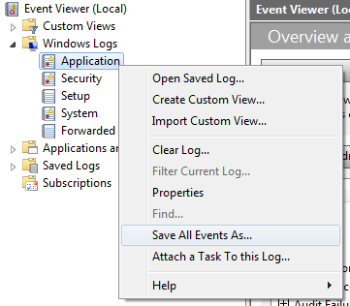

* + 1. Save as .csv file type to your desired location.
    2. Open the .csv in Excel.
    3. Run the macro in the ExeclMacroCodeForOSLogConversion.txt file, from ExcelVBA. It will do all the hard work for you.
    4. Save the .csv file as either **App_**<MachineName>.csv , **Sys_**<MachineName>.csv , or **Sec_**<MachineName>.csv to your OS Events Log Path directory (or Sys<MachineName>). Example: *Sys_Pub009.csv*
    5. System Monitor will now be able to pick it up. Repeat process for additional logs/nodes. Remember the naming convention!