DiadES survey on diadromous fish

Lambert et al.

2021-11-30

# Data upload

## Survey responses

## Additional data from fishbase

# Population growth rate

## Fecundity

| latin_name | FecundityMean | FecunditySe | n |
| --- | --- | --- | --- |
| Alosa alosa | 312,500 | 12,500 | 2 |
| Alosa fallax | 137,500 | 7,217 | 3 |
| Lampetra fluviatilis | 20,865 | 1,506 | 10 |
| Petromyzon marinus | 190,889 | 28,674 | 8 |
| Salmo salar | 9,606 | 1,064 | 10 |
| Salmo trutta | 2,713 | 1,227 | 9 |
| Acipenser sturio | 1,375,000 | 225,000 | 2 |
| Osmerus eperlanus | 26,938 | 1,316 | 4 |
| Anguilla anguilla | 2,500,000 |  | 1 |
| Chelon ramada | 442,668 | 164,093 | 4 |
| Platichthys flesus | 1,179,292 | 121,929 | 7 |

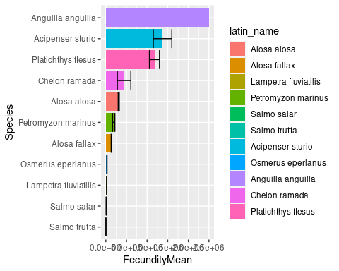

## Survival from egg to adult

| latin_name | survivalMean | survivalDown | SurvivalUp |
| --- | --- | --- | --- |
| Alosa alosa | 3.2e-05 | 1.8e-05 | 5.4e-05 |
| Alosa fallax | 4.2e-05 | 2.1e-05 | 8.1e-05 |
| Lampetra fluviatilis | 1.0e-04 | 5.9e-05 | 1.7e-04 |
| Petromyzon marinus | 1.5e-04 | 8.9e-05 | 2.6e-04 |
| Salmo salar | 3.8e-04 | 2.6e-04 | 5.6e-04 |
| Salmo trutta | 4.8e-04 | 3.1e-04 | 7.6e-04 |
| Acipenser sturio | 4.4e-06 | 1.9e-06 | 1.0e-05 |
| Osmerus eperlanus | 7.9e-04 | 3.7e-04 | 1.7e-03 |
| Anguilla anguilla | 1.7e-06 | 8.8e-07 | 3.3e-06 |
| Chelon ramada | 1.9e-05 | 7.4e-06 | 5.1e-05 |
| Platichthys flesus | 6.8e-05 | 4.3e-05 | 1.1e-04 |

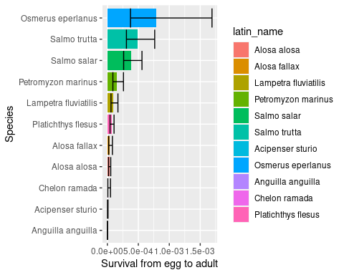

The comparison with mortalities calculated as the inverse of the fecundity (population at equilibrium, population growth rate = 1) shows optimistic values from the survey.

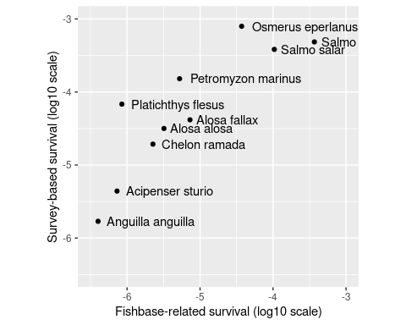

## Population growth rate

population growth rate, without taking into account anthropogenic mortality

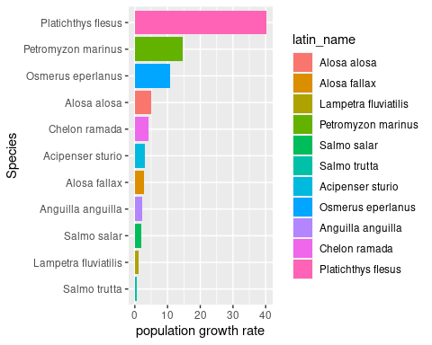

| latin_name | SurvivalMean | FecundityMean | r |
| --- | --- | --- | --- |
| Alosa alosa | 3.2e-05 | 3.1e+05 | 4.94 |
| Alosa fallax | 4.2e-05 | 1.4e+05 | 2.86 |
| Lampetra fluviatilis | 1.0e-04 | 2.1e+04 | 1.04 |
| Petromyzon marinus | 1.5e-04 | 1.9e+05 | 14.51 |
| Salmo salar | 3.8e-04 | 9.6e+03 | 1.84 |
| Salmo trutta | 4.8e-04 | 2.7e+03 | 0.66 |
| Acipenser sturio | 4.4e-06 | 1.4e+06 | 3.02 |
| Osmerus eperlanus | 7.9e-04 | 2.7e+04 | 10.70 |
| Anguilla anguilla | 1.7e-06 | 2.5e+06 | 2.12 |
| Chelon ramada | 1.9e-05 | 4.4e+05 | 4.27 |
| Platichthys flesus | 6.8e-05 | 1.2e+06 | 40.17 |

There is a possibility to rescale the *r* parameter between 1.2 and 2 after a log transformation… if you are enough naive to consider this calculation as relevant.

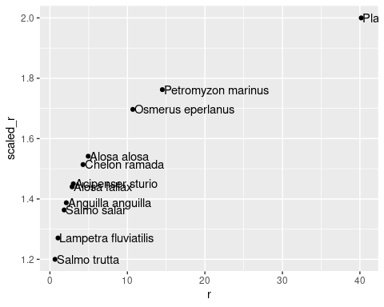

## Review of population growth rate

A population growth rate (*r*) of= 1 corresponds to a population at equilibrium (no changes in abundance). In pristine conditions (no anthropogenic mortalities), such a figure applied to all catchments, is the minimum value to avoid species extinction. In HyDiaD, a little higher value should be considered to compensate the strayers’ mortality. A population growth rate of 2 leads to a population doubling in 1 year, which is likely the upper limit for the *r* parameter.

Jaric et al. (2015) used a population growth rate of 1.1 for European sturgeon. The figure is based on the mean value of reported instantaneous population growth rates for other sturgeons species (ranging from 0.05 to 0.15) (Jaric and Guessner, 2013). For shads Jaric et al (2015) used a range for r between 1.17 and 1.65 based on the reported population doubling time in fishbase.

k =1.49 for *Osmerus mordax* in Jensen 1984.

# Dispersion

## Straying rate

Question: For a group of juveniles leaving a catchment in a given year, what is the approximate proportion of emigrant fish (in %)? In other words, what percentage of fish will not return to spawn in their origin catchment?

$γ$ in Barber et al.

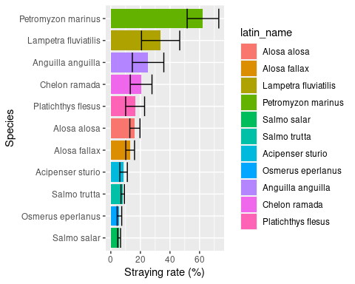

There is an alternative to calibrate the proportion of strayers so that apparent strayers equals value from the survey.

## Strayer survival

Question: Approximately what proportion (in %) of emigrants survive their journey to a new destination catchment (either freshwater catchment or marine habitat connected to catchment)?

Mdisp in Barber et al.

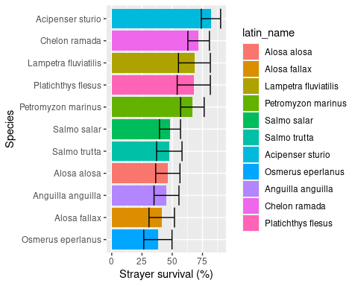

## Distance of straying

We are interested in the distance that emigrants are likely to disperse between an origin catchment and a new destination catchment. For all species except eels, consider the destination catchment as a new freshwater spawning habitat for anadromous species and a new marine spawning habitat in close proximity to a catchment for catadromous species.

### mean distance

Question For all species except eels, what is the **mean distance** in km an emigrant is likely to disperse between its origin catchment and a new destination catchment? In other words, by what distance have approximately 50% of emigrants stopped dispersing?

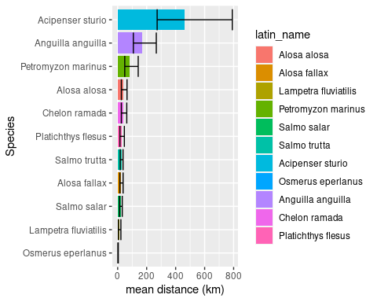

### maximal distance

For all species except eels, imagine there is a group of emigrants dispersing between an origin catchment and a set of new destination catchments. By what distance (in km) have the majority of emigrants found a destination catchment? We are not asking for the furthest distance that an individual of the species can travel. We are instead asking for the distance at which the majority of emigrants have stopped dispersing.

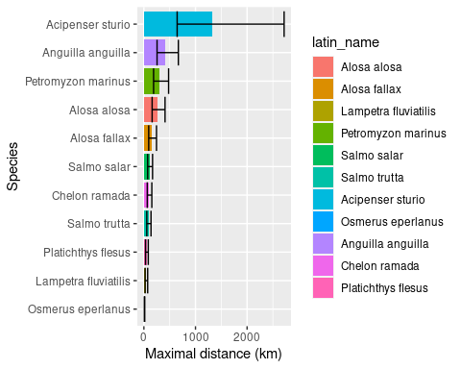

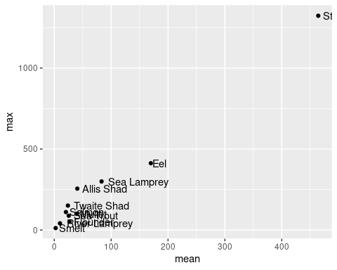

| **Species** | **Question** | **mu_natural** | **up_natural** |
| --- | --- | --- | --- |
| Allis Shad | mean | 40.47090 | 64.48762 |
| Allis Shad | max | 255.50971 | 409.67049 |
| Twaite Shad | mean | 23.95027 | 37.43641 |
| Twaite Shad | max | 150.85907 | 244.16206 |
| Mullet | mean | 39.81072 | 62.75679 |
| Mullet | max | 100.00000 | 153.76965 |
| Flounder | mean | 26.82696 | 46.05849 |
| Flounder | max | 51.79475 | 84.83429 |

### kernel function

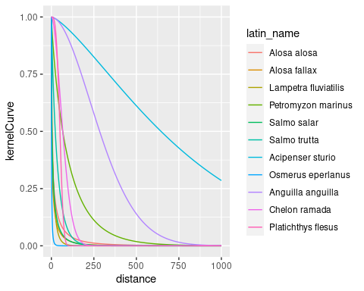

# Maximum density of fish per unit area (Dmax, # km-2)

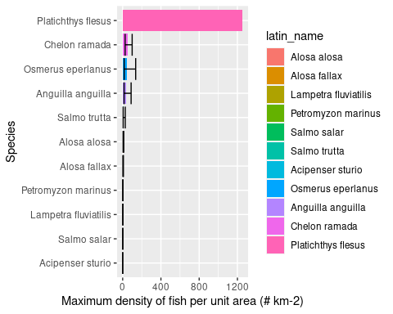

without flounder

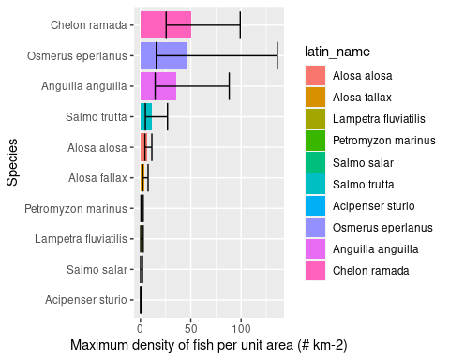

Need to validate surface area from respondents with values from Eurodiad

# Allee effect

$lambda$ in Barber et al

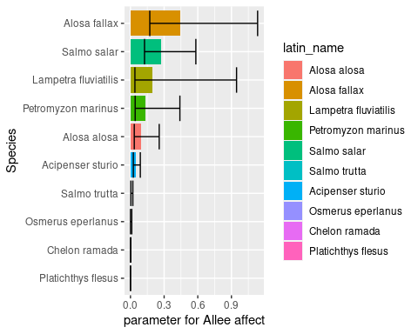

# Spawner cohorts in reproduction

to define bins; how many age classes to use when defining annual spawner abundance

| latin_name | bins |
| --- | --- |
| Alosa alosa | 3 |
| Alosa fallax | 3 |
| Lampetra fluviatilis | 3 |
| Petromyzon marinus | 3 |
| Salmo salar | 3 |
| Salmo trutta | 3 |
| Acipenser sturio | 3 |
| Osmerus eperlanus | 3 |
| Anguilla anguilla | 3 |
| Chelon ramada | 3 |
| Platichthys flesus | 3 |

# Mean age at first reproduction

define the time lag between when fish are produced and when they participate in reproduction

| latin_name | AgeFirstMatMean |
| --- | --- |
| Alosa alosa | 5.0 |
| Alosa fallax | 3.0 |
| Lampetra fluviatilis | 5.0 |
| Petromyzon marinus | 8.0 |
| Salmo salar | 3.0 |
| Salmo trutta | 3.5 |
| Acipenser sturio | 11.0 |
| Osmerus eperlanus | 2.0 |
| Anguilla anguilla | 12.0 |
| Chelon ramada | 3.5 |
| Platichthys flesus | 4.5 |

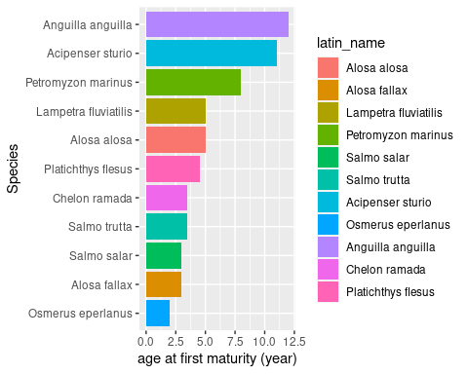

# Parameters table for HyDiaD

## Reference