# Using the Lidar feature of the FAST v8 – Simulink Interface

The following changes must be made in the Simulink module to accommodate the lidar module.

### S-Function Parameters

Setting *NumAdditionalInputs* = 3 causes the code to simulate a CW lidar, whose measurement is set in an output channel called “WindMeas1”. When *NumAdditionalInputs* = 3, the code expects this third parameter to contain an array of initialization data for the lidar module:

[3, UseLidar, LidRadialV]

*UseLidar* should be 0 (single point measurement; no lidar) or 1 (CW lidar). Future version will allow more flexibility.

*LidRadialV* should be 0 (returns estimate of velocity in x direction) or 1 (returns radial velocity). Other values for *LidRadialV* will be treated as 0.

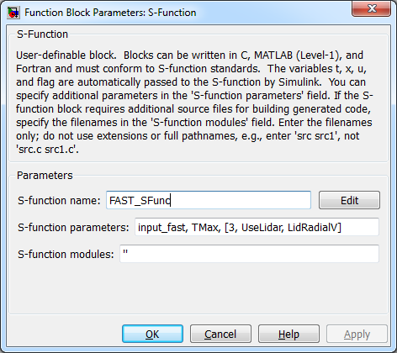

Figure : FAST_SFunc Block Parameters for Lidar

### S-Function Inputs

When *NumAdditionalInputs* is 3, FAST_SFunc expects the following additional inputs:

1. Lidar focus position (w.r.t lidar) in X direction (required for continuous wave lidar)
2. Lidar focus position (w.r.t lidar) in Y direction (required for continuous wave lidar)
3. Lidar focus position (w.r.t lidar) in Z direction (required for continuous wave lidar)

# FAST v7 control outputs that don’t exist in FAST v8

Some output channels that existed in FAST v7 do not exist in FAST v8. Some substitutions for variables commonly used in control include:

$HorWindV = \sqrt{{WindVxi}^{2} +{WindVyi}^{2}}$

$HorWindDir = \frac{180°}{π}\text{atan2} \left(WindVyi,WindVxi\right)$

$VerWindDir = \frac{180°}{π}\text{atan2} \left(WindVzi, \text{HorWindV}\right)$

$NacYawErr = HorWindDir-YawPzn-YawBrRDzt- PtfmRDzi$

To use these equations, replace variable names on the right-hand-side of the above equations using $u\left(\text{strmatch}\left('VariableName',OutList\right)\right)$.

