
Insa ilyas
FA24B1-SE-043(A)
BSE VA
CLOUD COMPUTING
ASSIGNMENT #01
Task 1: Install Gitea and Push a Repository from the Ubuntu Server
Connect to your assigned Ubuntu server.
package name is docker.io:
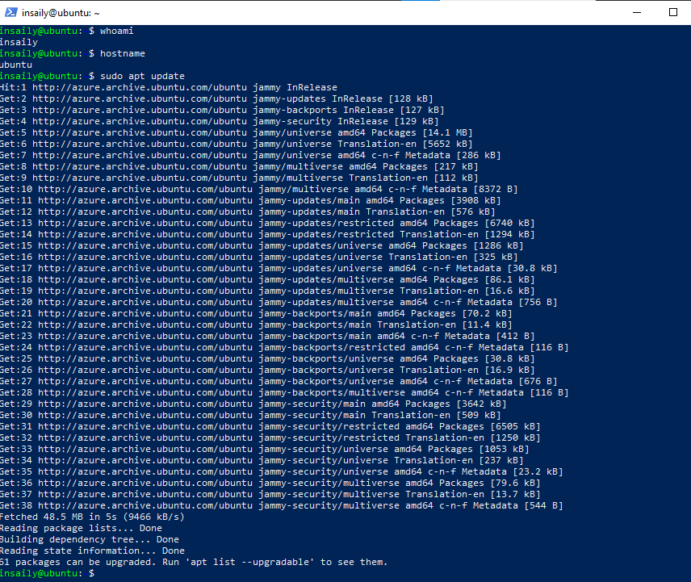

. Update the Ubuntu package index and install Docker Engine and curl. On Ubuntu, the required

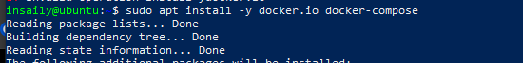
Create the system-wide Docker CLI plug-in directory and download the Docker Compose plug-in for
an x86_64 Ubuntu server:
4. Start the Docker service and add your current Ubuntu account to the docker group:
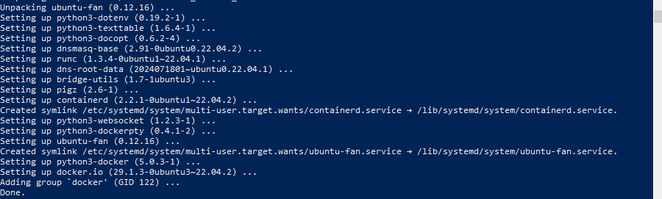
5. Verify the Git, Docker, and Docker Compose installations:
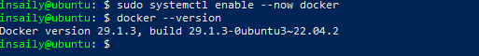
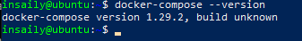
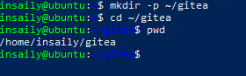
7. Use the existing compose.yaml without changing its server URL or port settings. Start Gitea and
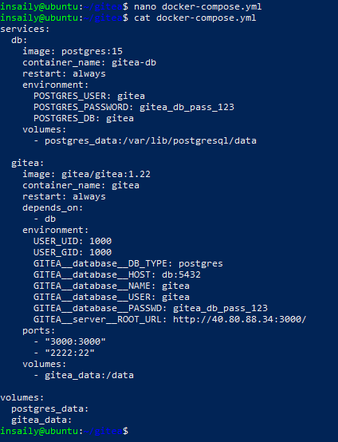
8. Confirm that both containers are running:
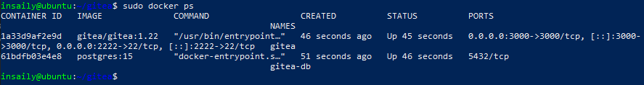
Task 2: Push the Same Repository to GitHub
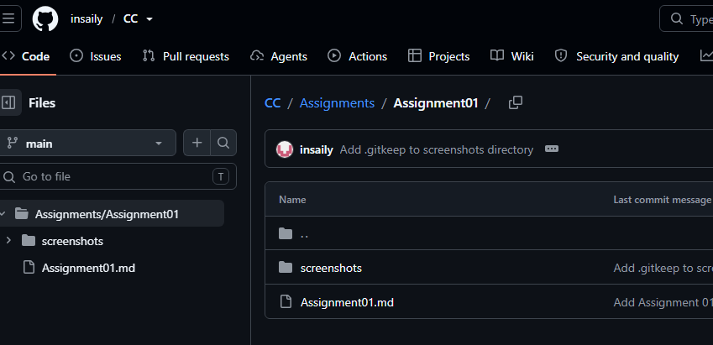
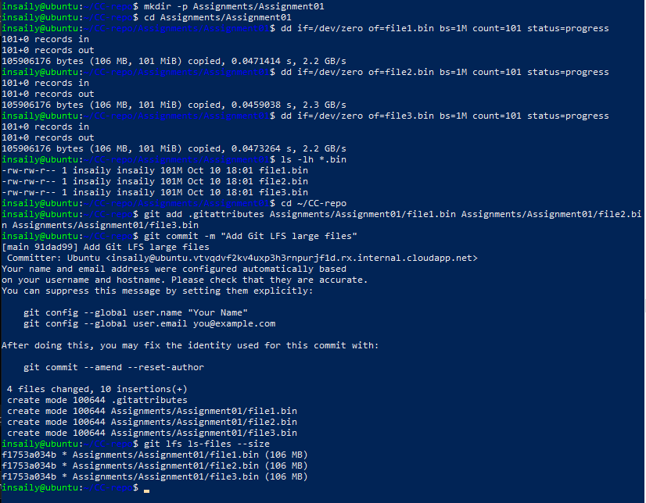
Task 3: Track Three Large Files with Git LFS
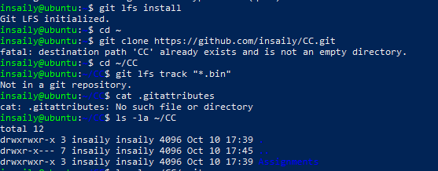
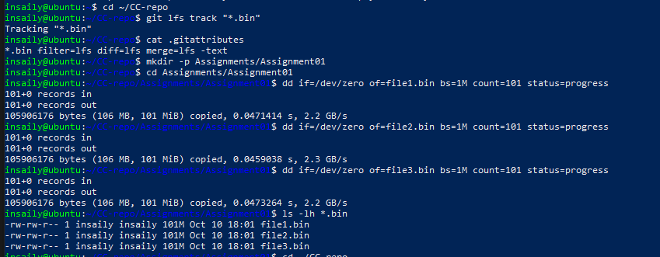
Task 4: Create a Portfolio or CV with GitHub Pages
Link: https://insaily.github.io/
