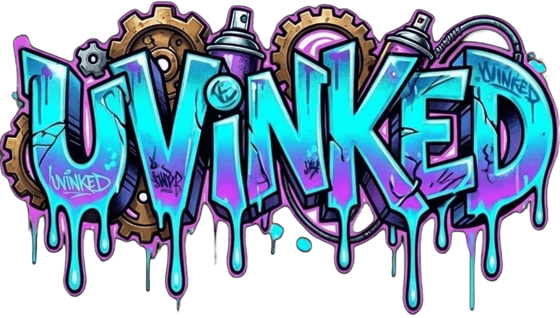
Precision UV Printing Solutions for Custom Substrates & Branding

About Our Services
Welcome to UVINKED. We specialize in high-definition, durable flatbed UV printing across a wide variety of substrates. Whether you need custom corporate gifting, promotional items, personalized merchandise, or specialized industrial marking, our state-of-the-art UV INK technology delivers vibrant, long-lasting results every single time.

UV DTF Printing

UV DTF printing is a modern way to print bright, raised stickers. You can put these stickers on hard things like glass, metal, wood, and plastic. The ink is cured with UV light. This makes the design waterproof, scratch-proof, and very strong.

Substrate Printing
Direct-to-substrate flatbed printing custom-tailored to hard surfaces, plastics, metals, wood, and acrylics.

Promotional & Corporate
Custom branded gear, marketing merchandise, signage, and bespoke corporate identity elements.

Custom Solutions
Flexible scaling from short runs to bulk orders, engineered precisely around your design specs.

Get In Touch
Ready to bring your next print project to life? Reach out to discuss your custom specifications, design layouts, or substrate requirements.
Contact Us via Email
© 2026 UVINKED (PTY) LTD. All rights reserved.

