**Course No:** CSE 3110

**Course Name**: Database Systems Laboratory

**Project Name**: **We-Cheaters Database Management System**

Submitted to:

**Jarin Firose Moon Md. Milon Islam**

Lecturer Lecturer

Department of Computer Science & Engineering Department of Computer Science & Engineering

Khulna University of Engineering & Technology Khulna University of Engineering & Technology

Submitted by:

**Md. Rahat Zaman**

Roll: 1507006

Section: A

Department of Computer Science & Engineering

**Date**: 26th June, 2018

**Project Overview**

**Brief Description:**

* The main objective of this project is to maintain a software’s shortcut strings repository using Database Management System.
* Shortcut’s names and description.
* Shortcuts have ownerships from users.
* Upvotes and Downvotes.
* Most of the functionalities of a sharing data software is added in this project.

**Database Structure Description:**

**We-Cheaters** is an Online Software Shortcut Uploading System. The Shortcut is uploaded in the Software and inserted in the Database. There are many users of this Software Uploading System. A lot of shortcuts are uploaded daily. To maintain and store the total votes online shortcut uploading system needs a Database Management System. This project is based on this. It includes daily shortcut uploads, vote counts which are uploaded in the online software system.

There will be about five tables. The five tables are as follows:

* **Users table,**
* **Shortcuts table,**
* **Uploads table,**
* **Votes table &**
* **Autogen table**.

**Users table** consists of all the information about the users, who upload the various shortcuts in the software systems. Email, Name and Pass are the attributes of Users table. Email is the primary key of Users table.

**Shortcut table** defines all types of information of Shortcut which are uploaded in the Software system. The attributes of the Shortcut table are Shortcut ID, name, upload date, uploader and reputation. The Shortcut ID is the primary key of the Shortcut table. Uploader is the foreign key of this table with reference to email of Users table.

**Uploads table** contains all the information about the uploads which are uploaded by the users. Users and Shortcut are the attributes of the Uploads table entity. User and shortcut are the conjugate primary key. Users is the foreign key of Uploads table with reference to email of Users table. And, Shortcut is the foreign key of this table with reference to Shortcut ID of Shortcut table. Because of Uploads table which Shortcuts are uploaded in the software and which users upload the shortcut are maintained and managed.

**Votes table** contains number of Upvotes or Downvotes which are given in the software by the Users to various Shortcuts. Users, Shortcut and Up vote are the attributes of the Votes table entity. Users is the foreign key of Votes table with reference to email of Users table. Shortcut is the foreign key of this table with reference to Shortcut ID of Shortcut table. If the value of the Up vote is 1 then, it is a upvote, On the contrary, if the value of the Upvote is 0 then, it is a Downvote.

**Autogen table** describes the increment of the shortcut number automatically. It works like Identity keyword of SQL-Server. It stores the latest shortcut ID which are uploaded in the software. Shortcut number is the only attribute of Autogen table.

**Schema diagram taken from DataGrip:**

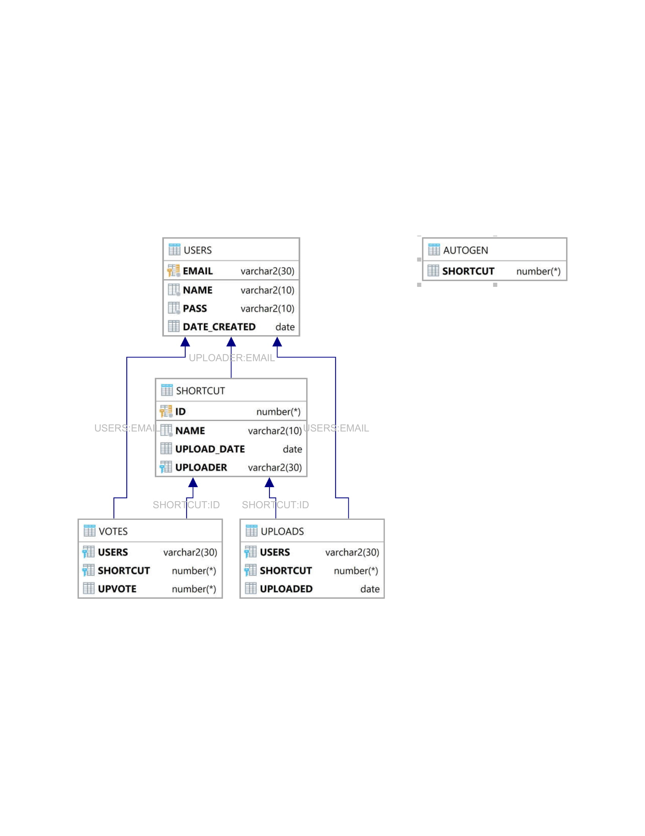

**Functionality:**

The database allows to complete the following functions:

* Shortcuts are stored on the basis of their ID, name and description.
* The Users can upload different Shortcuts in the Software system.
* The Users information is kept safe.
* Total votes are divided into Upvote and Downvote from the Votes table.
* The details of the various Shortcuts are kept.
* The total amount of Shortcuts are counted by auto incrementation method.

**Customers / Audience:**

The main customers are the Users who uploads the Shortcuts from the different parts of the world. The Users can also give UP votes and Down votes to the given Shortcuts. In this way, many Shortcuts can be shared with different User community.

**Database Design Process:**

Our goal was to create a practical based software database management design system. It was developed in oracle sql managed by oracle co. Some planning, design, and review of the existing prototype were researched to build the project.

Five tables were designed to maintain the online software system. Our table designs provide future flexibility for growth and changes to the database tables.

We learned several important lessons through the design process.

These include:

* Designing the tables is the most important step and must be done early in the project.
* Building a database from scratch is often easier than revising an

existing database.

* Initial design is so important.
* Being able to design a database well for a user client requires a lot of understanding about the business process and needs behind the applications.

**Future of the Database:**

The database is currently functional as a practical application of an online software system. It is completed with Oracle and DataGrip.

It is anticipated that the following tasks will need to be accomplished in order to achieve the goals:

* Create the database tables in Oracle sql with DataGrip.
* Update code to incorporate feedback
* Develop information for needed forms and database tables to support the form.

**Schema Diagram:**

|  |
| --- |
| USERS |
| Email |
| Name |
| Pass |
| Date Created |

|  |
| --- |
| SHORTCUT |
| ID |
| Name |
| Upload Date |
| Uploader |
| Reputation |

|  |
| --- |
| VOTES |
| Users |
| Shortcut |
| Up vote |

|  |
| --- |
| AUTOGEN |
| Shortcut |

|  |
| --- |
| UPLOADS |
| Users |
| Shortcut |

**Summary:**

The given project was a practical learning experience. It allowed us to improve upon our SQL skills. It is to look forward to seeing the database being put into actual use later on.