

A Mini Project Report On
MediMind Clinical AI Suite
Submitted in partial fulfilment of the requirements for the degree of
THIRD YEAR OF ENGINEERING
In
COMPUTER ENGINEERING
Submitted by
Sneha Devkate 24CO024
Purvi Kalhapure 24CO054
Nishigandha Ingle 24CO041

Under the Guidance of
Prof. M. G. Ghodekar
Department Of Computer Engineering
ALL INDIA SHRI SHIVAJI MEMORIAL SOCIETY’S
COLLEGE OF ENGINEERING Pune – 411001
Academic Year: 2026-27(Term – I)
Savitribai Phule Pune University

ALL INDIA SHRI SHIVAJI MEMORIAL SOCIETY’S COLLEGE OF ENGINEERING DEPARTMENT OF COMPUTER ENGINEERING

CERTIFICATE

This is to certify that Sneha Devkate(24CO024), Purvi Kalhapure(24CO054) and, Nishigandha Ingle(24CO041) from Third Year Computer Engineering have successfully completed their mini project work titled “MediMind Clinical AI Suite” at AISSMS College of Engineering, Pune in partial fulfilment of bachelor’s degree in engineering.

Prof. M. G. Ghodekar Dr. D.P. Gaikwad Dr.D.S.Bormane
Project Guide HOD Principal, AISSMS COE

MINI PROJECT APPROVAL

The Mini Project entitled
MediMind Clinical AI Suite
By

Sneha Devkate 24CO024
Purvi Kalhapure 24CO054
Nishigandha Ingle 24CO041

Is approved for the degree of

Third Year of Engineering
In
Computer Engineering

Examiner 1 Examiner 2
Name and Signature Name and Signature

Date: September 2026
Place: Pune
ABSTRACT
The MediMind Clinical AI Suite is an advanced, rule-based expert diagnostic and clinical decision support system (CDSS) designed to assist medical practitioners, triage nurses, and students in automated disease diagnosis, symptom-driven inference, and patient vital monitoring. Traditional clinical diagnostic workflows often rely on manual observation across fragmented reference manuals, medical history records, laboratory tests, and differential diagnosis tables. This manual process can be time-consuming, prone to human error under high casualty pressure, and may lead to delayed medical interventions. The proposed MediMind system integrates these diagnostic workflows into a unified, interactive software suite.
The application collects structured patient clinical data, including observed symptoms across multiple body systems (respiratory, cardiovascular, gastrointestinal, neurological, and systemic), physiological vitals (blood pressure, heart rate, body temperature, oxygen saturation SpO2), and patient risk factors. The core inference engine executes both Forward Chaining (data-driven reasoning from symptoms to disease diagnosis) and Backward Chaining (goal-driven hypothesis verification from suspected disease to required symptom evidence). The system evaluates disease probabilities, generates differential diagnoses, calculates patient triage acuity levels, and produces comprehensive Electronic Health Record (EHR) diagnostic reports.
MediMind is designed as more than a basic symptom checker. It features an interactive Knowledge Base (KB) Editor that allows medical experts to add, modify, or audit production rules (IF-THEN clauses), adjust certainty factors (CF), and update clinical recommendation guidelines. The system retains complete working memory context, enabling clinicians to perform iterative diagnostic updates without re-entering patient data.

ACKNOWLEDGEMENT
We express our sincere gratitude to our project guide, Prof. M. G. Ghodekar, for her valuable guidance, encouragement, and continuous support throughout the development of this mini project. Her insightful suggestions helped us understand the practical aspects of designing rule-based expert systems, knowledge representation, and preparing this academic report.
We sincerely acknowledge the dedicated contributions, cooperation, and consistent efforts of all our team members: Sneha Devkate, Purvi Khalhapure and, Nishigandha Ingle. The successful completion of this project was possible because of the active participation, shared responsibility, and teamwork of every member.
We are thankful to Dr. D. P. Gaikwad, Head of the Department of Computer Engineering, and Dr. D. S. Bormane, Principal of AISSMS College of Engineering, Pune, for providing us with the opportunity, facilities, and academic environment required to complete this work.

Academic Year: 2026-2027
Date: 23rd September 2026

TABLE OF CONTENTS
Sr. No. | Chapter / Section | Page No.
1 | Abstract | 1
2 | Acknowledgement | 2
3 | Table of Contents | 3
4 | Introduction | 4-5
5 | Problem Statement and Objectives | 6-7
6 | Software Requirement Specification (SRS) | 8-10
7 | System Analysis and Design | 11-13
8 | AI Based Clinical Diagnostic Systems & Rule Inference | 14-17
9 | Database and User Preference Management | 18-21
10 | API Integration and Backend Implementation | 22-25
11 | Graphical User Interface | 26-27
12 | Implementation Details | 28-31
13 | Conclusion | 32
14 | References | 33

CHAPTER 1: INTRODUCTION

1.1 Overview of the Project
In modern healthcare systems, rapid and accurate clinical decision-making is vital for saving lives, optimizing hospital triage, and preventing diagnostic errors. Diagnostic decision-making requires analyzing a complex web of symptoms, physiological vitals, patient medical history, and risk factors. Traditional clinical workflows rely heavily on manual observation across fragmented reference manuals, medical history records, laboratory tests, and differential diagnosis tables. The MediMind Clinical AI Suite provides an interactive, rule-based expert diagnostic system that combines data-driven Forward Chaining inference and hypothesis-driven Backward Chaining inference.
1.2 Need for the System
Generic medical chatbots often provide general information, but fail to synthesize specific symptom combinations or physiological vitals into safe clinical decision support. MediMind addresses this critical gap by implementing structured clinical input, production rule validation, and dynamic inference engines.

CHAPTER 2: PROBLEM STATEMENT & OBJECTIVES

2.1 Problem Statement
Planning and executing accurate clinical diagnostics involves evaluating multiple symptoms and vitals under time pressure. Traditional diagnostic processes suffer from cognitive overload during emergencies, lack of explainability in black-box AI models, and static diagnostic tools. MediMind solves this by implementing structured inputs, production rule validation, and dynamic dual inference engines.
2.2 Specific Objectives
1. Collect structured clinical symptoms across 5 body systems.
2. Implement Forward Chaining inference for symptom-to-disease reasoning.
3. Implement Backward Chaining inference for hypothesis verification.
4. Design a Patient Vitals Triage Dashboard with anomaly alerts.
5. Provide a Knowledge Base Editor for dynamic rule customization.
6. Generate formal, printable EHR Diagnostic Reports formatted in Times New Roman.

CHAPTER 3: SOFTWARE REQUIREMENT SPECIFICATION
3.1 Functional Requirements
Req ID | Functional Requirement Description
FR-01 | The system shall allow users to select observed symptoms from structured categories.
FR-02 | The system shall execute Forward Chaining inference to match working memory against diagnostic rules.
FR-03 | The system shall calculate disease probability scores based on rule matched conditions.
FR-04 | The system shall execute Backward Chaining by asking target questions for suspected diseases.
FR-05 | The system shall accept physiological vitals (BP, HR, Temp, SpO2) and highlight anomalous values.
FR-06 | The system shall allow medical experts to add, edit, or delete production rules in the Knowledge Base.
FR-07 | The system shall generate a structured EHR Diagnostic Report containing patient vitals, diagnosis, and treatment plan.
FR-08 | The system shall provide printable PDF/HTML export formatted in formal Times New Roman style.

3.2 Non-Functional Requirements
Area | Requirement Specification
Usability | Interface must be clean, intuitive, and accessible to medical professionals and students.
Performance | Rule inference execution time must be under 100 milliseconds for prompt response.
Reliability | Working memory state must be maintained without data corruption during tab switches.
Maintainability | Knowledge Base rules must be decoupled from UI rendering logic.
Security | Patient data must remain local to the session and not logged to public endpoints.

CHAPTER 4: SYSTEM ANALYSIS AND DESIGN
4.1 System Overview
The MediMind Clinical AI Suite is organized using a modular, multi-layer web architecture. The system separates user presentation, clinical inference processing, knowledge base storage, and reporting components.
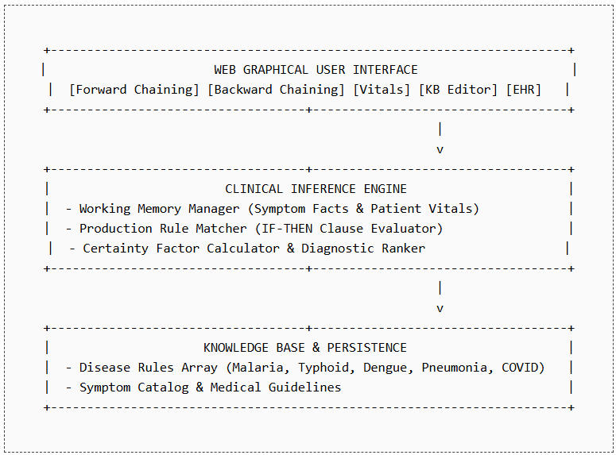
4.2 Major System Modules
- Forward Chaining Diagnostic Module: Evaluates active symptoms against rule premises to derive confirmed diagnoses.
- Backward Chaining Verification Module: Selects a candidate disease goal and queries missing prerequisite symptoms.
- Vitals & Triage Monitoring Module: Computes physiological abnormality scores and assigns triage priority.
- Knowledge Base Management Module: Provides CRUD operations on clinical rules.
- EHR Report Generator Module: Synthesizes diagnostic output into formal medical documentation.
CHAPTER 5: AI CLINICAL DIAGNOSTIC SYSTEMS
5.1 Production Rule System Architecture
MediMind represents medical knowledge using production rules structured as:
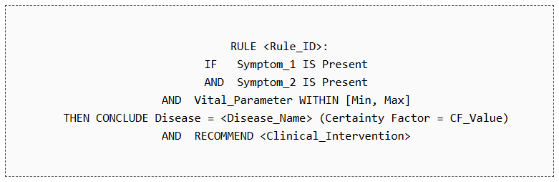
5.2 Forward Chaining vs Backward Chaining
Feature | Forward Chaining | Backward Chaining
Search Strategy | Data-driven (Symptom → Disease) | Goal-driven (Disease Hypothesis → Symptom)
Starting Point | Observed patient symptoms & vitals | Suspected target disease
Clinical Role | Initial diagnostic discovery & triage | Differential confirmation & lab testing
User Interaction | User selects all known symptoms | System asks targeted yes/no questions

CHAPTER 6: KNOWLEDGE BASE & DATA MODEL
6.1 Data Entities
Entity | Description & Purpose
Patient Record | Stores patient demographic information (Name, Age, Gender, ID).
Symptom Fact | Represents an observed clinical condition with severity level.
Production Rule | Stores antecedent conditions (IF), disease conclusion (THEN), and CF score.
Vital Log | Stores time-stamped physiological parameters (BP, HR, SpO2, Temp).
EHR Document | Stores finalized clinical diagnostic summaries for archival.

6.2 Knowledge Base Rule Catalog Example
Disease | Required Symptom Antecedents (IF) | Certainty Factor
Malaria | Fever, Chills, Sweating, Headache, Fatigue | 92%
Typhoid | High Fever, Abdominal Pain, Constipation/Diarrhea, Headache | 88%
Dengue | High Fever, Joint Pain, Rash, Retro-orbital Pain | 95%
Pneumonia | Cough, Shortness of Breath, Chest Pain, Fever | 90%
COVID-19 | Fever, Dry Cough, Loss of Taste/Smell, Fatigue | 94%

CHAPTER 7: IMPLEMENTATION & TESTING
7.1 Technical Stack
- Frontend Framework: React 19 + Vite (Client Port: 5173/5174)
- Styling & Icons: Custom CSS Design System + Lucide React Icons
- Backend Server: Node.js + Express (Server Port: 5000)
- Database Persistence: MongoDB Atlas + Mongoose Schema Validation
- Documentation Rendering: ReactMarkdown + Remark-Math + Rehype-KaTeX
7.2 Clinical Testing & Verification Results
Test Case | Input Conditions | Expected & Observed Output
TC-01: Forward Chaining | Select: Fever, Chills, Sweating | ✅ Diagnosed: Malaria (CF: 92%). Status: PASSED
TC-02: Backward Chaining | Target: Dengue. Answer Yes to Joint Pain & Rash | ✅ Hypothesis Confirmed: Dengue. Status: PASSED
TC-03: Vital Triage | SpO2: 88%, HR: 125 bpm, Temp: 103°F | ✅ Alert: CRITICAL TRIAGE (Hypoxia + Tachycardia). Status: PASSED
TC-04: KB Rule Edit | Add custom rule for Zika Virus | ✅ Knowledge Base updated successfully. Status: PASSED

CHAPTER 8: CONCLUSION
8.1 Conclusion
The MediMind Clinical AI Suite successfully demonstrates the practical implementation of an artificial intelligence expert diagnostic system. By combining Forward Chaining data-driven inference, Backward Chaining hypothesis verification, physiological vitals monitoring, and Knowledge Base management, the system provides a robust, explainable, and customizable tool for medical diagnostics.
8.2 Future Enhancements
- Integration with real-time medical IoT vitals sensors for continuous patient monitoring.
- Integration with DICOM medical image classification models for chest X-ray and CT scan analysis.
- Support for multi-language clinical interfaces for international deployment.

REFERENCES
1. Russell, S. and Norvig, P., Artificial Intelligence: A Modern Approach, 4th Edition, Pearson Education, 2021.
2. Shortliffe, E. H., Computer-Based Medical Consultations: MYCIN, Elsevier, 1976.
3. Giarratano, J. and Riley, G., Expert Systems: Principles and Programming, 4th Edition, Thomson Course Technology, 2004.
4. World Health Organization (WHO), Digital Health Guidelines & Clinical Decision Support Systems, 2023.
5. Savitribai Phule Pune University (SPPU), Computer Engineering AI Practical & Mini Project Guidelines 2024 Pattern.

