Ian Smith insd45 12442396

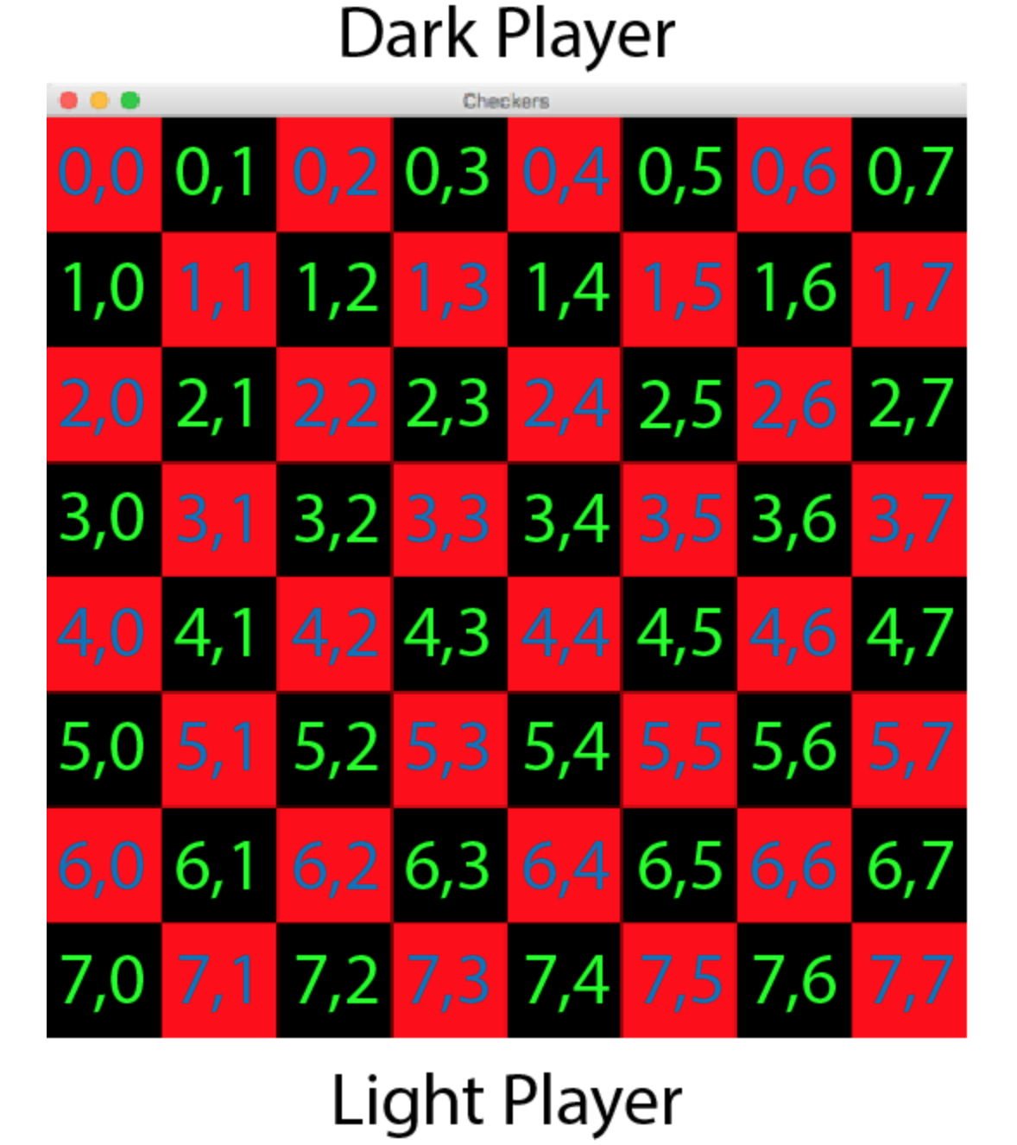

The best way to gather player names is to retrieve them upon the start of a new game. When having CPU vs. CPU, the names will automatically be filled with “cpu1” and “cpu2”. When playing Person vs. CPU, the player will enter their own name. When starting a player vs. player game, players will fill out both. The name of whoever’s turn it is will be displayed in the top gray bar above where it says “Checkers.”

To determine who moves first, if it’s CPU vs. CPU, it should choose cpu1 as the first to move, thus the dark pieces. When it’s player vs. CPU, the player should be given the choice. When it’s player vs. player, the first player should be given the choice.

The board should be displayed as above, without the green coordinates for the user to interact with. When pieces are placed on the dark pieces, each player should only be able to interact with their own pieces, pieces that can move, and only when it is the player’s turn.

To prevent illegal moves, it must first be noted that friendly pieces cannot jump over each other, and that a piece can’t be jumped over if it as the end of a boundary or if there is another piece behind. Also, if it is possible to capture a piece it must be captured. To check these constraints, with our coordinate system, we have to scan each piece before the start of a turn and check the adjacent spots. Each piece should have a Boolean marker to display whether it can capture a piece or not, and each piece should also have a counter (and possibly direction) of available adjacent spots. If a piece has no possible moves, it should not be able to be interacted with. If a piece has possible moves but another piece can capture another, it should not be able to be interacted with. The coordinate system allows the pieces to know which direction open spots are, and if they can capture a piece.

If a player can’t make any moves, the other wins. If all of a player’s pieces have been captured, the other player wins. The much more difficult item would be to find out when a draw occurs. The official rules state that any player can resign or offer draw at any time. Since that isn’t necessarily an option to give the player, the technical rules state that unless the game can be won in 40-50 moves, it is called a draw. Typically reserved only for high level play, we will wait ten turns and if no pieces are kinged or captured, the players will be prompted if they want to draw (CPU will always say yes). If they accept, the game ends. If they decline, we will wait another 10 turns, and if nothing happens, we will prompt them again, and keep doing so until victory is achieved or they agree to a draw.

Objects: GamePiece, BoardSquare, Board, Player

Methods:

GamePiece objects should hold their color, what player they belong to, how many BoardSquares are adjacent to it, how many open BoardSquares are adjacent to it, how many legal moves they can make, and methods determining if capturing a piece is possible.

BoardSquares hold a color, coordinates, if a GamePiece is on it, and what color the GamePiece on it is.

Board holds the total number of pieces, how many pieces of each player are left, and a counter for how many moves have passed without a significant game state change.

Player holds name, turns, and methods to start the game.