Ela Iwaszkiewicz-Eggebrecht
2025-11-28

This document describes analyses of the subset of individual barcoding data, namely the barcodes that were recovered in megabarcoding but did not find match in the metabarcoding dataset.

We recovered a barcode but didn’t find it in metabarcoding in 289 instances (individuals) (6% of the total number of specimens). This concerned 65 different barcode sequences.
Initial taxonomic assignment of those barcodes was the following (Fig. SX1) and detail in table List_unmatched_barcodes.csv.

Since many of the assignments in this group were fairly uncertain (low dominace_of_barcode_otu number and low numbers of reads in total), we run two additional taxonomic assigments: using BOLD and using BLAST against NCBI.
- BOLD – We took the set of all 65 barcodes (OTUs_FASTA file) and used Barcode_ID functionality on the web: https://id.boldsystems.org/. We used Animal Library (Public and Private) and Rapid Species Search operating mode.
Results were downloaded and are available in the BOLD_output subfolder.
- We also performed nucleotide BLAST for all 65 sequences at the https://blast.ncbi.nlm.nih.gov/Blast.cgi?PROGRAM=blastn&PAGE_TYPE=BlastSearch&LINK_LOC=blasthome using Standard database (nr etc.) and Highly similar sequences (megablast) algorithm.
Resuts are available in BLAST_output subfolder.

Code used to merge and visualize data is avaialbe in …..R script.

We first evaluated if the initial taxonomic assignment matched the BOLD identification.
If yes -> we corroborated the taxonomy of this barcode.
If BOLD assignment did not match -> we investigated BLAST results. Those were usually cases, where assignments had low support in either of the methods. Often was obvious that wrong assignment was obtained due to contamination in reference libraries (bacterial sequences or mites).
If BOLD assignment was missing (nothing in DB matched) -> This was likely not to be an insect sequence and we investigated further with BLAST.

We provide full table with synthesized taxonomic assigments and corrections in Unmatched_barcodes_check_summary.csv file.
As the result of all check-ups we developed subjective categories, that reflect our conclusions about barcoding: “Possibly_true”, “Likely_true”, “Likely, contamination” and “Contamination”.
Clear contamination were bacterial and
“Likely, contamination” and “Contamination” categories contained 1 bacterial sequence that escaped filtering procedures, one springtail, one termite and two thrips most likely from South-East Asia (individual barcoding was performed in Singapore) and various (poorly annotated) mites (n=212).
Bacteria, thrips and termite were obvious contaminations. The mites and springtail were very unlikely to have been sorted individually as a specimen by themselves. They were probably just a “passenger” on an arthropod for which the barcoding did not succeed.

The category that is very likely to have been the focal taxon and true barcoding result is “Likely_true”. In this category we find 52 Hymenopteran individuals, representing 13 different barcodes. All of them were parasitoids from families of Ceraphronidae (n=40), Ichneumonidae (n=3), Megaspilidae (n=3), Mymaridae (n=1) and Pteromalidae (n=1).
It is highly likely that those specimens were missed in the metabarcoding either due to their small size (and consequently contributing little DNA in the bulk extraction) or due to primer mismatch. It is well known that certain Hymenoptera do not amplify well with use of standard metabarcoding primers.

The last category was “Possibly_true” and those were 20 individual that might have been true barcodes or contamination.
There were 18 individuals that were Diptera: 2x Phoridae, 3x Cecidomyiidae, 1x Ceratopogonidae, 2x Mycetophilidae, 1x Dolichopodidae, 5x Ephydridae, 2x Heleomyzidae.
One Hemipteran from Cicadellidae familiy, most likely from genus Hebata.
One Lepidoptera, specifically Eriocrania semipurpurella (Purplish birch-miner).
Dipera could be true individual that were missed in metabarcding dues to their small size or primer mismatch. However, they also could have been contaminas coming from the lab, as many small Diptera were processed in the lab around that time.
The cicada and moth are difficult ot explain as misses in metabarcoding, therefore are suspecte dof being contaminant. But we do acknowledge that they might be true specimens that we did not detect in metabarcoding.

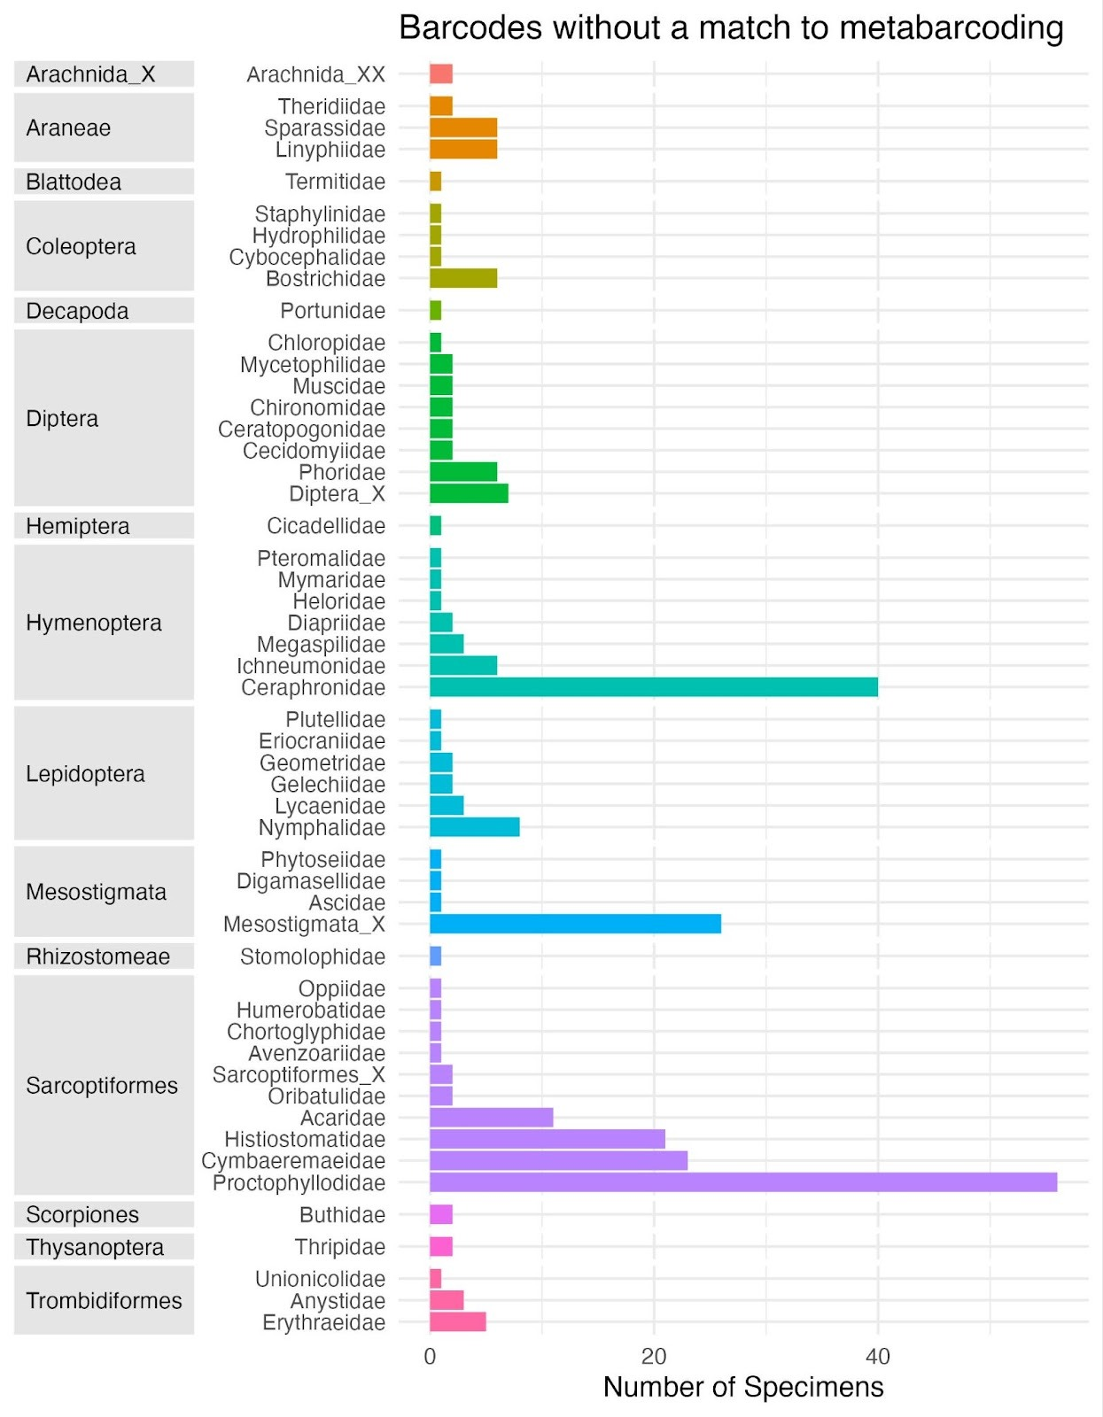
Fig SX1. Taxonomic composition of the specimens that were successfully barcoded but did not match to metabarcoding dataset.

