Determining Egg Output in Yellow Mealworms (Tenebrio molitor; Coleoptera: Tenebrionidae)
Version 1.0
December 2025
M. Barrett, Creator V1.0

Description: This protocol is designed to help researchers obtain the number of eggs, or the mass of eggs, laid by Tenebrio molitor adults over some defined time period. It should only be used with this species (but could probably be adapted for other mealworm beetles).

This version was used for the data in Dobrowolski and Perl et al. 2025. However, we learned many things during that study that we believe could improve data collection. Please see Version 1.1 for the improved protocol.

Table of Contents
General Protocol Details 2
Step 1. Experimental Setup 2
Materials, Animals, or Samples Needed 2
Protocol 3
Step 2. Daily Animal Care During Experiment 4
Materials, Animals, or Samples Needed 4
Protocol 4
Step 3. Experiment Breakdown and Egg Counting 4
Materials, Animals, or Samples Needed 5
Protocol 5
Troubleshooting Table 8
References 9

General Protocol Details
- Practical Details of Masking Treatment During Analysis:
  - We did not mask treatment, though data analyzers did not collect the egg count data for this experiment.
- Data Exclusion Criteria:
  - If a top is not placed over your containers, mealworm adults may escape (as they can fly). Data should be excluded if a large number of adults are ‘missing’ on the final day of the trial (and see second bullet).
  - Mealworm adults may also die and cannibalize each other during the experiment. Often, the abdomen is still retained and can be sexed; however, if not, the data for that individual will need to be excluded.
    - As far as we know, no one (including us) currently accounts for these dead adults (e.g., by recording death each day and factoring that into their analysis of eggs/adult/day).
- Pilots that May Be Necessary:
  - Determining how many days to keep the adults laying for the number of adults you have in your bin and their reproductive output is important. Too few, and you may not have good data; too many, and you have a headache. We found that for 30 adults, 10 days was enough and 15 was too many.
  - Determining head width and ovipositor width of your population if you plan to do extreme body size manipulation (see troubleshooting), allowing you to select the right excluder size.

Step 1. Experimental Setup
Description: This step will allow you to create the habitat for the egg counting experiment and place animals in that habitat.

Materials, Animals, or Samples Needed
Materials
- Plastic containers with lids (14 x 8.7 x 5 cm; 25 oz) - same number as replicates
- Metal mesh sheets with a mesh just barely < 2mm in diameter - enough material to cover the floor of all your replicates
 | Caution!  The holes in your excluder must be smaller than the head width of your beetles, but larger than the ovipositor width. This allows oviposition into the feed but prevents egg cannibalism, which is common in YM.
- Hot glue gun
- Ruler
- Sharpie
- Scissors
- Plastic wrap
- Mortar and pestle or food processor/blender
- Cinefoil or other material to form a ‘shade’
- Wheat flour (WF)
- Nutritional yeast (NY; if applicable)
- Agar or polyacrylamide gel

 | Animal Care and Use Note  Polyacrylamide gel may produce toxic monomers that could affect the health of the animals. Agar gel is preferred unless there is an experimental reason to avoid agar (e.g., avoiding its nutritional benefit to the animals).

Animals:
- 0 - 24 hour old adult T. molitor beetles (# animals need = # replicates * # animals/replicate)
  - we did 30 animals/replicate

Protocol
- Trace the floor of your plastic container onto the metal mesh with a sharpie. Then, cut out the shape with the scissors.
  - Do this until you have one ‘excluder’ for each container.
- Use the ruler to mark a height of 1 cm on each of the four corners of each plastic container.
  - Use the hot glue gun to create a small pool of hot glue in each of the four corners about 1 cm high. Then, press the mesh excluder into those four corners gently (to avoid warping) so that it is held at 1 cm above the ‘floor’ of the container.
- Fill your container with feed (wheat flour; WF) until the feed is slightly above the mesh excluder - you want a thin enough layer that the animals have something to eat, but not so much that they will lay eggs above the excluder. Tap the container a few times to allow the material to settle, and adjust the amount of feed as needed.
  - If using nutritional yeast (NY) as well as WF for feed, grind NY with mortar and pestle before adding so it is the same consistency as a flour. Then, mix to a 80:20 WF: NY ratio by mass. Add this combination of feed instead.
- If not using right away, store closed/with a lid until it is time to add adults. When ready to use, proceed to #5 of this step.
- Place a small square of plastic wrap (5-10 cm in each direction) on one side of the container. Place 8 g of agar gel onto the plastic wrap.

Caution!
The moisture source (agar) must not touch the feed. If so, it will turn the flour into a hard ‘cast’ which will make it impossible to count any eggs laid in that area of the container.

- Weigh your 30 beetles as a group to get their mass. Then, add them to the container.
- Cover half of the container with a piece of cinefoil, or some other light-blocking material, to create a shelter/shade.

Step 2. Daily Animal Care During Experiment
Description: This step will allow you to care for the animals for the duration of the experiment.

Materials, Animals, or Samples Needed
Materials
- Wheat flour (WF)
- Nutritional yeast (NY; if applicable)
- Agar or polyacrylamide gel
- Plastic wrap

Protocol
- Daily, check that the animals have feed available to eat (above the mesh excluder) and enough moisture with their gel.
  - Provide more feed as needed.
- Remove all the moisture source (by picking up the plastic square) and replacing both the plastic wrap square (5-10 cm/side) and the gel every 2 or 3 days, maximum.
- Allow animals to lay for 10 days after being placed on the feed.

Step 3. Experiment Breakdown and Egg Counting
Description: This step will allow you to break down the experiment, count all eggs, and sex all adults.

Materials, Animals, or Samples Needed
Materials
- Isoflurane (to be used only in a fume hood)
- Anesthesia induction container, airtight when closed
- Cotton ball
- Pipettes (ideally, positive displacement pipettes)
- Sieve (35 mesh, 0.5 mm diameter holes)
- Petri dishes
- Paint brushes (1, 3, 5, 2/0 models; a 0.2 - 0.3 mm diameter tip)
- Dissecting microscope
- -20 C freezer

Protocol
- Remove all the beetles and record the number living and dead.
- Place the living beetles from a single condition into the induction chamber in the fume hood and dispense 5% isoflurane using the positive displacement pipette onto the cotton ball (which should be prevented from directly touching the animals by being taped to the top of the jar or otherwise excluded from contact with the animals; see Barrett lab drop method anesthetic protocol); seal the jar and let rest for 20 minutes (mean time to induction for females, which take longer, is 15 minutes).
  - Isoflurane anesthesia usually causes them to evert their genitalia and thus makes sexing them very easy (Figure 1).
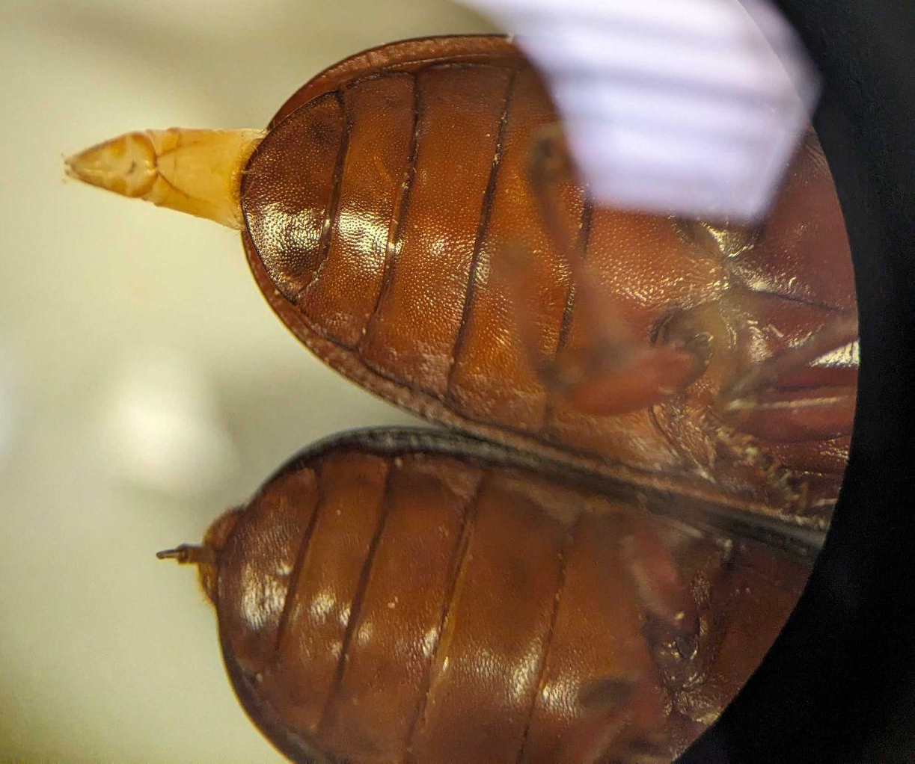
(Figure 1. Female (top) and male (bottom) beetles under the microscope with genitalia everted due to isoflurane exposure)
  - Beetles without exposed genitalia, or dead beetles, can be sexed using abdomen shape (Figure 2).
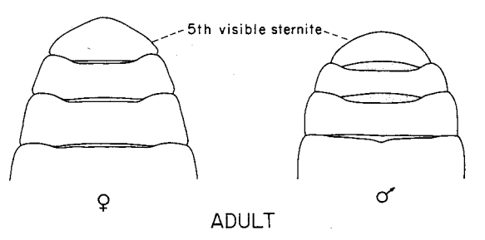
(Figure 2. From Bhattacharya et al. 1970)

- Humanely euthanize beetles when finished; repeat steps 1 - 3 for all conditions.
  - This could involve anesthetic overdose, or decapitation and head capsule crushing, or freezing while still anesthetized.

Animal Care and Use Note
5% isoflurane anesthesia for ~15 minutes lasts for a mean of 49 seconds (time to first movement) and 50 minutes (total recovery) following return to room air; animals can be returned to the induction chamber briefly to re-anesthetized prior to freezing.

- Remove the moisture source and check for any eggs or larvae. Record the number of ‘unhatched’ and ‘hatched’ (or empty eggs with the chorion open) eggs, and the number of larvae.
  - Squish and freeze the material for 48 hours to humanely euthanize any larvae and prevent hatching for biocontrol.
- Remove the excluder mesh and check for any eggs or larvae. Record the number of unhatched and hatched eggs, as well as larvae. Squish and freeze as in 4a.
- Sieve the feed from the container and place the remaining feed and egg/larvae mixture into a labeled petri dish. Then, use a paintbrush to collect any remaining eggs or larvae on the surface and corners of the container, visualized under the dissecting scope, and put them into the dish.
  - If your conditions have larvae, isoflurane anesthetize the dish before deposition into a - 20 C freezer.
- To count eggs/larvae, visualize the petri dish under a dissecting scope and use a paintbrush to carefully move all feed and eggs/larvae from one side of the dish to the other, counting as you go.

Troubleshooting Table
Issue | What may help
I don’t know the head width or ovipositor width of my beetle population | Anesthetize ~10 of your beetles with 5% isoflurane for 20 minutes; this anesthetic typically causes the ovipositor to extend and can allow you to measure it gently with dial calipers (head width can be taken at the same time).
My agar gel or feed gets moldy | Add XX propionic acid to the mixture, make sure it does not touch the feed mixture and sits fully on top of the plastic wrap, reduce RH of the rearing environment to 50-60%, and consider changing the gel out more frequently.
We have a lot of hatched larvae instead of unhatched eggs. | Lower the temperature of the rearing environment (25 - 27 C) or reduce the number of days the adults are allowed to lay to minimize hatching.
I have missing adults. | Making sure feed and water are accessible, and placing a vented lid on your container, will minimize ‘missing’ adults.
Counting all the eggs takes forever! | We noticed too. We believe the assay could be done gravimetrically (as indicated in Mahmoud et al. 2025), but we did not do that in this version of the protocol and could not confidently separate eggs from our feedstocks enough to do this.  We hope to update future protocols to include changes that would allow gravimetric analysis instead of counting by hand.

References
Bhattacharya, A.K., Ameel, J.J., & Waldbauer, G.P. (1970) A method for sexing living pupal
and adult yellow mealworms. Annals of the Entomological Society of America, 63, 1783.

Mahmoud, M.A., Abotaleb, A.O. & Zinhoum, R.A. (2025) Evaluation of various diets for improved growth, reproductive and nutritional value of the yellow mealworm, Tenebrio molitor L. Scientific Reports, 15, 15656.

Acknowledgements: Samuel Durosaro, Nicholas Dobrowlowski, and Rodrigo Rodriguez-Guevara suggested helpful improvements to this protocol for future versions. This protocol was adapted from the protocol listed in (Mahmoud et al., 2025).

