Software Requirements Specification
for
ADVANCE TOUR GUIDES
Prepared by:
INSHA SAMNANI (20K-0247)
ISMAIL AHMED ANSARI (20K-0228)
YUSRA ADAM (20K-0207)
FAST- NUCES

4 December 2022
Table of Contents
Table of Contents ii
Revision History ii
1. Introduction 1
1.1 Purpose 1
1.2 Document Conventions 1
1.3 Intended Audience and Reading Suggestions 1
1.4 Product Scope 1
1.5 References 2
2. Overall Description 2
2.1 Product Perspective 2
2.2 Product Functions 2
2.3 User Classes and Characteristics 3
2.4 Operating Environment 3
2.5 Design and Implementation Constraints 3
2.6 User Documentation 3
2.7 Assumptions and Dependencies 3
3. External Interface Requirements 4
3.1 User Interfaces 4
3.2 Hardware Interfaces 4
3.3 Software Interfaces 4
3.4 Communications Interfaces 4
4. System Features 5
4.1 Create Account 5
4.2 Login 5
4.3 View Services 6
4.4 Book Tour 6
4.5 Book Flight 7
4.6 Book Hotel 8
4.7 Book Transport 9
4.8 Cancel Bookings 9
4.9 Add/Update/Delete Data 10
4.10 Assigning Tour Guides 11
5. Other Nonfunctional Requirements 11
5.1 Performance Requirements 11
5.2 Safety Requirements 12
5.3 Security Requirements 12
5.4 Software Quality Attributes 12
5.5 Business Rules 12
Appendix A: Analysis Models 13
Appendix B: To Be Determined List 19

Introduction

Purpose
ATG is a web-based GUI application providing tailored travel support within Pakistan to end users. It provides hassle-free and complete services in the domain of customized tours, hotels, flights, and transportations. This SRS describes the overall ATG system as to what will be its functionalities. The functionality provided to the user will be all services in domain of travelling and touring.

Document Conventions
While writing the SRS for ATG, the headings for all section and sub-sections are written in font ‘Times New Roman’ having font size 14 and the descriptions are written in font ‘Arial’ having font size 11. Apart from this, we have bolded out those sentences or words that must be emphasized to be understandable by reader to understand the complete functionalities and features of our ATG website. Also, to make readers lock those words and sentences in their minds to get familiar with them throughout the documents. Moreover, the reference links are underlined having blue color to represent it as a web link. Furthermore, the important terminologies are written within single quotes to make reader notified about specific terms and conditions for our website. Lastly, the tools and technologies required to make this website is written capitalized.

Intended Audience and Reading Suggestions
This SRS is intended for the people who wants to travel within Pakistan and are the citizens of Pakistan. Moreover, it is intended for our ‘team of developers’ who have developed and tested this website and wrote this document. Furthermore, it Is for our ‘university mates’ to serve for marketing of this website on different social media platforms such as ‘LinkedIn’, ‘Facebook’, ‘Instagram’, ‘Twitter’, etc. Apart from this, it is intended for our ‘course instructor’ to serve as a manager for this website. It is suggested to read this document in the order in which it has being designed. If the document seems so lengthy, it is suggested to read section 2 and 4 for having basic idea about the features and functionalities of ATG website. If you are required to know about the complete requirements that led to this website, you must go through the section 3, 5, and 6. These are the important stake holders for ATG website.

Product Scope
ATG provides tours, flights, transportations, and hotels booking to the user. The complete description and pictorial representation of each service has been made available to the user as one-click facility. The objective of ATG is to achieve user’s attention to convenient and reliable service with an interacting interface to interact and book their personalized bookings. The goal is very simple which is to make ATG, a transportation partner of every person. The business strategy here lies that the admins can generate profits on every booking a user makes.

References
- https://colorlib.com/wp/template/tralive/

- https://github.com/hdmdhr/Travel-Agency-Web-App

- https://github.com/topics/tourism-website

- https://github.com/idilsulo/TheWorld

- https://www.farecompare.com/?ux=rdc2f&utm_source=google&utm_medium=cpc&utm_campaign=competitors_worldwide_low&utm_term=kayak&gclid=CjwKCAiAhKycBhAQEiwAgf19ektai03Y7XLeyaLJYiPxQ0gf7RxhdVNLpTY-69B6GR51aC2nKrHQyRoCDzEQAvD_BwE

- https://www.google.com/aclk?sa=l&ai=DChcSEwj56tnv5937AhXZ2dUKHZn3AScYABAEGgJ3cw&ase=2&sig=AOD64_1hBtV4AYlh2IOc8BlPLsve3COsqA&q&nis=4&adurl&ved=2ahUKEwirqtPv5937AhXfTKQEHWUVDgEQ0Qx6BAgGEAM

Overall Description

Product Perspective
ATG is a new self-contained website. It is designed as an improvement for existing tour guiding websites that either provides tours in combination with hotels or transportations. We have made ATG as all-in-one website to provide features and functionalities related to tours, transportations, hotels, and flights.

Product Functions
- The ‘user’ is allowed to login/signup.
- The ‘user’ is allowed to book tours for any number of children and adult seats.
- The ‘user’ is allowed to book transportation (only if tour is booked) for any number of available seats.
- The ‘user’ is allowed to book hotels (only if tour is booked) for any number of available rooms.
- The ‘user’ is allowed to book flights for any number of available seats as per the desired date, time, destination, and departure.
- The ‘user’ is allowed to cancel tour for any number of children and adult seats (valid as if they have really booked that number of seats).
- The ‘user’ is allowed to cancel transportation for any number of seats (valid as if they have really booked that number of seats).
- The ‘user’ is allowed to cancel hotel for any number of rooms (valid as if they have really booked that number of rooms).
- The ‘system’ must book/cancel tour, transportation, hotel, and flights for multiple users simultaneously.
- The ‘admin’ is allowed to update tour information (only price as tour description is fixed).
- The ‘admin’ is allowed to update, insert, and delete the transportation, hotels, and flights with appropriate details.
- The ‘tour guide’ is allowed to view their upcoming or on-going tours if exists.

User Classes and Characteristics
The Users audience has not been specified to use this application as it is not age restricted. No pertinent characteristic of user has been targeted as ATG is developed in user friendly- system. As of user friendly, a feature of OTP is used as if my user is old and has words per minute (wpm) less, so I have eliminated the time limit of OTP entering. Negligence factor of human is also considered and have not charged any penalty on wrong/ mistakenly booked traveling services.

Operating Environment
ATG is platform independent. Users will be able to look for their needs (that ATG provides) via any operating systems (whether ‘Windows’).

Design and Implementation Constraints
The ATG website developed until now have a complex code and fully dependency between different functionalities. For example, if tour is booked then only the transportation and hotels can be booked. So, these restrictions are complex to handle and modify. Such features are required to carefully look over by the ‘developers. Also, it is required to be executed with good internet speeds as there are tons of pictures used on the website that may require much time to get loaded. Moreover, large memory is required to store the database of ATG as if we are having many features and each feature provides multiple options to ‘users.’ These options are required to be stored in database. Apart from this, only the citizens within Pakistan are allowed to utilize ATG features as if the features are bounded in such a way. The tools and technologies required to implement this website is ‘PUG’, ‘CSS’ for front-end, ‘JAVASCRIPT’, ‘NODEJS’, ‘EXPRESSJS’ for back-end. ‘MYSQL’ for database (stored in ‘PHPMYADMIN’ along with ‘APACHE’). Communication protocol includes the database MySQL and backend code to make users interact through website with data brought from database to front-end through back-end. The security protocols includes that none of the ‘user’, ‘tour guide’, or ‘admin’ is allowed to access any page of website without logging/ signing in except for home page and about us page. Lastly, the design convention includes that only ‘admin’ can access and update database whereas the ‘tour guide’ and ‘users’ can access the functionalities of ATG as per their domain of scope.

User Documentation
Along with the software, the proper ‘user manual’ will be delivered to make users understand the proper functionalities and features of ATG. The user manual will contain ‘several links’ related to the similar platforms so that if user is familiar to those platforms can easily interact with ATG. Apart from this, the links for ‘tutorials’ to present a demo of using this website will also be added.

Assumptions and Dependencies
It is assumed that the user is familiar with an internet browser and familiar with handling the keyboard and mouse. Since the application is a web-based application there is a need for the internet browser. It will be assumed that the users will possess decent internet connectivity. While there is no dependency of any software nor the ATG reuses any other already build projects part.

External Interface Requirements

User Interfaces
The Graphical User Interface provides a pictorial colorful insight on every page rendered. Every page contains font family style (Lobster, YeonSung) whereas the background and font color switches between Black and Wheat. The grid property is also applied for aligning the textual content with the graphical content. Hovering effects using transitions and animations are also added to user interface. The member/admin/tour guide fills forms respective to their respective operations. They can input data with the help of keyboard or click with the mouse wherever necessary. The ATG system also provides radio buttons, checkboxes from which the users can select and links and icons to navigate among the webs pages. Pushbutton is also used to save and retrieve content from the database according to the preference selected (Book, Cancel, Perform CURD, etc.).

Hardware Interfaces
Since the application is web-based, it will use best-practice web generation tools and tested technologies such as (Google, Firefox, etc.). Xammp local host server for MySQL with latest version to provide host address. It is applicable all for windows browsers. It will also be supported on all different sized devices because it’s made responsive regardless of screen dimensions.

Software Interfaces
The ATG website was developed on VISUAL CODE STUDIO version 1.73.1. The tools and technologies that were required to implement this website is ‘PUG’, ‘CSS’ for front-end, ‘JAVASCRIPT’, ‘NODEJS’, ‘EXPRESSJS’ for back-end. ‘MYSQL’ for database (stored in ‘PHPMYADMIN’ along with ‘APACHE’). For now, it is tested on ‘windows.’ But it can be executed on ‘Linux’ and ‘MacOS’ also. The libraries used are ‘express’, ‘nodemailer’, ‘path’, ‘crypto’, and ‘MySQL’. The available tours, transportations, flights, and hotels data are integrated with the front-end coming from the database as per the user/tour guide demands or request. Moreover, user/tour guide/admin personal data is stored in database once they signup. Apart from this, the users booked tour packages (tours, transportation, hotels) or flights information is constantly updated in database as soon as they book or cancels any of them. This database must be accessible by admin only and capable enough to display the required information on website and update the information in database. Apart from this, the ‘PHPMYADMIN’ along with ‘APACHE’ is required to access to the testing of website and accessing database. Whereas the proper internet connection is required to utilize the features and functionalities of ATG.

Communications Interfaces
Communication Interface in ATG has HTTP servers to render from on web page to another web page. For communicating between user/tour guide and the system ATG uses Node Mailer to communicate via the mail address provided. The system and database also communicates to each other via the local host web server Xammp. The requirements associated with ATG with any communication protocols have been mentioned, future communication requirements will be securing endpoints so preventing direct rendering and illegal access.

System Features

The functional requirements for our web application ATG illustrates the system features and services provided to make sure that the ‘users’ can function as per their desires. The features provided by the ‘system’ are user friendly to ensure that user’s requests are entertained in the best possible way. System features also ensures that any incorrect information provided by the user is pointed at right time to let the users provide precise and accurate information.

Create Account
4.1.1 Description and Priority
Create account feature of the system enables users to get more familiar with our services and our specifications. To have more details of our services user must create an account to get benefits from our services. Create account feature is also used by the admin of the system so that he/she can perform his operations by Ranking this service in terms of priority would be high as user must create account to learn and explore more about what ATG has brought for them.
4.1.2 Stimulus/Response Sequences
For creating an account, the user needs to enter some valid requirements that will be specified to him. When the user provides all required information in correct format his/her account will be created and will be saved to ATG database record with a unique ID. If the user any required field invalid, he will be notified through error message to provide correct details as per the requirements and format.
4.1.3 Functional Requirements
The functional requirements associated with this feature are as follows:

REQUIREMENT 1: For creating an account, system must provide users or admins an understandable and user-friendly interface so that they can create an account and proceed further.
REQUIREMENT 2: For creating an account, it is required to have a database management system that can store the account information so that it can be used later at the time of login.
REQUIREMENT 3: For creating an account, there must be validations provided by the system that enable users or admins to provide correct and valid information as per requirements.

Login
4.2.1 Description and Priority
Login feature of the system provides users the facility to view the services that ATG offers. Once the user has logged in to his/her account he/she can view the services and depending on those services he/she can proceed with our availabilities that fulfils his/her desires and needs. The priority of this feature is high as ATG wants more and users to log in to our system and avail the best opportunities.
Login feature for admin enables them to perform their functionalities that is they can update, add, or delete any information and after doing so, it is visible to the users.

4.2.2 Stimulus/Response Sequences
For login feature, the user or admin needs to enter the credentials asked by the system. When the user enters credentials, his/her information is being checked from the database with that of when he/she created an account. If the credentials are valid, user or admin has successfully logged in and can proceed further. If the user or admin enters invalid credentials, messages will be shown to him/her regarding his/her invalid entries, and he/she must re-enter the credentials to log in to the system.
4.2.3 Functional Requirements
The functional requirements associated with this feature are as follows:

REQUIREMENT 1: For login to an account, system must provide users or admins an understandable and user-friendly interface so that they can login and proceed further.
REQUIREMENT 2: For login, it is required to have a database management system that can verify that credentials provided by the user or admin are same as of when they created their account.
REQUIREMENT 3: For login, there must be validations provided by the system that enable users or admins to provide correct and valid credentials. Proper validations are required to have correct and valid logins to avoid un-ethical activities.

View services
4.3.1 Description and Priority
View services feature provided by ATG enables users to explore the services that we provide. These services include all needed information regarding tours, hotels, transport, and depending on these services users can book their favorite tour, hotel and transport. The priority of this system feature is high as without this feature user cannot have a detailed picture of the services provided by ATG. This feature has all the required information that a user needs to procced further to avail any of our provided services.
4.3.2 Stimulus/Response Sequences
For view services features user just need to click on the provided button of view services and the system will redirect the users to the required page where he/she can view the services provided by ATG.
4.3.3 Functional Requirements
The functional requirements associated with this feature are as follows:

REQUIREMENT 1: System has ensured the view services feature is visible to users only when they are logged in their accounts with valid credentials. If user is not logged in to his/her account, he cannot view the services.
REQUIREMENT 2: To view the services provided by ATG, a user must first login to his/her account.

Book Tour
4.4.1 Description and Priority
Book tour feature of the system enables the users to book their most desirable tour. After viewing the services user must have made decision about which of the available tour would be best for him/her. According to his/her choice and preference, user can book the tour by providing the required information about bookings like the number of members, children, adults, which tour they have selected that is the tour ID. Once the user enters all the provided information required, his/her booked tour will be added to the database against user’s ID which is unique for every user and a specific amount will be calculated against the selected tour depending on the number of members. The priority of this feature is high as ATG wants users to get influenced by its services and book tours provided by ATG to have an amazing lifetime experience.
4.4.2 Stimulus/Response Sequences
For book tour feature, the user can click on the option provided on the user interface. The system will ask the user to enter some required information. User must enter valid information as validations are embedded which ensures that the provided information is complete and valid. Once the user enters all information in required format, he/she will be notified about his/her bookings, the tour user selected, total number of members, and the amount for that tour.
4.4.3 Functional Requirements
The functional requirements associated with this feature are as follows:

REQUIREMENT 1: For booking a tour, a software capability is that system must provide users an understandable and user-friendly interface so that they can book their favorite tour.
REQUIREMENT 2: For booking tour, it is required to have a database management system that can be used to retrieve tour information about a specific tour display the information regarding that tour for the users on the user interface. Also, a database must be there so that the information against a user is saved in the database with what tour he/she booked and other information so that this saved information can be used later.

Book Flight
4.5.1 Description and Priority
Book flight feature of the system enables the users to book their required flight available. One of the services that ATG provides to users is that they can book a flight from our system which is available. User can also avail this functionality even if he/she don’t want a tour from us but just a flight. For booking flight user will be asked to enter all the required information that is the departure location, destination location and the date on which he/she wants a flight. Once the user enters all the provided information required, his/her booked flight will be added to the database against user’s ID which is unique for every user and a specific amount will be calculated against the selected flight if the flight is available. The priority of this feature is high as ATG wants users to use this feature to book flight through our system and travel with us. Also, if the user does not want to avail the tour facility, it would be highly appreciable for us if he/she just books a flight through our system.
4.5.2 Stimulus/Response Sequences
For book flight feature, the user can click on the option provided on the user interface. The system will ask the user to enter some required information. User must enter valid information as validations are embedded which ensures that the provided information is complete and valid. Once the user enters all information in required format, all the available flights will be displayed to him/her from which he/she can select his/her desired one. The user is also notified regarding his bookings and the amount he needs to pay.
4.5.3 Functional Requirements
The functional requirements associated with this feature are as follows:

REQUIREMENT 1: For booking a flight, a software capability is that system must provide users an understandable and user-friendly interface so that they can check if their desired flight is available or not. If the flight is available user can proceed further with the bookings and if the flight is not available user is notified regarding the unavailability.
REQUIREMENT 2: For booking flight, it is required to have a database management system that contains information regarding all the available flights and the information can be retrieved from the database to display it to the users on the user interface. Also, a database must be maintained so that the information against a user is saved in the database with what flight he/she booked and other information so that this saved information can be used later.

Book Hotel
4.6.1 Description and Priority
Book hotel feature of the system enables the users to book their most desirable hotel available in the location of the tour selected. After viewing the services user must have made decision about which of the available hotel would be best for him/her. According to his/her choice and preference, user can book the hotel by providing the required information about bookings like the hotel they have selected from the displayed ones which is uniquely identified by the ID. Once the user enters all the provided information required, his/her booked hotel will be added to the database against user’s ID which is unique for every user and a specific amount will be calculated against the selected hotel depending on the hotel selected number of rooms. The priority of this feature is high as ATG wants users to get influenced by its services and book hotels provided by ATG to have an amazing lifetime experience.
4.6.2 Stimulus/Response Sequences
For book hotel feature, the user can click on the option provided on the user interface. The system will ask the user to enter some required information. User must enter valid information as validations are embedded which ensures that the provided information is complete and valid. Once the user enters all information in required format, he/she will be notified about his/her bookings, the hotel user selected in the location of the tour selected, total number of rooms, and the amount for that he/she needs to pay for that hotel.
4.6.3 Functional Requirements
The functional requirements associated with this feature are as follows:

REQUIREMENT 1: For booking a hotel, a software capability is that system must provide users an understandable and user-friendly interface so that they can book their affordable and favorite hotel.
REQUIREMENT 2: For booking hotel, it is mandatory for users to first book a tour of their choice and then search for a hotel in the location of the tour selected. To ensure this requirement, system has embedded some validations which does not let the users to book hotel until they have booked a tour.
REQUIREMENT 3: For booking hotel, it is required to have a database management system that can be used to retrieve hotel information about a specific hotel and display the information regarding that hotel for the users on the user interface. Also, a database must be there so that the information against a user is saved in the database with what hotel he/she booked and other information so that this saved information can be used later.

Book Transport
4.7.1 Description and Priority
Book transport feature of the system enables the users to book their most desirable transport available in the location of the tour selected. After viewing the services user must have made decision about which of the available transport would be best for him/her. According to his/her choice and preference, user can book the transport by providing the required information about bookings like the transport they have selected from the displayed ones which is uniquely identified by the ID. Once the user enters all the provided information required, his/her booked transport will be added to the database against user’s ID which is unique for every user and a specific amount will be calculated against the selected transport depending on the transport selected and the number of seats. The priority of this feature is high as ATG wants users to get influenced by its services and book transport provided by ATG to have an amazing lifetime experience.
4.7.2 Stimulus/Response Sequences
For book transport feature, the user can click on the option provided on the user interface. The system will ask the user to enter some required information. User must enter valid information as validations are embedded which ensures that the provided information is complete and valid. Once the user enters all information in required format, he/she will be notified about his/her bookings, the transport user selected in the location of the tour selected, total number of seats, and the amount for that he/she needs to pay for that transport.
4.7.3 Functional Requirements
The functional requirements associated with this feature are as follows:

REQUIREMENT 1: For booking a transport, a software capability is that system must provide users an understandable and user-friendly interface so that they can book their affordable and favorite transport.
REQUIREMENT 2: For booking transport, it is mandatory for users to first book a tour of their choice and then search for a transport. To ensure this requirement, system has embedded some validations which does not let the users to book transport until they have booked a tour.
REQUIREMENT 3: For booking transport, it is required to have a database management system that can be used to retrieve transport information about a specific transport and display the information regarding that transport for the users on the user interface. Also, a database must be there so that the information against a user is saved in the database with what transport he/she booked and other information so that this saved information can be used later.

Cancel Bookings
4.8.1 Description and Priority
Cancel bookings features of ATG enables the users to cancel the bookings they have done for tour, hotel, transport, or flight. The option of cancellation is available for all the four features such that tour, hotel, transport, and flight. When user wants to cancel tour, the system will ask for some details that is for how many members user needs to cancel the tour. Once the user enters the valid information he will be notified about the remaining bookings and the amount he/she needs to pay. If user wants to cancel flight bookings same information will be asked to him/her regarding the seat’s cancellation.
4.8.2 Stimulus/Response Sequences
For cancel booking feature, the user needs to click on the button for cancellation. After that he/she will be asked to enter some information regarding the cancellation. If the user enters valid information, his/her tour or hotel or transport or flight will be cancelled, and he/she will be notified regarding the cancellations. After cancellation user can also verify whether his cancellation went successful or not by clicking on the view my bookings options which displays all information about his/her bookings.
4.8.3 Functional Requirements
The functional requirements associated with this feature are as follows:

REQUIREMENT 1: For cancelling a booking, a software capability is that system must provide users an understandable and user-friendly interface so that they can cancel tour or hotel or transport or flight bookings as per their choice.
REQUIREMENT 2: For cancellation of tours or hotels or transport or flights, it is required to have a database management system that can maintain the changes and contain all the latest information about bookings after cancellation.

Add/ Update/ Delete Data
4.9.1 Description and Priority
Add/ update/ delete data feature of the system is used by the admins of the systems. Admin must first log in with their account to perform these operations. An admin can add data about tours, hotels, flights or transports which will be displayed to the user through user interface. By addition means that admin can add a tour, hotel, transport, or flight availability that a user can avail now. By deleting means that the admin will remove available tours, hotels, transport or flights and those deleted ones will now no longer be displayed to users. By updating means the admin will update fields of tours, hotels, transports or flights. The priority of this feature is high as time-to-time deletion, updating and addition of new availabilities is required to ensure that the user requirements are fulfilled.
4.9.2 Stimulus/Response Sequences
If the admin wants to perform add/ delete or update operation on tours, flights, hotels or transports he/she needs to click on the available options provided on the user interface. Admin can also perform these operations right through the database. If the addition/ updating/ deletion is valid then the changings will be saved to database and will be displayed to user.
4.9.3 Functional Requirements
The functional requirements associated with this feature are as follows:

REQUIREMENT 1: For performing add/update/delete operations, a software capability is that system must provide admins an understandable and user-friendly interface so that they can perform the operations successfully.
REQUIREMENT 2: For add/delete/update operations of tours, hotel, transport or flights there must be database management system through which the changes are visible to users. An admin can also use the database directly to make changes directly without the need to log in to the account and use the user interface.

Assigning Tour Guide
4.10.1 Description and Priority
This feature of tour guide assignment means that once a user has booked a tour with the available and preferable hotel or transport, he will also be assigned a tour guide. This tour guide would be responsible to make sure that the troops coming to tour through ATG platform explores every location in the best possible way. The tour guide will be assigned on the condition of availability based on the location of the tour selected by the user. The priority of this feature is high as ATG wants that all users who avails the services of our platform are satisfied.
4.10.2 Stimulus/Response Sequences
The assignment of the tour guide is done in a way that when a user books a tour, he will be notified about which tour guide will be guiding them throughout the tour. The tour guide will also be informed about his tour. If none of the tour guides are available, then the user will be notified about the unavailability and will be requested to either wait for a few days so that that tour guide is available for that particular tour or select any new tour.
4.10.3 Functional Requirements
The functional requirements associated with this feature are as follows:

REQUIREMENT 1: For assigning tour guide to troops there must be a database management system that retrieves the status of the availability of the tour guides so that they can be assigned.
REQUIREMENT 2: For assigning tour guide there must be a proper notification feature so that when a tour guide is assigned to a troop, tour guide is notified about his tour.

Other Nonfunctional Requirements

Performance Requirements
Performance requirements for the system describes the user-friendly provided interface reliability and maintenance. The different functionalities provided by the system requires timely response to maintain the performance. Performance requirements for the functional requirements is to have a responsive and easy to use interface which is understandable by user. To maintain different records and retrieval of stored information from the database also needs to be fast and reliable as the stored data must be displayed to users upon rendering to web page and the response must be fast.

Safety Requirements
Safety requirements of the products are mentioned for the user’s guidance. The safety requirements are mentioned on the user interface so that user can have a clear guidance regarding the policies. It has been mentioned that during tour loss of life, money or any other important thing is not under our responsibility. User must clearly understand these policies to avoid chaos and panic at any point. But still ATG will make sure that any type of hazardous situation is avoided so that user can fully take advantage of our services.

Security Requirements
Security requirements regarding our system is to protect the user’s information that is needed to fulfil various requirements of bookings and others. The information provided by user is saved to our database so that it can be accessible for later use but is not accessible by the admins. The security is maintained here by letting the admins to access the data only if they are familiar with the system’s OTP. No other person can access the database is he/she is not familiar with the OTP code.

Software Quality Attributes
Quality attributes that could be added useful to users would be to combine and support traditional behavior and single page applications. This will result in maintaining good and reliable user experience. Traditional applications load new page every time a user requests are made which slows down the speed of navigation. Single page application does not entirely execute new page reloads which results in faster navigation and accordingly a flexible and maintainable user interface. Combining these two would result in more stable website content and interaction-based website functions. Another software quality attribute that could be considered which would help in increasing the maintainability is the use of a more reliable and maintainable database platform. Introducing any cloud-based platform to maintain and use the records would be more maintainable.

Business Rules
Operating principles for the product would be based on the functionalities that user or admin can perform. Like a user cannot perform update, delete, or add operations on the product as this is functionality described only for admin and admin can perform this functionality only when he/she knows the OTP code and login with their account with valid credentials. But if an admin wants to use the services of ATG he/she needs to create account as a user first and then proceed further with the bookings.
Appendix A: Analysis Models
- DOMAIN MODEL:
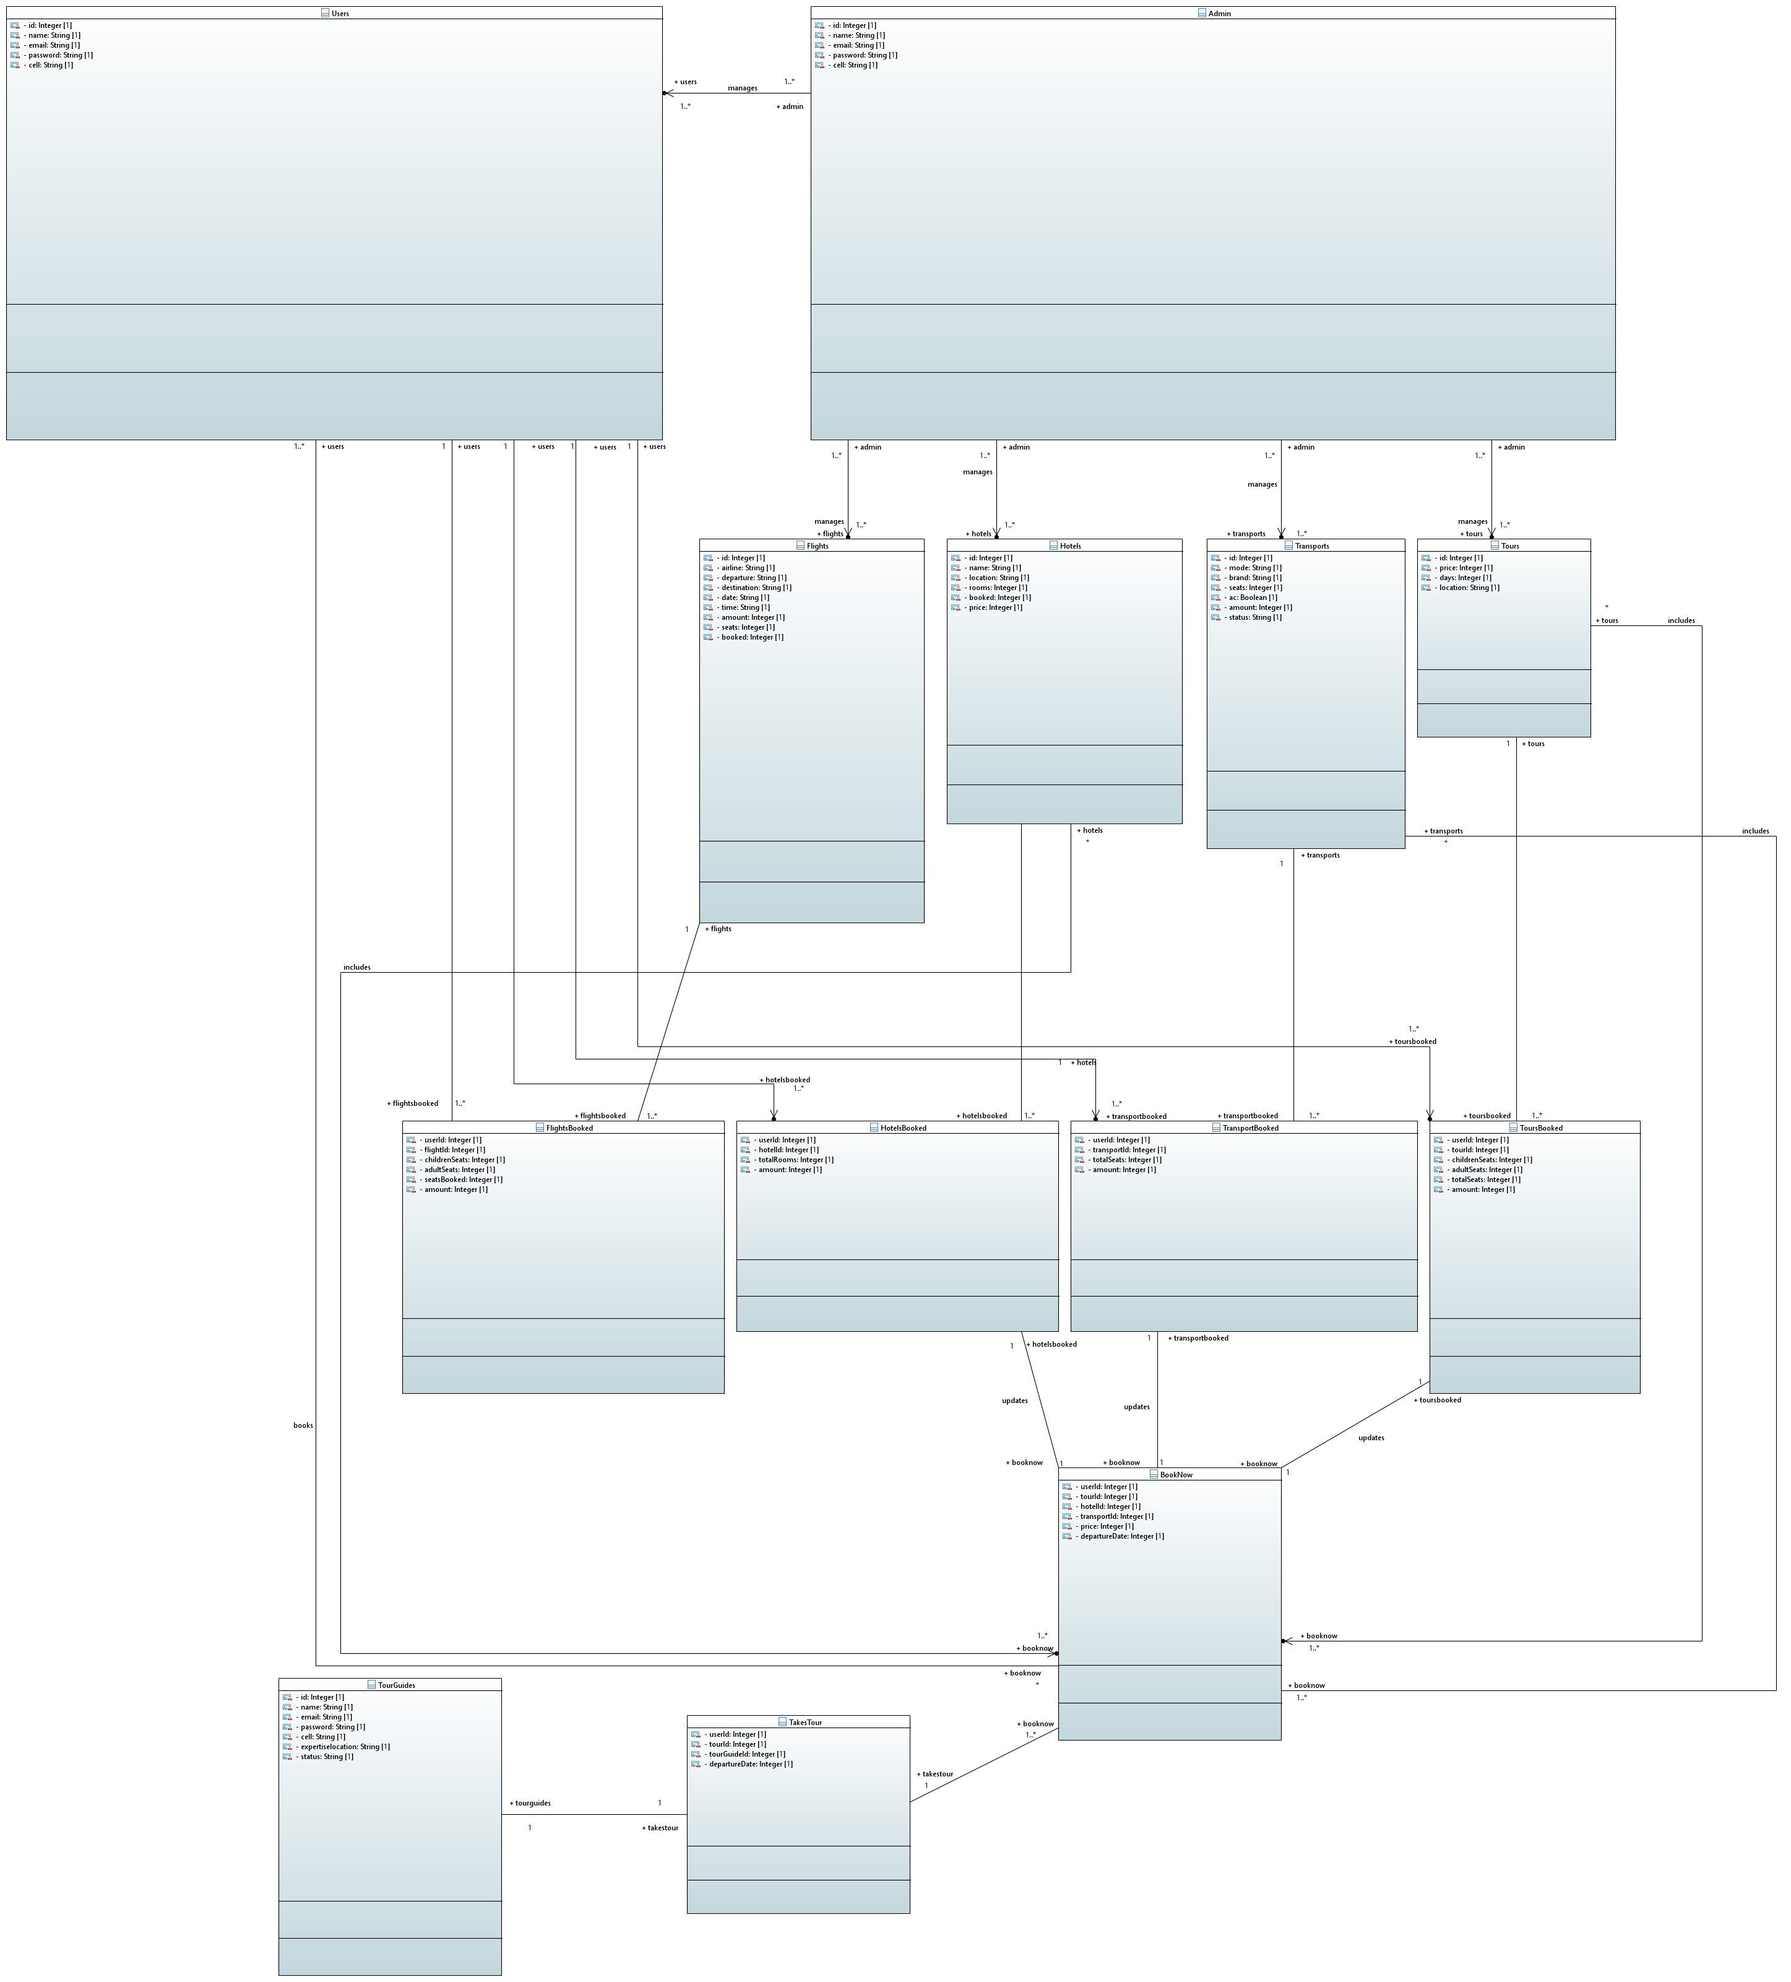

- CLASS DIAGRAM:
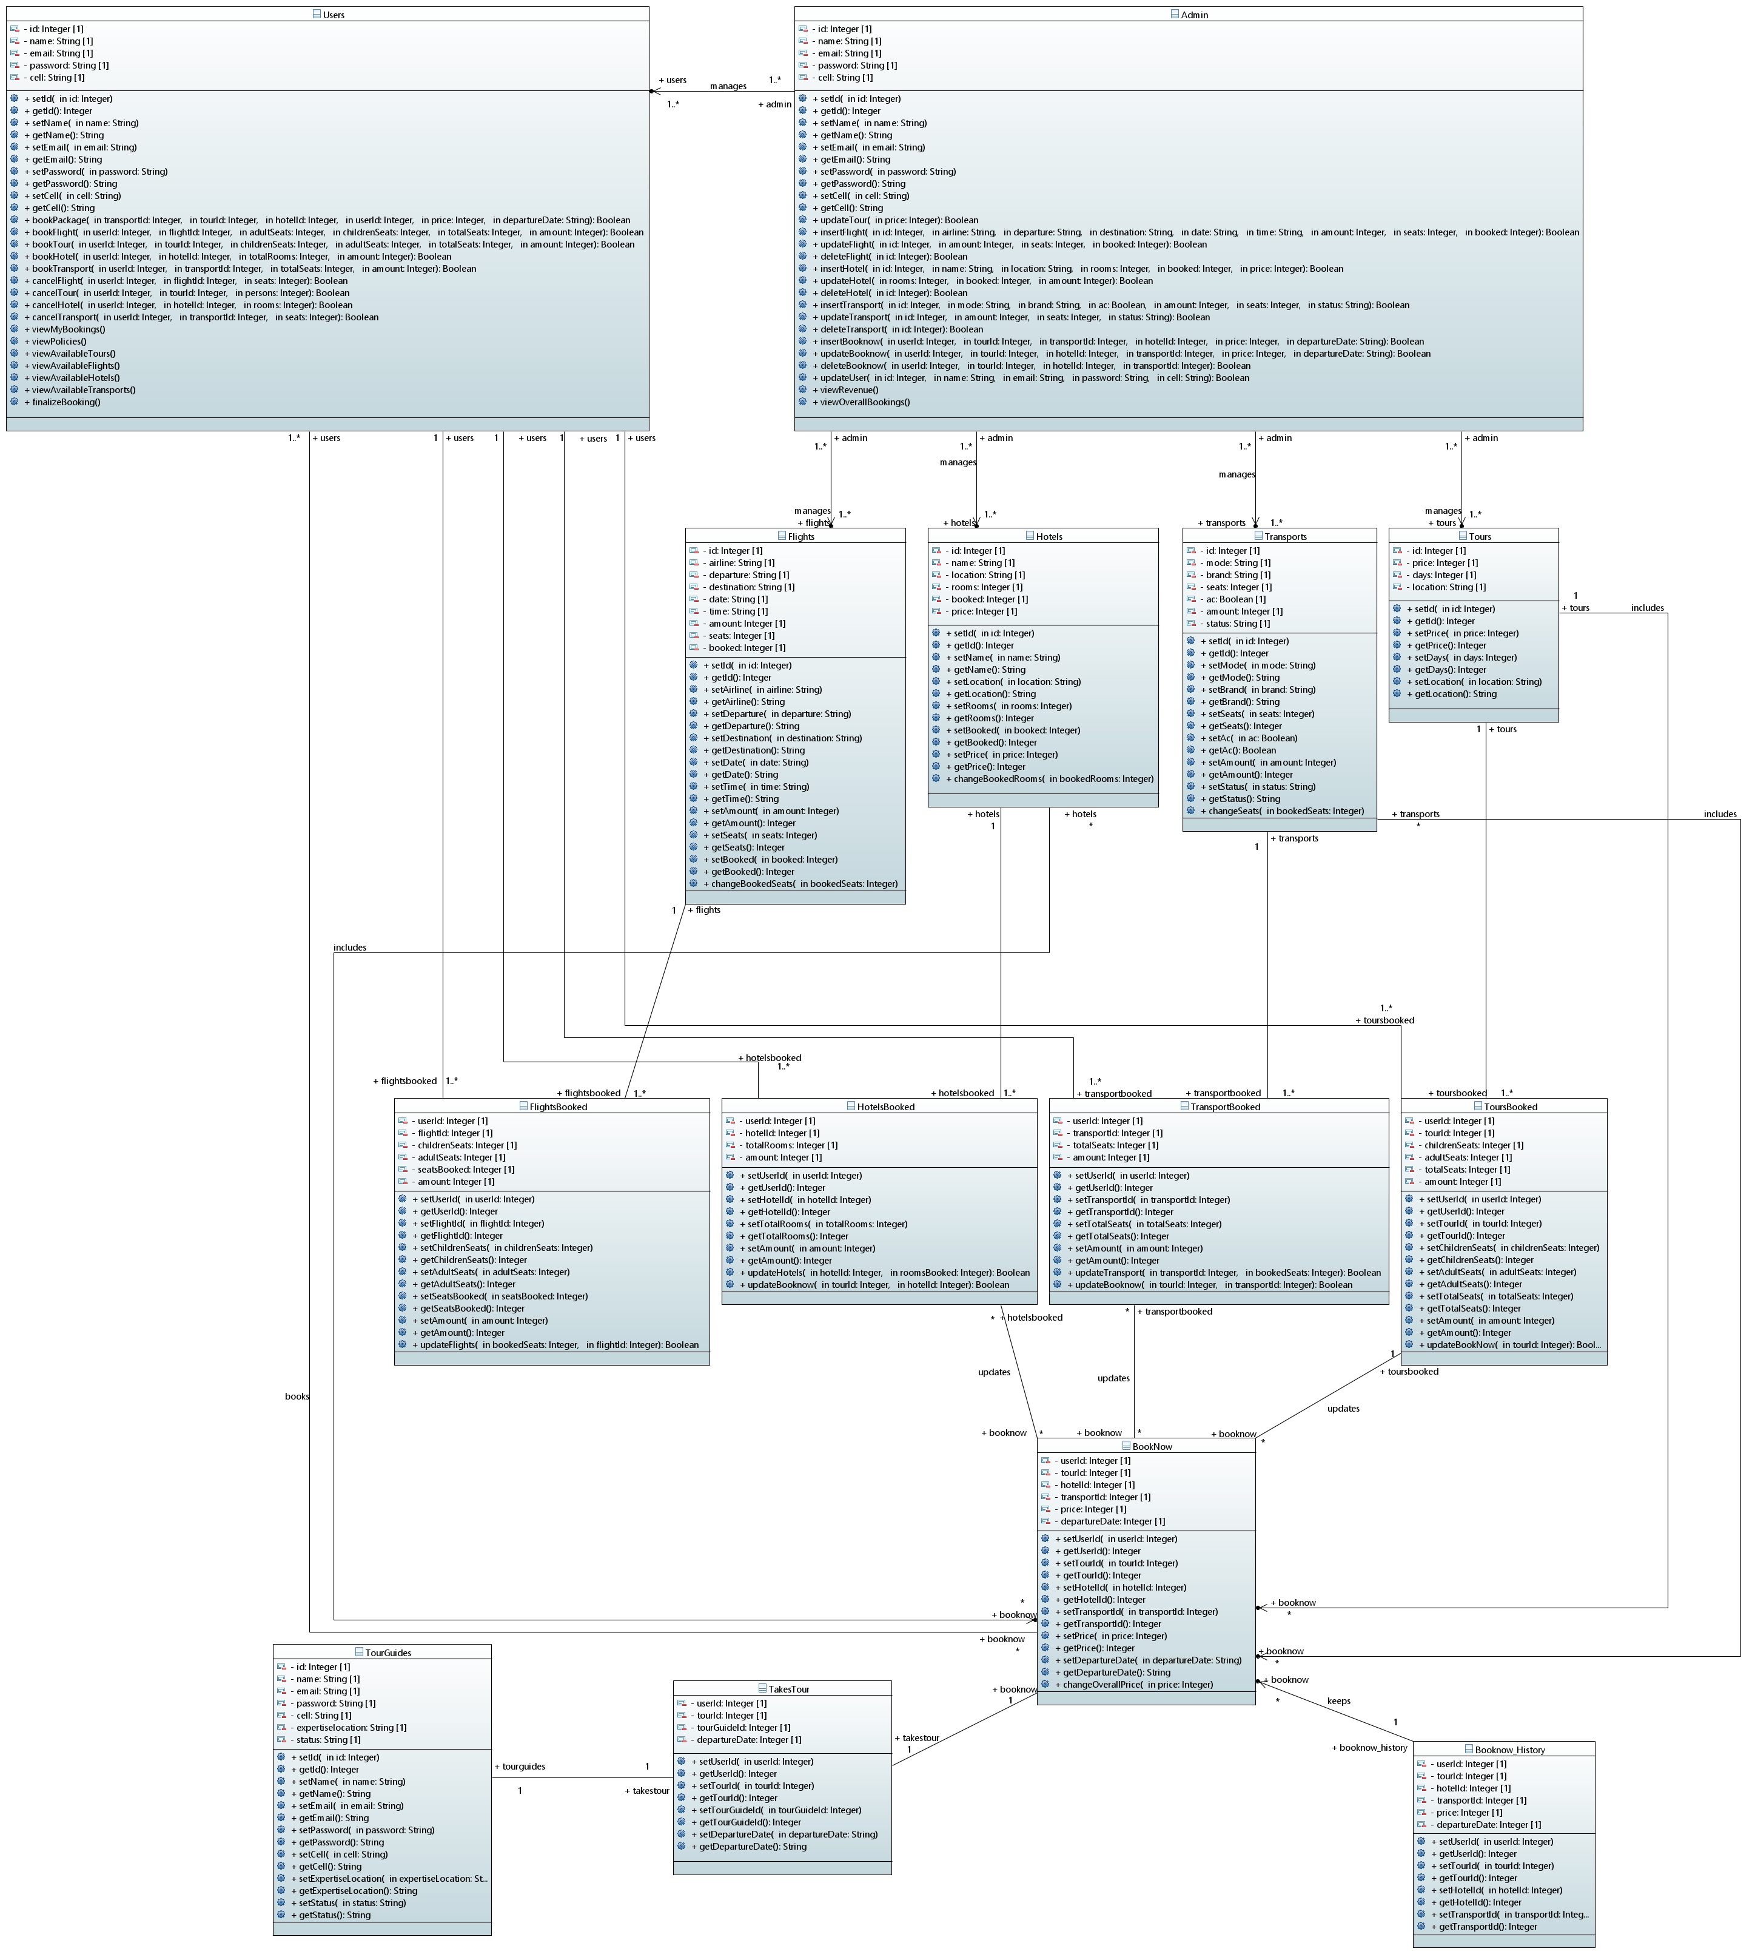

- ACTIVITY DIAGRAM:
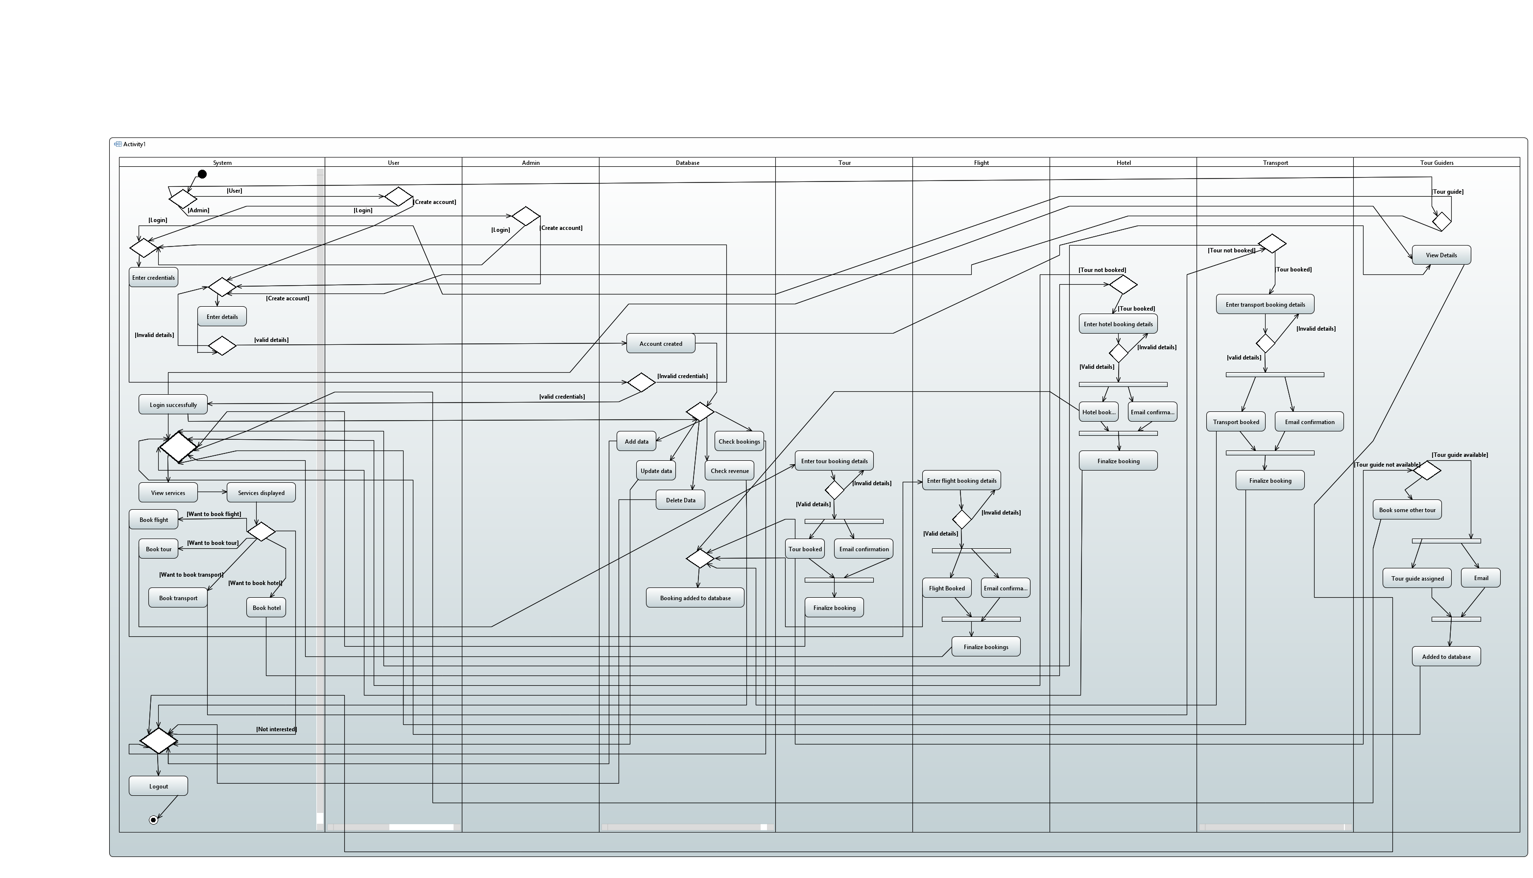

- USE CASE DIAGRAM:
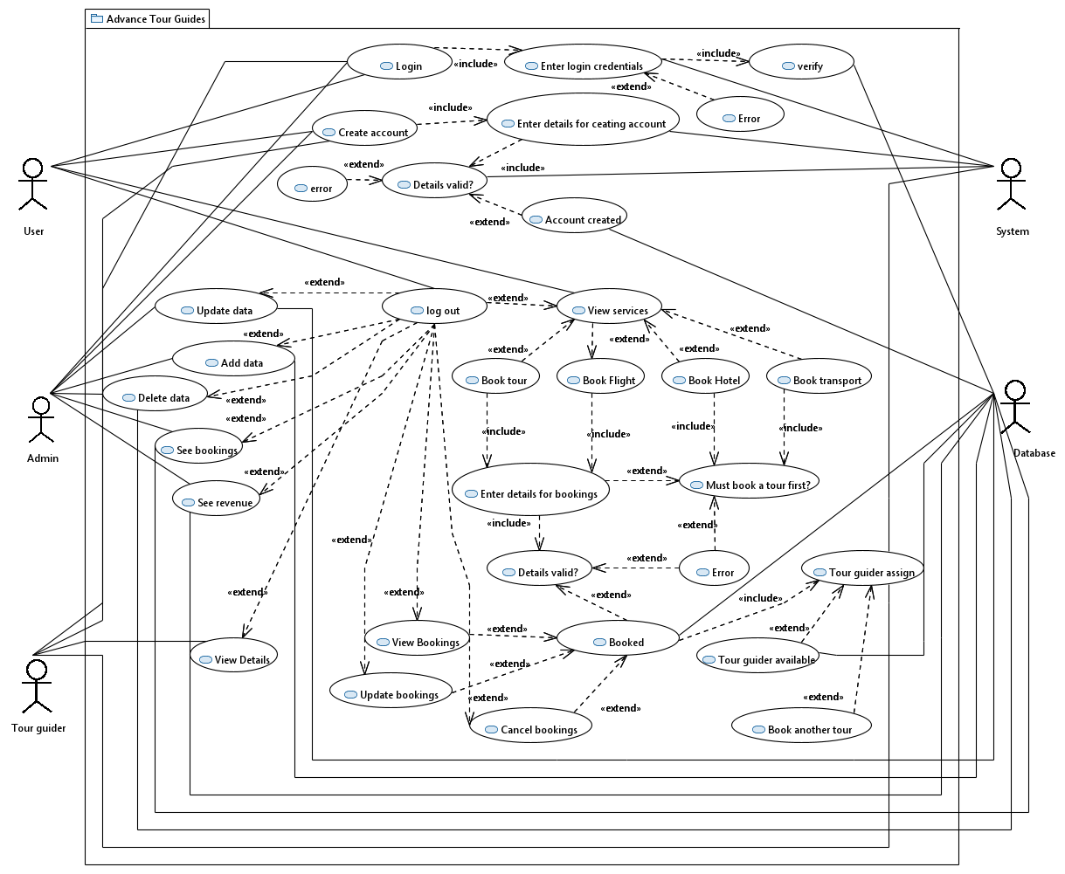

- COMPONENT DIAGRAM:
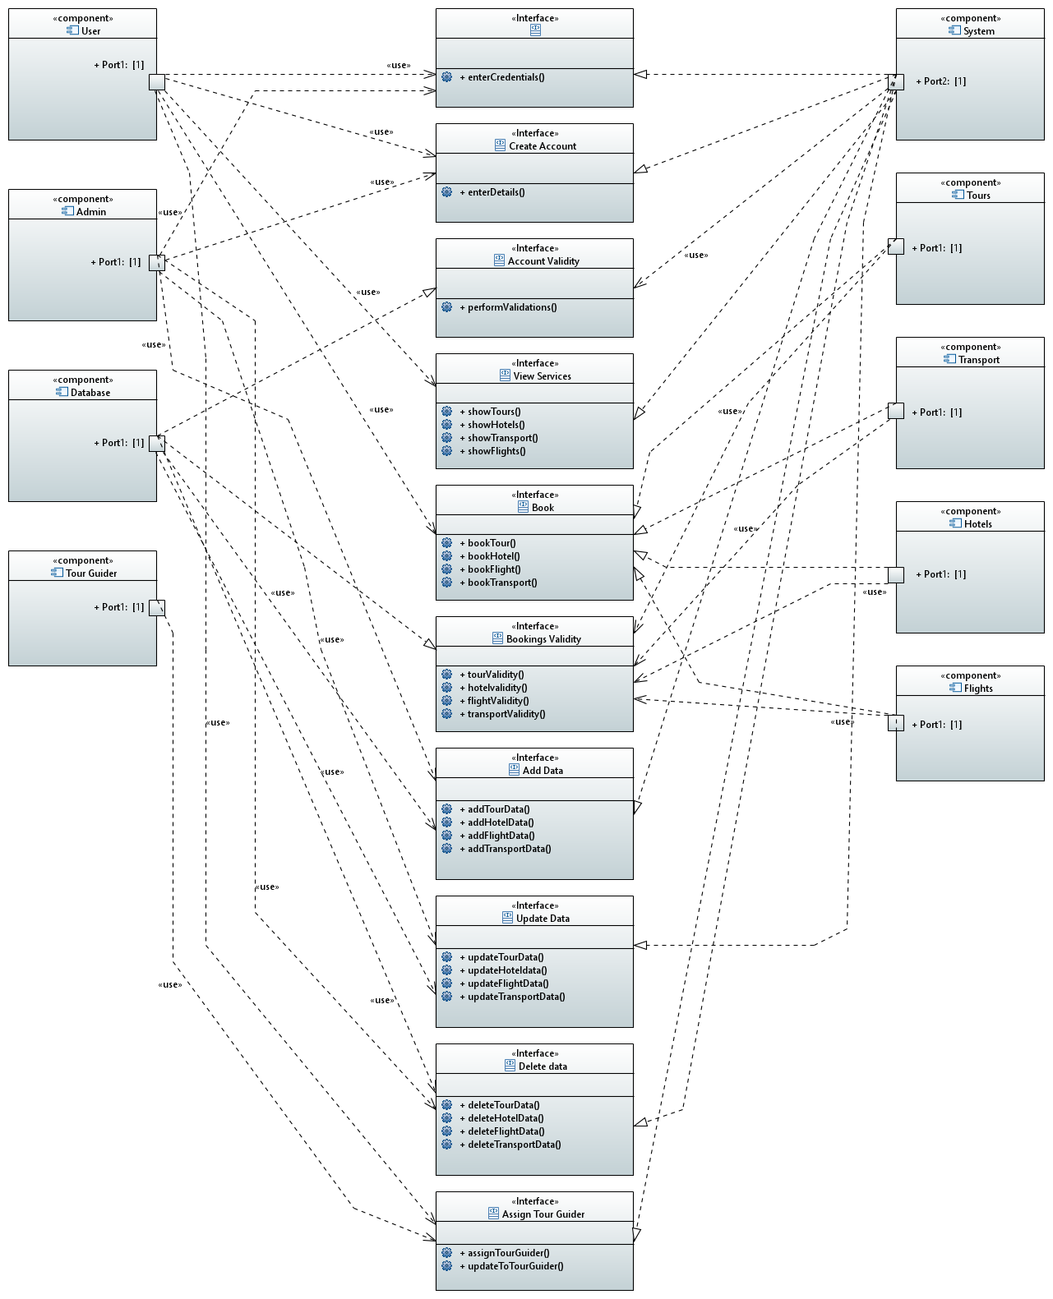
- SEQUENCE DIAGRAM:
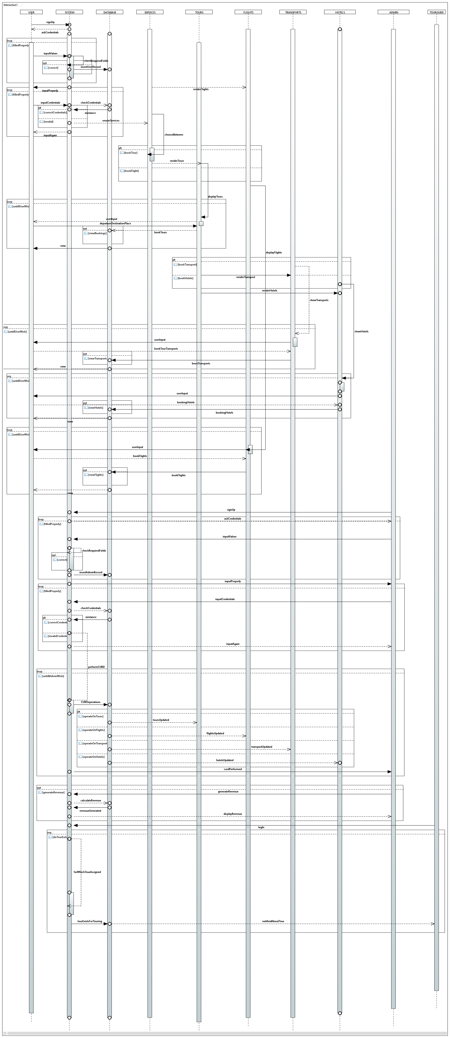
- COMMUNICATION DIAGRAM:
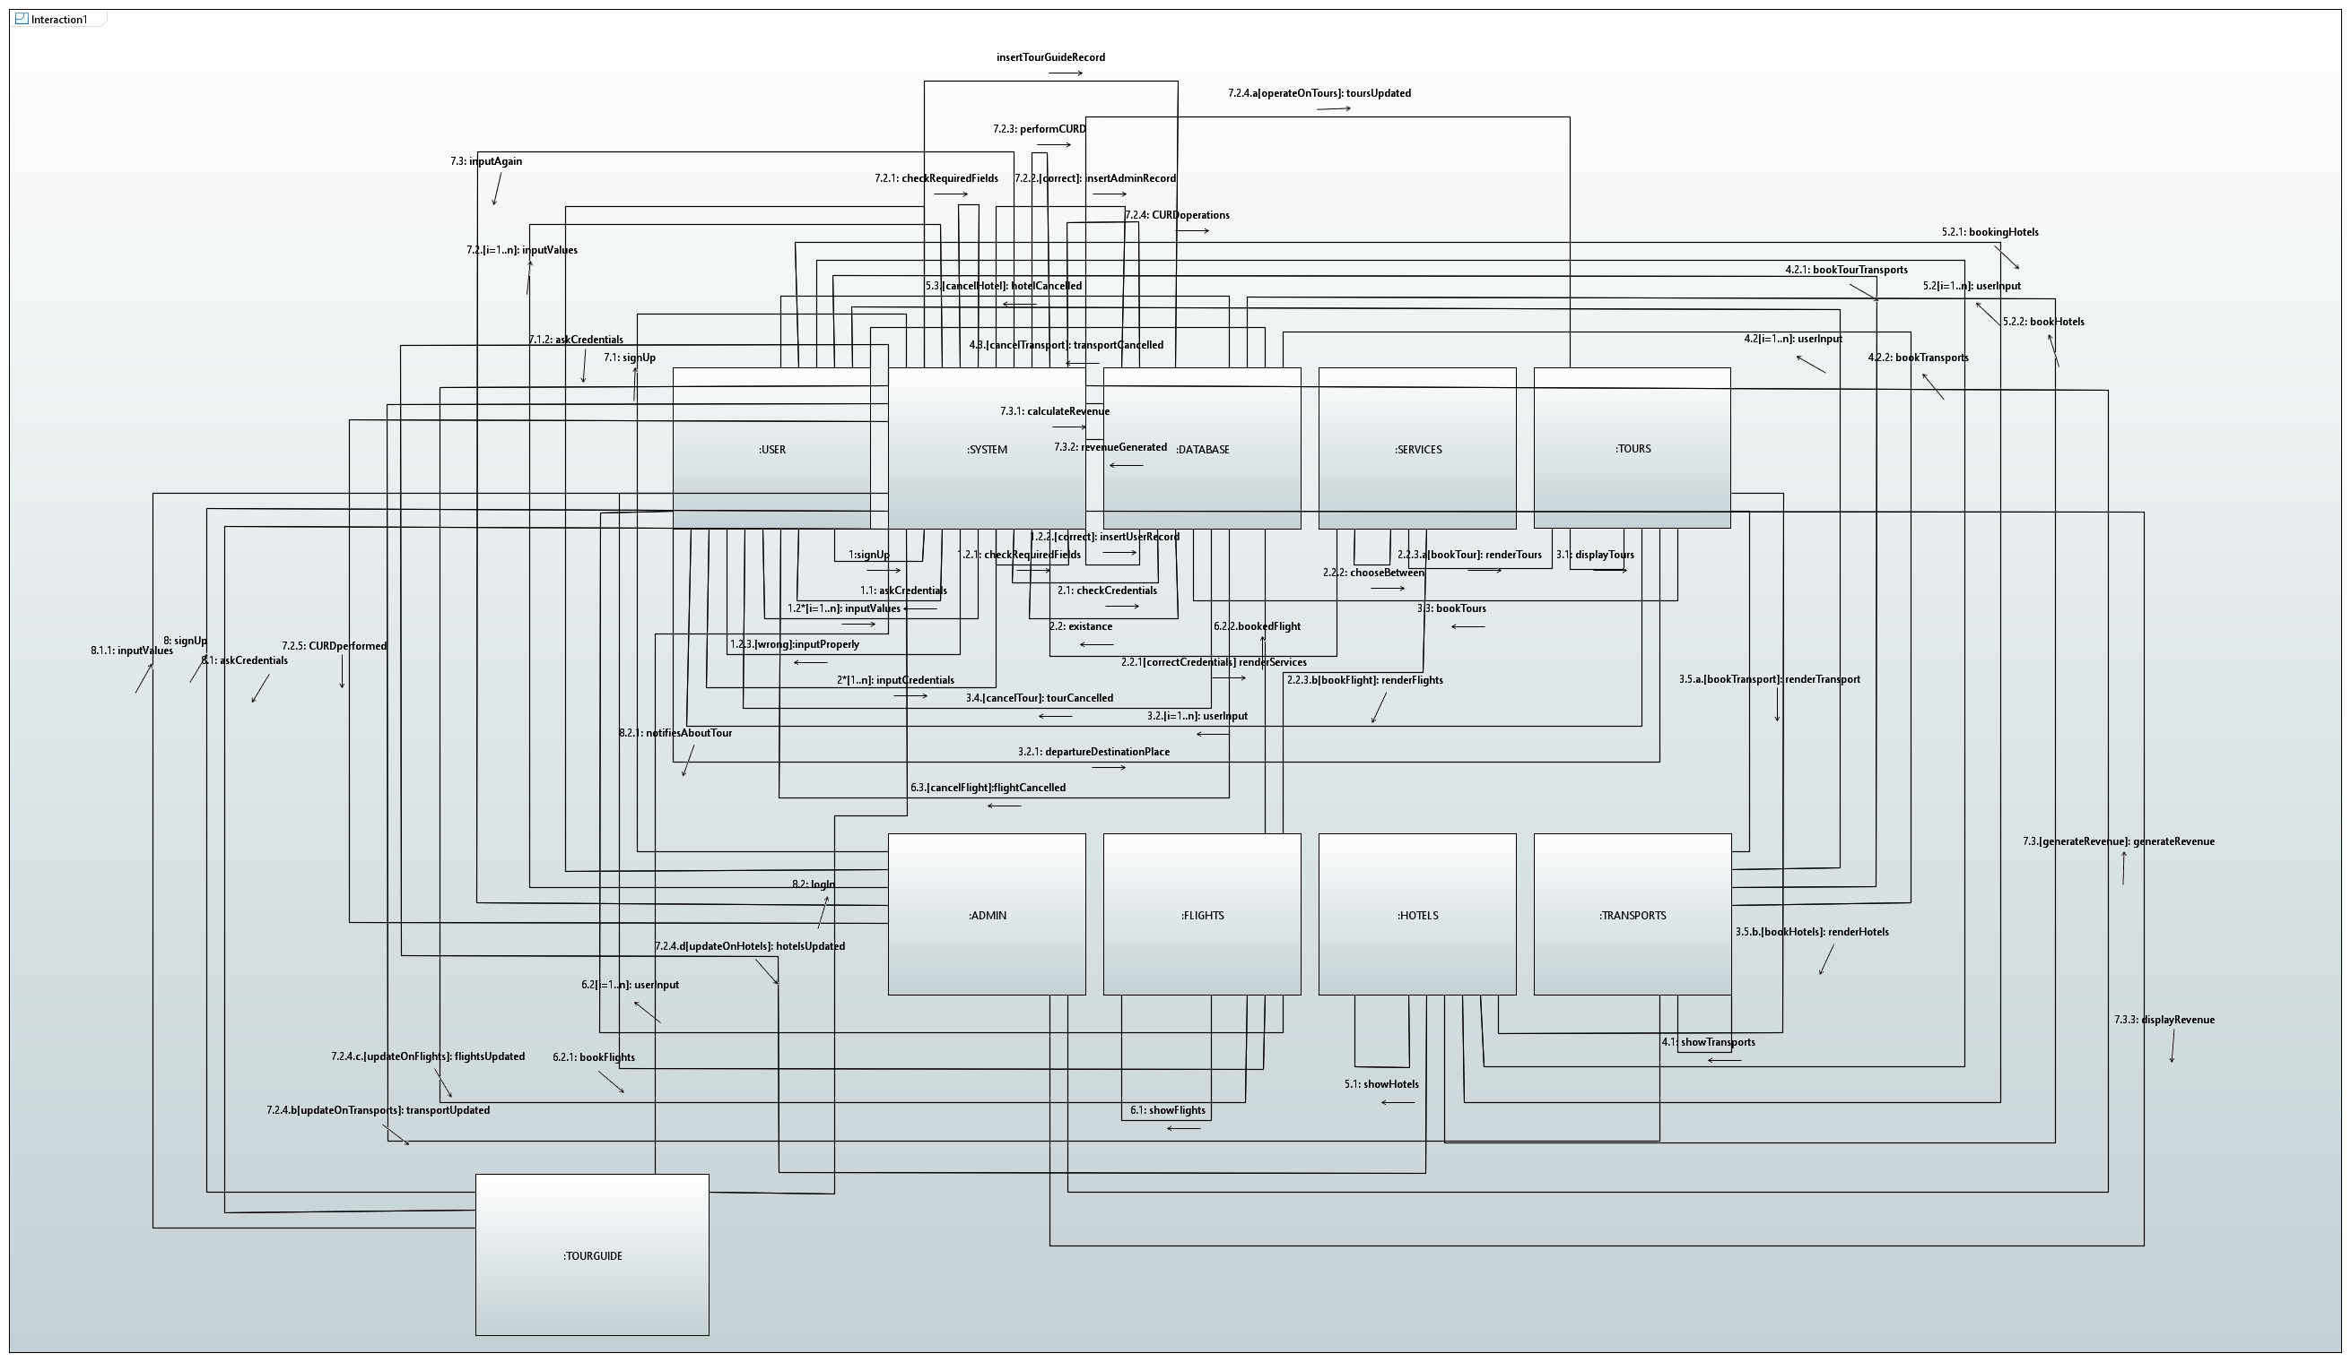
- DEPLOYMENT DIAGRAM:
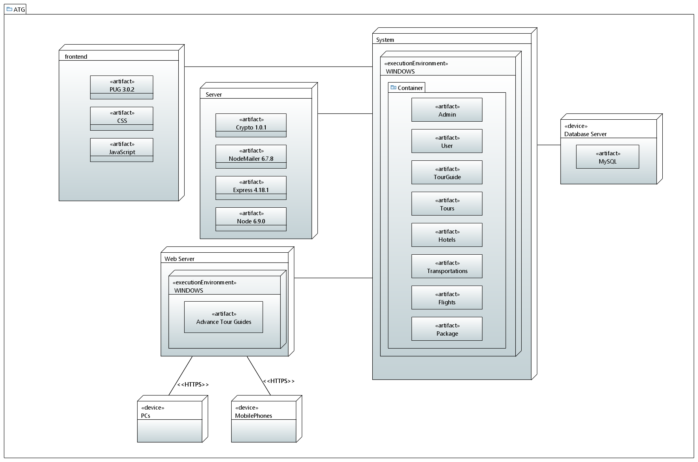
- STATE CHART DIAGRAM:
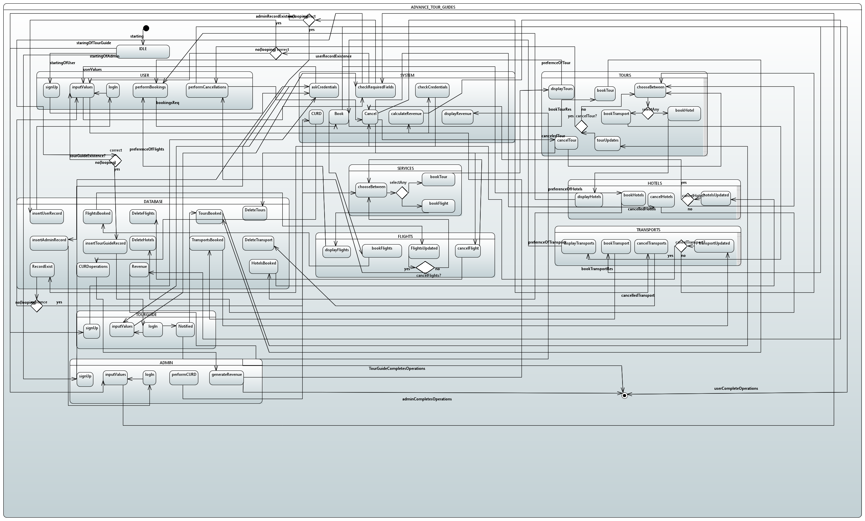

Appendix B: To Be Determined List
- Our project is limited to the citizens of Pakistan and services are only provided within Pakistan. Although, we are trying to extend ATG outside Pakistan. Once we get successful, this SRS will be again referred to make some changes in functional, nonfunctional requirements along with specifying the stake holders.

