**TO EXECUTE ON THE PYCHARM FOR GUI**

1. Open the folder “**ProductTitleClassification_k200247_k200228_k200333**” on PyCharm. Once opened, click on “**GUI.py”**:

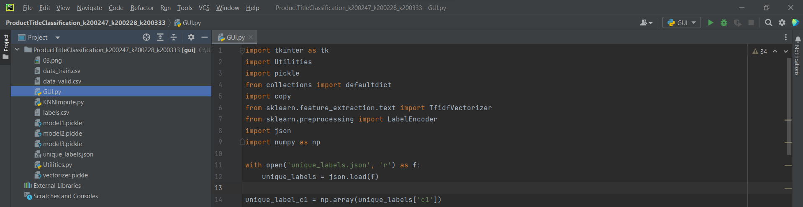

1. Once opened, click on this button at top right of the window:

1. Then the following window will appear:

1. Next Type the product title in place of “**Provide Title’s Description**”:

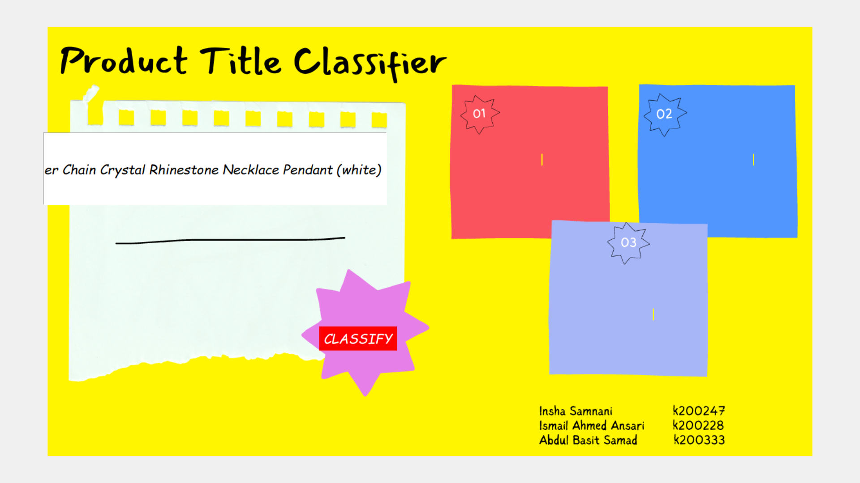

1. Then click on “**CLASSIFY**”:

1. Finally, you will see the resulting categories:

**TO EXECUTE ON THE GOOGLE COLAB FOR NORMAL EXECUTION**

**PREREQUISITE:**

Upload “**KNNImpute.py**” and “**Utilities.py**” files on your google drive.

1. **RANDOM FOREST CLASSIFIER:**

Open “**Random_Forest_Classifier.ipynb**” in **GOOGLE COLAB**.

Upload “**data_train.csv**”, “**data_valid.csv**”, and “**labels.csv**”.

Next, click on “**Run all**” to observe the execution:

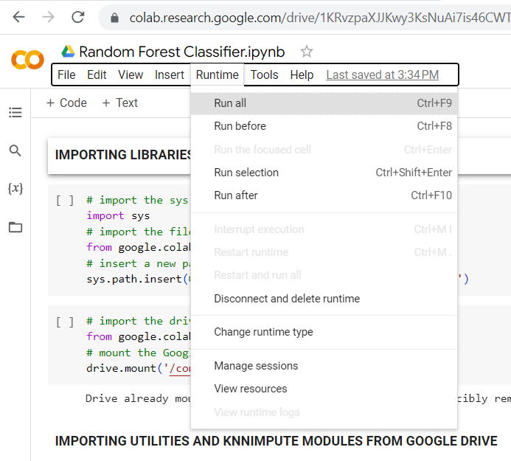

During execution, grant access to your Gmail account to mount the google drive on this notebook.

1. **SUPPORT VECTOR MACHINE:**

Open “**Support_vector_Machine.ipynb**” in **GOOGLE COLAB**.

Upload “**data_train.csv**”, “**data_valid.csv**”, and “**labels.csv**”.

Next, click on “**Run all**” to observe the execution:

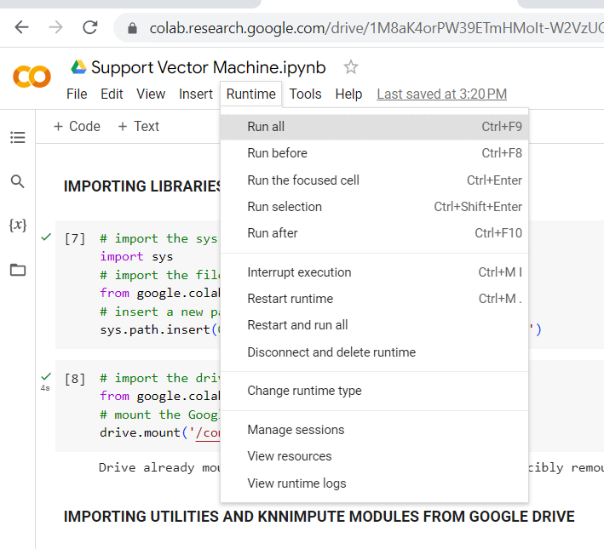

During execution, grant access to your Gmail account to mount the google drive on this notebook.

You can change the query as you want by typing it here in the last cell:

After successful execution, scroll down to the last cell to view the query results:

