**SUDOKU MYSTIFIER**

**INSHA SAMNANI (20k-0247)**

**ISMAIL AHMED ANSARI (20k-0228)**

**YUSRA ADAM (20k-0207)**

**NATIONAL UNIVERSITY OF COMPUTER AND EMERGING SCIENCES - FAST**

**INTRODUCTION:**

Sudoku, sounds interesting? A 9 by 9 grid that needs to be completed in such a way that each row, each column and each of the 9 main 3 by 3 sub-grids contains just one of each of the numbers 1 to 9. Our project “Sudoku Mystifier” also performs the same functionality. Solving the sudoku puzzle with user defined inputs as well as solving grid with random values detecting whether the inputs are valid or not is what “Sudoku Mystifier” does.

**LITERATURE REVIEW:**

Our project “Sudoku Mystifier”, fulfils the demand of solving the grid keeping in mind of all the rules. If any invalid input is being provided user is asked to enter again until rules are being fulfilled.

Solving a sudoku puzzle with accuracy is being done with the help of many algorithms. One algorithm is the “Paper-pencil” algorithm. In this algorithm human based used strategies are used to fulfill the requirements. The methods used in this algorithm are unique missing candidates, naked singles and hidden singles. Another algorithm used to solve sudoku puzzles is the “Brute Force” algorithm. In this algorithm, a random solution is being generated and after that it is checked whether the solution is correct or not. If it is not correct, then the process is repeated again. This algorithm can be time consuming because it will go through all possibilities of solutions. A scholar named “Nelishia Pillay” suggests solution for solving sudoku puzzles by combining human intuition and optimization.

Many algorithms have been considered to solve the sudoku puzzles but one thing every expert looks is optimized algorithm that produces accurate results.

**PROBLEM DEFINATION:**

Solving a sudoku puzzle with efficiency and accuracy can sometimes be something worth time consuming. Many algorithms have been previously used in order to generate accurate results after solving the sudoku grid. Online websites providing algorithms are not always worth to follow as there can be a chance of wrong implementation of rules. “Sudoku Mystifier” makes sure that the grid provided by user is solved keeping in view all the rules. Moreover, our project enables user to enter own values and if any invalid value is being entered, user is notified and asked to enter a new value.

**METHADOLOGY/SOLUTION STATEMENT:**

**TOOLS USED ARE:** Irvine32.inc Library, Microsoft Visual Studio Code 2019.

**Following is the flow of our project. The details also includes different techniques and algorithms used in the respective functions.**

* WelcomeInterface: The function is showing the front cover of our output (using setTextColor, writeString, clrscr). It is also taking the option as input from user (0 for playing game, 1 for getting your Sudoku solved) through ReadInt.
* PlayGame: The function is further calling ReadTheGrid, PrintGrid, and inputValues.
  + ReadTheGrid: The function is using filing and its functions (SIZEOF, OFFSET, OpenInputFile, and ReadFromFile) to read one Sudoku puzzle out of different Sudoku puzzles from the file. It is using Randomize and RandomRange function for selection. (INC, CMP, and Jumps are also used).
  + PrintGrid: The function is further calling printHorizontalLine using different variables to display a user defined grid to play the game in a successful user interface. It will also make the selected Sudoku to be displayed on the console along with the grid. Jumps are used to achieve respective tasks. (CMP, writeString, writeDec etc are also used).
  + InputValues: The function is calling findEmptyPlace to see if any of the element in the grid is 0 so that it will continue the process of taking values as input from user. Then user will be asked about row no col no and a value to be placed. All these will be verified via function Authentication1. It is also calling checkGrid function to check if the required space is containing 0(empty). Then value along with row and column will be checked via function isvalidplace. IsValidPlace further calls three functions: isPresentInRow, isPresentInCol, isPresentInBox. All these functions check if the value entered by the user are not repeated in the specified row, column, and the box. (CMP, INVOKE, and Jumps are used). LEA is also used to hold offsets of row and columns. It is also calling PrintGrid function to print grid immediately after user enters the value again and again.
* Getting your Sudoku solved (sudokuSolver): Firstly the function is calling inputgrid function, solverSudoku function.
  + Inputgrid: The function calls PrintGrid function. It is using nested looping to take input of all the 9 values of 9 respective rows from the user. All the values are checked through Authentication0 function. (INC, DEC, clrscr, writeString, CMP etc are used).
  + SolveSudoku: It is a recursive approach to solve Sudoku for the user. It traverses whole grid and tries to place a value starting from 1 if it is valid via isvalidplace. If it finds valid so indexes of rows and columns are incremented respectively. Else it is backtracked and filled with 0 to again check it for incremented value that is 2. The process is continued unless it is unable to find some empty space (0) via findEmptyPlace. (LEA, CMP, PUSH, Jumps, INC etc are used).
* Now after the whole process, it is checking that whether the Sudoku is solved or not, if solved so printed via PrintGrid, else an error is shown that Sudoku can’t be solved.

**DETAILED DESIGNED AND ARCHITECTURE:**

cin >> option; to play game or get your Sudoku solved?

**FOR PLAYING THE GAME:**

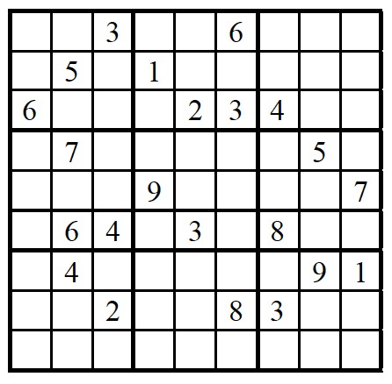

**NOTE: (0s will be filled in empty spaces)**

While any of the element in the grid is 0

Read the row number

Authentication1(); value lie between 1-9

Read the column number

Authentication1(); value lie between 1-9

checkGrid(); desired location is having 0?

Read value from user; value lie between 1-9

isValidPlace(); same value isn’t present in that row, column or box

PrintGrid(); print the grid everytime for the user after inserting a single value

**FOR GETTING YOUR SUDOKU SOLVED:**



**NOTE: (0s will be filled in empty spaces)**

Inputgrid(); above mentioned incomplete Sudoku puzzle will be taken as input from the user along with 0s as spaces.

Authentication0(); all values entered by Inputgrid() lie between 0-9

solveSudoku(); recursive approach (including backtracking) to let computer analyze the appropriate value for the specific row and column one by one in the incomplete puzzle by respectively incrementing the value or indexes and starting from 1.

if(boolval==1); if user input all values according to the Sudoku rules

PrintGrid(); printing solved Sudoku for user

else

cout << msg; Sudoku can’t be solved

**IMPLEMENTATION AND TESTING AND PROGRAM CODE:**

INCLUDE Irvine32.inc

;SUDOKU SOLVER AND GAME

Authentication0 PROTO, valt:DWORD

Authentication1 PROTO, valt:DWORD

checkGrid PROTO, rowNo:DWORD, colNo:DWORD

.data

;GRID-INFO:

N BYTE 9

score DWORD 0

grid BYTE 81 DUP (?)

gridcopy BYTE 81 DUP (?)

gridgame_tmp BYTE 1630 DUP(0) ;81 ELEMENTS, 80 SPACES (EACH LINE CONTAINS

;ONE SUDOKU-TOTAL 10 SUDOKUS)

;BOOLEANS:

bool1 BYTE ?

bool2 BYTE ?

mbool3 BYTE 0

bool4 BYTE ?

bool5 BYTE 0

bool6 BYTE 0

;MESSAGES:

end_msg BYTE "\\----- GAME IS NOW EXITING -----//", 0

mesg BYTE "The solved grid is: ", 0

msg BYTE "No solution exists for the given grid!", 0

msg2 BYTE "Unsolved Grid:", 0

msg3 BYTE "Solved Grid:", 0

msg4 BYTE "Enter the row no: ", 0

msg5 BYTE "Enter the column no: ", 0

msg6 BYTE "Enter the value: ", 0

msg7 BYTE "You Won!!!", 0

space BYTE ' ', 0

multiplespace BYTE " ", 0

vertical BYTE "| ", 0

horizontal BYTE "---", 0

rowmsg BYTE "Enter the elements for ROW-", 0

msgg BYTE "This is an INVALID VALUE! ", 0

st_msg1 BYTE "Hey! I'm Shaggy!", 0

st_msg2 BYTE "Do You Wanna PLAY SUDOKU with me or LET me SOLVE one with you??", 0

st_msg3 BYTE "ENTER 0 TO START THE GAME", 0

st_msg4 BYTE "ENTER 1 TO GET YOUR SUDOKU SOLVED", 0

st_msg5 BYTE "Your Option: ", 0

st_msg6 BYTE "ENTER ANY KEY TO GO BACK TO THE MAIN MENU......", 0

sc_msg BYTE "Woah! Your score is ", 0

;FILE-HANDLING:

filename BYTE "Sudoku.txt", 0

filehandle DWORD ?

.code

Authentication1 PROC USES edx, valt:DWORD ;checks whether the data is from 1 to 9

MOV bool6, 0

MOV edx, valt

CMP edx, 9

JNC J1

CMP edx, 1

JNC J2

J1:

JZ J2

RET

J2:

MOV bool6, 1 ;TRUE

RET

Authentication1 ENDP

Authentication0 PROC USES edx eax, valt:DWORD ;checks whether the data is from 0 to 9

MOV bool5, 0

MOV edx, valt

CMP edx, 9

JNC J1

CMP edx, 0

JNC J2

J1:

JZ J2

RET

J2:

MOV bool5, 1 ;TRUE

RET

Authentication0 ENDP

checkGrid PROC USES eax ebx esi, rowNo:DWORD, colNo:DWORD

MOV bool6, 0

MOV ebx, OFFSET gridcopy

MOV eax, rowNo

MUL N

ADD ebx, eax

MOV esi, colNo

cmp BYTE PTR [ebx+esi], 0

JNZ J1

MOV bool6, 1

J1:

RET

checkGrid endp

inputValues PROC USES eax esi edx ebx

LOCAL rowNo:DWORD, colNo:DWORD, Value:DWORD

L1: ; While Loop

MOV rowNo, 0

MOV colNo, 0

LEA eax, rowNo

LEA ebx, colNo

PUSH eax

PUSH ebx

CALL findEmptyPlace

ADD esp, 8

CMP bool2, 1 ;empty place found

JNZ J3

MOV ebx, OFFSET grid

MOV esi, 0

MOV edx, OFFSET msg4

CALL WriteString

CALL readDec

MOV rowNo, eax

INVOKE Authentication1, rowNo

CMP bool6, 1

JNZ J1

DEC rowNo

MOV bool5, 0

MOV bool6, 0

MOV edx, OFFSET msg5

CALL WriteString

CALL readDec

MOV colNo, eax

INVOKE Authentication1, colNo

CMP bool6, 1

JNZ J1

DEC colNo

PUSH rowNo

PUSH colNo

INVOKE checkGrid, rowNo, colNo

CMP bool6, 1

JNZ J1

MOV bool6, 0

MOV bool5, 0

MOV edx, OFFSET msg6

CALL WriteString

CALL readDec

MOV Value, eax

MOV bool4, 0

PUSH rowNo

PUSH colNo

PUSH Value

CALL isvalidplace

ADD esp, 12

CMP bool4, 1

JNZ J1

MOV eax, rowNo

MUL N

ADD ebx, eax

MOV esi, colNo

MOV eax, Value

INVOKE Authentication1, eax

CMP bool6, 1

JNZ J1 ;The case of invalid

ADD score, 5

MOV BYTE PTR [ebx+esi], al

CALL printGrid

JMP J2

J1:

CALL crlf

MOV edx, OFFSET msgg

CALL WriteString

CALL crlf

CALL crlf

CALL PrintGrid

J2:

JMP L1

J3:

MOV bool2, 0

MOV edx, OFFSET msg7

CALL crlf

CALL writeString

MOV edx, OFFSET sc_msg

CALL crlf

CALL crlf

CALL crlf

CALL WriteString

MOV eax, score

CALL WriteDec

CALL crlf

CALL crlf

MOV edx, OFFSET st_msg6

CALL WriteString

CALL crlf

CALL crlf

CALL readChar

RET

inputValues ENDP

inputgrid PROC USES eax ebx ecx edx

LOCAL var_counter: DWORD

MOV var_counter, 0

MOVZX ecx, N

MOV ebx, OFFSET grid

MOV eax, 0

L1:

PUSH ecx

MOV esi, 0

CALL PrintGrid

MOV edx, OFFSET rowmsg

CALL Writestring

MOV eax, var_counter

INC eax

CALL WriteDec

MOVZX ecx, N

CALL crlf

L2:

CALL ReadInt

INVOKE Authentication0, eax

CMP bool5, 1

JNZ JM2

CMP eax, 0

JZ J1

PUSH var_counter

PUSH esi

PUSH eax

CALL isvalidplace

ADD esp, 12

CMP bool4, 1

JNZ JM2

MOV bool4, 0

J1:

MOV BYTE PTR [ebx+esi], al

MOV eax, 0

INC esi ;COL-INC

LOOP L2

JMP JM3

JM2:

MOV edx, OFFSET msgg

CALL WriteString

CALL crlf

JMP L2

JM3:

INC var_counter

CALL clrscr

MOVZX edi, N

ADD ebx, edi ;ROW-JUMP

POP ecx

DEC ecx

CMP ecx, 0

JNZ L1

RET

inputgrid ENDP

printHorizontalLine PROC USES ecx

PUSH ebp

MOV ebp, esp

MOVZX ecx, N

DEC ecx

CALL crlf

MOV edx, OFFSET multiplespace

CALL WriteString

L1:

MOV edx, OFFSET horizontal

CALL WriteString

LOOP L1

POP ebp

RET

printHorizontalLine ENDP

PrintGrid PROC USES eax edx ebx esi edi ecx

PUSH ebp

MOV ebp, esp

CALL printHorizontalLine

CALL crlf

MOV ebx, OFFSET grid

MOVZX ecx, N

l1:

MOV edi, ecx

MOV esi, 0

MOVZX ecx, N

MOV edx, OFFSET multiplespace

CALL WriteString

l2:

CMP ecx, 6

JC J2

JNZ J1

MOV edx, OFFSET vertical

CALL WriteString

J2:

CMP ecx, 3

JNZ J1

MOV edx, OFFSET vertical

CALL WriteString

J1:

CMP ecx, 9

JNZ J5

MOV edx, OFFSET vertical

CALL WriteString

J5:

MOVZX eax, BYTE PTR [ebx+esi]

CALL WriteDec

MOV edx, OFFSET space

CALL WriteString

INC esi

CMP ecx, 1

JNZ J6

MOV edx, OFFSET vertical

CALL WriteString

J6:

LOOP l2

MOVZX eax, N

ADD ebx, eax

CMP edi, 7

JC J4

JNZ J3

CALL printHorizontalLine

J4:

CMP edi, 4

JNZ J3

CALL printHorizontalLine

J3:

CMP edi, 1

JNZ J7

CALL printHorizontalLine

J7:

CALL crlf

MOV ecx, edi

DEC ecx

CMP ecx, 0

JNZ l1

POP ebp

CALL crlf

RET

PrintGrid ENDP

isPresentIncol PROC USES ecx esi ebx eax edx

PUSH ebp

MOV ebp, esp

MOVZX ecx, N

MOV ebx, OFFSET grid

MOV esi, [ebp+32] ;COL-VALUE

MOVZX edx, BYTE PTR [ebp+28] ;NUM-VALUE

L1:

PUSH ecx

MOVZX ecx, N

CMP BYTE PTR [ebx+esi], dl

JZ J2

ADD ebx, ecx ;row-jump

POP ecx

LOOP L1

POP ebp

RET

J2:

POP ecx

INC mbool3

POP ebp

RET

isPresentIncol ENDP

isPresentInrow PROC USES ecx esi ebx eax edx

PUSH ebp

MOV ebp, esp

MOVZX ecx, N

MOV ebx, OFFSET grid

MOV eax, [ebp+32] ;row

MUL N

ADD ebx, eax

MOV esi, 0 ; COL-VALUE

MOVZX edx, BYTE PTR [ebp+28] ;NUM-VALUE

L1:

PUSH ecx

MOVZX ecx, N

CMP BYTE PTR [ebx+esi], dl

JZ J2

INC esi ;COL-INC

POP ecx

LOOP L1

POP ebp

RET

J2:

POP ecx

INC mbool3

POP ebp

RET

isPresentInrow ENDP

isPresentInBox PROC USES ecx esi ebx eax edx edi

PUSH ebp

MOV ebp, esp

MOV ebx, OFFSET grid

MOV esi, 0

MOVZX eax, BYTE PTR [ebp+40] ;row-row%3

MOVZX edi, BYTE PTR [ebp+32] ;EDI = NUM

MOV ecx, 3

MUL N ;eax

MOV edx, [ebp+36] ;col-col%3

ADD ebx, eax

L1:

PUSH ecx

MOV ecx, 3

MOV esi, edx

L2:

PUSH ecx

MOVZX ecx, BYTE PTR [ebx+esi]

CMP edi, ecx

JZ J1

POP ecx

INC esi

loop L2

PUSH edx

MOVZX edx, N

ADD ebx, edx ;OFFSET+9 (For next row)

POP edx

POP ecx

loop L1

POP ebp

RET

J1:

INC mbool3

POP ecx

POP ecx

POP ebp

RET

isPresentInBox ENDP

isValidPlace PROC

PUSH eax

PUSH edx

PUSH esi

PUSH ebp

MOV ebp, esp

mov mbool3, 0

PUSH DWORD PTR [ebp+28] ;ROW

PUSH DWORD PTR [ebp+20] ;NUM

call isPresentInRow

add esp, 8

PUSH [ebp+24] ;COL

PUSH [ebp+20] ;NUM

call isPresentInCol

add esp, 8

MOV esi, 3

MOV edx, 0

MOV eax, [ebp+28]

DIV esi

MOV eax, [ebp+28]

SUB eax, edx

PUSH eax ;row- (row%3)

mov edx, 0

mov eax, [ebp+24]

DIV esi

MOV eax, [ebp+24]

SUB eax, edx

PUSH eax ;col- (col%3)

PUSH [ebp+20] ;NUM

CALL isPresentInBox

ADD esp, 12

CMP mbool3, 0

JNZ J1

MOV bool4, 1

J1:

POP ebp

POP esi

POP edx

POP eax

RET

isValidPlace ENDP

findEmptyPlace PROC USES edx esi edi ebx eax ecx ;return address at ebp+28

PUSH ebp

MOV ebp, esp

MOV ebx, OFFSET grid

MOV eax, [ebp+36] ;row-address

MOV edx, [ebp+32] ;col-address

MOV DWORD PTR [eax], 0 ;row

MOV DWORD PTR [edx], 0 ;col

MOVZX ecx, N

L1:

PUSH ecx

MOV esi, 0

MOV BYTE PTR [edx], 0

MOVZX ecx, N

L2:

CMP BYTE PTR [ebx+esi], 0

JZ ST1

INC esi

INC BYTE PTR [edx]

LOOP L2

MOVZX edi, N

ADD ebx, edi

INC BYTE PTR [eax]

POP ecx

LOOP L1

POP ebp

MOV bool2, 0 ;FALSE

RET

ST1:

POP ecx

POP ebp

MOV bool2, 1 ;TRUE

RET

findEmptyPlace ENDP

SolveSudoku PROC USES eax ebx esi edi edx

PUSH ebp

mov ebp, esp

sub esp, 12

lea eax, [ebp-4] ; row

lea ebx, [ebp-8] ; col

PUSH eax

PUSH ebx

CALL findEmptyPlace

ADD esp, 8

CMP bool2, 1 ;empty place found

JZ J1

MOV bool1, 1 ;TRUE

MOV esp, ebp

POP ebp

RET

J1:

MOV bool2, 0

MOV DWORD PTR [ebp-12], 1 ;try each number

MOVZX ecx, N

L1:

PUSH [eax] ;row

PUSH [ebx] ;col

PUSH DWORD PTR [ebp-12]

CALL isValidPlace

ADD esp, 12

CMP bool4, 1

JNZ ST1

MOV bool4, 0

PUSH eax

MOV edi, OFFSET grid

MOV eax, [eax] ;row

MOV esi, [ebx] ;col

MUL N

ADD edi, eax

MOV edx, DWORD PTR [ebp-12]

MOV BYTE PTR [edi+esi], dl

POP eax

MOV bool1, 0

PUSH ecx

CALL SolveSudoku

POP ecx

CMP bool1, 1

JZ ST2

PUSH eax

MOV edi, OFFSET grid

MOV eax, [eax] ;row

MOV esi, [ebx] ;col

MUL N

ADD edi, eax

MOV BYTE PTR [edi+esi], 0

POP eax

ST1:

INC DWORD PTR [ebp-12]

mov edi, DWORD PTR [ebp-12]

LOOP L1

mov esp, ebp

POP ebp

MOV bool1, 0 ;FALSE

RET

ST2:

mov esp, ebp

POP ebp

RET

SolveSudoku ENDP

ReadTheGrid PROC USES ecx edx eax esi edi ebx

PUSH ebp

MOV ebp, esp

MOV score, 0

MOV edx, OFFSET filename

CALL OpenInputFile

MOV filehandle, eax

MOV ecx, SIZEOF gridgame_tmp

MOV edx, OFFSET gridgame_tmp

CALL ReadFromFile

MOV ebx, OFFSET gridgame_tmp

MOVZX eax, N ;UPPER BOUND FOR PSEUDO-RANDOM NUMBER

CALL Randomize

CALL RandomRange ;RANDOM NUMBER IN eax

MOVZX ecx, N

MOV edx, 0

RANDGRID:

CMP edx, eax

JE ASS1

ADD ebx, 163

INC edx

LOOP RANDGRID

;transfering the values of the randomly selected grid without spaces

ASS1:

MOV esi, ebx

MOV ecx, LENGTHOF grid

MOV edi, OFFSET grid

CLD

L2:

MOVSB

INC esi

LOOP L2

MOV esi, OFFSET grid

MOV ecx, LENGTHOF gridcopy

MOV edi, OFFSET gridcopy

CLD

L3:

MOVSB

LOOP L3

MOV ecx, LENGTHOF grid

MOV esi, OFFSET grid

MOV edi, OFFSET gridcopy

L1:

SUB BYTE PTR [esi], 48

INC esi

SUB BYTE PTR [edi], 48

INC edi

LOOP L1

POP ebp

RET

ReadTheGrid ENDP

PlayGame PROC

ENTER 1, 0

CALL ReadTheGrid

CALL PrintGrid

CALL inputValues

LEAVE

RET

PlayGame ENDP

initialisegrid PROC USES ecx edi eax

PUSH ebp

MOV eax, 0

MOV ecx, SIZE grid

MOV edi, OFFSET grid

CLD

REP STOSB

POP ebp

RET

initialisegrid ENDP

SudokuSolver PROC USES edx

PUSH ebp

MOV ebp, esp

CALL inputgrid

CALL SolveSudoku

CMP bool1, 1

JNZ ST2

MOV edx, OFFSET mesg

CALL WriteString

CALL crlf

CALL crlf

CALL PrintGrid

JMP ST3

ST2:

MOV edx, OFFSET msg

CALL WriteString

CALL crlf

CALL crlf

ST3:

CALL crlf

CALL crlf

MOV edx, OFFSET st_msg6

CALL WriteString

CALL crlf

CALL crlf

CALL readChar

POP ebp

RET

SudokuSolver ENDP

WelcomeInterface PROC USES ebx edx

PUSH ebp

MOV ebp, esp

MOV eax, 16

MOV bl, 15

MUL bl

CALL SetTextColor

CALL clrscr

MOV edx, OFFSET st_msg1

CALL WriteString

CALL crlf

MOV edx, OFFSET st_msg2

CALL WriteString

CALL crlf

MOV edx, OFFSET st_msg3

CALL WriteString

CALL crlf

MOV edx, OFFSET st_msg4

CALL WriteString

CALL crlf

MOV edx, OFFSET st_msg5

CALL WriteString

MOV eax, 0

CALL ReadInt

CALL clrscr

POP ebp

RET

WelcomeInterface ENDP

;ENTERING-POINT:

main PROC USES eax ebx edx ecx

ENTER 0, 0

L1:

CALL WelcomeInterface

;USER'S CHOICE IS RETURNING IN EAX

CMP eax, 0

JNZ J1

;MODULE FOR THE SUDOKU-PLAYER (SUDOKU-GAME)

CALL PlayGame

JMP J2

J1:

CMP eax, 1

JNZ J2

;MODULE FOR USER-GIVEN SUDOKU (SUDOKU-SOLVER)

CALL initialisegrid

CALL SudokuSolver

Loop L1

J2:

CALL crlf

CALL crlf

MOV edx, OFFSET end_msg

CALL crlf

CALL WriteString

CALL crlf

LEAVE

EXIT

RET

main ENDP

END MAIN

**SUDOKU.TXT:**

6 2 0 5 0 0 0 0 0 0 0 0 1 6 0 0 0 3 0 4 0 0 8 0 0 0 7 2 0 0 0 0 0 0 9 0 0 7 8 0 0 5 4 0 0 0 5 0 6 0 7 0 1 0 0 0 9 0 2 0 5 7 8 0 6 0 0 0 1 0 0 9 0 0 3 7 4 0 0 0 0

0 0 0 2 6 0 7 0 1 6 8 0 0 7 0 0 9 0 1 9 0 0 0 4 5 0 0 8 2 0 1 0 0 0 4 0 0 0 4 6 0 2 9 0 0 0 5 0 0 0 3 0 2 8 0 0 9 3 0 0 0 7 4 0 4 0 0 5 0 0 3 6 7 0 3 0 1 8 0 0 0

4 0 0 0 0 0 0 0 0 0 0 0 2 1 8 0 7 0 7 0 0 0 9 0 0 0 2 0 0 6 0 3 0 8 0 4 1 0 0 0 0 0 0 2 0 0 0 5 0 0 7 0 0 0 0 1 0 0 6 0 0 0 0 0 6 0 0 8 5 0 4 0 0 0 9 0 0 0 0 0 8

1 0 0 0 2 0 0 7 6 0 8 9 0 3 4 0 0 0 0 7 0 8 0 0 0 3 0 0 0 5 0 0 9 2 0 0 0 0 4 0 7 0 9 0 0 0 3 0 0 0 0 0 6 5 4 0 0 3 0 0 0 0 8 0 0 0 1 6 0 0 2 0 8 5 0 0 0 0 0 0 7

3 0 0 0 0 9 4 0 7 5 0 2 0 6 0 0 0 0 1 7 0 0 0 0 0 0 8 0 1 0 0 8 0 2 3 0 7 9 0 2 0 0 0 0 0 0 6 0 4 0 5 0 8 0 0 0 0 0 0 1 9 6 0 0 3 4 0 0 0 0 1 0 0 0 0 9 5 8 0 0 0

0 0 0 2 6 0 0 8 0 4 0 9 0 0 0 0 6 1 0 0 5 0 0 0 7 3 0 0 2 0 3 0 1 0 0 5 3 0 7 5 0 0 0 9 8 9 0 0 0 0 4 0 0 2 6 0 2 0 5 0 0 0 7 0 0 0 0 8 7 1 0 0 0 0 0 0 4 0 9 0 0

0 0 4 0 1 0 0 2 0 0 6 0 0 0 9 0 1 5 0 2 0 0 3 0 7 0 0 8 0 0 4 0 6 0 0 0 0 9 0 0 0 7 0 5 3 0 0 1 0 0 0 8 0 0 5 0 7 0 0 0 0 8 9 0 0 3 0 9 4 6 0 0 0 1 0 8 0 2 0 0 0

4 0 3 0 0 1 0 0 0 0 2 0 0 0 6 0 0 7 0 0 8 5 0 0 0 1 9 1 0 0 0 9 0 2 5 0 0 0 0 4 7 0 0 0 0 9 0 6 0 0 8 0 0 0 0 0 0 8 0 2 0 7 3 2 0 5 3 0 0 0 6 0 0 7 4 0 0 0 0 8 0

0 7 9 8 0 0 3 0 0 0 0 1 6 0 0 2 0 0 5 0 0 0 0 0 8 7 6 0 1 5 0 7 0 0 6 0 0 0 0 0 3 9 0 0 0 0 0 0 0 0 4 5 2 8 8 4 0 0 0 2 0 0 0 0 3 0 0 5 0 1 0 0 0 0 0 7 0 0 6 9 0

**RESULTS, SOFTWARE SIMULATION AND DISCUSSION:**

**There are two options in our project:**

1. Playing Game.
2. Getting Your Sudoku Solved.

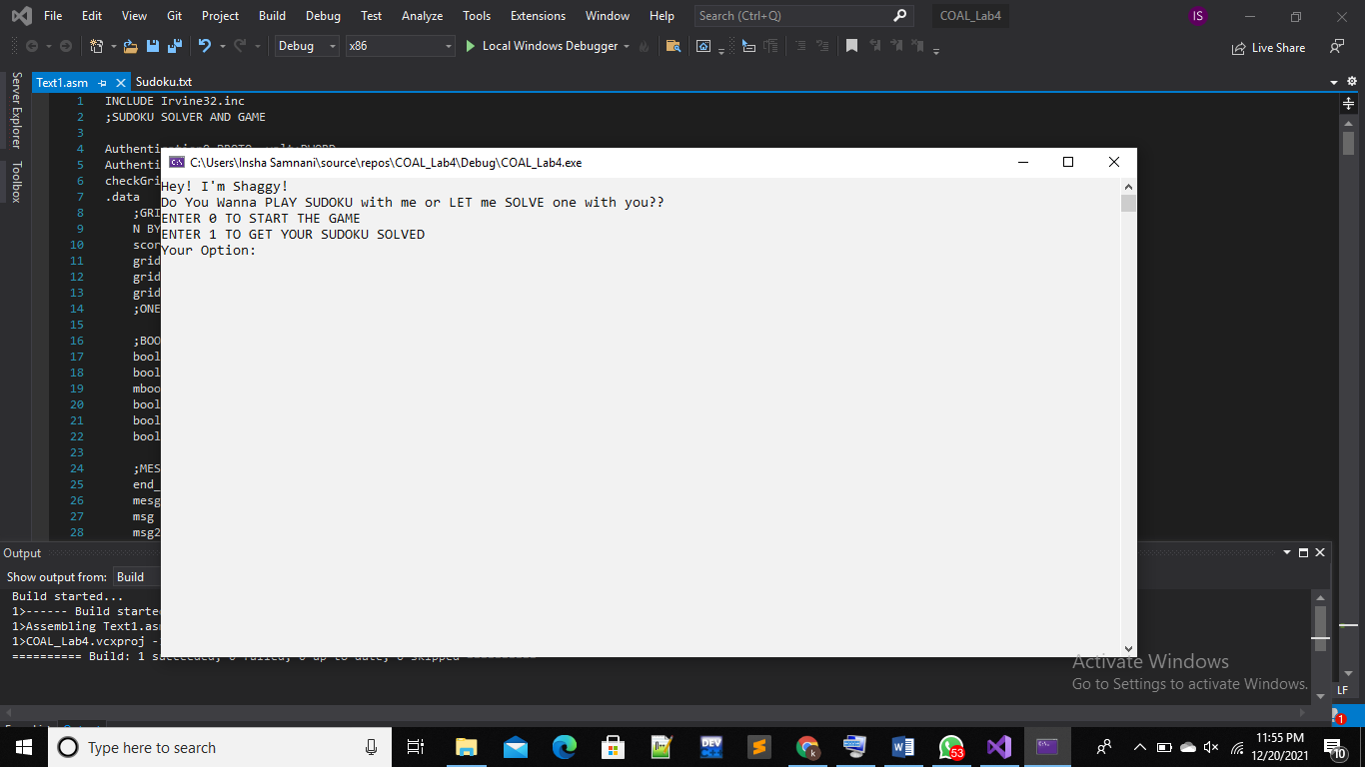

**Option 1:**

**Test Case 1:**

**Outputs:**

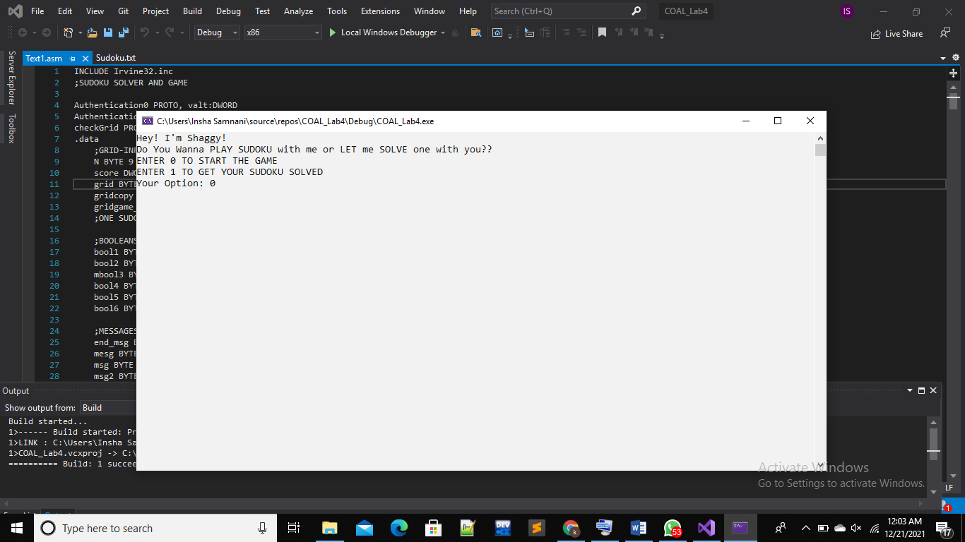

**//Sudoku given to user to fill the missing(0’s)**

**//Asks for row,col and the value to be inputted there (1)**

**//Asks for row,col and the value to be inputted there (2)**

**//For an Invalid Entry**

**//Intermediate Result**

**//Final Result**

**Option 1:**

**Test Case 2:**

**Outputs:**

**//Sudoku given to user to fill the missing(0’s)**

**//Asks for row,col and the value to be inputted there (1)**

**//Asks for row,col and the value to be inputted there (2)**

**//For an Invalid Entry**

**//Intermediate Result**

**//Final Result**

**Option 2:**

**Test Case 1:**

**Outputs:**

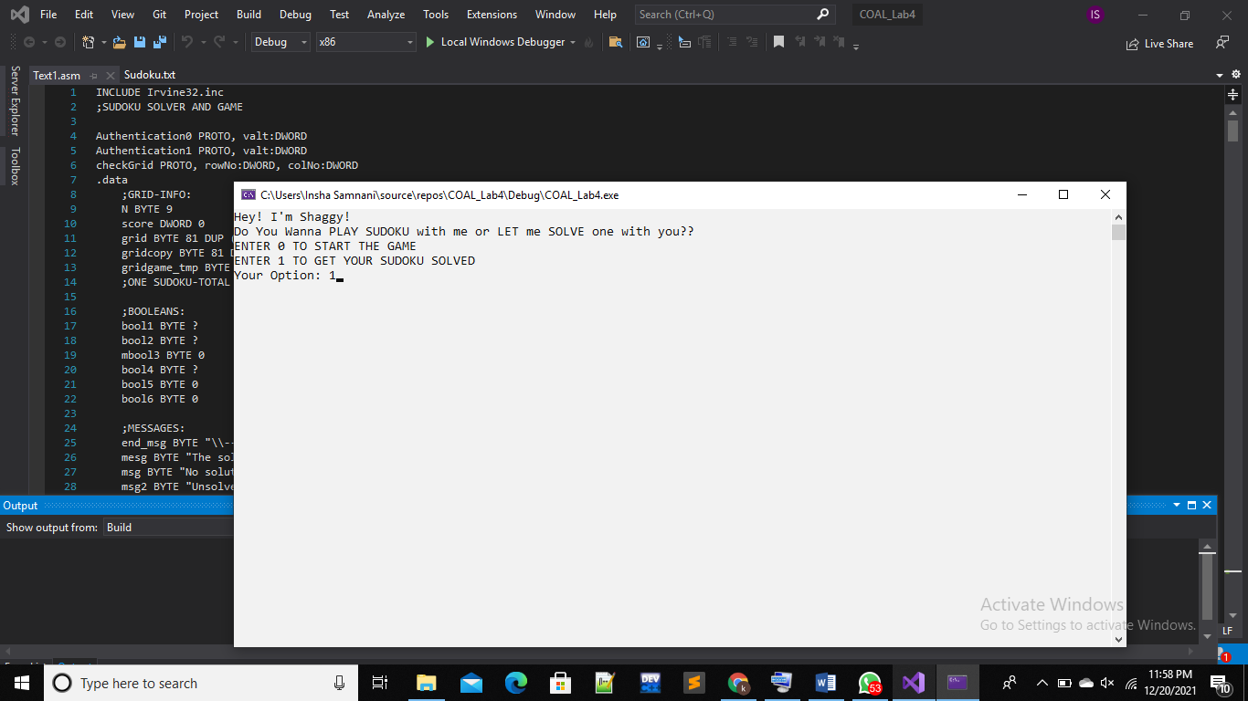

**//A 9*9 grid of all o’s(empty) grid given to fill**

**//Row by row entering of values**

**//Sudoku Solved by the Program**

**Option 2:**

**Test Case 2:**

**Outputs:**

**//A 9*9 grid of all o’s(empty) grid given to fill**

**//Row by row entering of values**

**//Sudoku Solved by the Program**

**CONCLUSION, COST AND FUTURE WORK:**

In brief, Soduko Mystifier accepts the challenge of solving easy to evil level Sudoku Puzzles by computing runtime values for the empty boxes. Not only it solves the puzzle, but it also does helps user to play Sudoku game and display its score at the end of solving the mystifier. Concentration, Memory, Learning, Relaxation are the attributes which are evaluated while solving a Sudoku. The conclusion to this Sudoku Mystifier is that it is optimized algorithm producing accurate results. Future advancements can be taken in advancement by expanding it to different matrix sizes i.e. (12*12,14*14, …,25*25).

**REFERENCES:**

1. <https://www.csc.kth.se/utbildning/kth/kurser/DD143X/dkand13/Group1Vahid/report/Aref-Fiorella-KexJobb-sist.pdf>
2. <https://www.sudokuonline.io/tips/benefits-of-sudoku>
3. <https://undergroundmathematics.org/thinking-about-algebra/equation-sudoku/solution>
4. https://www.geeksforgeeks.org/sudoku-backtracking-7/
5. https://towardsdatascience.com/solving-sudoku-with-ai-d6008993c7de
6. https://github.com/vindmi/asm-sudoku-solver/blob/master/sudoku.s