DevOps Fundamentals [Spring, 2026]
Assignment 04 – CI/CD Pipeline Integration
Total Marks: 100 | Weeks Covered: 10 – 14 | CLO: CLO2

OBJECTIVES
Students will design and implement a complete CI/CD pipeline for a containerized web application by integrating a CI workflow (triggered on a Pull Request) with a CD workflow (triggered on a merge/push to the develop branch). The assignment covers creating a fresh GitHub repository, versioning the assignment document, configuring GitHub Environments, managing secrets, and chaining two GitHub Actions workflows.

By the end of this assignment, students will be able to:
- Create a new GitHub repository from scratch and establish a proper branching strategy.
- Version the assignment question paper inside the GitHub repository.
- Create and configure a GitHub Development Environment with appropriate secrets.
- Design and implement a CI workflow triggered by a Pull Request targeting the “develop” branch.
- Design and implement a CD workflow triggered by a push event on the “develop” branch.
- Verify end-to-end automated delivery from a code push to a live deployment on Render.

IMPORTANT INSTRUCTIONS
- Group Size: Five (5) students per group (can be six members but in that case TL has to create an additional page for that member and then assign all tasks accordingly)
- Team Lead (TL): One student will act as the Team Lead; others will be Team Members.
- New Repository: Students MUST create a brand-new GitHub repository for this assignment. Do NOT reuse or fork any repository from a previous assignment.
- Assignment Document in Repo: The Assignment 04 question paper (this .docx file) must be committed to the root of the repository. Each student must fill in their own details in their respective row in Table 1 (Group Details) directly inside the versioned document.
- Secrets Ownership: All GitHub secrets (DOCKERHUB_USERNAME, DOCKERHUB_TOKEN, RENDER_DEPLOY_HOOK_URL) must be created by the Team Lead using the TL's own Docker Hub and Render credentials. No team member other than the TL should create or modify secrets.
- All deployments MUST be triggered via the GitHub Actions CD pipeline. Manual deployment on Render is NOT allowed after the initial service setup.
- Only the Team Lead will submit the final document to the LMS.
- Plagiarism will result in ZERO marks for all involved members.
- Each team member must work on their own feature branch and open a Pull Request (PR) targeting the “develop” branch.

GROUP DETAILS
Table 1: Group Details , Each student must fill their own row (including Assigned Page) in the versioned copy inside the repo
Here's your filled table:
Sr # | Student Name | GitHub Username | Role | Assigned Page | Branch Worked On | Screenshots Added
1 | Inshaal Mobeen | inshaal1 | Lead | index.html (Home/Dashboard) | feature/inshaal1/home | Yes
2 | Mirza Saif Ullah Baig | Mirza766 | Member | add-task.html (Add Task) | feature/Mirza766/add-task | Yes
3 | Zainab Mir | Zainab-Mir | Member | task-list.html (Task List) | feature/Zainab-Mir/task-list | Yes
4 | Arslan Khan | arslankhan022 | Member | about.html (About/Help) | feature/arslankhan022/about | Yes

Group Repository URL:
https://github.com/inshaal1/taskflow-cicd
Deployed Application URL:
https://taskflow-cicd-stsn.onrender.com

VERIFICATION SCREENSHOTS
Paste your verification screenshots in the table below. Label each one clearly.
Screenshot Label | Screenshot (Paste Here)
GitHub “development” Environment & All Secrets | 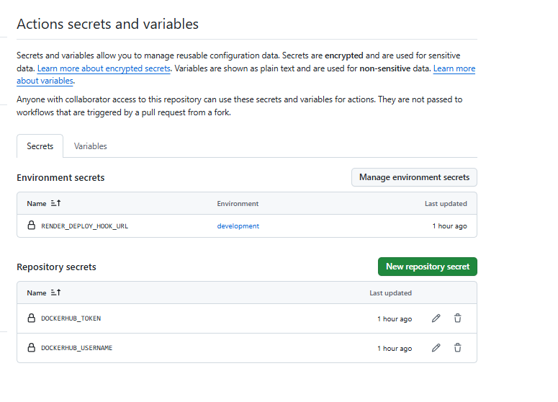
CI Workflow Runs – Triggered by each member's PR (all steps green) | 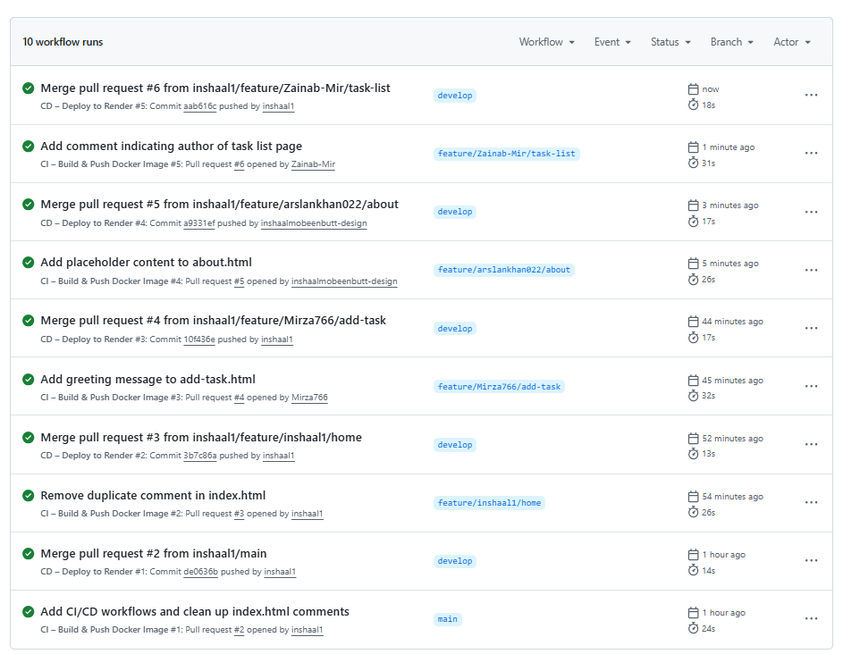
Docker Hub – Pushed Image with Tags | 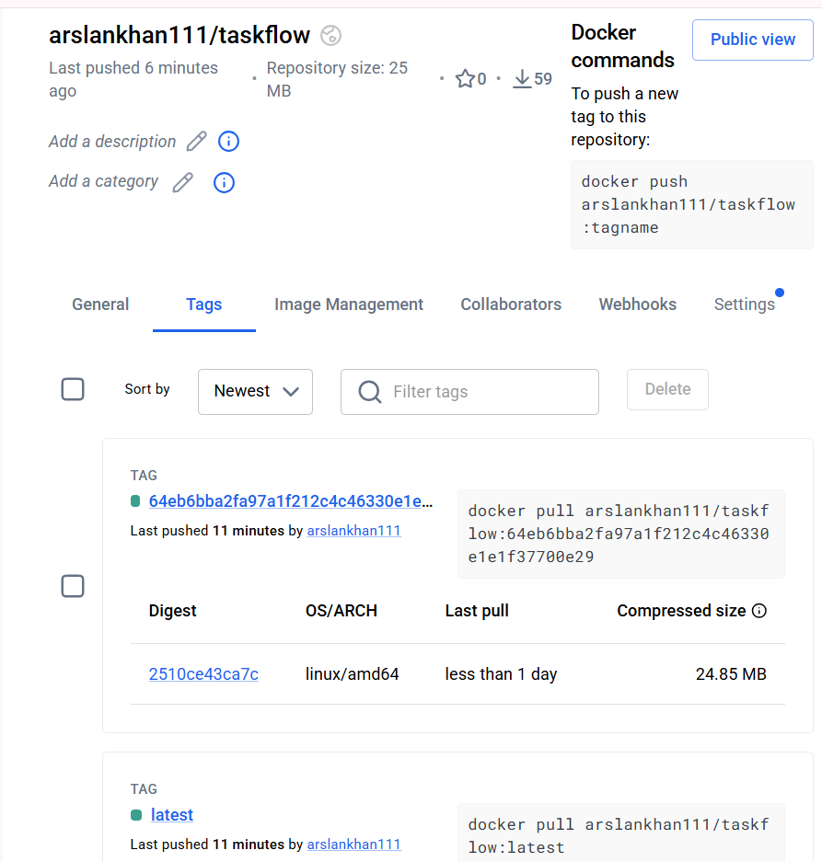
CD Workflow Run – Triggered by Push to “develop” | 
Live TaskFlow on Render – All 5 Pages Accessible | 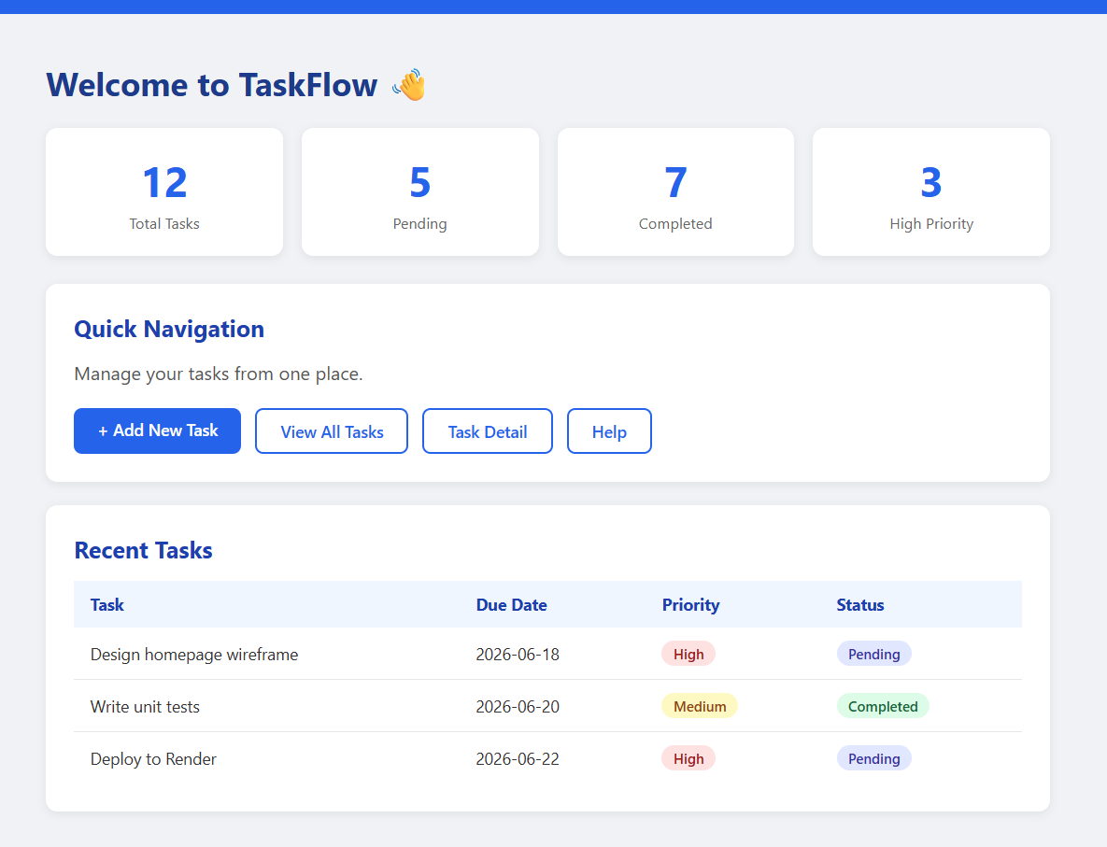
Assignment 04 .docx Visible in GitHub Repo | 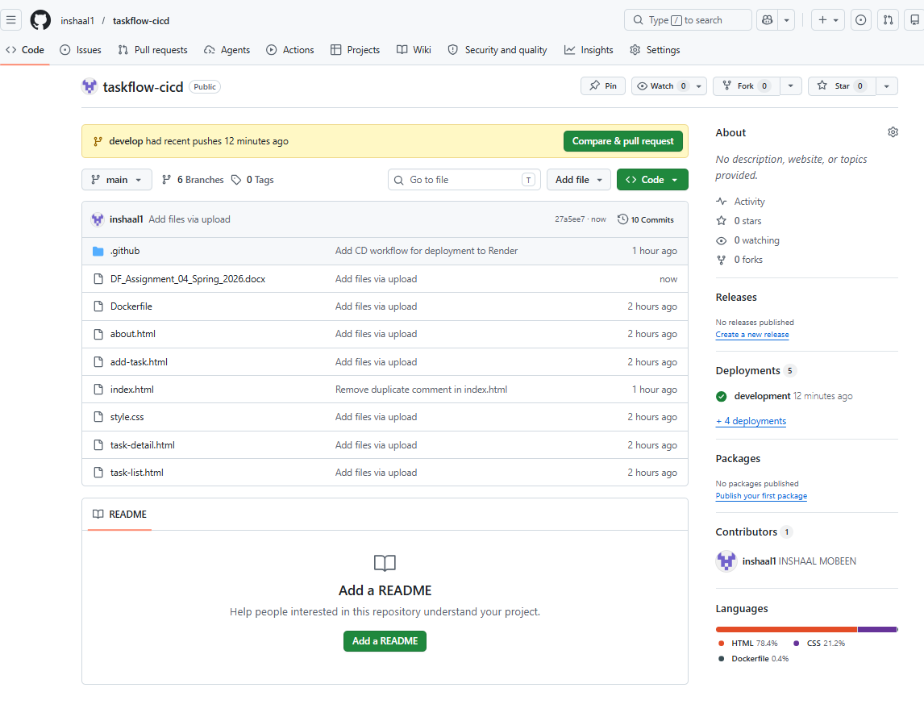

TEAM REFLECTION
Member 1 (Inshaal Mobeen)
This assignment provided practical experience with CI/CD automation using GitHub Actions, Docker Hub, and Render. The most challenging part was configuring repository secrets and ensuring that the workflows executed correctly after pull requests and merges. I learned how automated pipelines can reduce manual deployment effort and improve consistency. By reviewing workflow logs and testing each stage carefully, we successfully completed the deployment process.
Member 2 (Mirza Saif Ullah Baig)
Through this assignment, I gained a better understanding of how CI pipelines automatically build and validate applications before deployment. The most interesting aspect was seeing Docker images being generated and pushed to Docker Hub through GitHub Actions. Initially, understanding the relationship between branches, pull requests, and workflow triggers was challenging. However, through collaboration and testing, I was able to understand the complete development workflow.
Member 3 (Zainab Mir)
This project helped me understand the importance of automation in modern software development. I learned how GitHub Actions can be used to automate repetitive tasks such as building, testing, and deployment. The most challenging part was understanding how CI and CD workflows interact with each other after code changes are merged. By analyzing workflow runs and discussing issues with teammates, I gained valuable practical knowledge of DevOps practices.
Member 4 (Arslan Khan)
Working on this assignment improved my understanding of Docker-based deployments and cloud hosting services. I learned how application updates can be automatically deployed to a live environment using Render. The main challenge was ensuring that all components, including workflows, secrets, and deployment configurations, were correctly connected. Through testing and troubleshooting workflow executions, we successfully achieved a fully automated deployment pipeline.

