1. At first, please check admin user of OSQA site can see in osqa control panel API setting section with fields:

Username for API access; Password for API access

1. Set the username and password for API access through REST.
2. You can use Chrome postman or Firefox RESTclient to test and debug your web service. Guofeng found that Chrome postman is better than Firefox RESTclient. You can download Chrome postman here <https://chrome.google.com/webstore/detail/postman-rest-client/fdmmgilgnpjigdojojpjoooidkmcomcm>
3. Then, please add to your web browser a REST API client. I use Chrome postman add-in:

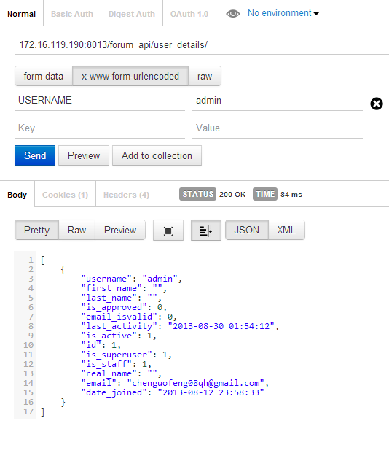

As method, please use POST as defined in views.py (decorator). And then you also need to set credentials by setting header. On the top of the view you can find "Authentication" menu. Please select Basic auth and then define user name and password as in control panel.

You can check actions in forum_modules\forum_api\urls.py. So far, there are:

|  |
| --- |
| urlpatterns = patterns('', |
| url(r'^%s$' % _('forum_api/user_details/'),  get_user_details, name='get_user_details'), |
| url(r'^%s$' % _('forum_api/questions/'),  get_all_questions, name='get_all_questions'), |
| ) |

Then press send and if everything is ok, you shoud see 200 OK response in Body. Further you can view request content on other tabs.