***CREATING TABLE***

create table hospital(

Hospital_Name varchar(100),

Location varchar(50),

Department varchar (50),

Doctors_Count integer,

Patients_Count numeric,

Admission_Date date,

Discharge_Date date,

Medical_Expenses numeric(10,2)

);

select*from hospital;

-***Import Data into Hospital Table***

COPY hospital(Hospital_Name,Location,Department,Doctors_Count,Patients_Count,Admission_Date,Discharge_Date,Medical_Expenses)

FROM 'C:\Users\Nyla Majid\OneDrive\Documents\sql\Hospital_Data.csv'

CSV HEADER;

1**. Write an SQL query to find the total number of patients across all hospitals.**

select sum(patients_count) as Total_patients

from hospital;

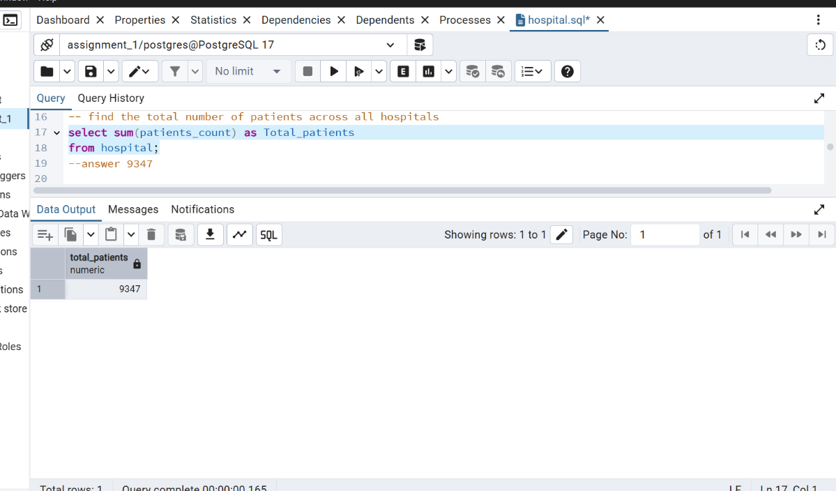

**2. Retrieve the average count of doctors available in each hospital**.

select hospital_name,avg("doctors_count") as avg_doctor_per_hospital

from hospital

group by hospital_name;

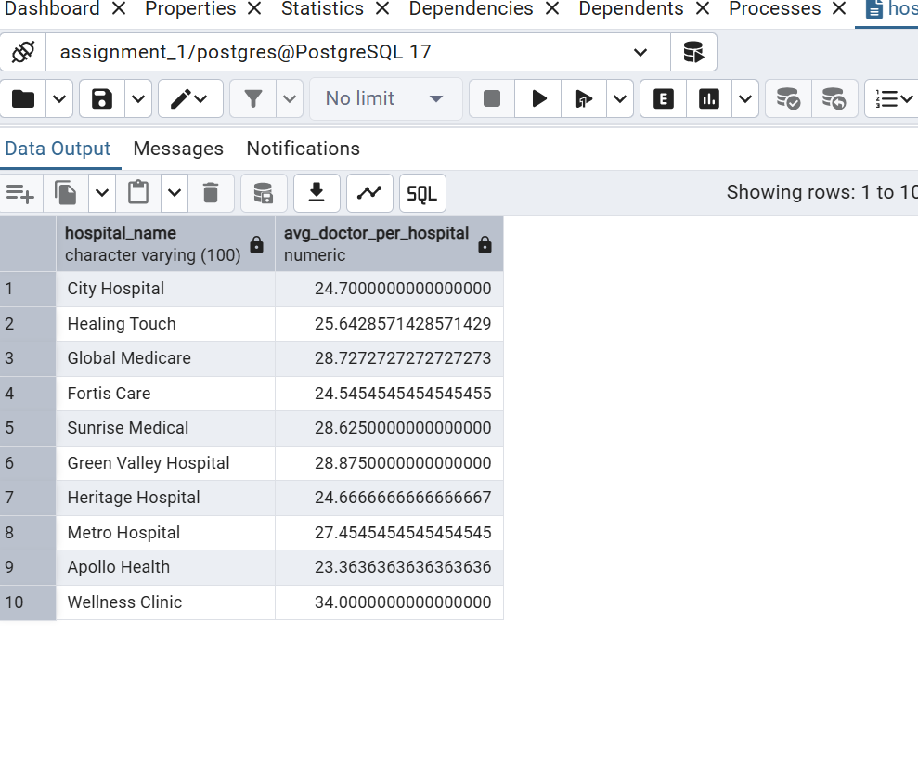

3. Find the top 3 hospital departments that have the highest number of patients.

select department, sum(patients_count)as dept_with_highest_patients

from hospital

group by department

order by dept_with_highest_patients desc

LIMIT 3;

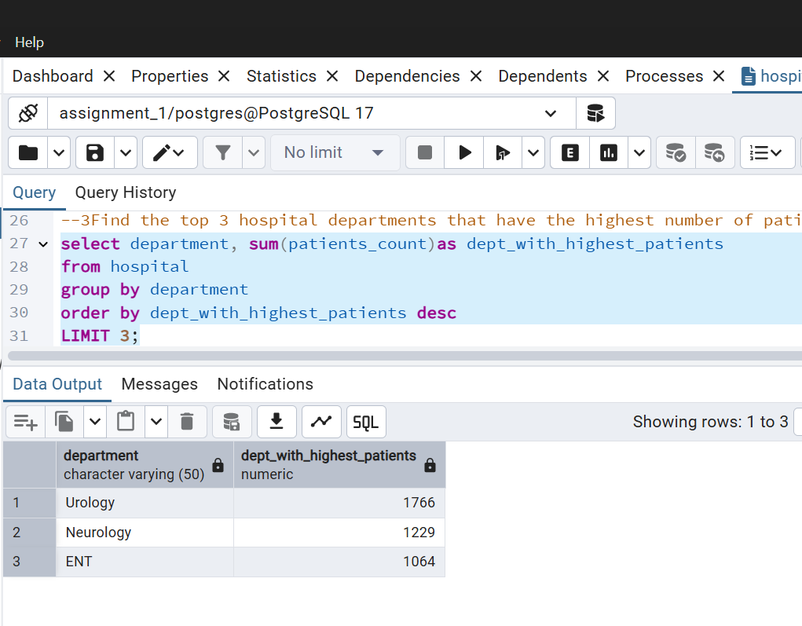

**4. Identify the hospital that recorded the highest medical expenses.**

select hospital_name, sum(medical_expenses)as hospital_with_highest_med_expenses

from hospital

group by hospital_name

order by hospital_with_highest_med_expenses desc

LIMIT 1;

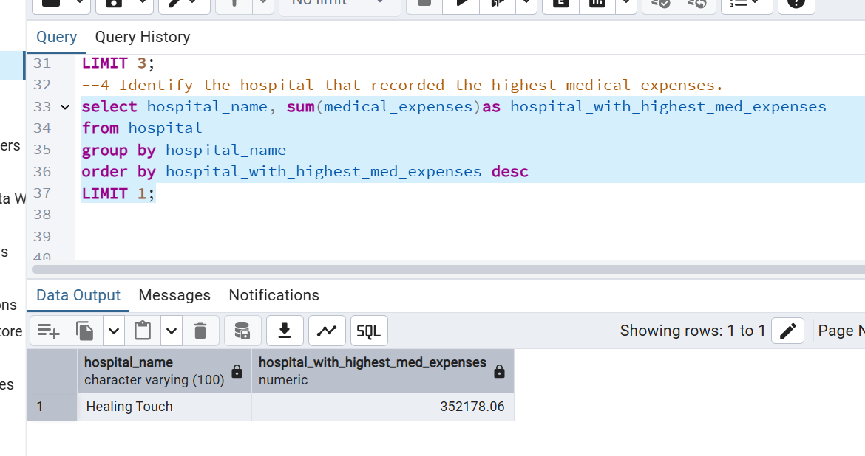

**5. Calculate the average medical expenses per day for each hospital.**

select hospital_name,round(avg(medical_expenses),2) as med_exp_per_day

from hospital

group by hospital_name;

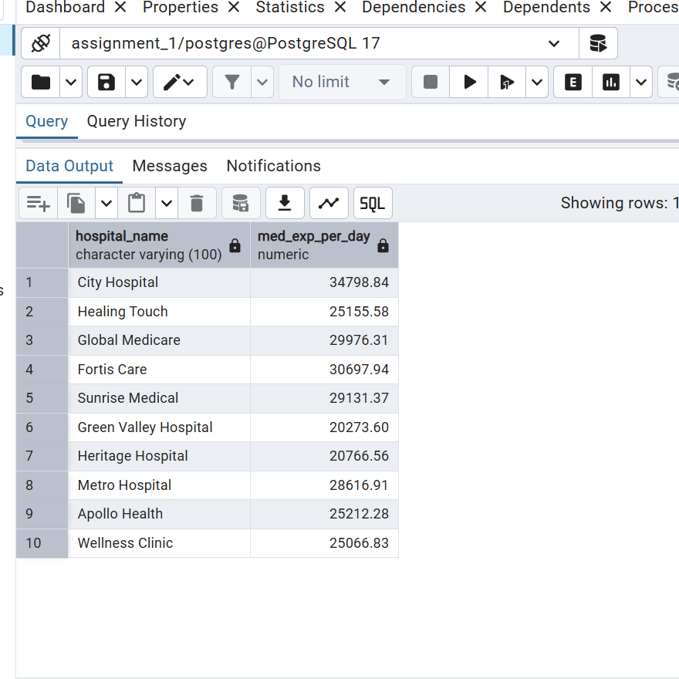

**6. Find the patient with the longest stay by calculating the difference between the Discharge Date and the Admission Date.**

select hospital_name, location,department, (discharge_date- admission_date,) as Days_Stayed

from hospital

order by Days_Stayed desc

limit 1;

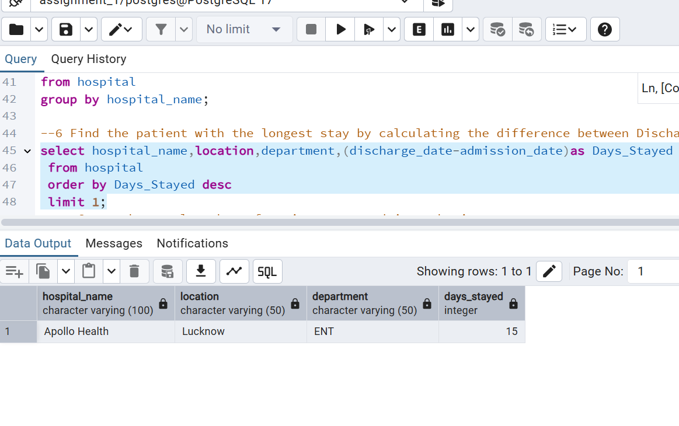

**7. Count the total number of patients treated in each city.**

select location,sum(patients_count)as total_no_of_patients_teated_in_each_city

from hospital

group by location;

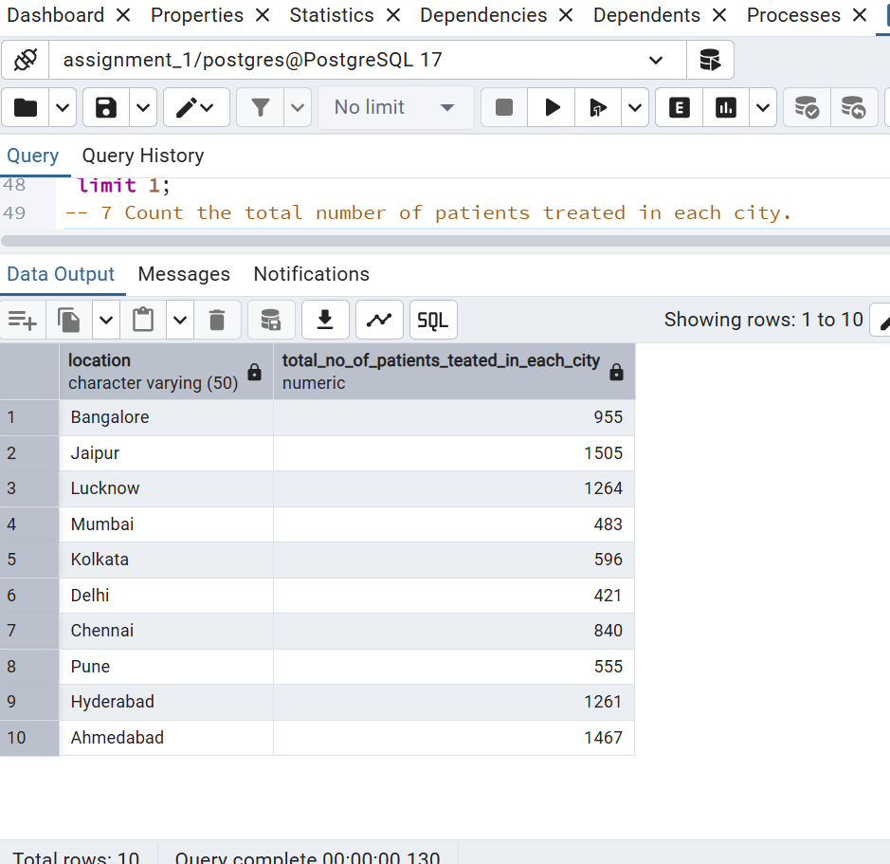

**8. Calculate the average number of days patients spend in each department.**

select department,round(avg(discharge_date-admission_date),2)as Avg_Days_Stayed_in_dept

from hospital

group by department;

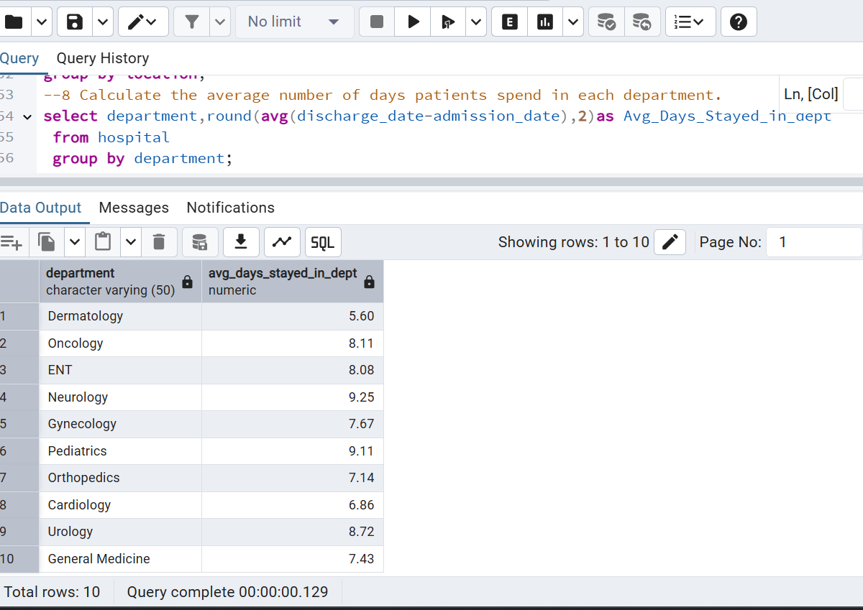

**9. Find the department with the least number of patients.**

select department, sum(patients_count) as least_patient_in_dept

from hospital

group by department

order by least_patient_in_dept asc

limit 1;

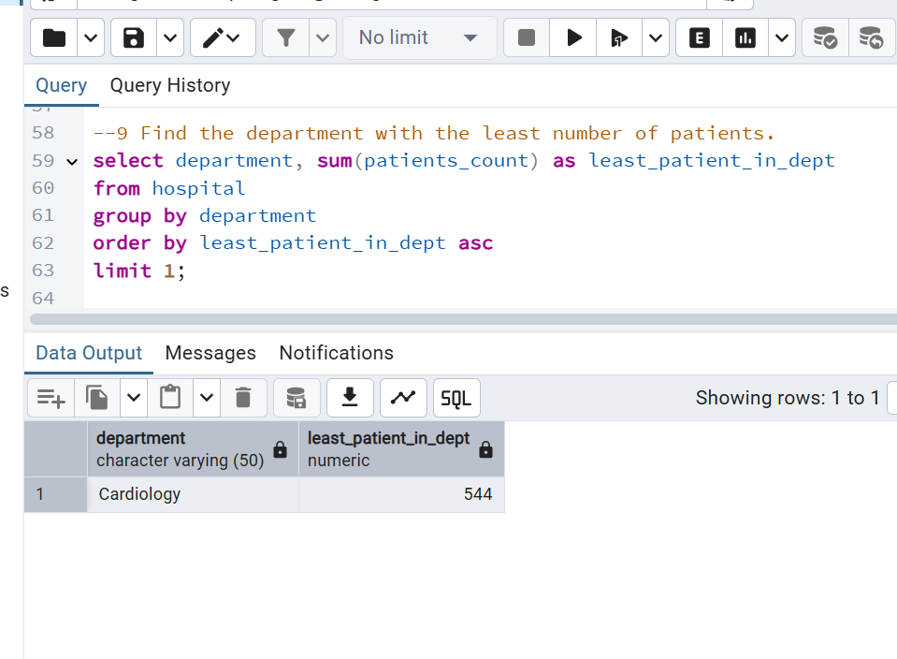

**10. Group the data by month and calculate the total medical expenses for each month**

select to_char(Admission_Date, 'yyyy-mm') as month,round(sum(medical_expenses),2) as total_expenses

from hospital

group by to_char(Admission_Date, 'yyyy-mm')

order by month;

