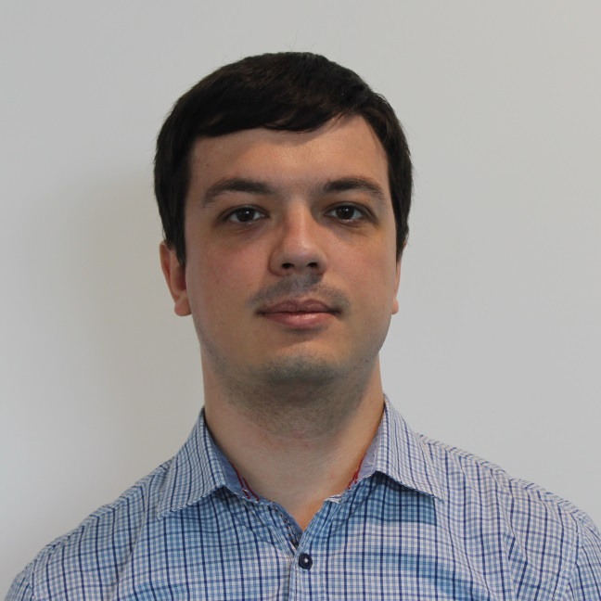
Oles Kurivchak
Krakow, Poland
Cell: +48662578867
E-mail: kurivchak@gmail.com

Objective
To work in a creative, challenging environment that will hone my skills and help me grow as a professional

Education
National Aviation University, Kyiv, Ukraine
- Master of Computer Science, The software of the automated systems, 2010

Employment

EPAM Systems
DevOps (06/2017 – now)
- created CI/CD system for a project
- investigate and migrate deployment process of an app to new platform
- install & configure Jenkins and integrated the CI
- configure CD system using internal tools and automated release deployment
- configure code scanning with Fortify
- release management

PulsarFour LLC. (now Valtech)
DevOps (03/2015 – 05/2017) on westwing.de project
- perform data backups and disaster recovery operations;
- maintain and administer servers applications software, and all configurations;
- operate master consoles in order to monitor the performance of computer systems and networks, and to coordinate computer network access and use;
- perform routine network startup and shutdown procedures, and maintain control records;
- monitor network performance in order to determine whether adjustments need to be made

SANAHUNT Group
System Administrator (08/2014 – 03/2015)
Accomplishment: Wiki-portal for call-center; managed Wi-Fi hotspot (RouterOS).

NJSC “Nadra Ukrayny”
Chief Specialist (system administrator) (05/2008 – 12/2014)
Accomplishment: deployed fully functioning LAN (120 workstations); launched local mail, print server, legal support system, accounting server; implemented add-on for non-standard reports.

“Tradep” Ltd.
System Administrator / Developer (10/2012 – 11/2013)
Accomplishment: developed fast smart search engine based on Apache Solr and Tomcat; implemented features for search - instant search, highlighting, faceted search, json results, etc.

Skills
Jenkins, git, puppet, icinga, splunk, tomcat, fortify, ansible, Solr, nginx, teamcity, ruby, unix shell scripting, appdynamics, sonarqube, servicenow, Amazon EC2 Route53 RDS, nexus, Foreman, maven, gradle, vagrant

Languages
English – advanced, German – intermediate, Polish – basic

