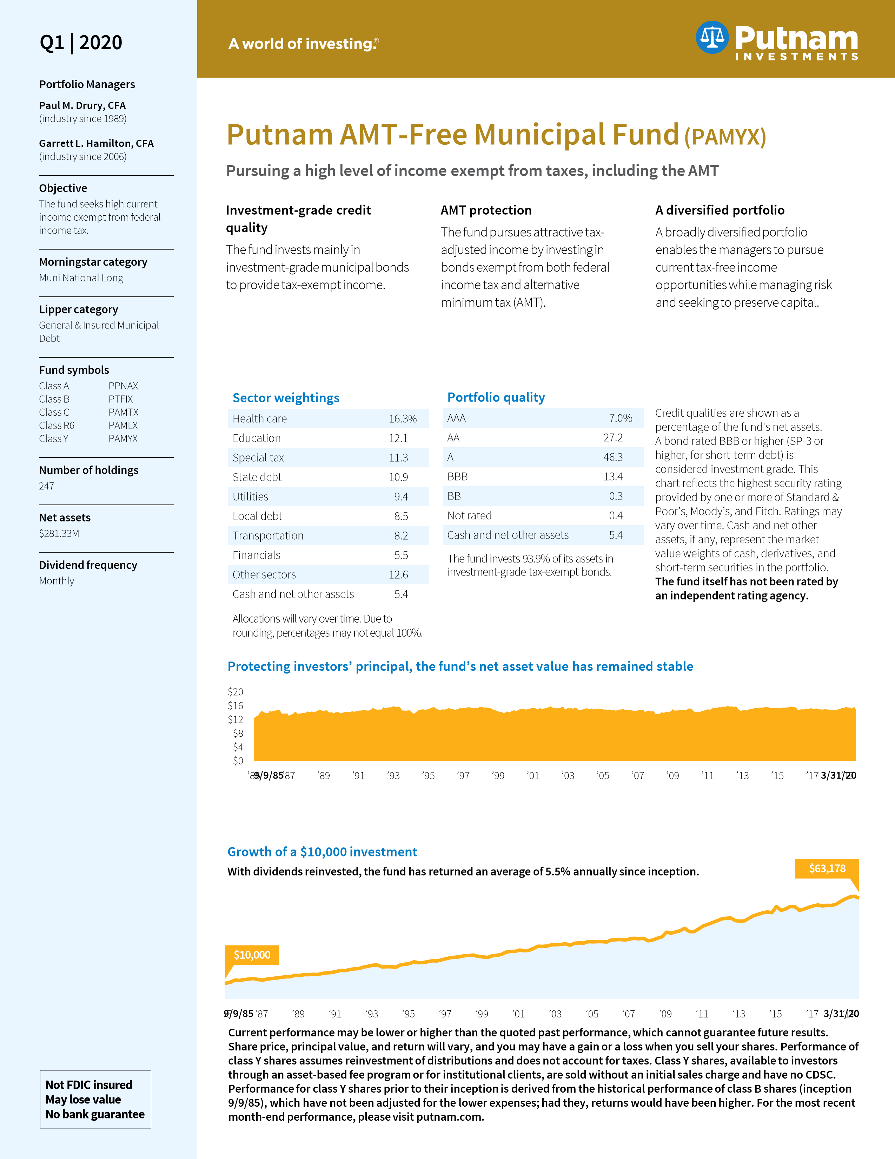

**3 | 31 | 2020**

# Lipper rankings

(Y shares, based on total return)

1 year 38% (109/291) 3 years 31% (77/250)

5 years 37% (80/221)

10 years 39% (66/170)

# Total expense ratio

(Y shares)

0.58%

**Option adjusted duration**

7.91

**Duration to worst**

5.59

**Average stated maturity**

18.64

**Average effective maturity**

6.41

**AMT exposure**

0.00%

# Top 10 state allocations

IL 13.43%

TX 11.73% MI 8.01%

NY 5.59%

KY 5.04%

OH 4.32%

AZ 3.85%

WA 3.83%

NJ 3.81%

CA 3.68%

For informational purposes only. Not an investment recommendation.

Putnam Retail Management

FS043_Y 321189 4/20

# Putnam AMT-Free Municipal Fund

## Annual performance at net asset value (all distributions reinvested)

**2011 2012 2013 2014 2015 2016 2017 2018 2019 2020 YTD**

Y shares 10.7% 8.3% -3.3% 10.4% 2.9% 0.1% 6.0% 0.7% 8.4% -1.9%

BBG Barclays Municipal

10.7 6.8 -2.6 9.1 3.3 0.3 5.5 1.3 7.5 -0.6

Bond Index

**Annualized total return performance Current performance may be lower or higher than the quoted past performance, which cannot guarantee future**

### BBG Barclays results. Share price, principal value, and return will vary, Inception 1/2/08 Class Y shares Index 1 year 3.18% 3.85% distributions and does not account for taxes. Class Y shares, 3 years 3.84 3.96 available to investors through an asset-based fee program

**Municipal Bond and you may have a gain or a loss when you sell your shares.**

**Performance of class Y shares assumes reinvestment of**

**or for institutional clients, are sold without an initial sales**

### 5 years 2.94 3.19 charge and have no CDSC. Performance for class Y shares 10 years 4.15 4.15 prior to their inception is derived from the historical Life of fund 5.48 6.31 performance of class B shares (inception 9/9/85), which

**have not been adjusted for the lower expenses; had they, returns would have been higher. For the most recent month-end performance, please visit putnam.com.**

## Attractive yield

* Based only on investment income, calculated using the

**Net asset value** maximum offering price in accordance with SEC guidelines.

Current 30-day SEC yield* 2.03% † Assumes a maximum 40.80% combined federal and state Taxable equivalent† 3.43% tax rate inclusive of the 3.80% Medicare surtax.

## Highlights of five-year performance periods (9/9/85‒3/31/20)*

### Best Best Worst Worst Average % of 5-year Number Number 5-year period 5-year period 5-year periods with of positive of negative return end date return end date return positive returns 5-year periods 5-year periods

9.74% 9/30/92 1.47% 9/30/08 5.20% 100% 119 0

* Based on annualized returns for quarterly rolling periods.

―――――――――――――――――――――――――――――――――――――――――――――――――――――――――――――――――――――――――――――――――――――――――――――――――――――――――――

The Bloomberg (BBG) Barclays Municipal Bond Index is an unmanaged index of long-term fixed-rate investment-grade tax-exempt bonds. You cannot invest directly in an index.

Lipper rankings for class Y shares are based on total return without sales charge relative to all share classes of funds withsimilar objectives as determined by Lipper.

Average effective maturitydepends on the maturity of the underlying bonds within each fund. The longer the maturity, the greater the interest-rate risk. Average stated maturityis determined based on the legal final maturity of a bond. Duration to worstis the duration of a bond computed assuming the bond is called at the worst possible time and uses the date associated with the lowest yield. Depending on the interest-rate environment and structure of the bond, there may be scenarios in which the worst possible time for the bond to be paid off is the maturity date. Optionadjusted duration is the modified duration of a bond after adjusting for any embedded optionality.

Tax-free funds may not be suitable for IRAs and other non-taxable accounts.

Not all share classes are available on all platforms.

Consider these risks before investing: Capital gains, if any, are taxable for federal and, in most cases, state purposes. Income from federally tax-exempt funds may be subject to state and local taxes. Bond investments are subject to interest-rate risk (the risk of bond prices falling if interest rates rise) and credit risk (the risk of an issuer defaulting on interest or principal payments). Interest-rate risk is generally greater for longer-term bonds, and credit risk is generally greater for below-investment-grade bonds. Unlike bonds, funds that invest in bonds have fees and expenses. The fund may invest significantly in particular segments of the tax-exempt debt market, making it more vulnerable to fluctuations in the values of the securities it holds than a fund that invests more broadly. Interest the fund receives might be taxable. The value of investments in the fund’s portfolio may fall or fail to rise over extended periods of time for a variety of reasons, including general economic, political, or financial market conditions; investor sentiment and market perceptions; government actions, geopolitical events or changes, and factors related to a specific issuer, geography, industry or sector. These and other factors may lead to increased volatility and reduced liquidity in the fund’s portfolio holdings. You can lose money by investingin the fund.

**Request a prospectus or a summary prospectus, if available, from your financial representative or by calling Putnam at 1-800-225-1581. These prospectuses include investment objectives, risks, fees, expenses, and other information that you should read and consider carefully before investing.**

### Putnam Investments | 100 Federal Street | Boston, MA 02110 | 1-800-225-1581 | putnam.com