

Data Technician

Name: Lisa Weipert
Course Date: 01st to 05th December 2025
Table of contents
Day 1: Task 1 3
Day 1: Task 2 4
Day 3: Task 1 5
Day 4: Task 1: Written 6
Day 4: Task 2: SQL Practical 10
Course Notes 22
Additional Information 22

Day 1: Task 1

Please research and complete the below questions relating to key concepts of databases.

What is a primary key? | Is a field in a database entity that uniquely identifies each record.
How does this differ from a secondary key? | A secondary key is an attribute/s used for searching or indexing, but not for uniquely identifying a record. This means secondary keys can be duplicated across records.
How are primary and foreign keys related? | A foreign key is a field in one table that refers to the primary key in another table. This allows a relationship between two entities.
Provide a real-world example of a one-to-one relationship | Business branch – Branch manager  One branch has one branch manager  One branch manager is responsible for one branch
Provide a real-world example of a one-to-many relationship | Regional manager – Branch manager  One regional manager is responsible for many branch managers  Each branch manager has one regional manager
Provide a real-world example of a many-to-many relationship | Marketing campaign – Target audience  One campaign may target several audience groups  One audience group may be targeted by multiple campaigns

Day 1: Task 2

Please research and complete the below questions relating to key concepts of databases.

What is the difference between a relational and non-relational database? | A relational database stores data in structured tables with fixed schemas and uses SQL to manage relationships between those tables. It enforces strict consistency and is ideal for structured data with clear, well-defined relationships. Relational databases typically scale vertically, you increase capacity by upgrading the existing server (more CPU, RAM, or storage).  A non-relational (NoSQL) database stores data in flexible formats such as key-value pairs, documents, wide-column stores, or graphs, without requiring a strict schema. The term NoSQL means “not only SQL,” highlighting that these systems can still support some SQL-like querying while offering alternative data models. NoSQL databases are well-suited for handling large volumes of unstructured or rapidly changing data. They typically scale horizontally. More servers are added to distribute the load across a cluster, which makes them effective for high-availability and high-throughput applications.
What type of data would benefit off the non-relational model?  Why? | Data such as social media posts, chat messages, and multimedia content (images, videos, audio) benefit from a non-relational database model.  These data types are often unstructured or semi-structured, change frequently, and can vary greatly from record to record. Because relational databases require rigid schemas, they struggle with this level of variability and scale.  Non-relational databases allow flexible schemas and can distribute data across many servers, making them better suited for large, fast-moving datasets.  Examples of benefits of non-relational databases  - Flexible schema: When a platform introduces a new feature, such as “GIF reactions”,only posts that use the new feature need to store that field. No global table migration is required.  - Horizontal scalability: During traffic spikes, such as during the World Cup or large global events, a NoSQL cluster can scale horizontally by adding nodes, allowing millions of new posts or messages to be ingested without slowing down.  - Efficient feed generation through denormalization: NoSQL databases can store the same post or index in multiple locations to optimize read speed. Avoiding the expensive JOIN operations that a relational system would require for similar workloads.

Day 3: Task 1

Please research the below ‘JOIN’ types, explain what they are and provide an example of the types of data it would be used on.

Self-join | A self-join is when a table is joined to itself.  It is useful when data in the same entity is related, for example hierarchical relationships, employee-manager structures, or categories/subcategories.
Right join | Returns all records from the right table and the matching records from the left table. If there is no match in the left table, the left table columns will contain NULL. Non-matching left table records are excluded.  It is useful for master lists where no data in the right table should be excluded, for example stores, departments or categories.
Full join | Returns all records from both tables. Any unmatched records are included and their missing columns contain NULL.  It is useful for auditing information, for example ensuring all customer payments are allocated and no customers have outstanding balances.
Inner join | Returns only rows where there is a match in both tables, so no NULL values are returned.  It is useful for transactional data where you only want matched records for example customers who have rentals, outstanding order or payments.
Cross join | A cross join returns every combination of records from the two tables. Each record from the first table is paired with every record from the second table.  It can be useful for creating lists of all possible product variations, pricing matrices, or shift schedules. For example, a clothing store could generate every combination of colours and sizes.
Left join | Returns all records from the left table, plus matching records from the right table. Left join is essentially a mirror of right join. The same result can be achieved by swapping the table order.  Left joins are more commonly used because they are generally easier to read and understand.

Day 4: Task 1: Written

In your groups, discuss and complete the below activity. You can either nominate one writer or split the elements between you. Everyone however must have the completed work below:

Imagine you have been hired by a small retail business that wants to streamline its operations by creating a new database system. This database will be used to manage inventory, sales, and customer information. The business is a small corner shop that sells a range of groceries and domestic products. It might help to picture your local convenience store and think of what they sell. They also have a loyalty program, which you will need to consider when deciding what tables to create.

Write a 500-word essay explaining the steps you would take to set up and create this database. Your essay should cover the following points:
- Understanding the Business Requirements:
  - What kind of data will the database need to store?
  - Who will be the users of the database, and what will they need to accomplish?
- Designing the Database Schema:
  - How would you structure the database tables to efficiently store inventory, sales, and customer information?
  - What relationships between tables are necessary (e.g., how sales relate to inventory and customers)?
- Implementing the Database:
  - What SQL commands would you use to create the database and its tables?
  - Provide examples of SQL statements for creating tables and defining relationships between them.
- Populating the Database:
  - How would you input initial data into the database? Give examples of SQL INSERT statements.
- Maintaining the Database:
  - What measures would you take to ensure the database remains accurate and up to date?
  - How would you handle backups and data security?

Your essay should include specific examples of SQL commands and explain why each step is necessary for creating a functional and efficient database for the retail business.

Please write your 500-word essay here | To support its daily operations, the small retail store requires a database system that can manage inventory, customer information, and sales.  The database must store accurate information about the products sold, including product names, categories, and available stock levels. This ensures that popular items do not run out and that the manager can reorder stock in a timely manner. To support the reordering process, the database also needs to store supplier details and track purchase orders made to replenish stock. This allows the store to keep clear records of where products come from and when deliveries are expected.  The store additionally operates a customer loyalty scheme, so the system must store information about customers who sign up. This includes contact details, loyalty card numbers, and spending history. By tracking customer purchases, the business can award loyalty points, analyse buying patterns, and identify which promotions are most effective.  Several user groups will interact with the database. Store staff update sales transactions and individual sales items every time a purchase is made at the till. They may also update customer contact details, but only when the customer provides new information. Staff update purchase records when suppliers deliver stock and adjust supplier details if they receive updated contact information.  The IT department has full access to all tables for maintenance, administration, and managing data transfer from the till and purchases systems into the database.  To store this information efficiently, the database is structured into several related tables. The Inventory table contains details of each product and its stock quantity, while the Suppliers table stores supplier information and links to the Purchases table, which records each order made to restock products.  Sales data is captured in two tables: the Sales Transactions table, which records each receipt, and the Sales_Items table, which records each individual product sold within that sale. This separation ensures that a single sale can contain multiple items, each linked back to the correct product in the Inventory table.  The Customer table stores loyalty and contact details, and relationships between tables are maintained through primary and foreign keys to ensure data consistency.  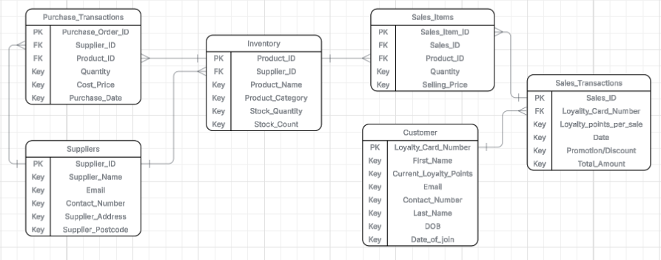  The database is implemented using SQL commands to create tables and define relationships. For example:  CREATE TABLE Inventory ( Product_ID INT PRIMARY KEY, Supplier_ID INT, Product_Name VARCHAR(100), Product_Category VARCHAR(50), Stock_Quantity INT, FOREIGN KEY (Supplier_ID) REFERENCES Suppliers(Supplier_ID) );  Data can then be added using INSERT statements, such as:  INSERT INTO Inventory (Product_ID, Supplier_ID, Product_Name, Product_Category, Stock_Quantity) VALUES (1, 3, 'Milk 1L', 'Dairy', 45);  INSERT INTO Customer (Loyalty_Card_Number, First_Name, Last_Name, Email, Contact_Number, DOB, Date_of_Join) VALUES (1001, 'Sarah', 'Jones', 'sarah@email.com', '07700 111222', '1990-04-12', '2025-01-05');  To maintain database accuracy and protect critical information, the store updates sales and purchase transactions daily. Sales data is transferred from the till system, while delivery records, for example via Excel, are imported into the database. Data validation is applied during the transfer to ensure the accuracy of the Stock_Quantity in the Inventory table, and monthly stock checks compare physical stock with database records to identify discrepancies. Staff updates are tracked using their usernames and login credentials, providing accountability and helping to monitor changes to the system.  To safeguard this data, transaction records are backed up regularly using differential backups, performed hourly or daily depending on transaction volume; daily is sufficient for a small retailer. A full backup of the database is taken weekly, with an additional copy stored off-site or in the cloud monthly. Backups are encrypted and access is restricted to authorised IT personnel. Automating these processes ensures consistency, reduces human error, and keeps the system secure, accurate, and up to date, supporting operational efficiency and customer service.  Data integrity is further protected through clear procedures for validating updates. Staff verify supplier updates by contacting a known representative and confirm customer updates by checking details such as loyalty card number and date of birth. These checks prevent errors and unauthorized changes to sensitive information.

Day 4: Task 2: SQL Practical

In your groups, work together to answer the below questions. It may be of benefit if one of you shares your screen with the group and as a team answer / take screen shots from there.

Setting up the database:

- Download world_db(1)
- Follow each step to create your database

For each question I would like to see both the syntax used and the output.

- Count Cities in USA: Scenario: You've been tasked with conducting a demographic analysis of cities in the United States. Your first step is to determine the total number of cities within the country to provide a baseline for further analysis.

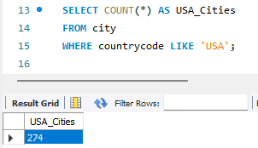
- Country with Highest Life Expectancy: Scenario: As part of a global health initiative, you've been assigned to identify the country with the highest life expectancy. This information will be crucial for prioritising healthcare resources and interventions.

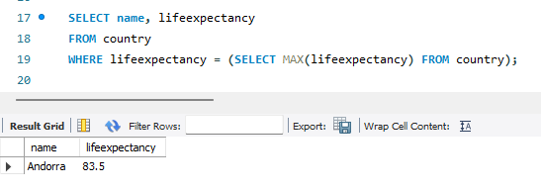

- "New Year Promotion: Featuring Cities with 'New : Scenario: In anticipation of the upcoming New Year, your travel agency is gearing up for a special promotion featuring cities with names including the word 'New'. You're tasked with swiftly compiling a list of all cities from around the world. This curated selection will be essential in creating promotional materials and enticing travellers with exciting destinations to kick off the New Year in style.

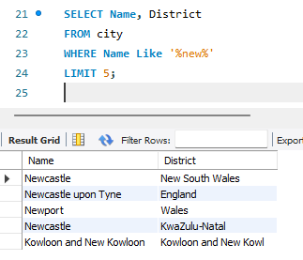

- Display Columns with Limit (First 10 Rows): Scenario: You're tasked with providing a brief overview of the most populous cities in the world. To keep the report concise, you're instructed to list only the first 10 cities by population from the database.

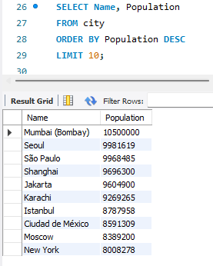

- Cities with Population Larger than 2,000,000: Scenario: A real estate developer is interested in cities with substantial population sizes for potential investment opportunities. You're tasked with identifying cities from the database with populations exceeding 2 million to focus their research efforts.

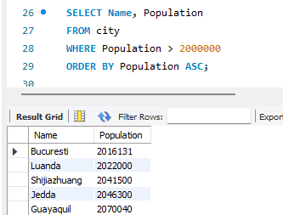

- Cities Beginning with 'Be' Prefix: Scenario: A travel blogger is planning a series of articles featuring cities with unique names. You're tasked with compiling a list of cities from the database that start with the prefix 'Be' to assist in the blogger's content creation process.

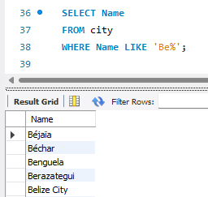

- Cities with Population Between 500,000-1,000,000: Scenario: An urban planning committee needs to identify mid-sized cities suitable for infrastructure development projects. You're tasked with identifying cities with populations ranging between 500,000 and 1 million to inform their decision-making process.

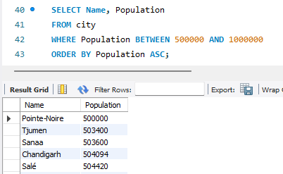

- Display Cities Sorted by Name in Ascending Order: Scenario: A geography teacher is preparing a lesson on alphabetical order using city names. You're tasked with providing a sorted list of cities from the database in ascending order by name to support the lesson plan.

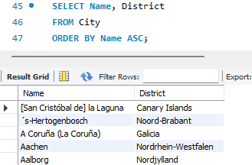

- Most Populated City: Scenario: A real estate investment firm is interested in cities with significant population densities for potential development projects. You're tasked with identifying the most populated city from the database to guide their investment decisions and strategic planning.

The scenario mentions population densities, which can only be derived from the country database. Therefore, I’ve approached the task in two ways.
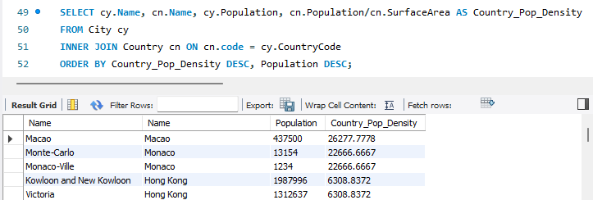
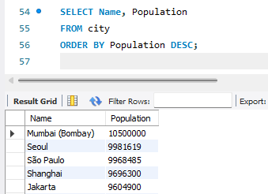

- City Name Frequency Analysis: Supporting Geography Education Scenario: In a geography class, students are learning about the distribution of city names around the world. The teacher, in preparation for a lesson on city name frequencies, wants to provide students with a list of unique city names sorted alphabetically, along with their respective counts of occurrences in the database. You're tasked with this sorted list to support the geography teacher.

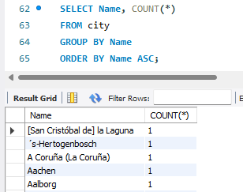

- City with the Lowest Population: Scenario: A census bureau is conducting an analysis of urban population distribution. You're tasked with identifying the city with the lowest population from the database to provide a comprehensive overview of demographic trends.

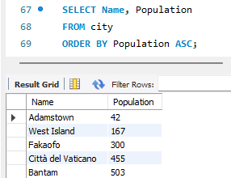

- Country with Largest Population: Scenario: A global economic research institute requires data on countries with the largest populations for a comprehensive analysis. You're tasked with identifying the country with the highest population from the database to provide valuable insights into demographic trends.

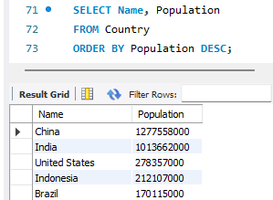

- Capital of Spain: Scenario: A travel agency is organising tours across Europe and needs accurate information on capital cities. You're tasked with identifying the capital of Spain from the database to ensure itinerary accuracy and provide travellers with essential destination information.

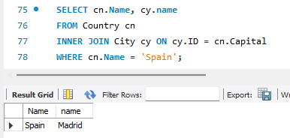

- Country with Shortest Life Expectancy: Scenario: A healthcare foundation is conducting research on global health indicators. You're tasked with identifying the country with the highest life expectancy from the database to inform their efforts in improving healthcare systems and policies.

The task heading says ‘shortest life expectancy’ in bold, but the description refers to the highest. I’ve provided the lowest value, since the highest was already completed in Task 2.

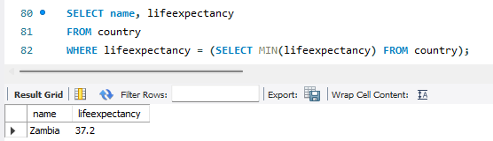

- Cities in Europe: Scenario: A European cultural exchange program is seeking to connect students with cities across the continent. You're tasked with compiling a list of cities located in Europe from the database to facilitate program planning and student engagement.

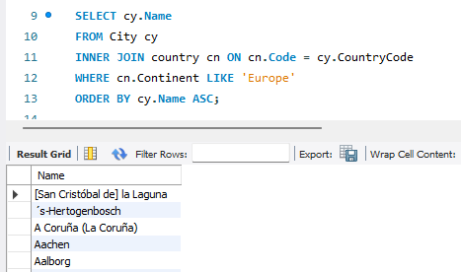

- Average Population by Country: Scenario: A demographic research team is conducting a comparative analysis of population distributions across countries. You're tasked with calculating the average population for each country from the database to provide valuable insights into global population trends.

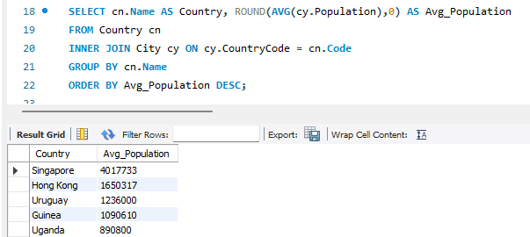

- Capital Cities Population Comparison: Scenario: A statistical analysis firm is examining population distributions between capital cities worldwide. You're tasked with comparing the populations of capital cities from different countries to identify trends and patterns in urban demographics.

The calculated % of population in capital for Singapore is incorrect because it exceeds 100%. I have included screenshots from the City and Country tables showing that the data is being pulled correctly from the database, which suggests that one of the tables contains outdated or incorrect population information.
Before sending the results, I would perform a data validation check and update the population data. The current total population of Singapore is approximately 6.11 million.
Since Singapore is a city-state and its capital is itself, the percentage of the population in the capital should correctly be 100%.

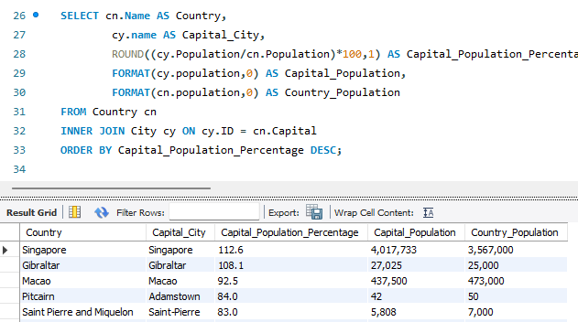
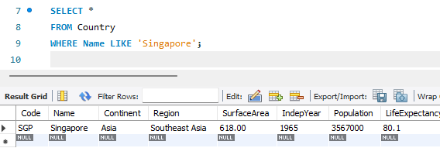

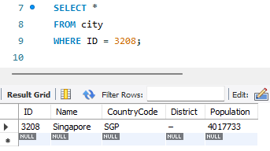

- Countries with Low Population Density: Scenario: An agricultural research institute is studying countries with low population densities for potential agricultural development projects. You're tasked with identifying countries with sparse populations from the database to support the institute's research efforts.

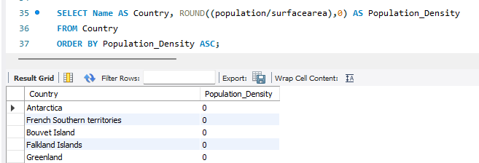

- Cities with High GDP per Capita: Scenario: An economic consulting firm is analysing cities with high GDP per capita for investment opportunities. You're tasked with identifying cities with above-average GDP per capita from the database to assist the firm in identifying potential investment destinations.

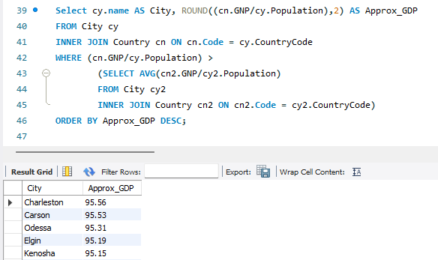

- Display Columns with Limit (Rows 31-40): Scenario: A market research firm requires detailed information on cities beyond the top rankings for a comprehensive analysis. You're tasked with providing data on cities ranked between 31st and 40th by population to ensure a thorough understanding of urban demographics.

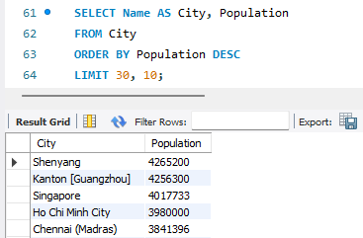

Course Notes

It is recommended to take notes from the course, use the space below to do so, or use the revision guide shared with the class:

Additional Information

We have included a range of additional links to further resources and information that you may find useful, these can be found within your revision guide.

END OF WORKBOOK

Please check through your work thoroughly before submitting and update the table of contents if required.

Please send your completed work booklet to your trainer.

