

Data Technician

Name: Lisa Weipert
Course Date: 24th to 28th November 2025
Table of contents
Day 1: Task 1 3
Day 1: Task 2 4
Day 2: Task 1 5
Day 2: Task 2 7
Day 3: Task 1 9
Day 3: Task 2 10
Day 4: Task 1 14
Day 4: Task 2 18
Course Notes 19
Information 19

Day 1: Task 1

Please research the different versions of Tableau, compare and contrast them below and explain the limited functionality on ‘Tableau Public’.

Different Tableau versions | 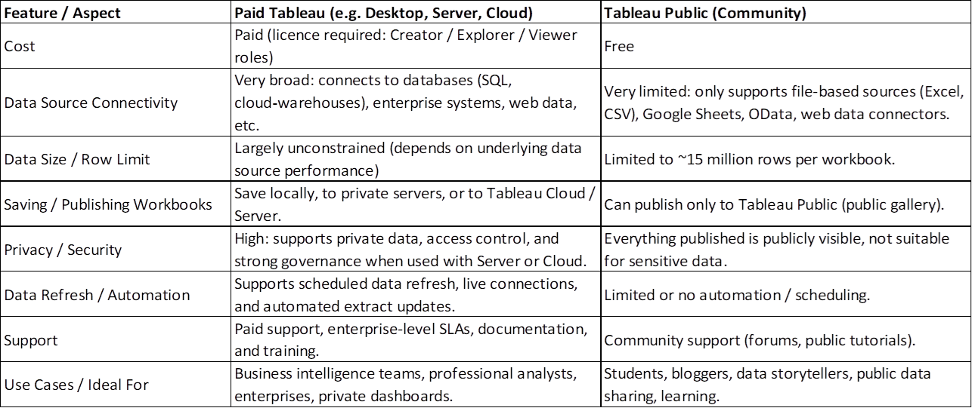  Limitations of Tableau Public  Everything is Public: Any dashboard you publish can be viewed and downloaded by anyone. Not suitable for confidential or corporate data.  Limited Data Connections: Only connects to simple files (Excel, CSV) and a few web-based sources. Cannot connect to databases like SQL Server, Snowflake, Oracle, etc.  No Private Server or Cloud Publishing: Cannot publish to Tableau Server or Tableau Cloud — only to the public gallery.  Reduced Functionality: Some export options and advanced features are restricted.  Row and Size Constraints; Public workbooks have row limits and performance restrictions compared to Desktop.

Day 1: Task 2

Using the EMSI_JobChange_UK dataset, create your own dashboard, I want to see a bar chart showing percentage change and a UK based map showing the key city locations impacted.

Paste your print screen here | 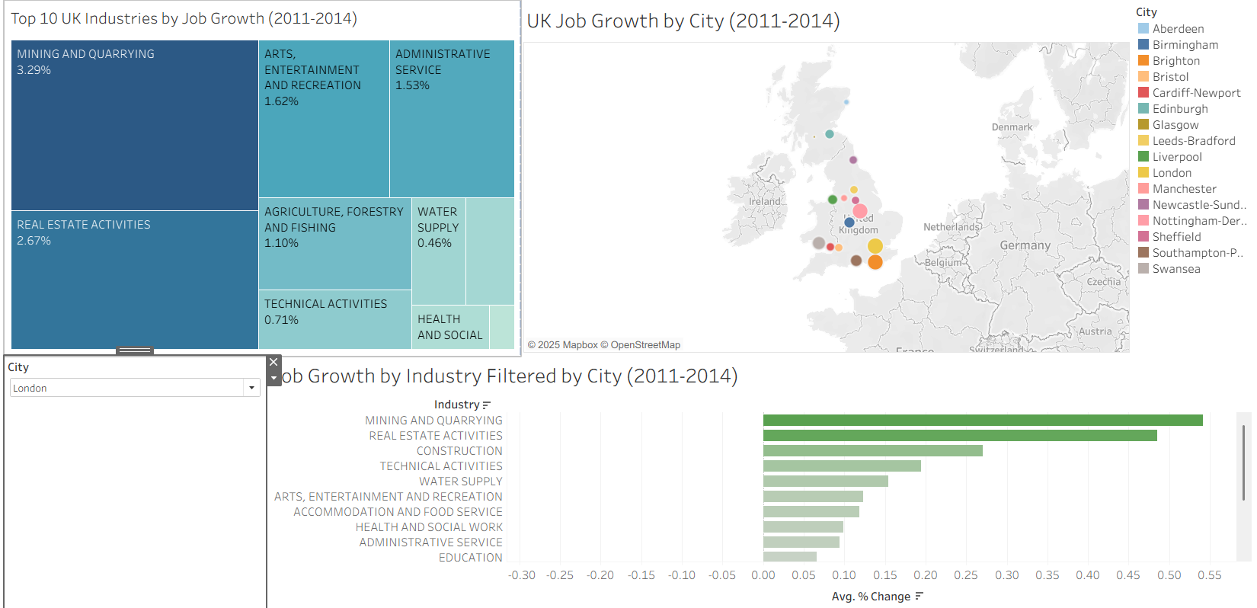

Day 2: Task 1

Using the Spotify data set, conduct an analysis to find trends and key information that could be used by an organisation for future projects.

There is no set scope for the analysis, simply to find trends and document them below:

Paste your print screens here | 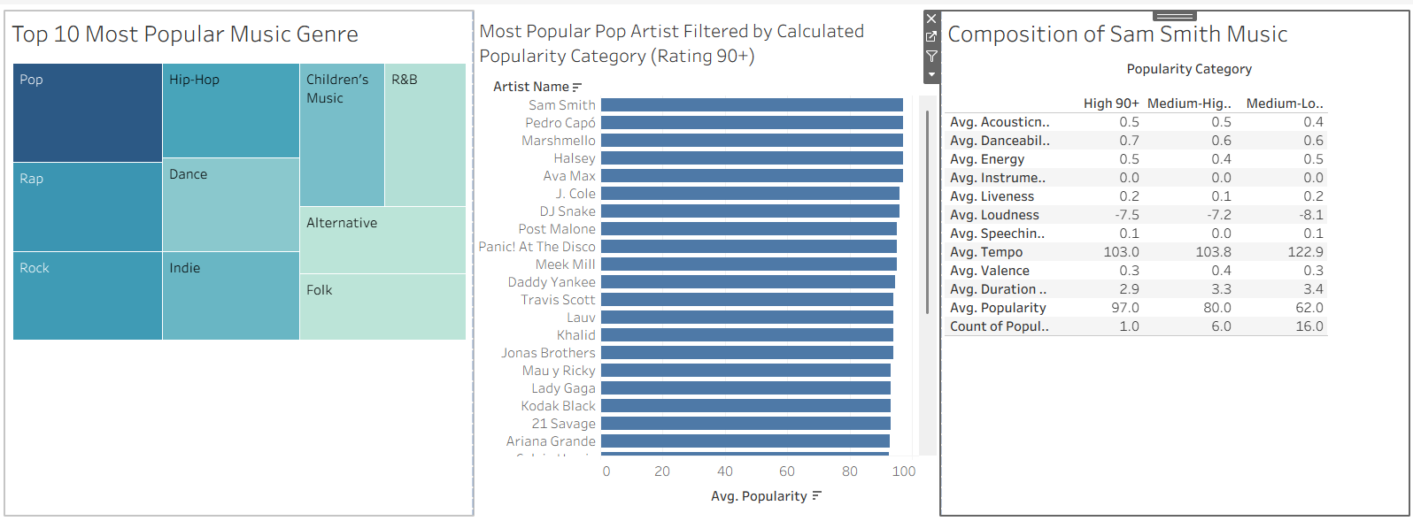  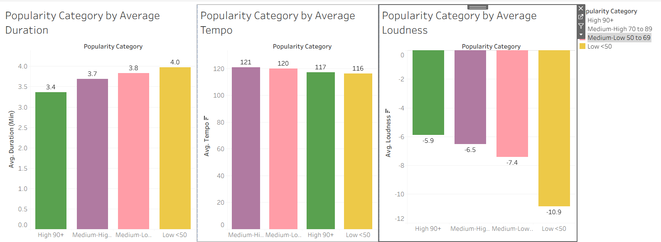  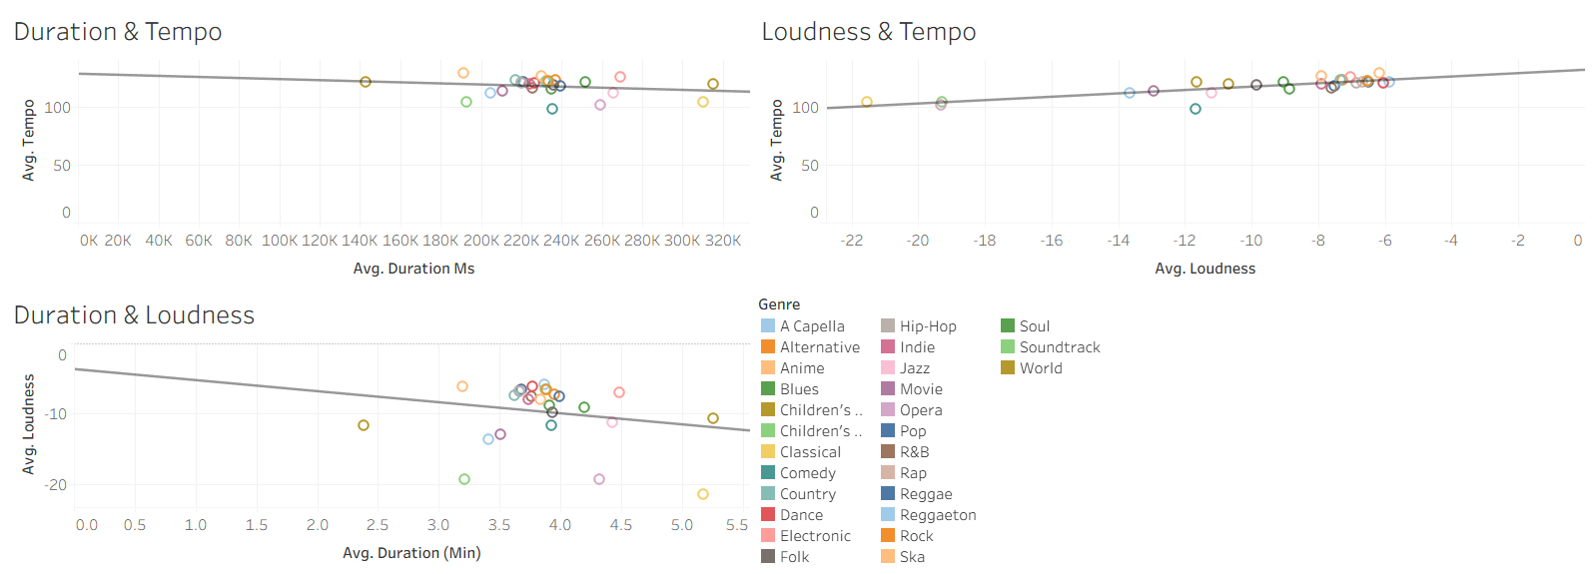

What did you find? | First, I examined the most popular music genres and identified pop as the most dominant.  Next, I categorised the popularity scores to help filter the data. Popularity was grouped into four categories: High (90+), Medium-High (70–89), Medium-Low (50–69), and Low (<50).  Using these categories, I found that Sam Smith had the highest-rated pop tracks within the High popularity group.  I then focused specifically on Sam Smith’s tracks to analyse which musical attributes varied the most across the different popularity levels. Based on this, I chose to examine Duration, Tempo, and Loudness.  The analysis showed that more popular songs tend to have shorter durations and lower loudness levels. Tempo should also be relatively low, but not too low, extremely slow tempos were associated with the least popular tracks. This pattern is somewhat unexpected for pop music, which is typically upbeat and usually features higher tempos. It may therefore be useful to research typical tempo ranges for pop songs and compare them with the dataset, as the tracks included may already fall within a relatively high tempo range.  Finally, I reviewed the correlations between the three dimensions. The relationships were generally weak, with the strongest correlation being between Loudness and Tempo at 0.658.

Day 2: Task 2

Using the Health, conduct an analysis to find trends and key information that could be used by an organisation for future support.

There is no set scope for the analysis, simply to find trends and document them below.

- Data can be lifesaving and is being used more within the NHS, reflect on how this data could support decision making for the NHS.

Paste your print screens here | 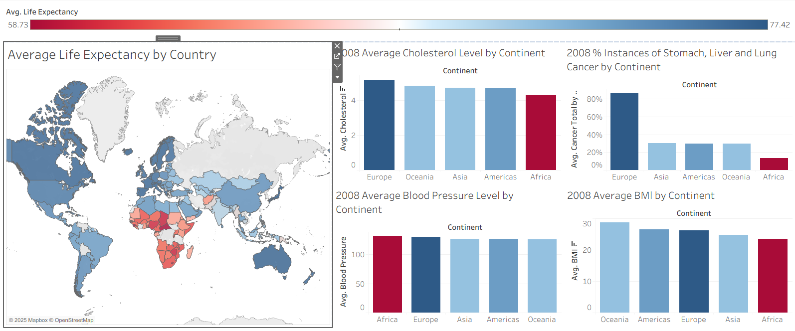  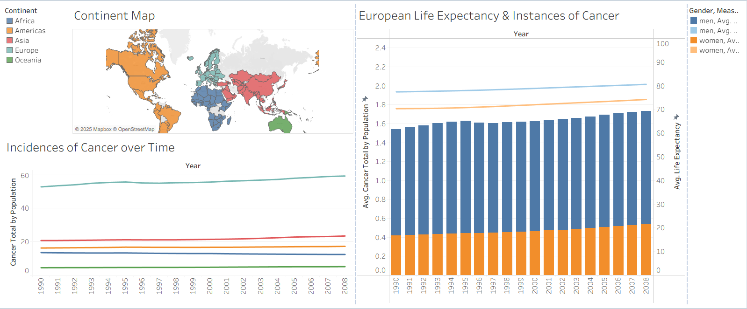
What did you find and any reflections on how the NHS could use this? | The map indicates that countries in Africa have a lower average life expectancy. Where as Europe, Americas and Oceania have higher average life expectancy.  When reviewing the available health measures for the most recent year (2008), the only indicator in which Africa shows higher values is blood pressure. Additional information on the factors contributing to high blood pressure would be helpful for further analysis.  One of the most striking findings is that cancer rates are significantly higher in Europe, where average life expectancy is also higher.  To explore cancer rates, I combined the counts of lung, stomach, and liver cancer and calculated incidence rates relative to the population.  The line graph shows that Europe has consistently experienced higher cancer incidences from 1990 to 2008. It would be interesting to investigate the age range of the population and of people who suffer from cancer. Does the age of the population increase the incidences of cancer? This could mean an increasing cancer burden due to people living longer.  I then examined the distribution between men and women, and it appears that cancer incidences are higher in men compared to women.  Adding a line to show the average life expectancy split by gender shows that, despite men showing higher cancer rates, women still have a lower life expectancy than men.  It is important to note that the cancer data is incomplete, as it does not include breast cancer, which is known to be more prevalent among women, as well as many other cancer types. The NHS might need to consider gender specific health strategies.

Day 3: Task 1

Please complete Lab 1 ‘Get Data in Power Bi Desktop’. Once complete, paste a print screen below and in the collaboration board.

“Teaching is the best way to learn, so please listen out for support requests from the class and we’ll work through the challenges together”

Paste your completed lab here | 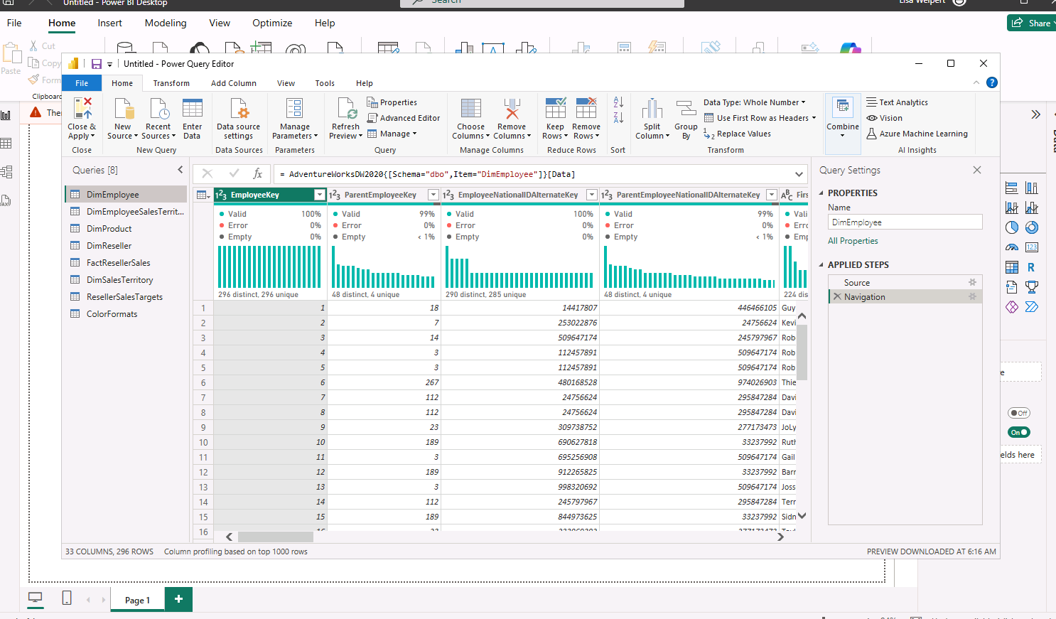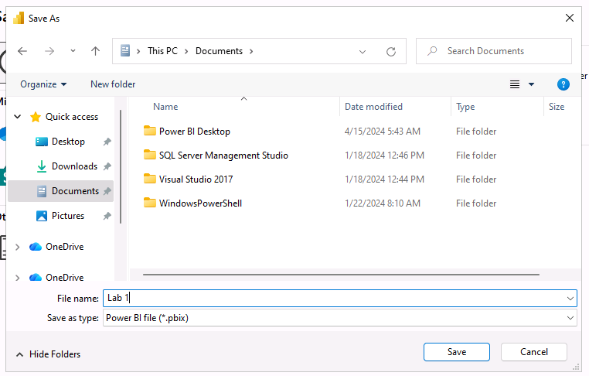

Day 3: Task 2

Please complete Lab 2 ‘Load Transformed Data in Power BI Desktop’. Once complete, paste a print screen below and in the collaboration board.

“Teaching is the best way to learn, so please listen out for support requests from the class and we’ll work through the challenges together”

Paste your completed lab here | 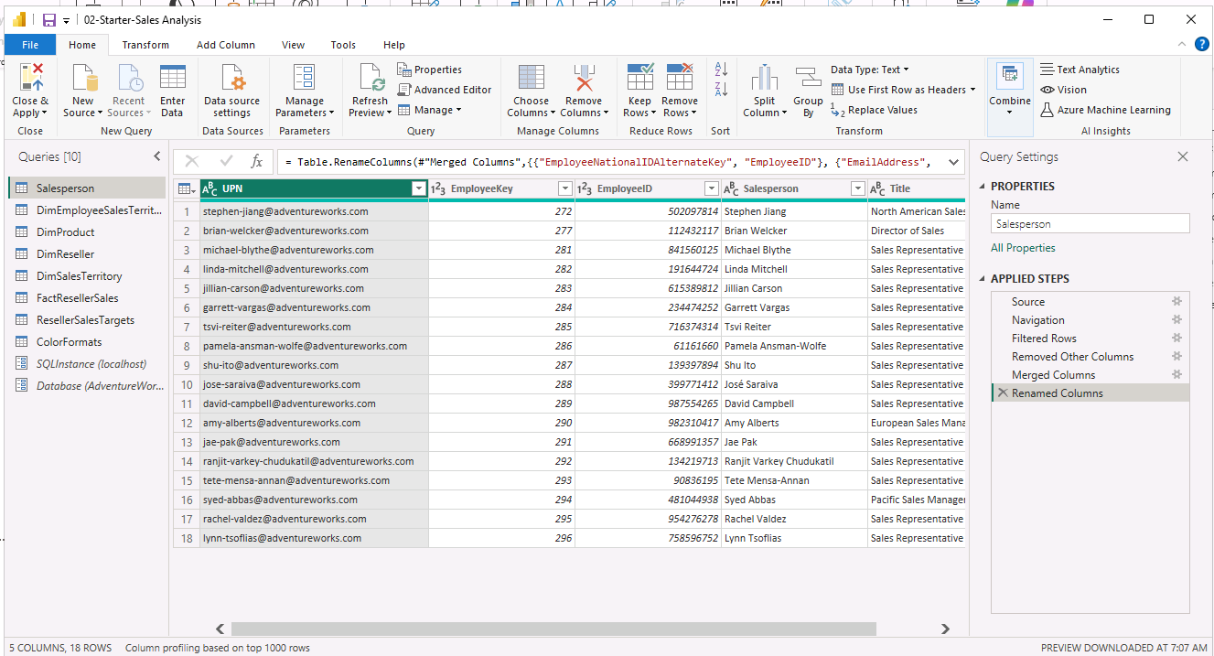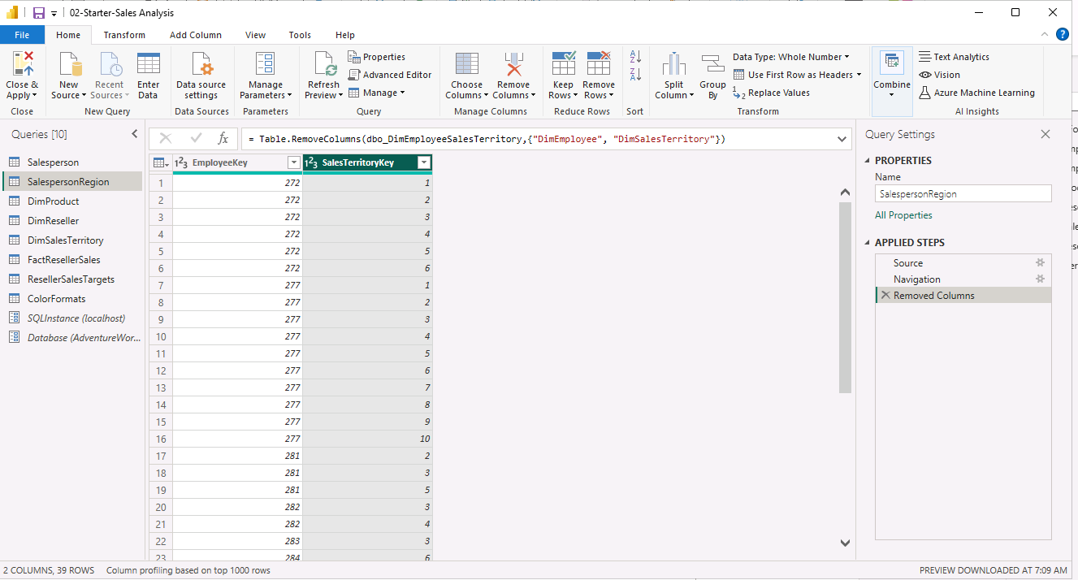  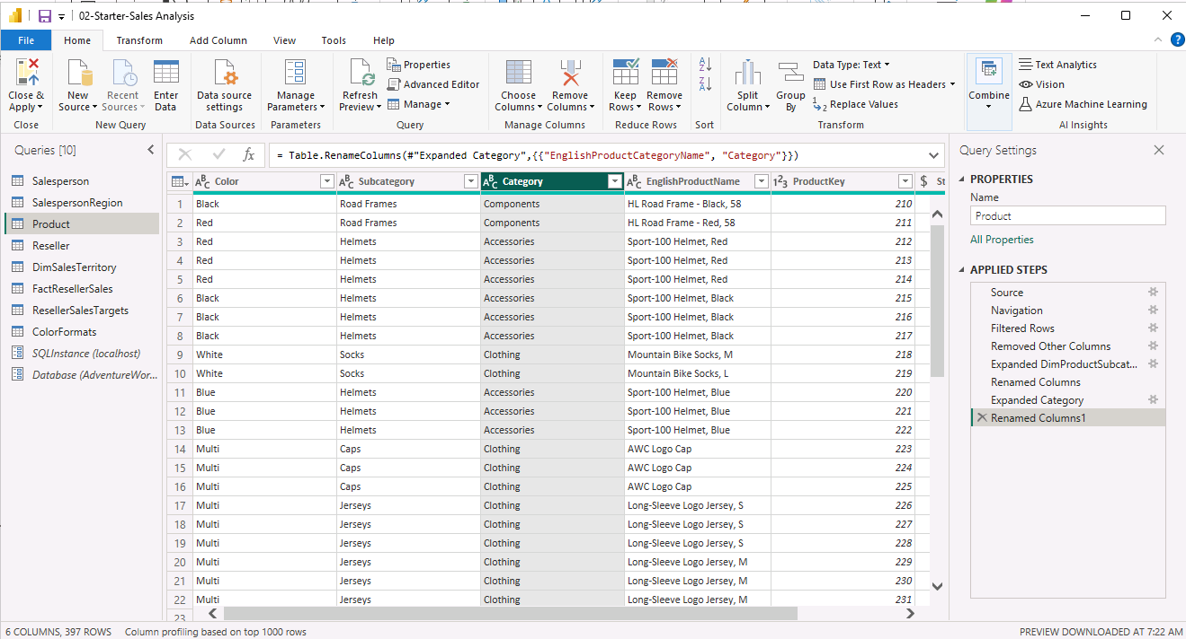  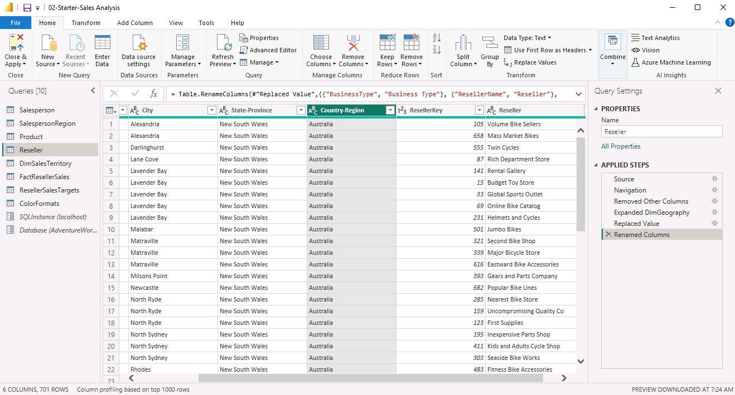  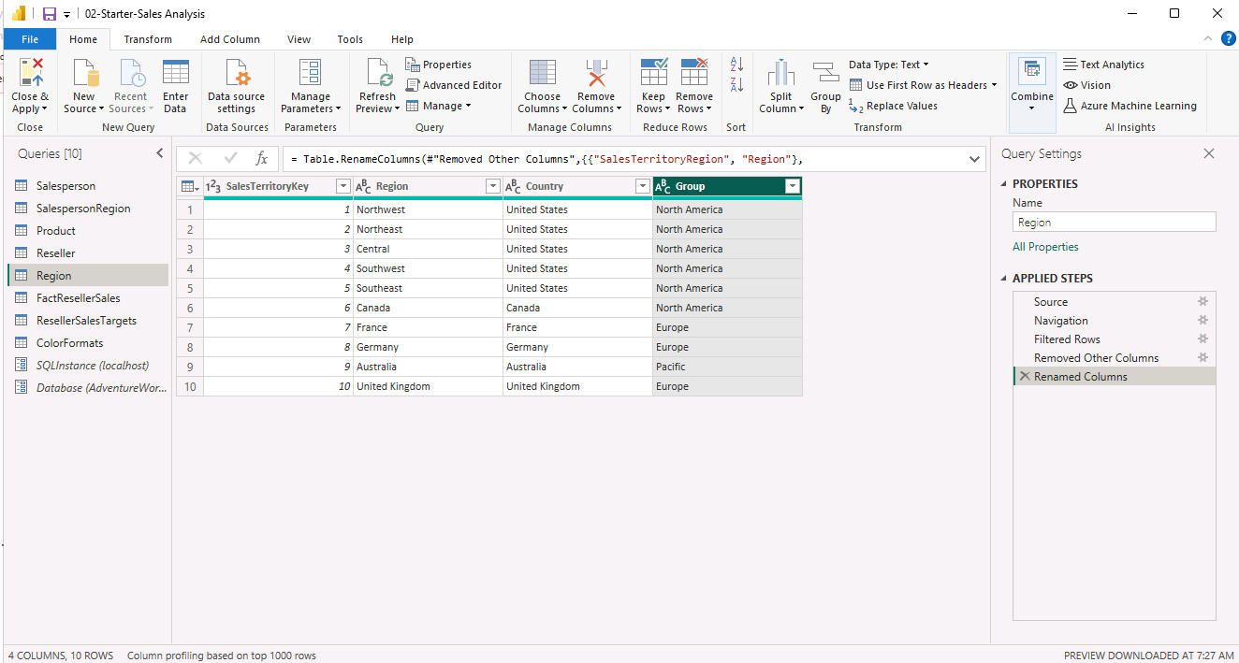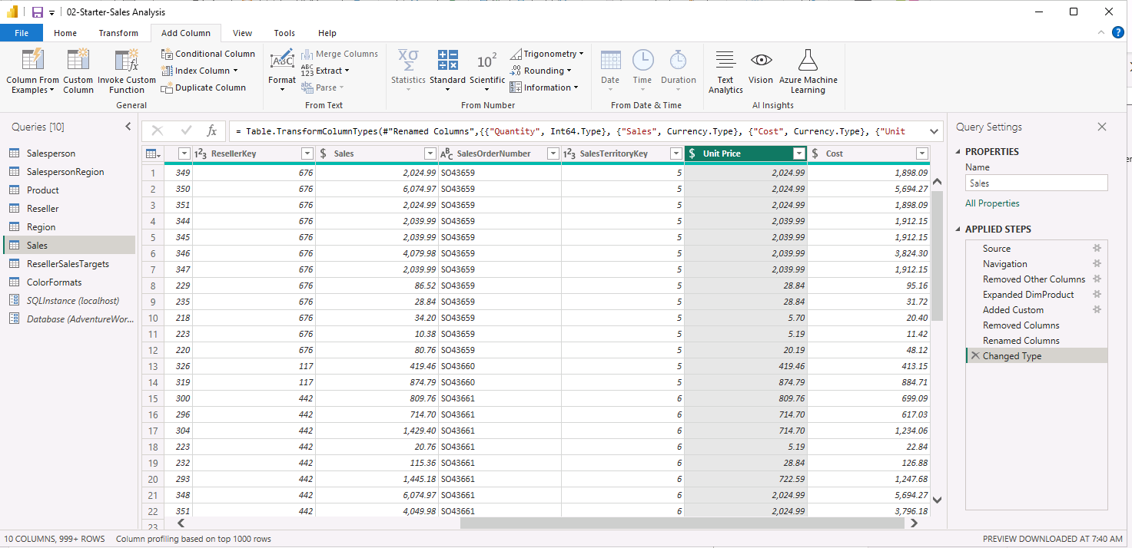  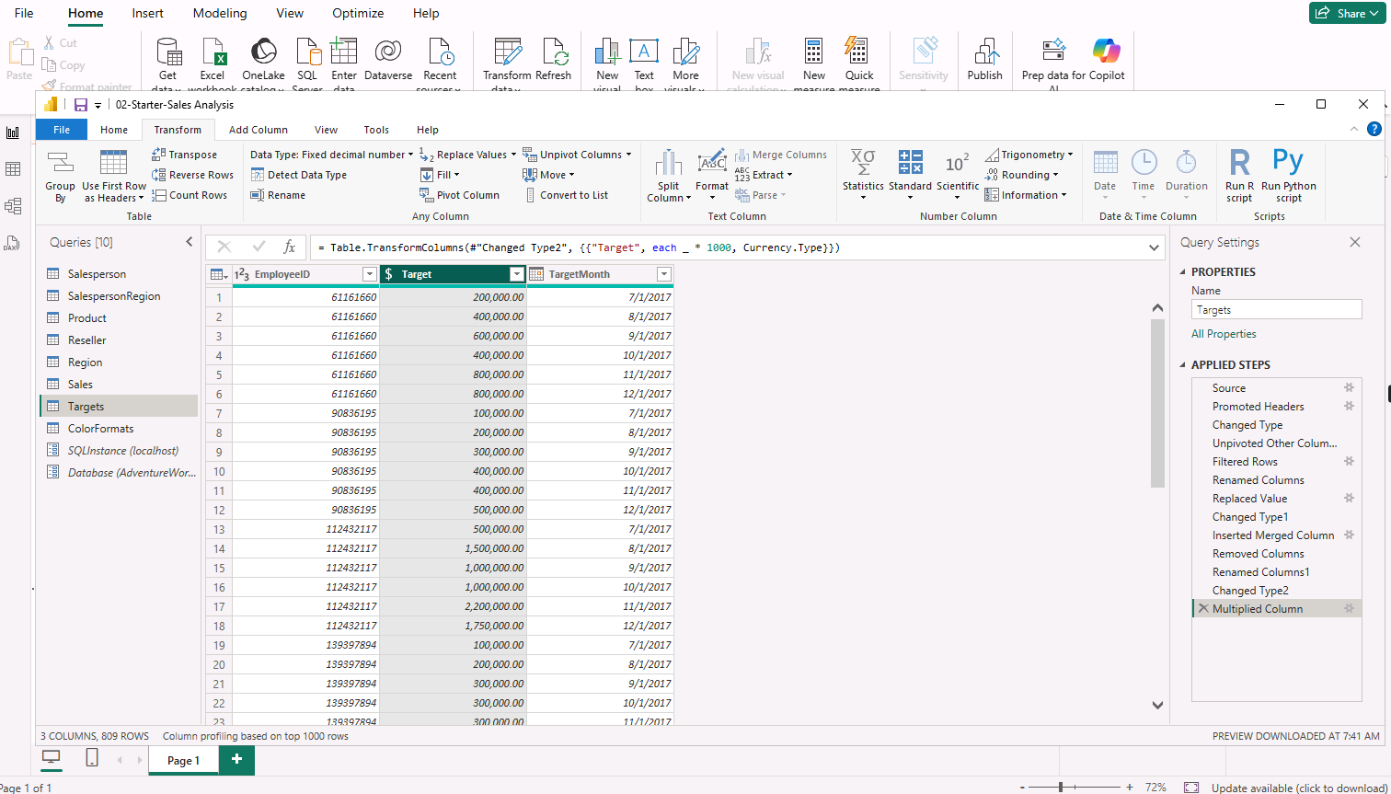  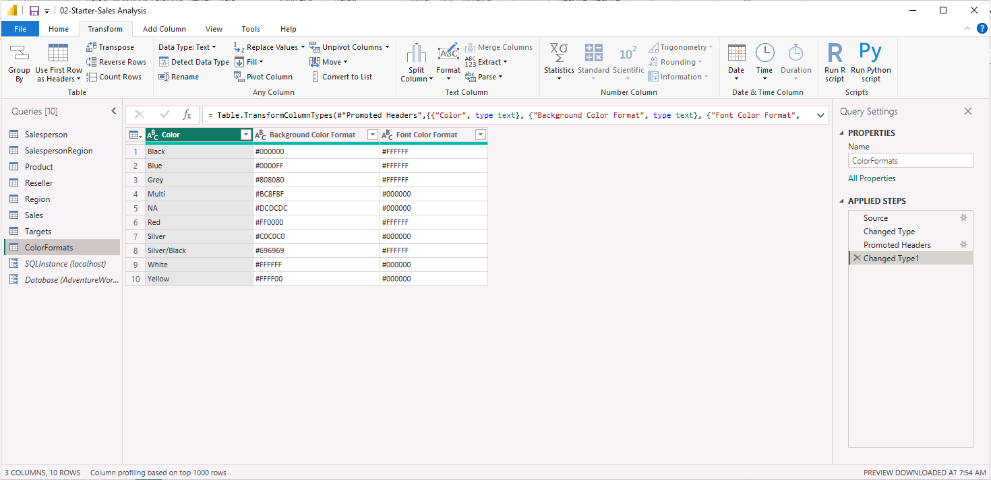  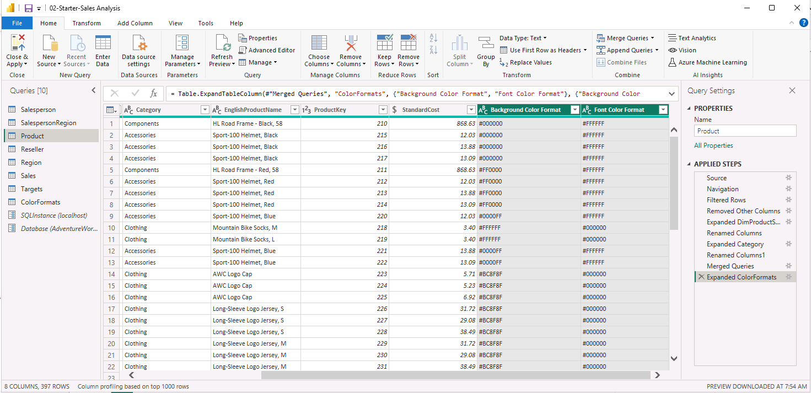  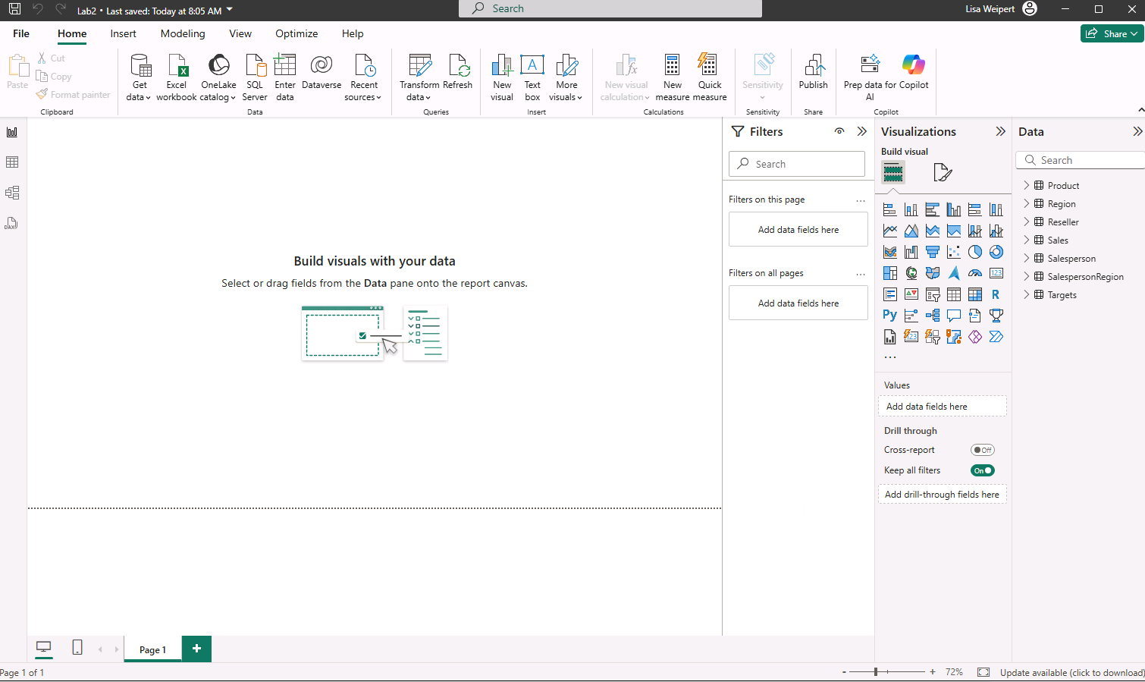

Day 4: Task 1

Please complete Lab 8 ‘Design a Report in Power BI Desktop’. Once complete, paste a print screen below and in the collaboration board.

“Teaching is the best way to learn, so please listen out for support requests from the class and we’ll work through the challenges together”

Paste your completed lab here | 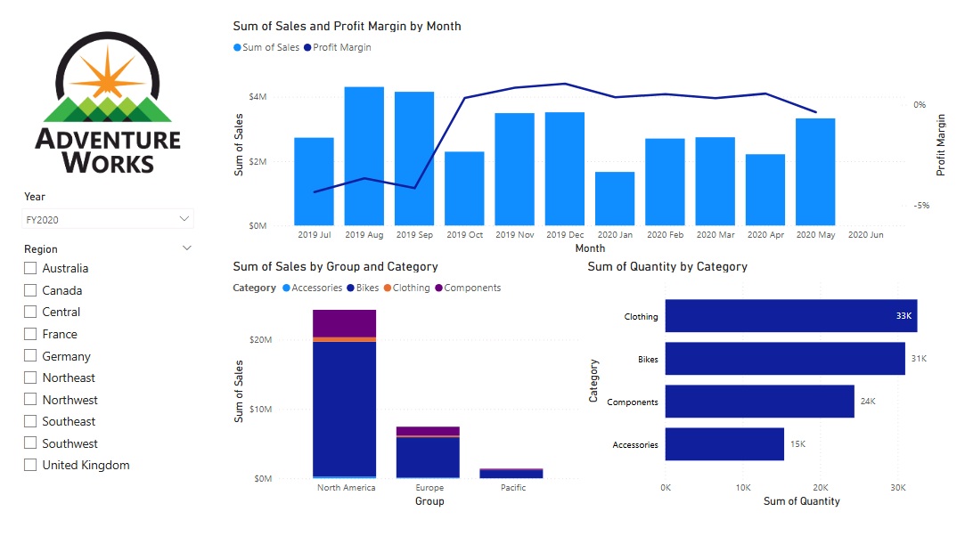  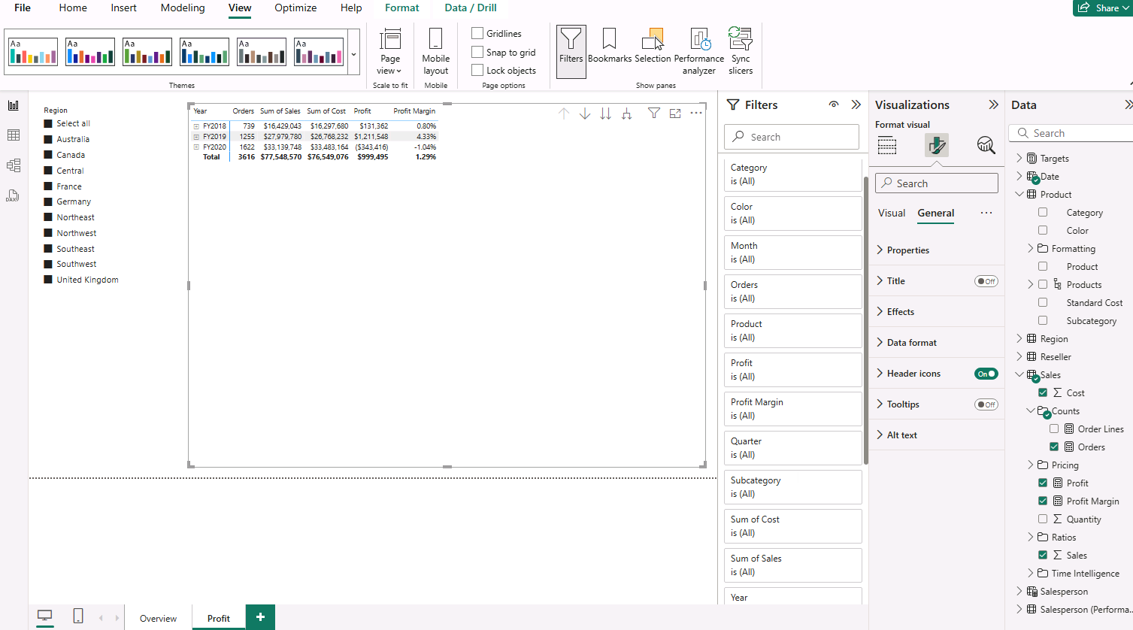  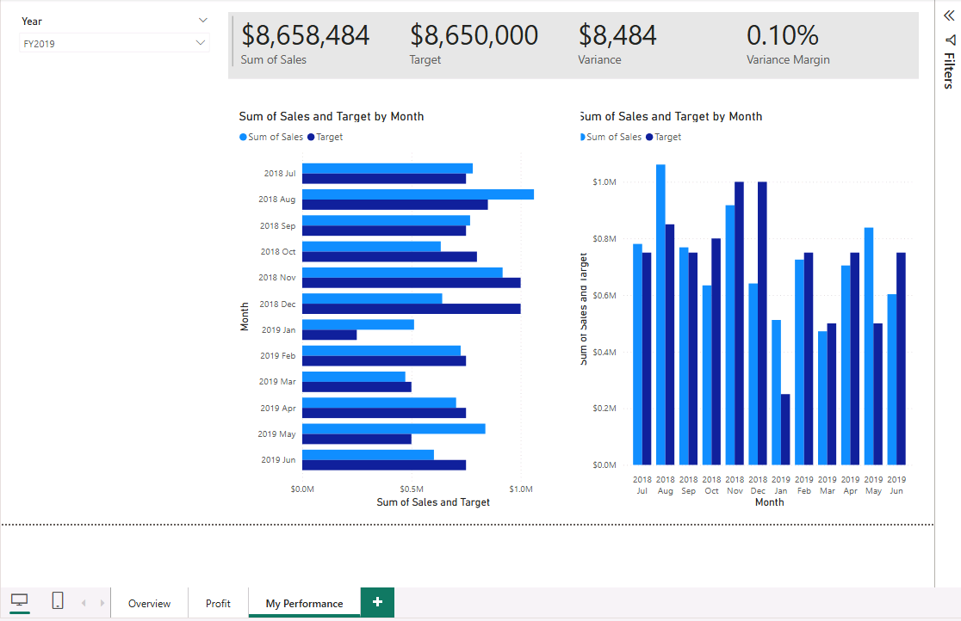  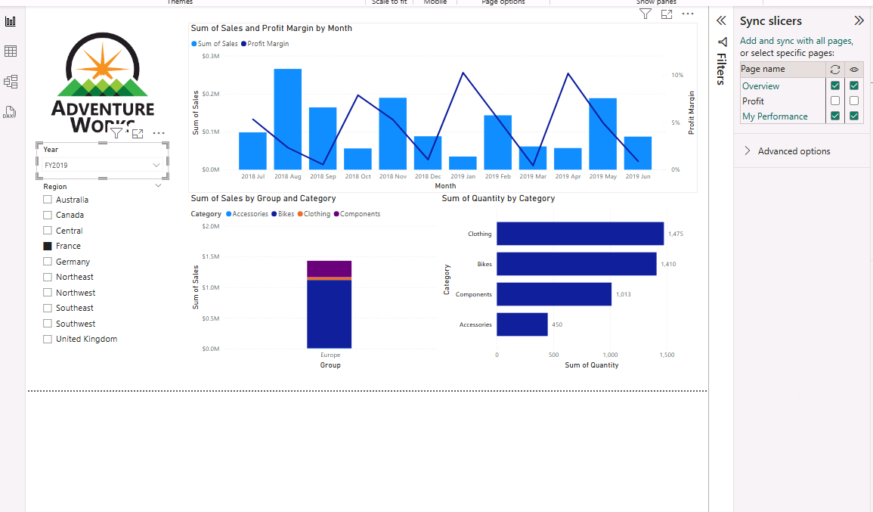  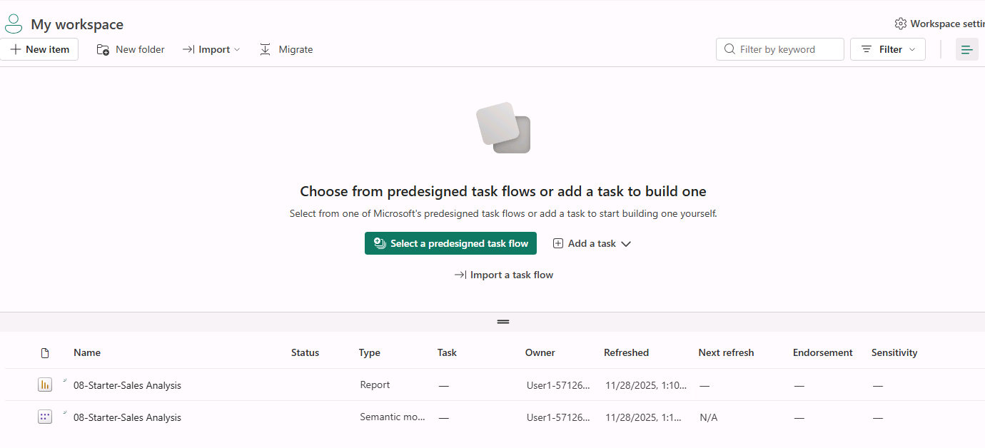  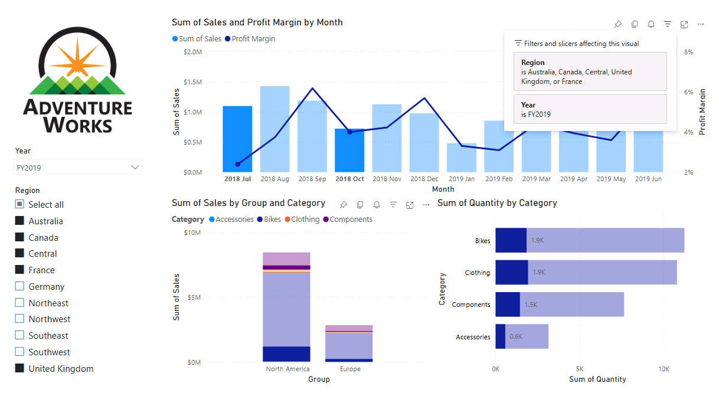  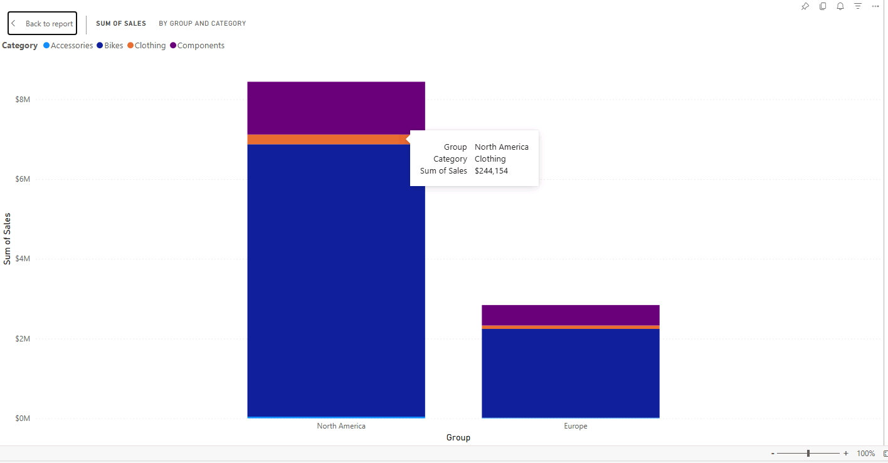  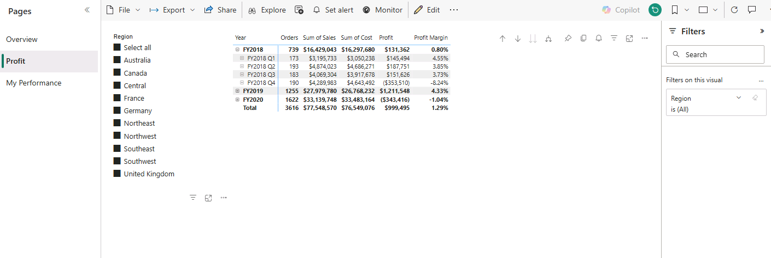  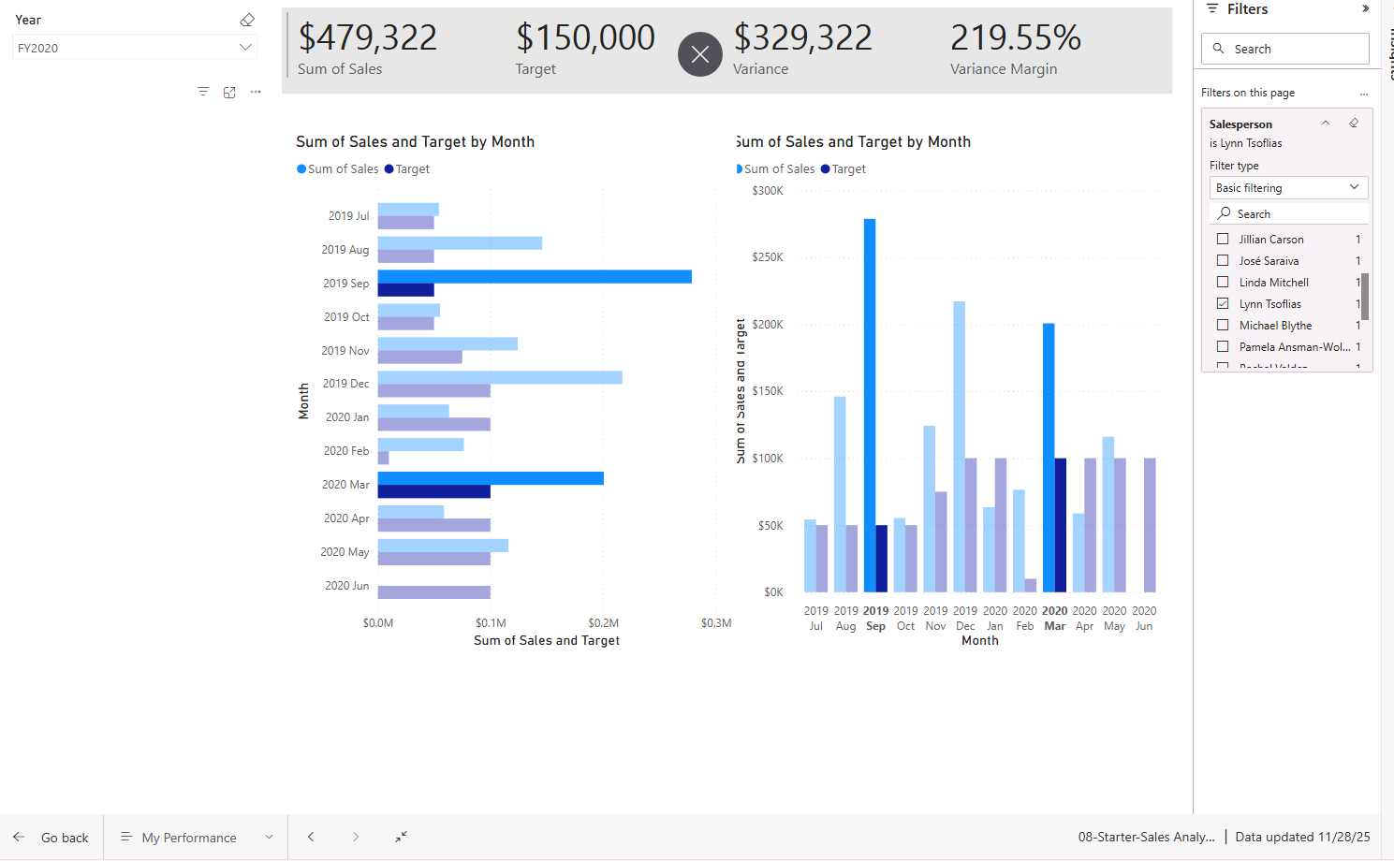

Day 4: Task 2

Please complete Lab 12 ‘Create a Power BI Dashboard’. Once complete, paste a print screen below and in the collaboration board.

“Teaching is the best way to learn, so please listen out for support requests from the class and we’ll work through the challenges together”

Paste your completed lab here | 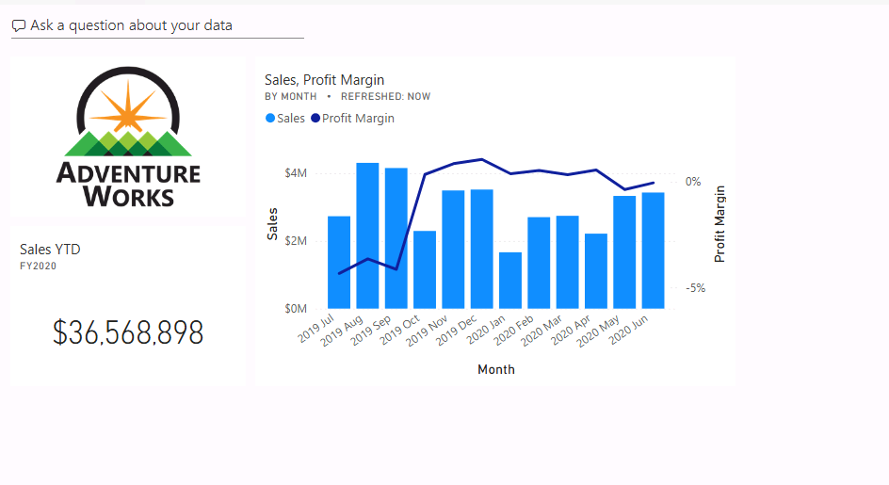

Course Notes

It is recommended to take notes from the course, use the space below to do so, or use the revision guide shared with the class.

We have included a range of additional links to further resources and information that you may find useful, these can be found within your revision guide.

END OF WORKBOOK

Please check through your work thoroughly before submitting and update the table of contents if required.

Please send your completed work booklet to your trainer.

Information

