

Data Technician

Name: Lisa Weipert
Course Date: 15th to 19th December 2025
Table of contents
Day 1: Task 1 3
Day 1: Task 2 5
Day 1: Task 3 6
Day 2: Task 1 8
Day 3: Task 1 11
Day 3: Task 2 12
Day 3: Task 3 13
Day 4: Task 1 15
Day 4: Task 2 16
1. Scenario Background 16
2. Data Laws and Regulations 16
3. Azure Service Recommendations 16
4. Data Types and Data Modelling 16
5. Data Storage Formats and Structures in Azure 17
6. Additional Considerations 17
Submission Guidelines: 17
Course Notes 24
Additional Information 25

Day 1: Task 1

Please research and complete the below questions relating to key concepts of cloud.

Be prepared to discuss the below in the group following this task.

What can cloud computing do for us in the real-world? | Cloud computing lets people and organisations use computing resources over the internet instead of owning and managing physical hardware. Providing on-demand servers and storage, global access from anywhere, high availability and disaster recovery and automatic scaling as demand changes.  Examples;  Streaming services (Netflix, YouTube): scale instantly to millions of users  Online banking: secure transactions, backups, fraud detection  Remote work: file sharing, collaboration tools, video calls  E-commerce: handle traffic spikes during sales  Healthcare: store patient records, run data analysis  Mobile apps & games: global access, fast performance anywhere
How can it benefit a business? | Cost benefits  - No large upfront capital cost  - Do not need space or maintenance for hardware  - Pay only for what you use (pay as you go)  Scalability & Flexibility  - Easily scale up during high demand  - Scale down when demand drops  - Perfect for growing or seasonal businesses  Speed & agility  - Test areas or new features can be established easily without infrastructure delays.  - Experimentation becomes low-risk as unsuccessful projects can be easily removed.  - Ready-made services are available, so you don’t need to build everything  Risk reduction & Security  - Cloud providers operate at a scale most organisations cannot afford, spreading disaster risk across multiple data centres and regions.  - Built-in backups  - Advanced security tools (encryption, access control)  Business Focus  - Teams focus on core business, not hardware management  - Enables digital transformation and remote working
What’s the alternative to cloud computing?
  Option | What it is | Key Features
  On-Premises | IT infrastructure owned and run by the organisation | Physical servers on-site, fixed capacity, manual scaling
  Private Cloud | Cloud-style infrastructure dedicated to one organisation | Virtualisation, automation, self-service portals
  Hybrid Cloud | Mix of on-prem/private cloud and public cloud | Workload portability, shared management
  Colocation (Colo) | Organisation-owned hardware in a third-party data centre | Professional power, cooling, physical security
What cloud providers can we use, what are their features and functions?
  Area | Meaning | AWS | Azure | GCP
  Compute (running apps) | How you run your applications or websites | Very flexible, many ways to run apps | Works well with Microsoft apps like Windows or Office | Strong for apps that need data and AI
  Storage (saving data) | Where and how your files, databases, or backups are kept | Many storage options, reliable | Easy if you already use Microsoft products | Great for large-scale data and analytics
  Databases | Systems to store and manage structured or unstructured data | Supports many database types | Works well with SQL Server or Microsoft databases | Excellent for analysing huge datasets quickly
  Networking | How your systems talk to each other and the internet | Lots of options, very customizable | Integrates with corporate networks easily | Fast global network for users everywhere
  Analytics & AI (data insights & smart features) | Tools to understand data and build smart apps (like recommendations, predictions) | Big ecosystem, mature AI tools | Easy for businesses already using Microsoft AI | Best if your business relies on big data and AI/ML
  Containers & App Mnagmnt | How apps are packaged and moved around easily | Strong support for modern apps | Good if using Microsoft tools | Great for developers to scale quickly
  Security & Access | How you control who can access what | Very mature security tools | Integrates with Microsoft security systems | Strong access controls and monitoring
  Global reach | Where your data and apps can be hosted | Lots of regions worldwide | Similar global presence | Fast network and edge locations for speed
  Pricing | How you pay | Flexible, can save if you commit long-term | Flexible, can integrate with existing Microsoft licenses | Good for long-running workloads and data-heavy use
  Business | Overview | Largest range of services, easy to scale, widely used | Integrates easily with existing systems, good for enterprises | Fast global network, strong AI/ML tools, great for data-heavy apps

Day 1: Task 2

Please research the below cloud offerings, explain what they are and examples of use cases.

Cloud Offerings | Explain what it is | When / how might you use this service in the real-world?
IaaS (Infrastructure as a service) | IaaS is like renting a fully-equipped virtual data centre instead of buying and maintaining physical hardware. | IaaS is used when businesses need flexible, scalable, and cost-effective computing infrastructure without investing in physical hardware.  Example: Netflix runs its entire streaming service on AWS IaaS.  They use virtual servers, storage, and networking to handle millions of users streaming video simultaneously.  By using IaaS, Netflix can scale infrastructure dynamically depending on demand (e.g., high traffic during evenings or new content releases).  They don’t have to maintain physical data centres, reducing costs and complexity.
PaaS (Platform as a service) | PaaS simplifies application development by providing a complete cloud-based platform, enabling businesses to innovate faster while the provider manages the technical foundation. | PaaS is used when organizations want to build, test, and deploy applications quickly without worrying about infrastructure management. It is ideal for software development teams, web and mobile app development, API creation, and agile projects where speed, scalability, and collaboration are important.  Example: Uber uses PaaS solutions such as Google App Engine to support parts of its application platform. PaaS allows Uber’s developers to rapidly build, test, and deploy services while automatically scaling to handle fluctuating demand from millions of users worldwide. By using PaaS, Uber can focus on improving app features and user experience rather than managing servers or infrastructure.
SaaS (Software as a service) | SaaS delivers complete software solutions over the internet, making it ideal for organizations that want powerful applications without the complexity of installing or managing software themselves. | SaaS is used when businesses or individuals need ready-to-use software with minimal setup and maintenance.  Example: Salesforce is a well-known SaaS. It provides cloud-based CRM software that businesses use to manage customer data, sales pipelines, and marketing campaigns. Companies access Salesforce through a web browser, and Salesforce handles hosting, security, updates, and scalability, allowing businesses to focus on selling and customer relationships rather than software maintenance.

Day 1: Task 3

Please research the below terms and explain what they are, when they would be appropriate and a real-world example of where it could be implemented (i.e. what type of organisation).

Public Cloud | A public cloud is a service where a company stores and runs its data and applications on servers owned and managed by a third-party provider (like Microsoft, Amazon, or Google). You access it over the internet, and you usually pay only for what you use.  When it’s appropriate:  When an organization wants to avoid buying and managing its own servers.  When it needs flexibility to quickly scale up or down (e.g., during busy seasons).  When the workload is standard and doesn’t involve very sensitive data that requires private storage.  Example: Startup or small business hosting its website or app.  Instead of buying expensive servers, they use Amazon Web Services (AWS) to store data, run their app, and handle traffic spikes.  In short: public cloud is like renting a fully equipped office online, you don’t own it, but you can use as much space as you need, and it’s ready to go.
Private Cloud | A private cloud is a computing environment dedicated to a single organization. The organization either owns the servers or rents them exclusively, and the cloud can be hosted on-site or by a third party. Only that organization can use it, so it’s more secure and customizable than a public cloud.  When it’s appropriate:  When an organization handles sensitive or regulated data (e.g., medical records, financial data).  When there’s a need for high security, privacy, or control over data.  When the organization can afford to manage or pay for dedicated resources.  Example: Banks or hospitals often use private clouds.  A hospital might store patient records on a private cloud to keep data secure while still allowing doctors and staff to access it online.  In short: private cloud is like having your own private office building online—you control who gets in, and it’s secure, but it costs more to run.
Hybrid Cloud | A hybrid cloud uses both a private and a public cloud together. Sensitive data stays on the private cloud for security, while less-sensitive tasks or extra computing power can use the public cloud. The two clouds work together, so data and workloads can move between them easily.  When it’s appropriate:  When an organization wants flexibility and scalability without compromising security.  When workloads vary, some data is sensitive, and some isn’t.  When cost efficiency is important: pay for extra public cloud resources only when needed.  Example: Retail companies store customer payment information on a private cloud for security but use a public cloud to handle heavy website traffic during sales or holidays.
Community Cloud | A community cloud is a cloud infrastructure shared by a group of organisations with similar goals or requirements, like security, compliance, or industry standards. They share costs and resources while keeping data accessible only to the group.  When it’s appropriate:  When multiple organizations have similar security or compliance needs.  When collaboration is needed between organizations, but they don’t want to use a public cloud.  When cost-sharing makes it more affordable than each building a private cloud.  Example: Universities or research institutions working together on a joint research project could use a community cloud to share data and computing resources.  Healthcare organisations in the same region could use it to securely share patient data for research while meeting strict privacy rules.

Day 2: Task 1

Describe, with examples, the three major areas that the Computer Misuse Act deals with.

Area | Description | Example
Unauthorized Access to Computer Material | It is illegal to access a computer or its data without permission, even if you don’t make any changes. | Hacking into someone’s email account to read their messages without authorisation.  Logging into a company server using a stolen password without making any changes.
Unauthorized Access with Intent to Commit Further Offenses | Accessing a computer without permission with the intent to commit a further crime. | Breaking into a bank’s database to steal financial information or transfer money.  Accessing a company’s customer records to commit identity theft or fraud.
Unauthorized Modification of Computer Material | Illegally changing, deleting, or adding data on a computer. This covers malware, viruses, and other harmful actions. | Uploading a virus to a company network to disrupt operations.  Changing grades on a school’s computer system without permission.  Installing ransomware that encrypts files and demands payment.

The computer misuse act 1990 is an act where an individual can be criminalised because of computer related offense. Describe three extra powers that the Police and Justice Act 2006 (Computer Misuse) has added.

Description
The Computer Misuse Act 1990 did not explicitly address Denial-of-Service (DoS) attack offenses, and the 2006 Act filled this gap as these attacks became more prevalent. It made it an offense to intentionally impair the operation of a computer.
The 2006 Act criminalized the creation, distribution, or possession of malware intended for committing further offenses. This means it is illegal to write or sell a virus or keylogger intended to hack into someone’s accounts. This law helps police take action before any damage occurs, rather than only responding after the fact.
Prior to the 2006 Act, penalties for computer misuse were not always proportionate to the intent or potential risk associated with the crime. The Act increased the maximum sentences for serious offenses related to computer misuse and provided courts with greater flexibility. For instance, severe hacking that results in significant financial or operational damage can now lead to higher fines and longer prison terms.

Look at the below website to answer the questions:
https://www.gov.uk/personal-data-my-employer-can-keep-about-me

Write down three items of data which a company can store about an employee.
Name

National Insurance Number

Any disciplinary action

Give three more examples of data that an employer can only store if they first get the employee’s permission.
Race and ethnicity

Biometrics

Health and medical conditions

Conduct further research to answer the below questions.

Question | Answer
Provide one example of: Copyright infringement | Downloading and sharing pirated movies or software. When someone copies and distributes films or software without permission from the copyright owner.
Provide one example of: Plagiarism | Copying without giving credit to the original source. Directly copying text from ChatGPT without citing it.
What are two consequences of copyright infringement and software piracy? | Fines or imprisonment from the authorities.  The copyright owner can seek financial compensation to recover any losses.
Give three possible consequences for individuals when using pirated software | Pirated programs can contain malicious code such as malware, viruses or spyware.  Unlicensed software lacks access to updates, support, or patches, compromising security.  People can face criminal charges and civil lawsuits, resulting in fines, jail time, and compensation payments.

Listed below are some laws which we have covered today:

1. Computer Misuse Act 1990
2. Police and Justice Act 2006 (Computer Misuse)
3. Copyright, Designs and Patents Act 1988
4. Copyright (Computer Programs) Regulations 1992
5. The Health and Safety (Display Screen Equipment) Regulations 1992
6. Data Protection Act 2018
7. Consumer Rights Act 2015

- Insert a number in the first column of each row to match each of the statements with one of the above Acts.

- One of statements is incorrect and not illegal. For this statement, write ‘Not illegal’.

Act number | Clause
4 | With some exceptions, it is illegal to use unlicensed software
7 | Any product, digital or otherwise, must be fit for the purpose it is supplied for
1 | Unauthorised modification of computer material is illegal
Not illegal | It is illegal to create or use a hacking tool for penetration testing
6 | Personal data may only be used for specified, explicit purposes
5 | Employers must provide their computer users with adequate health and safety training for any workstation they work at
2 | It is illegal to distribute hacking tools for criminal purposes
3 | It is illegal to distribute an illicit recording
6 | Personal data may not be kept longer than necessary
1 | Gaining unauthorised access to a computer system is illegal
5 | Employers must ensure that employees take regular and adequate breaks from looking at their screens
2 | It is illegal to prevent or hinder access (e.g. by a denial-of-service attack) to any program or data held in any computer
6 | Personal data must be accurate and where necessary kept up to date

Day 3: Task 1

Please complete the below lab (3) ‘Explore relational data in Azure’ and paste evidence of the completed lab in the box provided.



Completed lab | 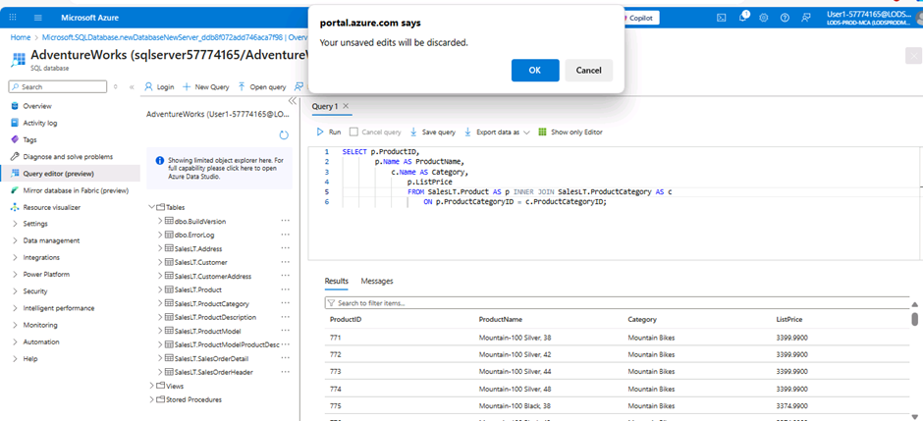

Day 3: Task 2

Please complete the below lab (4) ‘Explore non-relational data in Azure’ and paste evidence of the completed lab in the box provided.



Completed lab | 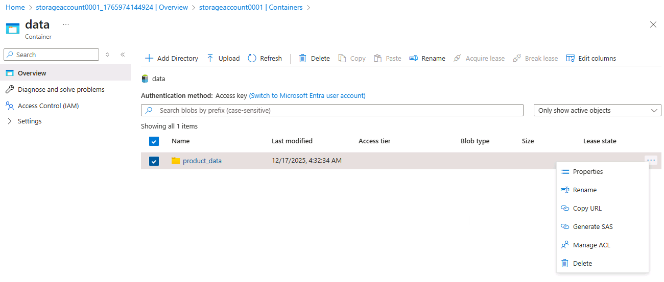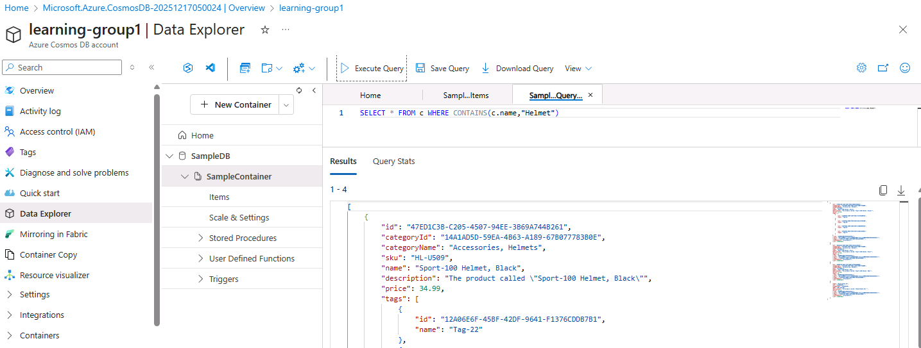

Day 3: Task 3

Please complete the below lab (5) ‘Explore data analytics in Azure’ and paste evidence of the completed lab in the box provided.

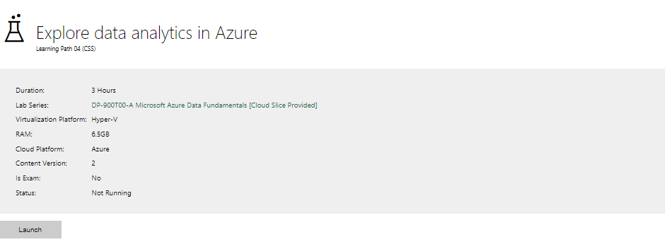

Completed lab | 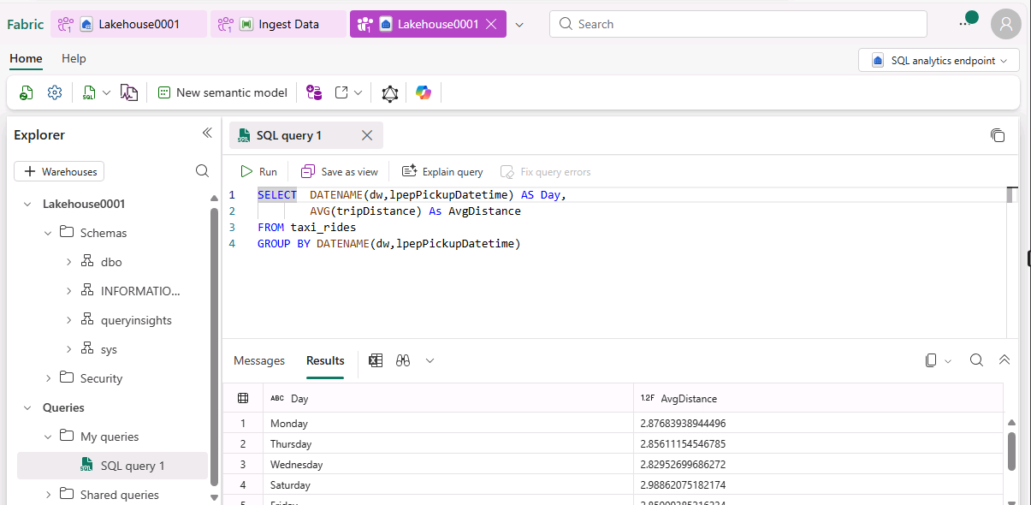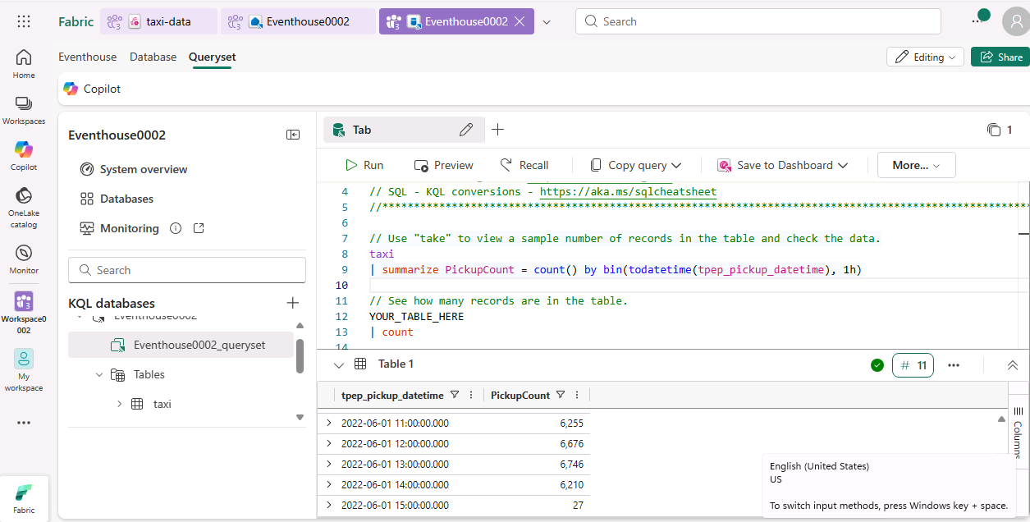  The map failed to generate for the next section. I’ve attached screenshots showing that I had enabled the map visuals and switched the data category to 'city'.  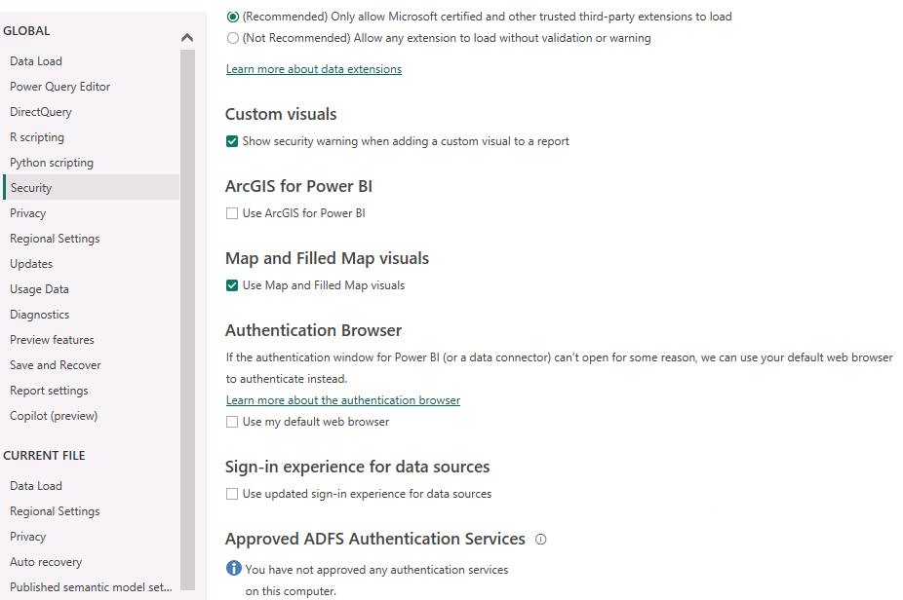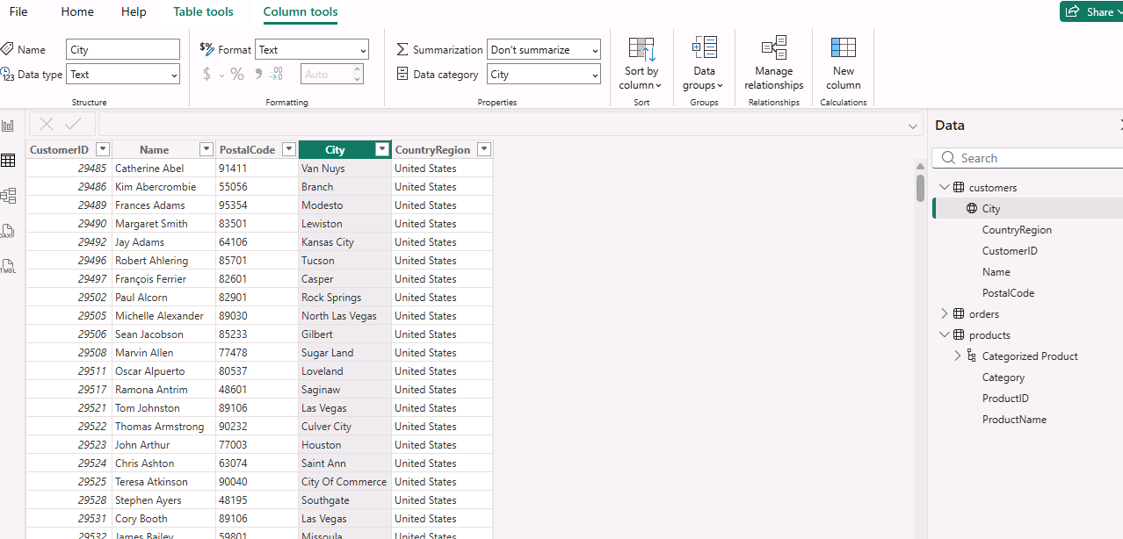  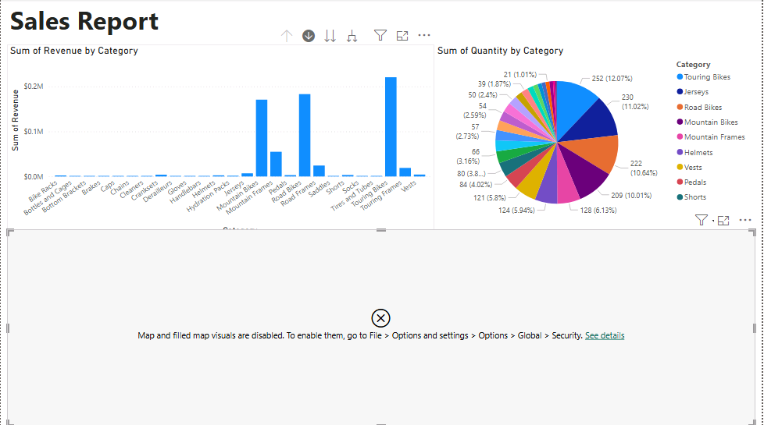

Day 4: Task 1

In your teams, complete the Azure DP-900 practice exam and paste your result below – this is open book and please research and discuss your answers as a team.


Result | 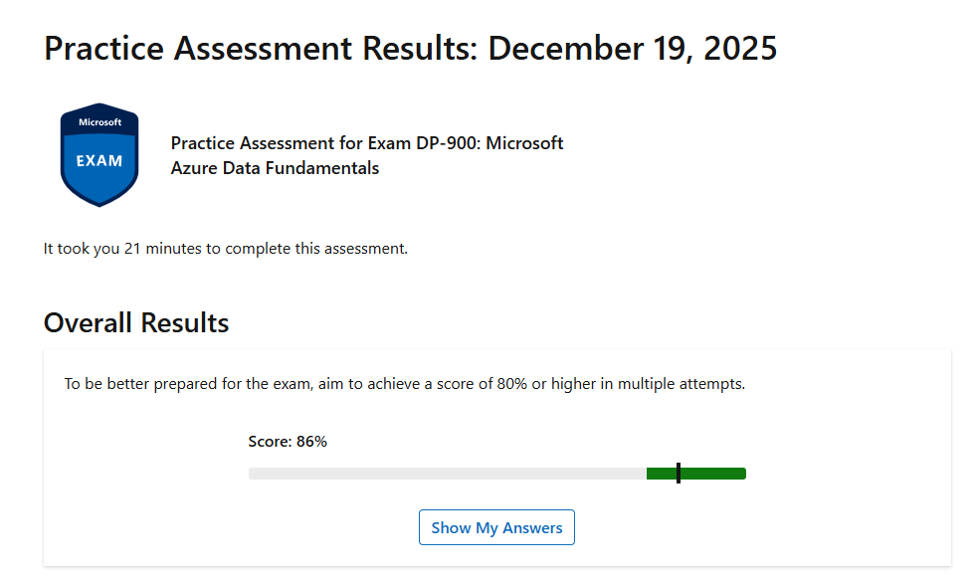

Day 4: Task 2

1. Scenario Background
"Paws & Whiskers" is a growing pet shop that aims to improve its business by analysing sales, customer information, and inventory data. Currently, the data is collected manually or stored in spreadsheets. Management is interested in transitioning to Microsoft Azure to streamline data storage, analysis, and reporting, enabling them to make data-driven decisions.

2. Data Laws and Regulations
Identify and explain the data laws and regulations relevant to handling customer data within the proposal. Ensure you cover the following points:
- GDPR Compliance: Highlight the importance of adhering to the General Data Protection Regulation (GDPR), particularly as it relates to storing and processing customer information.
- Data Protection Act (DPA) 2018: Outline how the DPA 2018 may affect the way "Paws & Whiskers" collects and stores data, ensuring compliance with UK laws on data privacy.
- Other Industry Standards: Research any additional data protection standards or regulations that may apply to pet shop data, particularly if they involve sensitive or payment information.

3. Azure Service Recommendations
Recommend Microsoft Azure services that would suit the company’s data analysis needs and explain why these services are suitable. Your recommendations should include:
- Data Storage: Identify suitable storage options, such as Azure Blob Storage or Azure SQL Database, and discuss the benefits of each for storing large datasets, including inventory, sales transactions, and customer details.
- Data Analysis Tools: Recommend tools such as Azure Machine Learning for customer behaviour analysis or Azure Synapse Analytics for analysing sales trends.
- Data Integration and Automation: Explain how services like Azure Data Factory could automate data collection and integration processes, improving efficiency.

4. Data Types and Data Modelling
Define the types of data "Paws & Whiskers" will need to work with and describe your approach to data modelling:
- Data Categories: Identify key data types, such as customer demographics, transaction history, pet inventory, and product categories.
- Data Modelling Approach: Outline how you would structure this data using a relational model or a data warehouse approach, considering factors like tables, entities, relationships, and primary keys.

5. Data Storage Formats and Structures in Azure
Discuss how you would store data within Azure and the formats you would recommend:
- Data Formats: Specify recommended formats (e.g., CSV for raw data imports, JSON for structured data, Parquet for analytics) and explain why these formats are suitable for specific data types.
- Data Security and Encryption: Include recommendations for securing data using Azure’s built-in encryption features and access controls to ensure compliance with data privacy regulations.

6. Additional Considerations
Provide any other considerations that might enhance data handling and efficiency in Azure, such as:
- Backup and Disaster Recovery: Outline a backup plan using Azure Backup or Azure Site Recovery to safeguard against data loss.
- Data Visualisation: Discuss potential use of Power BI within Azure for creating dashboards that provide management with real-time insights into sales and customer trends.
- Future Scalability: Comment on how Azure services can scale as the business grows, accommodating larger datasets and more complex analyses.

Submission Guidelines:
- Structure: Ensure your report is well-organised, with sections for each task (e.g., Data Laws, Azure Services, Data Types, etc.).
- Formatting: Include headings, bullet points where appropriate, and any visuals or diagrams that support your explanations.
- References: Cite any resources or regulations referenced in the report.
- Length: Aim for 1500-2000 words.

1. Scenario Background

Paws & Whiskers aims to enhance its storage, management, and reporting capabilities to empower management to make data-driven decisions that support business growth. This report explores the implications and advantages of transitioning to Microsoft Azure as a centralised data platform.

2. Data Laws and Regulations

Collecting, storing, and distributing customer data is highly regulated under the General Data Protection Regulation (GDPR), which is supported in the UK by the Data Protection Act 2018. The key principles of GDPR are lawfulness, purpose limitation, data minimisation, accuracy, storage limitation, integrity and confidentiality, and accountability. The Data Protection Act complements GDPR by setting out how these principles are enforced in the UK, including the role of the Information Commissioner’s Office (ICO) and specific exemptions.

Paws & Whiskers must ensure that there is a clear and legitimate reason for collecting personal data and that this purpose is communicated transparently to customers. For example, if customer information is collected for a loyalty scheme, it cannot lawfully be used to send marketing newsletters unless the customer has explicitly consented. This requirement explains why many websites include multiple opt-in tick boxes during registration, a measure reinforced by the Privacy and Electronic Communications Regulations (PECR), which work alongside GDPR to regulate electronic marketing communications and ensure customers have clear choices about how their data is used.

Where payment card data is processed, compliance with the Payment Card Industry Data Security Standard (PCI DSS) is required. PCI DSS supports GDPR principles by ensuring that only essential cardholder data is collected (data minimisation), that it is securely stored and transmitted (confidentiality and integrity), and that it is not retained longer than necessary (storage limitation). By aligning these security standards with GDPR, organisations can protect sensitive customer financial information while meeting legal obligations.

GDPR also requires organisations to be accountable for demonstrating compliance with data protection legislation. This means that data protection considerations must be embedded into the design of any new systems or databases to ensure that only appropriate data is held and that it can be easily reviewed and audited.

There is stronger legal protection for more sensitive information, known as special category personal data, which includes health information, biometric data, religious beliefs, and data relating to criminal convictions. While this type of data is less commonly processed in typical customer relationships, if Paws & Whiskers were to work closely with a veterinary group or offer grooming, microchipping, or insurance referrals, they would need to critically assess whether this information falls under the special category. Awareness of these additional protections therefore remains important.

3. Azure Service Recommendations

Data Storage Solutions

Paws & Whiskers currently store all their sales, customer information, and inventory in spreadsheets. This data is structured and relational, making it well suited for a relational database. Azure SQL Database is a fully managed relational database that can import spreadsheet data, providing a seamless transition. Compared to spreadsheets, it offers automatic updates and backups, strong security with GDPR compliance, and integration with Power BI, enabling analytics and interactive visualizations to support informed business decisions.

However looking ahead, unstructured and semi-structured data could play an important role in the strategic growth of Paws & Whiskers. Examples include:
Customer-uploaded photos or videos for competitions and loyalty programs
Scanned receipts or invoices to support future transaction automation
Social media posts or comments that reveal trends in product popularity for inventory planning

Azure Data Lake Storage provides a scalable and flexible platform for both structured and unstructured data. In addition to storing data, it enables Paws & Whiskers to monitor adoption and engagement with unstructured data sources. Strong security features, including encryption at rest and in transit, access controls, and audit logging, support GDPR compliance when combined with appropriate business processes.

Azure Data Lake is the preferred storage solution, providing a foundation for current and future unstructured data, supporting analytics and machine learning (discussed in the following section). The ability to tier rarely used data into archive storage ensures cost-effective long-term retention without compromising accessibility.

Data Analysis Tools

Power BI is a market-leading business intelligence and reporting tool that supports data-driven decision-making. It connects seamlessly to Azure Data Lake, allowing Paws & Whiskers to analyze both structured and unstructured data. Its drag-and-drop interface enables staff to create interactive dashboards from sales, inventory, and customer data, providing management with real-time insights for operational and strategic decisions.

Azure Machine Learning supports predictive analytics and AI, allowing forecasting of sales, inventory needs, and customer behavior. When combined with unstructured data in the Data Lake, it can uncover patterns not visible in spreadsheets alone — for example, predicting engagement from customer-uploaded photos or analyzing sentiment from social media posts. Outputs from ML models can be integrated with Power BI dashboards, providing a complete view of both current performance and future trends. Azure Machine Learning is pay-as-you-go, allowing the business to scale usage and cost as richer datasets are collected.

Azure Synapse Analytics is an integrated data warehouse and analytics platform. It combines large-scale analytics, warehousing, and ML pipelines in one platform. While powerful, it is more complex to set up and may be overkill for a small business like Paws & Whiskers unless data volumes grow significantly.

I recommend a combination of Power BI for reporting and visualisation and Azure Machine Learning for cost-effective predictive analytics, which are scalable, and future-proof. This approach allows Paws & Whiskers to leverage structured and unstructured data to drive insights, improve decision-making, and support strategic growth. Synapse Analytics could be considered as a future upgrade when data volumes justify it.

Data Integration and Automation

Azure provides several tools for data integration and automation, ensuring data flows seamlessly into storage and is ready for analytics and machine learning with minimal manual intervention.

Azure Data Factory (ADF) is designed to automate the movement and transformation of data from multiple sources into a centralized storage system, such as the Data Lake. ADF supports structured, semi-structured, and unstructured data, including spreadsheets, customer-uploaded media, and social media feeds. Scheduled and event-driven pipelines ensure that data is consistently up-to-date, providing reliable datasets for Power BI dashboards and machine learning models.

Azure Logic Apps and Power Automate focus on workflow automation. These tools allow Paws & Whiskers to automate operational tasks, such as:
Sending alerts when inventory falls below a threshold
Refreshing Power BI dashboards when new data is loaded
Routing customer-uploaded photos and videos to the Data Lake
The no-code/low-code interface makes it accessible to staff without programming expertise. While these tools are not designed for heavy-duty ETL like ADF, they excel at orchestrating processes across multiple systems and applications.

Azure Functions provides additional flexibility for event-driven or custom tasks, such as processing scanned receipts or validating data before loading into the Data Lake. Functions are cost-effective because charges are based on actual execution and can scale as needed.

Paws & Whiskers should implement Azure Data Factory as the primary data integration tool to automate the movement and transformation of data into the Data Lake. As the business grows, Azure Logic Apps and Azure Functions can be easily added to handle operational workflows, event-driven automation, and custom processing. This phased approach allows Paws & Whiskers to focus on collecting useful data and generating actionable insights today, while maintaining flexibility to expand automation capabilities and pursue further growth opportunities in the future.

4. Data Architecture

Paws & Whiskers requires an organized and efficient data architecture to ensure that sales, customer, and inventory information is collected, stored, and analysed effectively. This section describes the types of data the business works with, how it is structured, and the relationships between different datasets, enabling accurate reporting, analysis, and predictive insights.

Structured data supports reporting, dashboards, and relational analytics. In a Data Lake architecture, structured data is stored as files (such as CSV, Parquet, JSON, or Avro) rather than in traditional relational database tables. These files do not have an enforced schema at rest. Instead, a schema-on-read approach is used, where the structure, column names, and data types are applied when the data is accessed by analytics tools such as Power BI.

Semi-structured data, including supplier information in JSON or XML formats and online order forms (often CSV or HTML), as well as unstructured data such as customer reviews, social media posts (text, JSON, HTML), and images (JPEG, PNG), are stored in their raw form within the Data Lake. Using Azure Data Factory, this raw data can be transformed, enriched, or aggregated. Relevant outputs from this processing can then be converted into structured formats suitable for analytics and integrated into the analytical model used by Power BI.

This approach provides flexibility, allowing structured, semi-structured, and unstructured data to coexist within the same storage environment. It also enables new columns or attributes to be added over time without breaking existing datasets, reports, or data pipelines.

A star schema model logically organises data into fact and dimension tables supporting analytics. Fact tables store transactional measures such as sales quantity and revenue, while dimension tables store descriptive attributes such as customer details, product information, pets, and dates.

The ER diagram below represents this logical analytical model, rather than a physical schema within the Data Lake. It illustrates how structured data for customers, sales, and inventory is interpreted and related at query time. Primary and foreign keys define relationships between entities; for example, the Customer entity is linked to the Transaction fact table. These relationships enable dashboards to analyse metrics such as revenue per customer, sales trends over time, product performance, inventory levels, and geographical sales distribution.

ER Diagram for Paws & Whiskers: Star Scheme of Structured Data
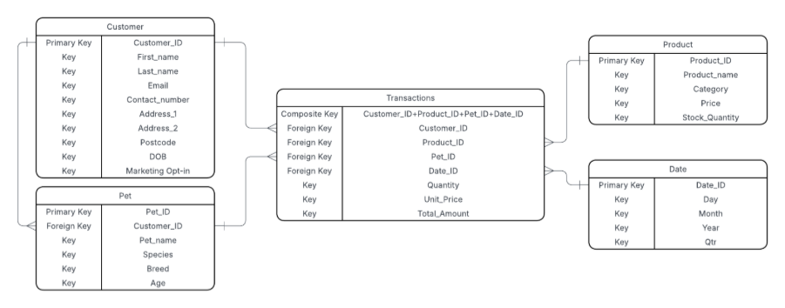

Data stored in the Data Lake and processed through Azure Data Factory is protected using encryption at rest and in transit. Access to sensitive data is controlled through role-based access controls (RBAC), ensuring that only authorised users can access or modify datasets. This approach supports compliance with data protection regulations while maintaining flexibility for analytics and reporting.

5. Additional Considerations

While the proposed Azure architecture addresses storage, analytics, and automation, several additional considerations can further enhance data handling, efficiency, and strategic value:

Data Quality Management

Ensuring that data is accurate, consistent, and complete is critical for reliable analysis and decision-making. Paws & Whiskers can implement:
Data Validation Pipelines: Using Azure Data Factory to check for missing, duplicate, or inconsistent records during ingestion.
Data Profiling: Regularly assessing datasets to identify anomalies, outliers, or errors.

Performance Optimisation

As datasets grow, ensuring fast and efficient analytics is important:
Partitioning and File Formats: Organise data into partitions (e.g., by date or category) and use efficient formats like Parquet to speed up queries.
Schema-on-Read and Aggregations: Apply consistent schemas when reading data and pre-compute aggregations to reduce query load.
Optimised ETL Pipelines: Use Azure Data Factory to transform and prepare data efficiently, ensuring downstream analytics and dashboards run quickly.

Change Management and Staff Training

Introducing a new data platform involves operational changes:
Staff should be trained on Power BI dashboards, Azure Data Factory, and proper handling of sensitive customer data.
Clear policies for data access, sharing, and governance reduce the risk of accidental data breaches and support regulatory compliance.
Establishing a data stewardship role ensures ongoing responsibility for data quality and usage across the organisation.

Disaster Recovery and Backup Plan

To safeguard against data loss and ensure business continuity, Paws & Whiskers should implement a formal disaster recovery plan:
Azure Backup: Regularly back up databases and Data Lake storage, with automated scheduling and retention policies.
Azure Site Recovery: Establish replication of critical systems to a secondary Azure region, enabling rapid failover in the event of a system failure or disaster.
Testing and Monitoring: Periodically test backup restores and failover procedures to ensure that recovery objectives are met.
Data Retention and Compliance: Align backup and recovery policies with GDPR and PCI DSS requirements, ensuring that personal and payment data are retained securely for the required period and then safely deleted.

6. References

OpenAI (2025) ChatGPT (GPT-5 mini). Available at: https://chat.openai.com/ (Accessed: 18 December 2025).

PCI Security Standards Council (2022) Payment Card Industry Data Security Standard (PCI DSS) v4.0. Available at: https://www.pcisecuritystandards.org/document_library (Accessed: 18 December 2025)

UK Government (2018) Data Protection Act 2018. Available at: https://www.legislation.gov.uk/ukpga/2018/12/contents/enacted (Accessed: 18 December 2025).

Information Commissioner’s Office (ICO) (2023) Guide to the UK General Data Protection Regulation (UK GDPR) and related guidance. Available at: https://ico.org.uk/for-organisations/guide-to-data-protection/ (Accessed: 18 December 2025).

Microsoft Corporation, 2025. Microsoft Azure documentation. [online] Available at: https://docs.microsoft.com/en-us/azure/ [Accessed 18 December 2025].

Kimball, R. and Ross, M. (2013) The Data Warehouse Toolkit: The Definitive Guide to Dimensional Modeling. 3rd edn. Hoboken, NJ: Wiley.

Course Notes

It is recommended to take notes from the course, use the space below to do so, or use the revision guide shared with the class:

Additional Information

We have included a range of additional links to further resources and information that you may find useful, these can be found within your revision guide.

END OF WORKBOOK

Please check through your work thoroughly before submitting and update the table of contents if required.

Please send your completed work booklet to your trainer.

