Elements of genetic algorithms

Chromosome: a set of genes; a chromosome contains the solution in form of genes. In TSP each cites can be considered as a chromosome.

Gene : a part of chromosome; a gene contains a part of solution. It determines the solution. In TSP the latitudinal and longitudinal coordinates of each cities can be considered as a gene.

Population: - number of individuals (solution space) present with same length of chromosome or solution space.

Fitness : the value assigned to an individual based on how far or close a individual is from the solution; greater the fitness value better the solution it contains

Breeding(crossover) : taking two fit individuals and then intermingling their chromosome to create new two individuals

Fitness function: - a function that assigns fitness value to the individual. It depends on the problem in question.

Selection: - selecting individuals for creating the next generation based on the fitness values

Encoding: - a function that maps certain chromosomes to the phenotype. There are several encoding function such as binary encoding, permutation encoding, value encoding and tree encoding. In TSP we use permutation encoding

How the concepts of natural evolution are adapted to EA /GA algorithms?

Genetic algorithm is an adaptive heuristic search algorithm based on the evolutionary ideas of natural selection and genetics. At a certain stage of evolution, a population is composed of a number of individuals, also called

Strings or chromosomes. These are made of units (genes, features, characters), which control

the inheritance of one or several characters. Each genotype would represent a potential solution to a problem.

The decision variables, or phenotypes, in a GA are obtained by applying some mapping from

the chromosome representation into the decision variable space, which represent potential

solutions to an optimization problem. A suitable decoding function may be required for

mapping chromosomes onto phenotypes.

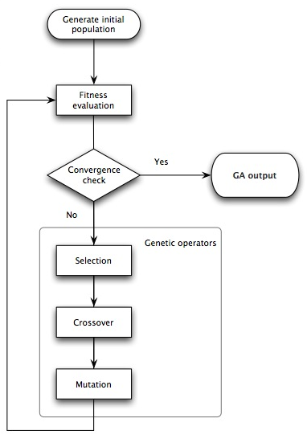

What kind of problems can be solved with these methods?

Genetic algorithm is a search and optimization algorithm that can solve both discrete and continuous problems. TSP is also a good example that can be solved using the genetic algorithm.

Teams and definitions in genetic algorithm

Scaling: we use scaling in may that we want to scale the fitness so that selection pressure remains the same throughout the run. There are three type of scaling mechanism: Linear scaling, power scaling, and exponential scaling.

Fitness: the value assigned to an individual based on how far or close a individual is from the solution; greater the fitness value better the solution it contains

Ranking: is a way of ranking the solutions (individuals) in a population instead of using the fitness as a probability of selection. The best rank will get N for N individual and the worst solution (individual) will get 1

Research areas that use genetic algorithm

-In Multiple sequence alignment

-In RNA structure prediction

-In Motife discovery

-In building a phylogenetic tree

-Gene expression profiling