Environmental Physics Spring 2014

Problem Set 7: Energy-Efficient Buildings Assignment

Due 5:30 PM Monday, June 2 **(Goes only to Joel, *not* usual Olin 301 mailbox)**

**I. Introduction**

The following project will enable you to study energy flows into and out of buildings.

Consider the boxes that are sitting outside of Goodsell (see Fig. 1). They represent buildings with different insulation and window configurations. The boxes are heavily instrumented to report and record environmental variables at regular intervals. You will be asked to make some predictions about the boxes, which should be done before you look at the data.

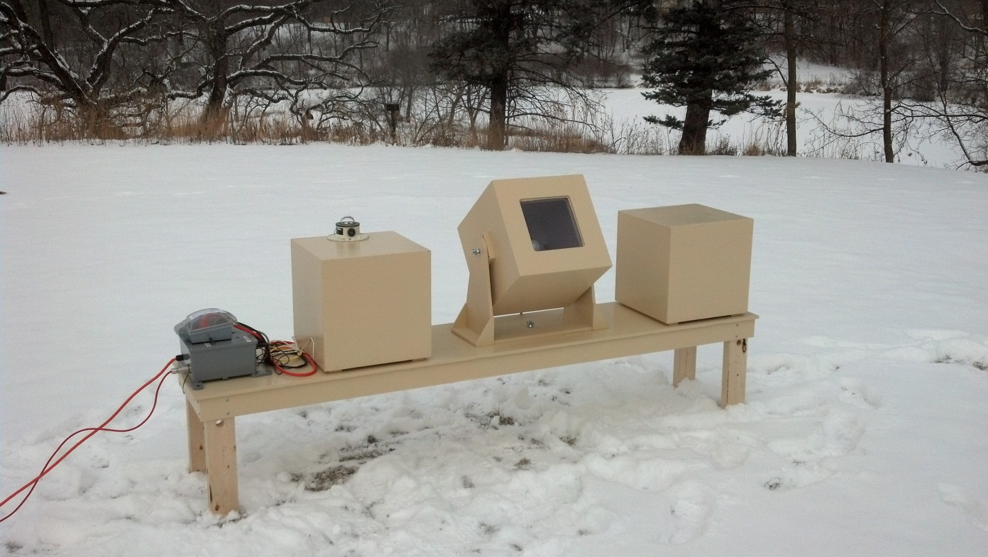

**II. Building Specifications**

Here are the specs on the three buildings (boxes):

- 1 foot cubes with all sides exposed  
- Box material is 1/2" plywood,[1] covered with rigid foam insulation

- **Box 1**: R-value=3 (English units), no window

- **Box 2**: R-value=5, with window

- **Box 3:** R-value=5, no window

- Each box has a “heater” (a 60 W light bulb) inside. In an effort to keep the interior temperature constant at ~21 °C, the bulb is controlled, by a computerized thermostat (although, because there is no cooling, the temperature can rise *above* the nominal value).

**III. The Project**

As noted above, it will be a more interesting and thoughtful exercise if you make and record predictions before examining the actual data.

1. On the coldest day in February-March for which you have data, what would be the total heat loss rate from box 1 and box 3? (Give the date!)
2. Predict which box will be able to maintain its interior temperature most efficiently (defining “efficiently” for your purposes), and explain your predictions. Then use the data to answer the question more definitively, and explain whether or not the data support your predictions and why.
3. Choose any two (non-trivial) questions that you can explore with the data from these boxes. Write down your question, your predicted answer, and whether or not the data support your prediction. If your question is *qualitative*, the discussion must be thorough (at least ½ typed page per question). If your question is *quantitative*, show and explain your calculations (as on a problem set).
4. Create one graph that you think tells an interesting story about some aspect of the data from these boxes. Spend time creating an informative and attractive graph, with an accompanying descriptive caption. Feel free to use hand-annotation; i.e., no need to waste time teaching Excel to do the labeling and annotation if you can more easily add it yourself!
5. After doing all the above steps, reflect and integrate what you have learned, by suggesting how to extend these simplified models to more realistic situations. This wrapup should also be at least ½ typed page.

**IV. Details on Environmental Data Acquired**

We have archival data from Feb. 20 – May 11. The data in csv (spreadsheet-ready) files will be on Moodle by midnight tonight, Wednesday, May 28. Each file, labeled by date, is a “Daily Digest Summary,” containing lines of data representing 15-minute segments throughout that date.[2],[3] The input of each line is as follows:

**Column A** (i.e. the first column), labeled “datetime,” is just what it sounds like.

**Column B**, labeled “epochseconds,” is the time in seconds (with an arbitrary zero), to facilitate time comparisons among rows.

**Column C**, labeled “L1,” is the number of seconds during a 15 minute period for which the light was on in Box 1

**Column D**, labeled “L2,” is the number of seconds during a 15 minute period for which the light was on in Box 2

**Column E**, labeled “L3,” is the number of seconds during a 15 minute period for which the light was on in Box 3

**Column F**, labeled “C1,” is the average temperature in Box 1 during that 15 minute period

**Column G**, labeled “C2,” is the average temperature in Box 2 during that 15 minute period

**Column H**, labeled “C3,” is the average temperature in Box 3 during that 15 minute period

**Column I**, labeled “C4,” is the average *outdoor* temperature during that 15 minute period

**Column J**, labeled “Sun,” is the average solar output during that 15 minute period. (Multiply the value displayed by 910 to convert it to units of Watts/m2.

**Column K**, labeled “Eventdensity,” is a data problem detector. Some of the one-second data transmissions were lst. The K entry gives a ratio; e.g., 865/900, which tells how many of the one-second data outputs were actually read in the 15-min (900 sec) interval. Presumably L1, L2, L3 should be *divided* by this ratio to account for the missing data. But if this ratio drops far below 1.0, you should probably throw out this row (but note which ones you did it to).

Additional information on the weather at Carleton on various dates is available from the Carleton weather station site at <http://weather.carleton.edu/>

**Acknowledgements**

This lab was originally created by Prof. Melissa Eblen-Zayas. The “buildings” and their instrumentation and readouts were created by Mark Zach and Bruce Duffy. Caffi Meyer, who originally participated in the project as a student and then as a lab asst., suggested modifications targeted at Environmental Physics students. Many thanks to all of them.

1. The R-value of 1/2” plywood (alone) is about 0.63 ft2 °F hr/Btu. (Note the English units.)
2. There are some data dropouts. See column K explanation, and remember to describe what you did as a result of dropouts.
3. Note that we threw a box over the “buildings” on clear first Friday nights of each month and on clear Monday nights spring term, so as to not disturb astronomical observations with its lights shining onto near by telescopes! If you see anomalies in the data at those times, that is probably why! (The ‘scopes are sometimes used on other evenings too, so be aware of possible anomalies *any* evening.)