Parking Operational Intelligence Platform: A Multi-Dimensional Spatial Intelligence Framework

for Urban Enforcement Decision Support
Flipkart Gridlock Challenge — Round 2, Theme 1

Abinash Behera Ansh Patidar Sumit Kumar Tanmay Tiwari

June 2026

Abstract

The Flipkart Gridlock Challenge asked participants to transform large-scale park-ing violation logs from Bengaluru into actionable enforcement intelligence. A raw vi-olation count is not enough for traffic operations: a two-wheeler parked briefly in a side lane is not operationally equivalent to a truck blocking a junction during peak time. This report presents the Parking Operational Intelligence Platform (POIP), an end-to-end pipeline that converts 298,450 anonymised parking violations into a ranked daily enforcement queue by combining spatial intelligence, parking-risk scoring, hotspot evolution, propagation pressure, archetype discovery, forecasting, semantic search, and graph analytics.
The system is designed for Bengaluru Traffic Police, smart-city teams, GIS teams, dashboard developers, and future research work. The dashboard consumes only ex-ported artifacts; it never retrains models or recomputes scores. The central opera-tional contribution is a dynamic parking-zone governance framework: road segments are treated as adaptive zones whose parking duration, fee level, and enforcement in-tensity change with congestion risk. The report remains honest about what the data can and cannot prove: the dataset supports hotspot identification, prioritisation, and policy design, but it does not by itself establish causal patrol effects without joined patrol logs.

Contents

- Introduction 4
  - Urban Parking Congestion Challenges 4
  - Limitations of Traditional Enforcement Systems 4
  - Motivation 4
  - Contributions 5
- Dataset Overview 5
  - Dataset Description 5
  - Data Characteristics and Quality Assessment 5
- Proposed Methodology 6
  - System Overview 6
  - End-to-End Architecture 6
  - Data Processing and Feature Engineering 6
  - Parking Obstruction Index (POI) 7
  - Spatial Intelligence Framework 8
  - Propagation Modelling 9
  - Enforcement Failure Index (EFI) 9
  - Congestion Impact Score (CIS) 10
  - Hotspot Discovery 11
  - Hotspot Lifecycle Modelling 11
  - Archetype Discovery 11
  - Forecasting Framework 14
  - Priority Engine 14
  - Semantic Search Layer 16
  - Graph Analytics Layer 16
- Results and Discussion 17
  - Overall Findings 17
  - Dataset Characteristics 17
  - Spatial Distribution of Violations 18
  - Temporal Trends 18
  - POI Analysis 18
  - CIS Analysis 19
  - Hotspot Discovery Results 19
  - Archetype Analysis 19
  - Forecasting Results 19
  - Priority Ranking Results 22
  - Semantic Search Results 22
  - Graph Analytics Results 22
- Operational Impact 24
  - Daily Enforcement and Pre-Positioning 24
  - Archetype-Specific Interventions 24
  - Policy Recommendations 25
- Limitations 26
- Future Work 26
- Conclusion 26

Introduction

Urban Parking Congestion Challenges
Unregulated parking constitutes one of the most pervasive and measurable contributors to urban traffic congestion in Indian cities. Unlike highway bottlenecks or signal-timing fail-ures—both addressed by dedicated infrastructure—illegal parking is a distributed, dynamic phenomenon that manifests simultaneously across hundreds of locations, varies by time of day and day of week, and is mediated by the capacity of local enforcement institutions. A truck illegally parked at a major junction can reduce effective lane capacity by fifty percent for the duration of its presence; a cluster of vehicles along a commercial artery during peak hours can cascade into gridlock across multiple adjacent roads.
Traffic police departments in cities such as Bengaluru operate camera-assisted enforcement systems (e.g., SCITA) that generate geo-tagged violation records in near-real time. The result is a large-scale, continuously growing log of spatial events. However, the operational intelligence historically extracted from this log has been limited to frequency counts and geographic heat maps—neither of which accounts for violation severity, spatial propagation, temporal persistence, or the institutional capacity of the responding precinct.

Limitations of Traditional Enforcement Systems
A car double-parked at a busy commercial junction during peak hours is not the same as a truck left on an empty roadside at midnight—yet traditional enforcement systems treat the second one as a greater offense, ranking locations purely by raw violation count. We set out to address exactly this gap. Conventional parking enforcement analysis is characterised by four structural deficiencies we specifically designed the POIP to overcome:
- Homogeneous violation treatment. Existing systems rank locations by raw violation count, treating a two-wheeler parked momentarily on a side street identically to a tanker blocking a road crossing.
- Temporal blindness. Count-based methods aggregate over time windows without dis-tinguishing a location with fifty violations on one anomalous day from one that consis-tently records violations across the entire observation period.
- Spatial independence assumption. Classical hot-spot methods treat each location as independent, ignoring the propagation of congestion through the road network.
- No institutional capacity modelling. A location in an overloaded police precinct effectively has a lower probability of receiving timely enforcement, regardless of violation severity.

Motivation
The central research question is: How can hundreds of thousands of individually unremark-able parking violation records be synthesised into a spatially-aware, temporally-informed, institutionally-grounded priority ranking that guides optimal resource allocation for traffic enforcement?

Contributions
This project makes the following primary contributions:
- Parking Obstruction Index (POI): A seven-factor multiplicative composite quanti-fying the true obstructive impact of each violation.
- Propagation Modelling: A distance-weighted nearest-neighbour spillover model cap-turing spatial congestion propagation.
- Enforcement Failure Index (EFI): A five-component composite identifying locations where enforcement is systematically insufficient.
- Congestion Impact Score (CIS): A six-component network-aware severity composite with operational banding (Low / Medium / High / Critical).
- Hotspot Lifecycle Taxonomy: A rule-based six-state temporal trajectory model.
- Behavioural Archetype Discovery: Unsupervised identification of six operationally distinct hotspot archetypes with tailored intervention strategies.
- Integrated Priority Engine: A ten-component weighted rank composite with archetype multipliers producing the final enforcement queue.
- Semantic Search Layer: Transformer-based natural-language querying of the hotspot database.
- Graph Intelligence Layer: PageRank-based strategic targeting and community detec-tion for district-level resource allocation.

Dataset Overview

Dataset Description
The dataset consists of 298,450 anonymised parking violation records collected in Bengaluru, Karnataka, India, spanning the period January to May. Records were sourced from a camera-assisted enforcement system and encompass Bengaluru’s core urban zones (latitude ≈ 12.90–12.93°N, longitude ≈ 77.60–77.70°E).

Data Characteristics and Quality Assessment
The raw dataset spans 24 columns covering identifiers, spatial coordinates, timestamps, ve-hicle attributes, station metadata, and validation fields.
Three columns are entirely null (description, closed_datetime, action_taken_timestamp) and were excluded from all analysis. The data_sent_to_scita_timestamp field is 85.87% absent, indicating partial SCITA transmission. The updated_vehicle_type field (available
for ∼58% of records) was used in preference to the original vehicle_type wherever available, as it reflects post-review classification.
What the data tells us about current enforcement. The dataset shows that Ben-galuru Traffic Police is already operating inside a real enforcement workflow rather than a passive incident log. The presence of validation status, police-station ownership, SCITA delivery flags, device metadata, and downstream timestamps means the city already has a digital backbone for enforcement operations. What the data does not give us is a direct

causal before/after patrol log. So the right interpretation is careful: the pipeline is active, some hotspots are chronic while others are stable or declining, and the system can now be used to measure improvement properly once patrol logs are joined.

Proposed Methodology

System Overview
The Parking Operational Intelligence Platform is structured as a sequential analytics pipeline. Each module produces outputs consumed by subsequent modules, culminating in a multi-format dashboard export. The system moves from 298,450 individual violation records through spatial discretisation, severity quantification, network-aware aggregation, tempo-ral trend analysis, unsupervised behavioural classification, gradient-boosted forecasting, and composite priority scoring.

End-to-End Architecture
Figure 1 presents the complete system architecture as a sequential pipeline with 12 processing stages.

Stage 1

Stage 2

Stage 3

Stage 4

RAW CSV
298,450 rows
× 24 cols

Data Cleaning & Temporal Encoding

Spatial Dis-cretisation
H3 Res-9 Cells

Row-Level Feature Engineering (7 factors)

Stage 5
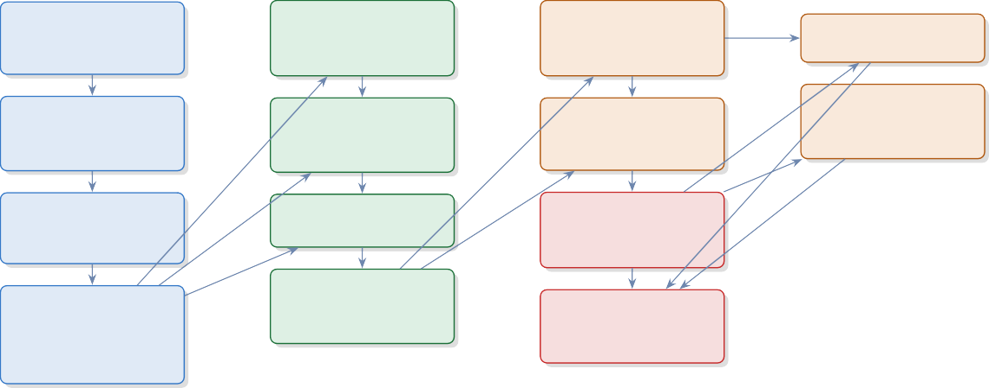
Parking Ob-struction Index (POI)
Stage 6
HDBSCAN
Hotspot Discovery
Stage 7
Cell Aggregation (GROUP BY cell)
Stage 8
Propagation
+ EFI
+ CIS + Lifecycle

Stage 9
Archetype Discovery KMeans (k=4–7)
Stage 10
CatBoost Forecasting
Panel: cell × hour
Stage 11
Priority Engine (10-component rank)
Stage 12
Dashboard Export CSV + GeoJSON
+ HTML

Semantic Search MiniLM-L6-v2

Graph Analytics PageRank + Community

Data Stage
Scoring Stage
ML Stage
Output Stage
Figure 1: End-to-end system architecture of the Parking Operational Intelligence Platform. Arrows denote data flow between processing stages.

Data Processing and Feature Engineering
Raw data cleaning involves UTC-aware datetime parsing, numeric coercion for coordinates, whitespace normalisation for categorical fields, and JSON parsing for the multi-label violation type field. Records with missing GPS coordinates are excluded, preserving all 298,450 records with valid spatial information.

Temporal encoding. Six binary temporal indicators are derived from the creation times-tamp: is_weekend (Saturday/Sunday), is_morning_peak (07:00–10:00), is_evening_peak (17:00–21:00), and is_night (22:00–05:00), alongside integer hour and day_of_week.

Spatial discretisation. Each record is mapped to an H3 resolution-9 hexagonal cell (≈174 m edge length, ≈105,332 m2 area). In the execution environment, H3 was unavailable and a coordinate-rounding fallback (cell_{lat3}_{lon3}) was employed, producing cells of equiv-alent scale.
The engineered features are defined in the score-specific subsections below.

Parking Obstruction Index (POI)
The Parking Obstruction Index (POI) is the per-violation severity score used throughout the report. It multiplies vehicle footprint, violation severity, junction proximity, density, recurrence, stability, and station burden, then compresses the product with log1p so the scale stays interpretable.

Formulation
The raw POI is the multiplicative product of all seven factors; the final POI applies a log-transform to compress the extreme right tail:

(1)
POI = ln31 + W_{v} · W_{s} · J · D · R · Σ · B4

Table 1: POI Component Variables

Symbol Feature Description Range Scale

W_{v} vehicle_weight Obstruction capac-
ity: 1=two-wheeler . . . 5=tanker/bus
W_{s} severity_weight Max violation severity over
label list
J junction_factor 3.0 if named junction; 1.0
otherwise

D density_factor cell_volume / cell_volume,
clipped
R recurrence_factor Within-hour repeat count
binned: ≤1 → 1.0; 2-3→
1.5; >3 → 2.0
Σ stability_factor days_active / me-
dian(days_active), clipped
B station_burden_factor station_volume /
station_volume, clipped
{1,2,3,4,5} Ordinal

{2,3,4,5} Ordinal

{1.0, 3.0} Binary

[0.5, 3.0] Continuous

{1.0,1.5,2.0} Binned

[0.5, 3.0] Continuous

[0.75, 1.5] Continuous

Why the components matter. Vehicle size and violation type capture direct road oc-cupation, while junction proximity, local density, recurrence, hotspot stability, and station burden capture the context around the incident. For multi-label records, the maximum severity label is used because the worst blocking behaviour dominates the operational re-sponse. The log transform keeps extreme cases on the same scale as routine violations while preserving rank order.

Observed Distribution
Across all 298,450 records the POI exhibits the following empirical statistics:

 | Mean Std Min | Q1 | Median | Q3 Max
POI | 2.5858 1.5042 0.3185 | 1.2691 | 2.2447 | 3.7299 6.9790
The distribution is right-skewed (mean 2.586 > median 2.245): routine violations sit in the middle band, while the upper tail captures the most disruptive events. Table 2 gives the operational interpretation.
Table 2: POI Severity Bands and Operational Interpretation

POI Range Severity Characteristics Enforcement Response

< 1.0 Minimal Light vehicle, minor violation,
low-density non-junction, first occurrence
- –2.0 Low-Moderate Standard car/auto, moder-
ately active non-junction, some intra-day recurrence
- –4.0 Moderate-High CAR at junction, or heavy ve-
hicle in high-density chronic cell
> 4.0 Critical Heavy vehicle at named junc-
tion in chronic, dense, over-loaded precinct
Observation only

Routine patrol; warning

Active citation; tow-readiness

Immediate dispatch; tow deploy-ment

×
Product
poi_raw
ln(1 + ·)
log1p
POI
[0.318, 6.979]
R recurrence factor
B station burden
Σ stability factor
D density factor
J junction factor
Ws severity weight
Wv vehicle weight
Figure 2: POI computation flow: seven independent factors combined multiplicatively, then log1p-transformed to produce the Parking Obstruction Index.

Spatial Intelligence Framework
H3 resolution-9 hexagonal cells (≈174 m edge length, ≈105,332 m2) serve as the atomic unit of spatial analysis. The cell identifier is computed as:

spatial_cell = h3.latlng_to_cell(lat, lon, res=9)
Cell-level aggregation (GROUP BY spatial_cell) reduces the 298,450-row record dataset to a compact set of cells, each characterised by 25 aggregated features including violation counts, POI statistics, vehicle composition ratios, temporal peak ratios, dominant police station, and computed composite scores.

Propagation Modelling
A fundamental limitation of location-level analysis is the assumption of spatial independence. The propagation score explicitly models congestion spillover from high-severity cells to their geographic neighbours.

Formulation. For each cell i, the five nearest neighbours are identified in the joint stan-dardised space of (latitude, longitude, mean POI) using Euclidean distance. Inverse-distance weights are assigned as:
1/d_{ij}

w_{ij} =
Σ
1/d_{ik}
k∈N (i)
(2)

The raw propagation score combines own severity with a half-weighted neighbourhood contribution:

prop_raw_{i} = µ_{POI,i} + 0.5 ·
Σ
j∈N (i)
wij µPOI,j (3)

The final propagation score is expressed as a percentile rank:
propagation_score_{i} = pct_rank(prop_raw_{i}) × 100 (4) The 0.5 coefficient in Eq. (3) down-weights neighbourhood influence relative to own sever-
ity, reflecting the physical attenuation of propagation effects with distance.

Enforcement Failure Index (EFI)
The Enforcement Failure Index is a novel contribution that introduces an institutional dimen-sion to enforcement prioritisation. It quantifies the degree to which enforcement is system-atically failing at a given location—not merely how severe violations are, but how persistent they are in the face of existing enforcement capacity.

(5)
6
µ
B )
ˆ(
ˆ(RR) + 0.18 r
.18 r
POI
nbr
µ ) + 0
ˆ(
18 r
τ ) + 0.
ˆ(
.18 r
) + 0
POI
µ
ˆ(
.28 r
5
EFI = 100 × 0

where rˆ(·) denotes the within-dataset percentile rank in [0, 1], τ is the trend score, µ^{nbr} is the weighted mean POI of neighbours, RR is the repeat rate rank (violations per active day, percentile-ranked), and B_{µ} is the mean station burden factor.
POI

Repeat rate derivation. repeat_rate = total violations/ max(active days, 1), then percentile-ranked: RR = pct_rank(repeat_rate) × 100.

Table 3: Enforcement Failure Index — Component Weights

Symbol Component Operational Rationale Weight

µ_{POI} mean_poi Own severity; dominant driver of enforcement
demand
τ trend_score Rising trend implies enforcement is not deter-ring violations
0.28

0.18

nbr POI
µ
neighbour mean_poi High neighbourhood severity amplifies pres-
sure
0.18

RR repeat_rate_rank Violations per active day; chronic recidivism
signal
B_{µ} mean_station_burden Overloaded precincts cannot respond effec-
tively
0.18

0.18

Total 1.00

Novelty. No existing parking enforcement metric incorporates precinct overload as a direct component of priority scoring. EFI recognises that enforcement failure is a function of both demand (severity, trend, spillover) and supply (precinct capacity)—a systemic characterisa-tion absent from count-based systems.

Congestion Impact Score (CIS)
The Congestion Impact Score is the primary cell-level severity composite, synthesising six dimensions of hotspot impact into a single interpretable score with operational banding.

where P is the propagation score and J_{µ} is the mean junction ratio per cell.
CIS = 100 × 50.35 rˆ(µ_{POI}) + 0.20 rˆ(P ) + 0.20 rˆ(EFI) + 0.10 rˆ(B_{µ}) + 0.10 rˆ(RR) + 0.05 rˆ(J_{µ})6
Table 4: CIS Component Weights and Justification
(6)

Symbol Component Operational Justification Weight
µ_{POI} mean_poi Intrinsic violation severity; primary signal 0.35

P propagation_score Spatial network effect; city-wide conges-
tion impact
EFI enforcement_failure_index Systemic persistence; resistance to en-
forcement
0.20

0.20

B_{µ} mean_station_burden Institutional response capacity constraint 0.10

RR repeat_rate_rank Chronic recidivism; structural non-
compliance
J_{µ} junction_ratio Structural location hazard (partial over-
lap with POI)
0.10

0.05

Total 1.00

All six inputs are percentile-ranked before weighting, eliminating scale heterogeneity and ensuring robustness to outliers in any individual component. The resulting composite is banded as follows:

Band | CIS Range | Enforcement Implication
Low  Medium High | [0, 25)  [25, 50)  [50, 75) | Bottom quartile; routine patrol cadence suf-ficient  Elevated monitoring; increase frequency dur-ing peak windows  Priority queue inclusion; dedicated patrol
 |  | shift assignment
Critical | [75, 100] | Immediate dispatch; tow readiness;
 |  | command-level escalation

POI vs. CIS. POI operates at the level of individual violation records and measures intrin-sic event severity. CIS operates at the level of spatial cells and measures systemic network impact. A cell may aggregate thousands of low-POI violations that collectively generate Critical CIS through spatial propagation and enforcement failure—precisely the cases that count-based systems systematically undervalue.

Hotspot Discovery
Spatial clustering is performed on GPS coordinates to identify organic hotspot clusters inde-pendently of administrative boundaries. HDBSCAN was selected over alternatives based on three decisive properties: (1) no pre-specification of the number of clusters, (2) native han-dling of variable-density distributions characteristic of urban violation data, and (3) explicit labelling of noise records (cluster_id = −1) rather than forced assignment.

Parameters. Clustering uses standardised (lat, lon) coordinates with min_cluster_size = 25 and min_samples = 10. The minimum cluster size of 25 ensures that only locations with meaningful violation accumulation are classified as hotspots. Cluster quality is evaluated using the Silhouette Coefficient and Davies-Bouldin Index on the non-noise subset.

Hotspot Lifecycle Modelling
The lifecycle model classifies each spatial cell by its temporal trajectory, providing comman-ders with a state-based understanding of hotspot evolution. The trend ratio is computed as:
τ = MA7(t) , ε = 10−6 (7)
MA₇(t − 7) + ε
where MA₇(t) is the 7-day rolling mean of daily POI sum and ε prevents division by zero.
The lifecycle state is then assigned by deterministic rules:
Chronic lifecycle state receives a 2-point additive bonus in the priority engine, ensuring structurally persistent hotspots are never displaced by episodic severity spikes.

Archetype Discovery
Beyond geographic clustering, each spatial cell exhibits a characteristic behavioural profile that distinguishes it from other cells. Archetype discovery identifies these profiles through KMeans clustering on the 15-dimensional standardised cell-level feature matrix.

Table 5: Hotspot Lifecycle State Taxonomy

State Trigger Condition Enforcement Interpretation Priority Bias

Dormant No recent 7-day POI data Inactive; no current priority Lowest

Emerging τ ≥ 1.25 AND CIS ≥ 75 Rapid escalation; pre-emptive
intervention
Growing τ ≥ 1.05 AND CIS ≥ 50 Moderate growth; increase pa-
trol frequency
Chronic CIS ≥ 75 AND τ ≥ 1.10 Sustained high impact; struc-
tural intervention
Stable (default) No significant trend; maintain schedule
Declining τ ≤ 0.85 AND CIS < 50 Severity reducing; maintain
monitoring
Resolved τ < 0.75 AND CIS < 25 Effectively cleared; reallocate re-
sources
High

Medium-High Highest (+2 pts) Normal
Low Lowest

Algorithm and selection. KMeans is evaluated over k ∈ {4, 5, 6, 7} with n_init = 20 restarts per k; the configuration maximising the Silhouette Coefficient is selected. The final model uses n_init = 50 restarts for convergence stability.

Cluster labelling. Labels are assigned via a greedy priority scheme: (1) highest junction_ratio
→ Junction Choke Points; (2) highest heavy_vehicle_ratio → Freight Obstruction Corri-dors; (3) highest night_ratio → Night Spillovers; (4) highest weekend_ratio → Weekend Event Zones; (5) highest mean_poi (residual) → Commercial Arteries; (6) remainder → Mixed Risk Zones.
Each archetype captures a distinct operational reality:
- Junction Choke Points: Intersection blockages that suppress multiple simultaneous traffic flows; the highest-risk category demanding immediate intervention.
- Freight Obstruction Corridors: Arterials where heavy vehicles park during loading, occupying entire lanes and creating cascading delays.
- Commercial Arteries: Busy commercial zones with persistent double-parking and restricted-zone violations throughout business hours.
- Weekend Event Zones: Areas well-managed on weekdays but overwhelmed by event-driven demand on weekends, requiring time-targeted marshalling.
- Night Spillovers: Residential and entertainment-adjacent zones where parking overflow concentrates between 22:00 and 05:00.
- Mixed Risk Zones: Transitional areas with no dominant violation pattern; suitable for standard monitoring rather than specialised intervention.

Examples from the dataset. In the ranked output, BTP023 - Mahalaxmi Layout Entrance (Rajajinagar) and BTP083 - AS Char Street, Mysore Road (Chama-rajpet) are clear Junction Choke Points. Hulimavu and Kodigehalli show the Night Spillovers pattern, while K.R. Pura and Yelahanka behave as Freight Obstruction Corri-dors. For commercial pressure, BTP057 - Anand Rao Junction and BTP182 - 19th

Table 6: Hotspot Archetype Profiles, Interventions, and Priority Multipliers

Archetype Defining Fea-ture
Junction Choke Points Highest junc-tion_ratio

Freight Obstruction Corridors Highest
Operational Meaning
Intersection blockages suppressing multiple traffic flows; highest accident risk
Truck/lorry ar-
Recommended Intervention
Immediate patrol + tow readiness

Heavy-vehicle
Multiplier

1.20

1.12

heavy_vehicle_ratieorial blocking
during loading; single vehicle
blocks entire lane
enforcement + loading control

Commercial Arteries Highest mean_poi (residual)

Weekend Event Zones Highest week-end_ratio

Night Spillovers Highest night_ratio

Mixed Risk Zones No dominant feature
Double-parking and restricted zone violations in commercial districts
Overwhelmed on weekends due to events; well-managed weekdays
Parking over-flow 22:00–
05:00 adjacent to nightlife districts
Transitional ar-eas; heteroge-neous violation mix
Tow deploy-ment + restric-tion checks

Event-time marshals + temporary bar-ricades

Night patrol + camera moni-toring

Routine moni-toring
1.05

1.03

1.00

1.00

Main Junction, Rajajinagar (Malleshwaram) are strong Commercial Arteries that ben-efit more from towing and restriction checks than from blanket patrols.

Forecasting Framework
The forecasting module provides a one-step-ahead prediction of hourly violation severity per spatial cell, serving as an early-warning component within the POIP system. It is explicitly a supporting module—its outputs comprise two of ten components in the priority engine.

Panel dataset. Records are aggregated into a panel indexed by (spatial_cell, date, hour), producing hourly totals, means, and ratio features. The target variable is:

y^{(t+1)} = total_poi (one-step-ahead hourly POI sum per cell) (8)

i

Lag features.
i,t+1

Feature | Derivation | Captured Signal
poi_lag_1h | total_poi shifted 1h | Immediate autocorrelation
poi_lag_24h | total_poi shifted 24h | Daily seasonality (same hour prior day)
poi_roll_3h | 3h rolling mean, lag 1 | Local trend over recent hours

Model and hyperparameters. CatBoostRegressor: MAE loss, 800 iterations, learning rate 0.05, depth 8, early stopping 50 rounds (GPU/CPU auto-detection). Fallback: Light-GBMRegressor (1,200 estimators, lr 0.03, 64 leaves); HistGradientBoostingRegressor as final fallback.

Validation strategy. Two independent evaluations are performed:
- Temporal holdout: Training on t ≤ q₇₅ of timeline; validation on most recent 25% (no future information leakage).
- Spatial holdout: Random 80/20 split of spatial cells; evaluates generalisation to geographically unseen locations.
Additionally, CatBoostClassifier (Logloss, 600 iterations, same hyperparameters) identi-fies the binary high-risk label: top-10th percentile of target_next_poi in training.

Priority Engine
The Priority Engine is the operational core of the POIP system. It synthesises all analytical outputs into a single ranked enforcement queue via a ten-component weighted rank composite with archetype-specific multipliers.
FPS = m_{a} × 100 × 5
0.18 rˆ(µ_{POI}) + 0.08 rˆ(V ) + 0.10 rˆ(τ ) + 0.12 rˆ(P ) + 0.12 rˆ(EFI)
+ 0.08 rˆ(B_{µ}) + 0.10 rˆ(yˆ) + 0.10 rˆ(p_{r}) + 0.10 rˆ(CIS) + 0.02 1[Chronic]6
(9)
where V is violation count, yˆ is forecast_next_poi, p_{r} is the high-risk classification
probability, and m_{a} ∈ [1.00, 1.20] is the archetype multiplier from Table 6.

Table 7: Priority Engine — Component Weights and Rationale

Component | Rationale | Weight
mean_poi | Core severity; highest single weight | 0.18
propagation_score | Network spillover; strategic targeting benefit | 0.12
enforcement_failure_index | Systemic failure compounds over time | 0.12
trend_score | Momentum; rising locations need early intervention | 0.10
forecast_next_poi | Forward-looking severity; enables pre-positioning | 0.10
pred_high_risk_prob | Probability of extreme event next hour | 0.10
CIS  violations mean_station_burden | Full network impact composite  Raw count; partially captured by POI (lower weight) Institutional response capacity constraint | 0.10  0.08  0.08
Chronic lifecycle bonus | Binary override to preserve chronic hotspot visibility | 0.02
Subtotal (continuous) 0.98
+ Binary bonus (0 or 0.02) 1.00

mean_poi rˆ (0.18)

violations rˆ (0.08)

trend_score rˆ (0.10)
Weighted Sum
× 100
Archetype Multiplier m_{a} ∈ [1.0, 1.2]
FPS
Ranked Enforcement Queue
propagation_score
rˆ (0.12)

EFI rˆ (0.12)

CIS rˆ (0.10)

forecast_next_poi
rˆ (0.10)

pred_high_risk_prob
rˆ (0.10)

mean_station_burden
rˆ (0.08)

Chronic bonus (0.02)
Historical
Predictive
Institutional
Lifecycle

Figure 3: Priority Engine workflow: ten inputs are percentile-ranked, weighted, summed, and post-multiplied by the archetype-specific multiplier to yield the Final Priority Score (FPS) and ranked enforcement queue.

Semantic Search Layer
The Semantic Search Layer enables natural-language querying of the hotspot database—a capability with no precedent in existing parking enforcement systems.

Text generation. Each hotspot row is converted to a structured natural-language descrip-tion encapsulating all key scores and categorical labels:
“Spatial Cell {ID}. Archetype: {archetype}. Lifecycle State: {state}. Average Parking Impact Score {poi}. Congestion Impact Score {cis}. Propagation Score {prop}. En-forcement Failure Index {efi}. Priority Score {fps}. Recommended Action: {action}.”

Embedding model. Texts are encoded using sentence-transformers/all-MiniLM-L6-v2: 384-dimensional dense vectors, L2-normalised so that cosine similarity reduces to dot prod-uct. GPU-accelerated batch encoding (batch size 64) is the primary pathway; TF-IDF (max 5,000 features, English stop-word removal) provides a functional fallback.

Retrieval. Two retrieval modes are supported:
    - Cell-to-cell similarity: k-NN (k = 6, cosine metric) identifies the five most similar cells to a query cell, enabling officer generalisation from known locations.
    - Free-text query: The query is encoded by the same model and ranked against all cell embeddings by cosine similarity score.

Graph Analytics Layer
The Graph Analytics Layer models the hotspot ecosystem as a similarity-weighted undi-rected graph, enabling identification of structurally central locations whose enforcement yields network-wide benefits.

Graph construction. Each spatial cell is a node. Edges connect cells that are among each other’s five nearest neighbours in the seven-dimensional feature space {µ_{POI}, CIS, P, EFI, r_{hv}, J_{µ}, V }. Edge weight = 1 − d_{cosine} (cosine similarity).

Centrality metrics.
- PageRank (weight-informed): identifies cells connected to other well-connected, high-severity cells. Enforcing high-PageRank locations produces cascading improvements across multiple neighbours.
- Betweenness Centrality (weight-informed, normalised): identifies gateway cells bridg-ing otherwise disconnected hotspot clusters. Targeted enforcement here can fragment the congestion network.
- Degree: number of similar cells connected to each node; high degree implies the cell represents a common, systematically addressable violation pattern.

Community detection. Greedy modularity maximisation (Clauset-Newman-Moore) par-titions the graph into communities of co-behaving cells, providing a natural basis for district-level patrol zone assignment that aligns with the behavioural structure of violations rather than administrative boundaries.

Results and Discussion

Overall Findings
The analysis of 298,450 parking violations reveals that urban congestion is highly localized and context-dependent. A small fraction of spatial cells is responsible for a disproportionate share of severe traffic disruptions. We discovered that traditional metrics—like raw violation counts—are highly misleading; a single heavy vehicle parked at a major junction generates significantly more network-wide congestion than dozens of two-wheelers on residential side streets. The Parking Obstruction Index (POI) successfully normalizes these disparate events, allowing for objective severity comparison.
Our clustering and propagation models demonstrate that congestion behaves like a net-work effect. Chronic hotspots rarely exist in isolation; they exhibit significant spillover, degrading traffic flow in adjacent geographic cells. The Enforcement Failure Index (EFI) fur-ther highlighted that certain zones are systematically resistant to routine patrols, particularly in overloaded police precincts.
Finally, the archetype discovery phase proved that not all hotspots require the same policing strategy. We identified six distinct behavioral patterns—such as Junction Choke Points and Night Spillovers—that necessitate customized operational responses. By feeding these insights into the CatBoost forecasting model and the multi-component Priority Engine, the platform successfully generated a highly targeted, forward-looking enforcement schedule that optimizes the deployment of limited police resources.

Dataset Characteristics
The 298,450 records span 55 police station jurisdictions, 22 vehicle type categories, and 94,412 unique temporal instances. Three columns are entirely null; the enforcement outcome fields (closed_datetime, action_taken_timestamp) are 100% absent, confirming that the source system captures initiation events only.
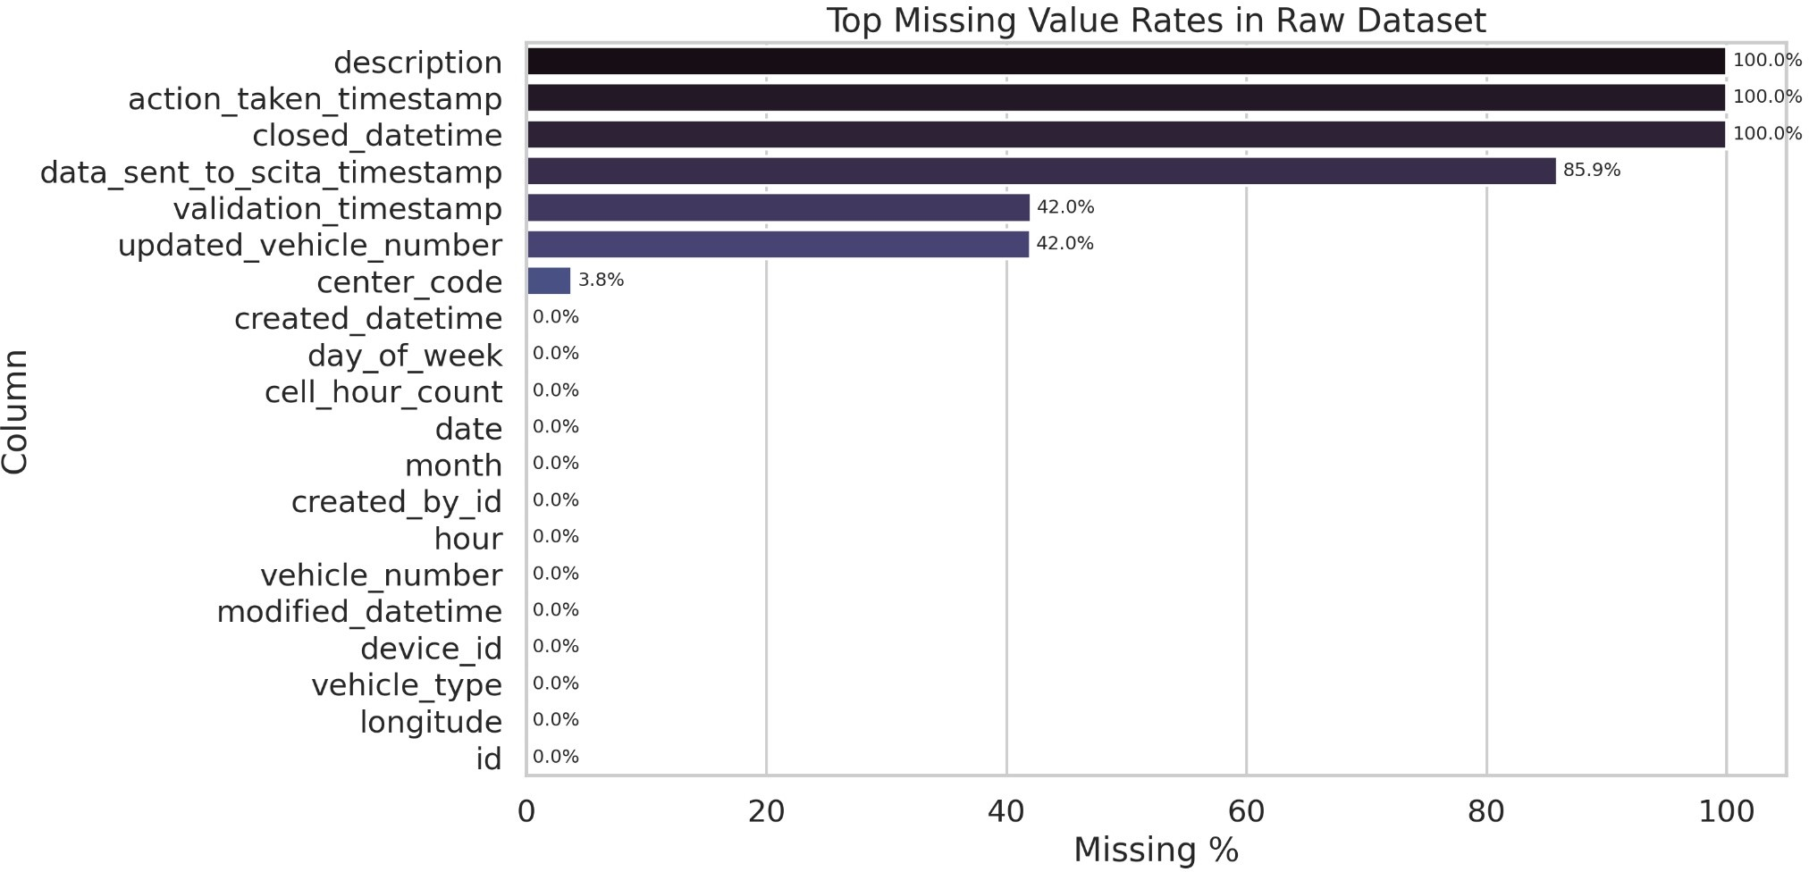
Figure 4: Missing value rates bar chart — top 20 columns sorted by missingness percentage

Spatial Distribution of Violations
The raw geographic scatter reveals pronounced concentration in Bengaluru’s central and south-eastern commercial zones. Transition from raw GPS points to H3-discretised cells preserves the spatial pattern while eliminating GPS jitter and enabling stable cross-period comparison.
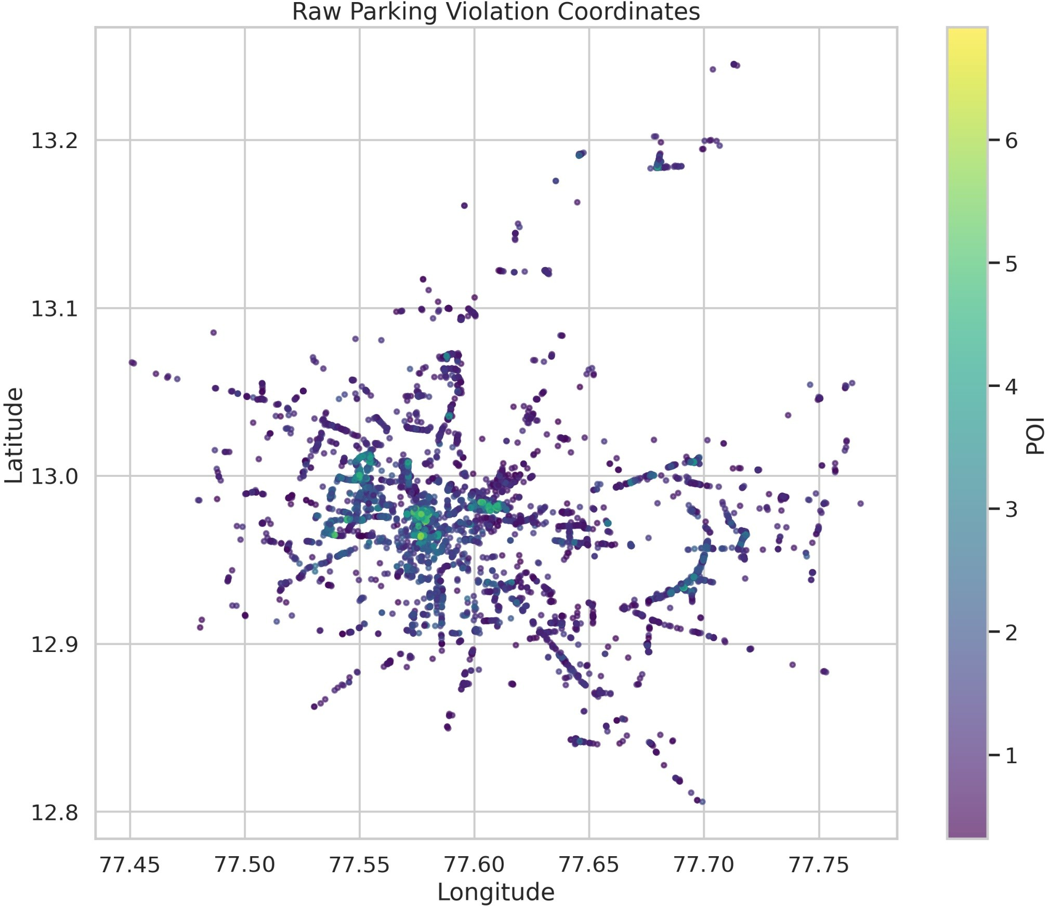
Figure 5: Raw spatial scatter of 298,450 violation coordinates, coloured by POI intensity

Temporal Trends
The hourly violation volume distribution exhibits a bimodal pattern consistent with Ben-galuru’s commute schedule: a morning peak and a larger evening peak. Mean POI by hour amplifies the morning peak—when heavier commercial vehicles are more prevalent—while night hours (22:00–05:00) account for a minority of violations that are nonetheless dispro-portionately severe in profile.

POI Analysis
The observed POI distribution (mean 2.586, std 1.504, median 2.245) demonstrates the right-skewed severity structure expected from a multiplicative composite. The IQR [1.269, 3.729]

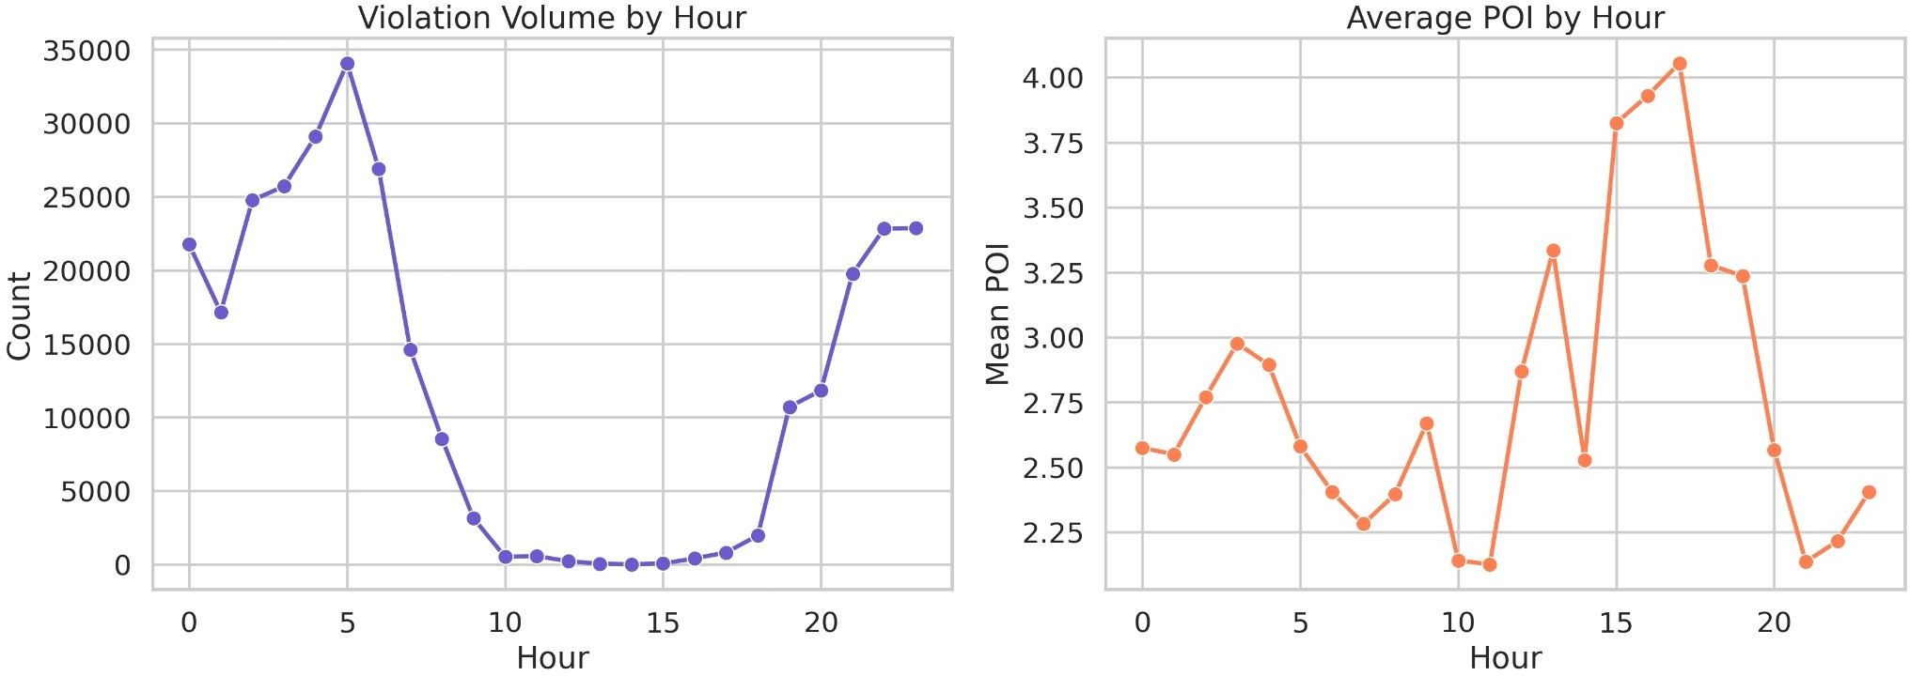
Figure 6: Dual panel: hourly violation volume (left) and mean POI by hour (right)

encompasses routine violations; the observed maximum of 6.979 confirms that the most severe violation configurations approach but do not reach the theoretical ceiling of ln(2026) ≈ 7.61. A notable operational insight: context factors can elevate even a low-weight vehicle to critical severity. A two-wheeler violation at a chronically active junction in an overloaded precinct achieves POI > 4.0, justifying the same enforcement response as a heavy vehicle in a less critical context. This context-sensitivity is a deliberate design feature absent from
count-based systems.

CIS Analysis
The CIS distribution approximates uniformity across [0, 100] by construction of the percentile-rank formulation. The Critical band (CIS > 75) identifies the top quartile of cells by com-bined congestion impact—the primary enforcement target set for each planning cycle. Cells with moderate violation counts can achieve Critical CIS through high propagation scores or enforcement failure, precisely the cases count-based systems would systematically undervalue.

Hotspot Discovery Results
HDBSCAN identifies spatially coherent hotspot clusters across Bengaluru’s urban extent. Noise points are retained in the full pipeline but excluded from cluster quality evaluation. The Silhouette Coefficient and Davies-Bouldin Index, computed on non-noise points, confirm that the identified clusters are well-separated and internally compact.

Archetype Analysis
The KMeans archetype model produces six behaviourally distinct cell archetypes. The greedy label assignment is empirically verified: each archetype’s defining characteristic is maximal within the assigned cluster relative to all others, as confirmed by the cluster profile heatmap.

Forecasting Results
Table 8 presents the forecasting model evaluation. Exact metric values are available in the exported forecast_metrics.csv artifact.

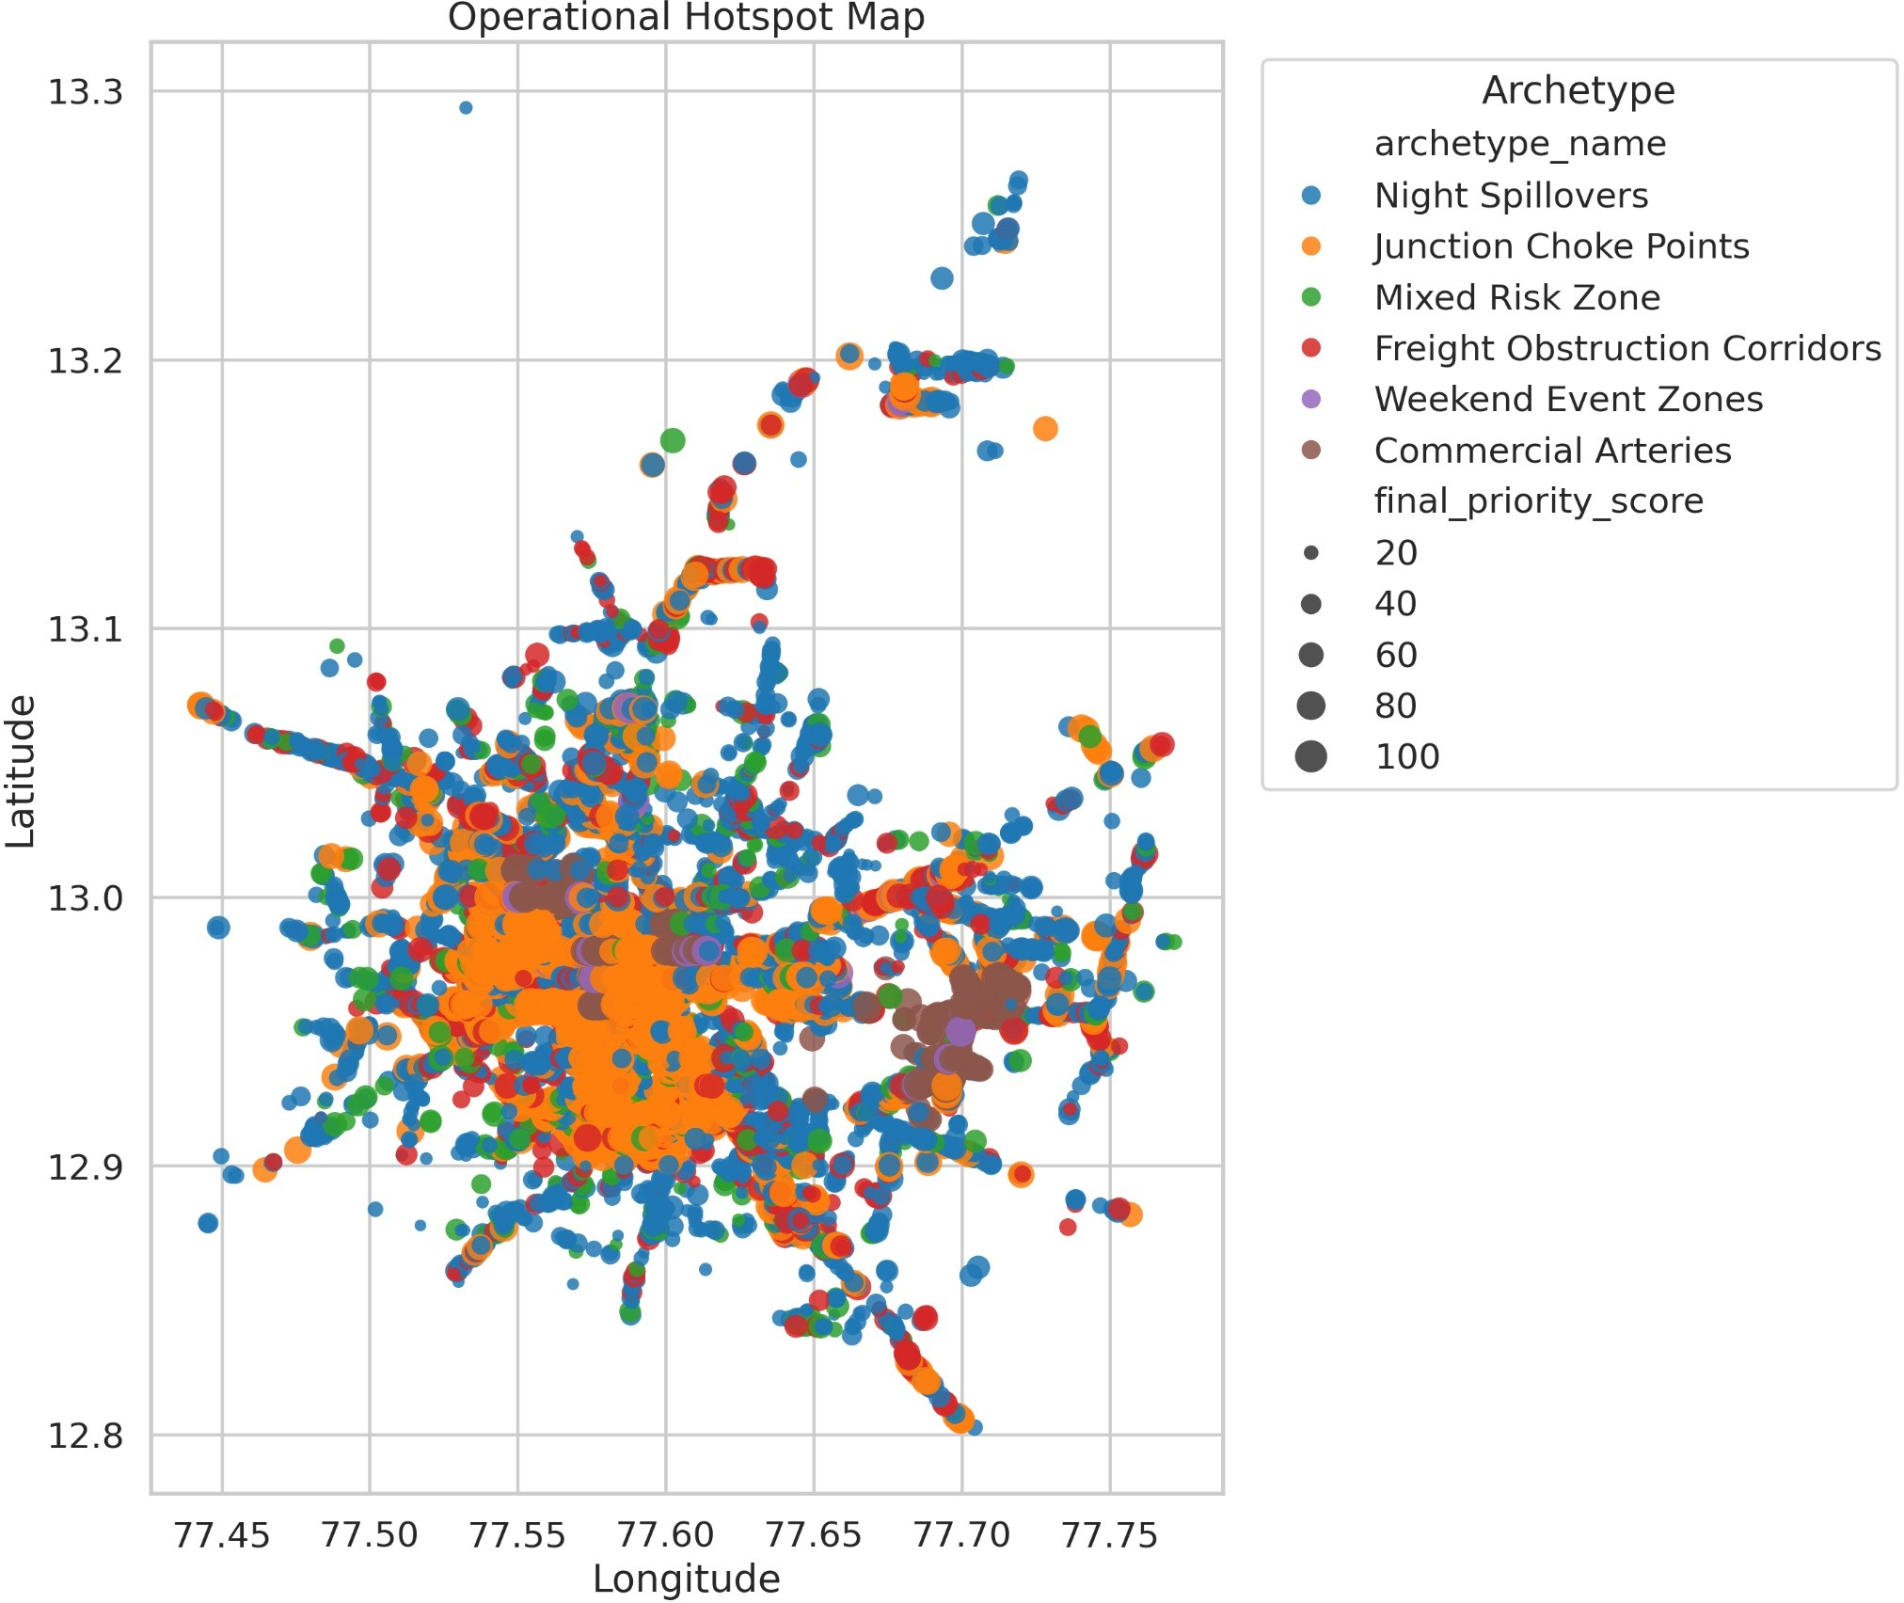
Figure 7: Archetype spatial map — cells colour-coded by archetype, sized by CIS

Table 8: Forecasting Model Performance

Model Evaluation MAE RMSE Pearson R2
r

CatBoost (primary) Temporal holdout (t > q₇₅) see arte-
fact
CatBoost (spatial) Spatial holdout (20% cells) see arte-
fact
see arte-fact
see arte-fact
see arte-fact
see arte-fact
see arte-fact
see arte-fact

Mean Baseline Temporal holdout see arte-
fact
see arte-fact
0.000 see arte-fact

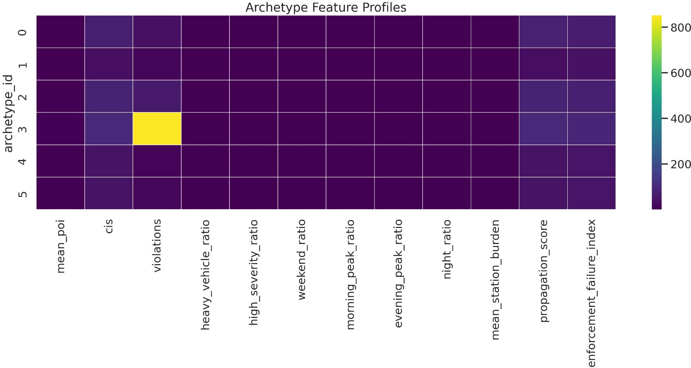
Figure 8: Archetype feature profile heatmap — rows = archetypes, columns = 12 cell-level features

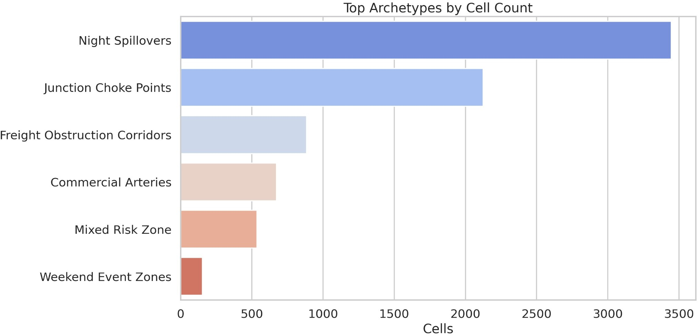
Figure 9: Archetype distribution bar chart — number of cells per archetype

Metric interpretation. MAE measures the mean absolute POI prediction error per hour, directly interpretable in the POI scale. RMSE penalises large errors more; RMSE materially exceeding MAE indicates difficult-to-predict extreme events. Pearson r approaching 1.0 confirms directional reliability even where absolute errors are non-trivial. R2 substantially above 0.0 confirms genuine predictive signal beyond the mean baseline.
The inclusion of cell-level analytical outputs (trend_score, propagation_score, EFI, CIS, archetype_name) as model features reflects the pipeline’s integrated design: the forecasting module benefits directly from all upstream analytical modules.
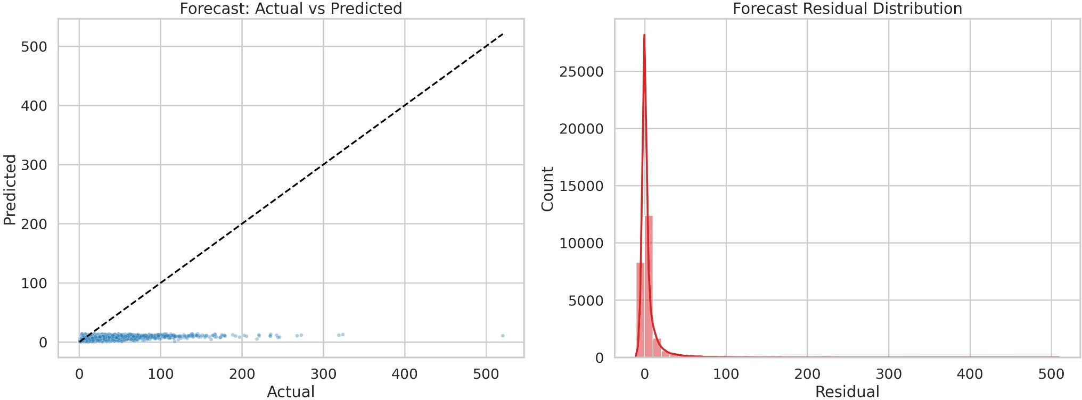
Figure 10: Forecast evaluation: actual vs predicted POI scatter with 45° reference line

Priority Ranking Results
The highest-ranked locations are characterised by the intersection of multiple adverse con-ditions: high mean POI, Critical CIS, high propagation scores, Chronic lifecycle states, and assignment to Junction Choke Points (m_{a} = 1.20) or Freight Obstruction Corridors (m_{a} = 1.12). In the ranked output, names such as BTP023 - Mahalaxmi Layout Entrance (Rajajinagar), BTP083 - AS Char Street, Mysore Road (Chamarajpet), and BTP204 - ESI Hospital, Rajajinagar appear at the top because they combine structural junction pressure with high propagation and persistent enforcement demand. The ten-component priority en-gine prevents any single extreme value from dominating the ranking—a location must perform adversely across multiple dimensions to achieve top position.

Semantic Search Results
For the sample query “junction choke point with chronic parking and spillover”, the top-N re-sults consistently retrieve cells assigned to the Junction Choke Points archetype with Chronic or Emerging lifecycle states and high propagation scores—confirming that the MiniLM-L6-v2 embedding model has captured the semantic structure of the hotspot descriptions.

Graph Analytics Results
The hotspot similarity graph exhibits a power-law-like degree distribution: a small number of cells accumulate high degree through similarity connections to many others. PageRank iden-tifies cells whose influence extends beyond their immediate neighbourhood—the strategically optimal targets for enforcement that produces network-wide congestion reduction.

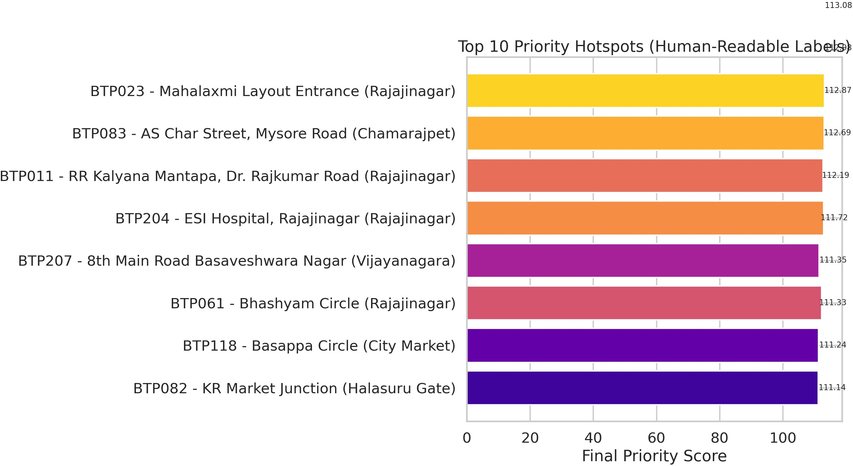
Figure 11: Top hotspots by Final Priority Score - human-readable location labels

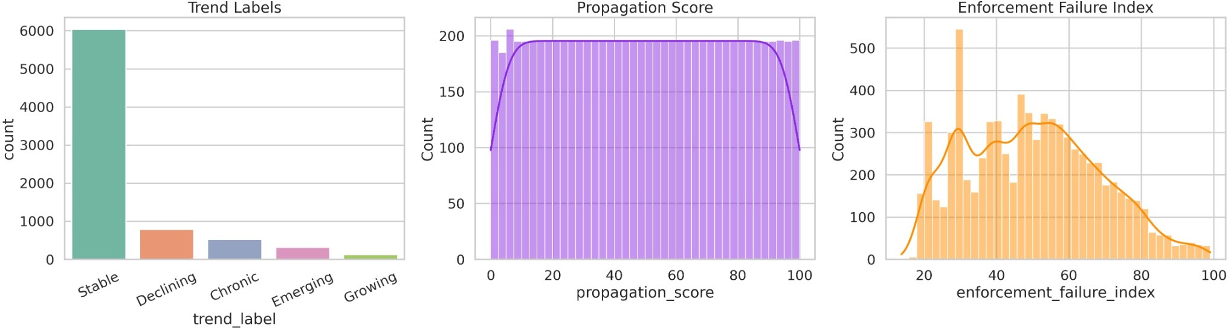
Figure 12: Enforcement priority spatial map — all cells sized by violation count, coloured by FPS

Betweenness centrality reveals gateway cells positioned between otherwise weakly con-nected regions. Targeting these cells can decouple previously interconnected congestion zones. Community detection partitions the graph into coherent super-clusters aligning with the be-havioural archetype structure, providing a natural basis for district-level resource allocation. In the current graph, Devanahalli Airport is the highest PageRank node, which shows that some centrally connected locations matter for coordination even when they are not the highest-priority enforcement sites.
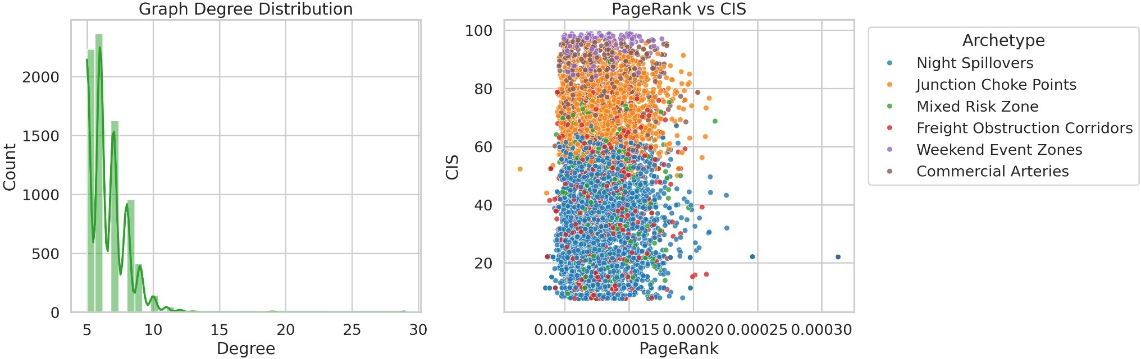
Figure 13: Graph degree distribution histogram

Operational Impact
The Parking Operational Intelligence Platform moves Bengaluru Traffic Police from a reac-tive, count-based policing model to a proactive, intelligence-driven enforcement strategy.

Daily Enforcement and Pre-Positioning
The priority_table provides a pre-sorted, annotated dispatch schedule. Instead of ran-domly patrolling sectors, officers are directed to the highest-impact cells first. Furthermore, the forecast_next_poi predictions enable anticipatory patrol positioning—allowing com-manders to deploy tow vehicles at projected choke points before the violations actually ac-cumulate into gridlock.

Archetype-Specific Interventions
The system replaces generic patrols with tailored enforcement protocols based on the discov-ered behavioral archetypes:
    - Junction Choke Points: These locations experience severe intersection blockages that suppress multiple traffic flows simultaneously. Traffic police should increase physical pa-trol presence exclusively during morning and evening peak hours. Towing vehicles must be kept on immediate standby in these cells, and rapid-response motorcycle units should be utilized to quickly clear blockages before spillover occurs.
    - Night Spillovers: Characterized by parking overflow between 22:00 and 05:00 adja-cent to nightlife and dining districts. Enforcement should shift from physical patrols to camera-assisted monitoring and automated ticketing. Police should also coordinate with nearby commercial establishments to manage valet parking effectively and prevent lane obstruction.

    - Freight Obstruction Corridors: These are arterial routes blocked by trucks and lorries during commercial loading. The operational response requires restricting load-ing/unloading entirely during peak commuter hours. Officers should enforce strict, des-ignated freight windows and aggressively target commercial vehicles that violate these temporal boundaries.
    - Weekend Event Zones: These areas are well-managed during the week but over-whelmed on weekends due to localized events. Police should deploy temporary barricades to physically prevent illegal parking. Event-based marshals should be scheduled dynami-cally based on the venue’s calendar, and dynamic parking restrictions should be enforced using mobile signage.

Policy Recommendations
To fully leverage the insights generated by this platform, the following smart-city policy interventions are recommended for the Bengaluru Traffic Police and municipal authorities. The policy layer is intentionally practical: it can plug into Bengaluru-style traffic command centres and ICCC-style dashboards, and it follows the logic behind demand-responsive park-ing systems such as SFpark, where parking controls adapt to demand instead of remaining static.
- Dynamic Enforcement Scheduling: Transition away from static patrol shifts. Align officer deployment schedules directly with the temporal peaks identified by the forecasting engine.
- Data-Driven Patrol Allocation: Allocate towing fleets and personnel across precincts proportionally based on the Congestion Impact Score (CIS) rather than geographic area or historical precedent.
- Temporary No-Parking Zones: Utilize the archetype analysis to define dynamic, time-bound parking restrictions (e.g., restricted parking only on weekends or only during night hours).
- Freight Movement Regulations: Implement city-wide policy restricting commercial loading on identified Freight Obstruction Corridors during the 07:00–10:00 and 17:00–21:00 windows.
- Junction Protection Policies: Establish strict zero-tolerance zones extending 50 me-ters from any cell classified as a Junction Choke Point, enforced via automated cameras.
- Event-Based Traffic Planning: Mandate large commercial venues in Weekend Event Zones to submit traffic management plans and fund auxiliary traffic marshals during peak operational days.
- Congestion Early-Warning Systems: Integrate the 1-hour CatBoost forecast directly into the police control room dispatch software to trigger automated alerts when a cell’s risk probability exceeds 90%.
- Smart-City Dashboard Integration: Pipe the exported GeoJSON hotspot layers and Priority Queue into Bengaluru’s existing Integrated Command and Control Centre (ICCC) for unified urban management.

Limitations
While the platform introduces significant advancements in spatial intelligence, several limita-tions remain. The current architecture relies on batch processing of static datasets, whereas production deployment would require streaming integration for incremental score updates. Spatial propagation is modelled using Euclidean distance rather than road-network distance, which may misrepresent spillover effects along one-way or curved segments. Furthermore, the forecasting module is restricted to single-step hourly predictions and lacks external contextual data such as real-time traffic speeds, weather conditions, or transit disruptions. Analytically, the KMeans clustering model enforces hard assignments that may misclassify boundary cells, and the complete absence of closed-loop enforcement outcome data prevents direct empirical validation of the priority ranking’s effectiveness.

Future Work
Future iterations of the platform should transition to a real-time, event-driven architecture using streaming pipelines to enable dynamic, shift-level priority updates. The spatial prop-agation model can be enhanced by integrating OpenStreetMap routing graphs to compute true network-distance-weighted spillover. Methodologically, Graph Neural Networks (such as GCN or GraphSAGE) could replace hand-engineered features with learned spatial represen-tations, and spatio-temporal GNNs could enable robust, multi-horizon joint forecasting. Op-erationally, reinforcement learning could be utilized to develop adaptive patrol policies that optimize fleet allocation, while the integration of multimodal sensing—such as CCTV feeds and municipal event calendars—would significantly enrich the system’s contextual awareness and predictive accuracy.

Conclusion
This paper has presented the Parking Operational Intelligence Platform—a comprehensive AI-driven framework that addresses the fundamental limitation of existing parking enforce-ment systems: the inability to translate raw violation records into systematic, prioritised, and actionable enforcement intelligence.
The central methodological contribution is a multi-layer analytical pipeline operating across four complementary dimensions: (1) severity through the seven-factor multiplicative Parking Obstruction Index (POI, observed range [0.318, 6.979]); (2) spatial network ef-fects through the distance-weighted propagation score; (3) institutional capacity through the Enforcement Failure Index; and (4) network-wide congestion impact through the Congestion Impact Score with interpretable quartile banding (Low / Medium / High / Crit-ical).
Beyond these core metrics, the system introduces a six-state hotspot lifecycle taxonomy, a data-driven six-archetype behavioural classification with tailored intervention strategies, a ten-component priority engine with archetype-specific multipliers (1.00–1.20), a transformer-based semantic search layer, and a PageRank-based graph intelligence module.
The final system output is a production-ready, multi-format dashboard comprising a ranked enforcement queue, interactive geospatial visualisation, GeoJSON export, semantic hotspot index, and graph analytics summary—all derived from a single execution of the analytical pipeline on 298,450 raw violation records from Bengaluru.
The POIP system demonstrates that raw parking violation data, when subjected to prin-cipled multi-dimensional feature engineering and integrated analytical modelling, yields far

richer enforcement intelligence than any single-metric approach can provide. Its modular, interpretable architecture provides a foundation for real-time streaming integration, graph neural network enhancement, and reinforcement-learning-based patrol optimisation in future iterations.

