# RENDER_ML_MODEL

requirement.txt

pip install –r requirement.txt

fastapi

uvicorn

pydantic

pickle-mixin

scikit-learn

numpy

Procfile –

web: **uvicorn Heroku_ML:app --host 0.0.0.0 --port $PORT**

service start command : **uvicorn Heroku_ML:app --host 0.0.0.0 --port $PORT**

[**https://diabetes-ml-model-deploy-rupal.onrender.com**](https://diabetes-ml-model-deploy-rupal.onrender.com)

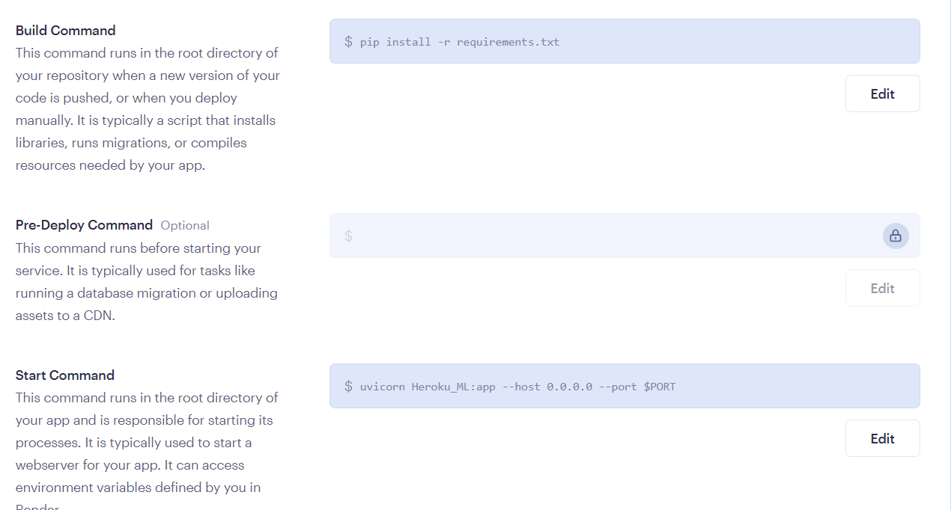

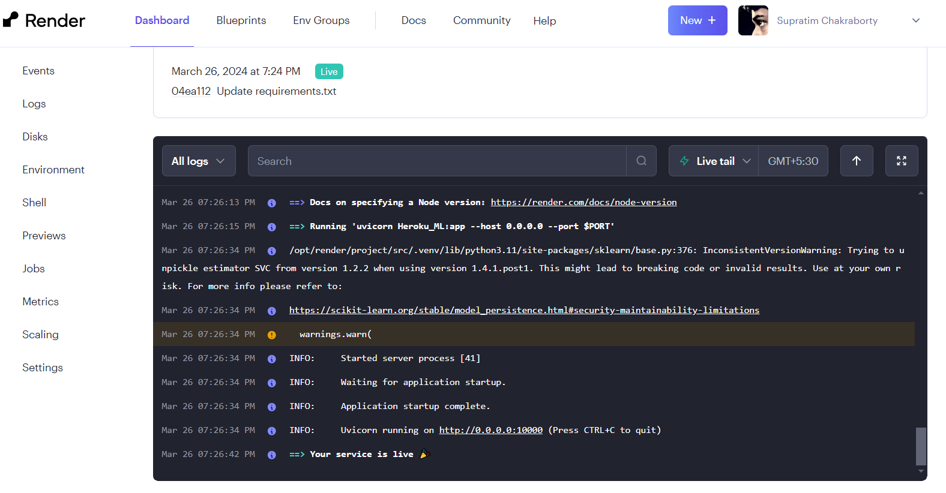

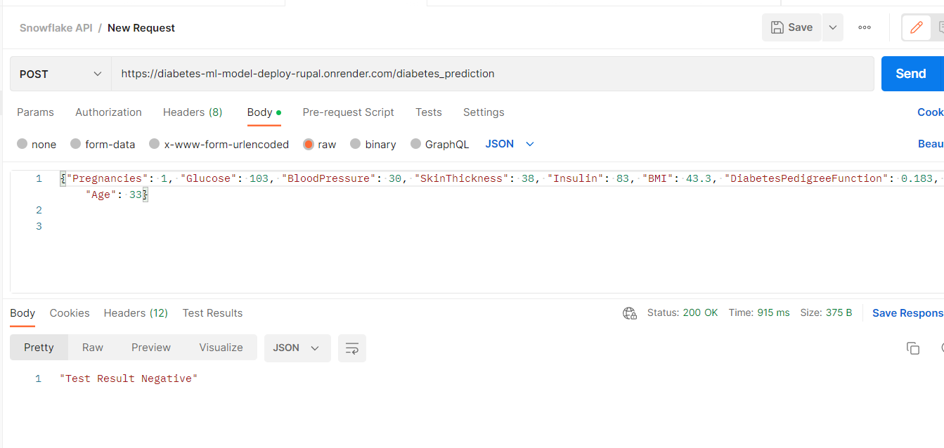

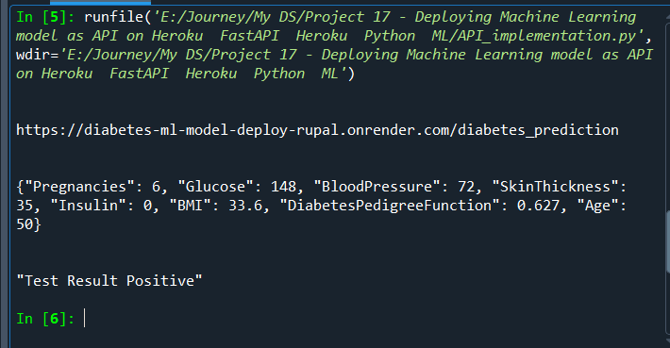

# Private URL to trigger a deploy

# https://api.render.com/deploy/srv-co1cs50cmk4c73b92u60?key=9smGSe8GbDc