**High Level Description of Custom Lab**

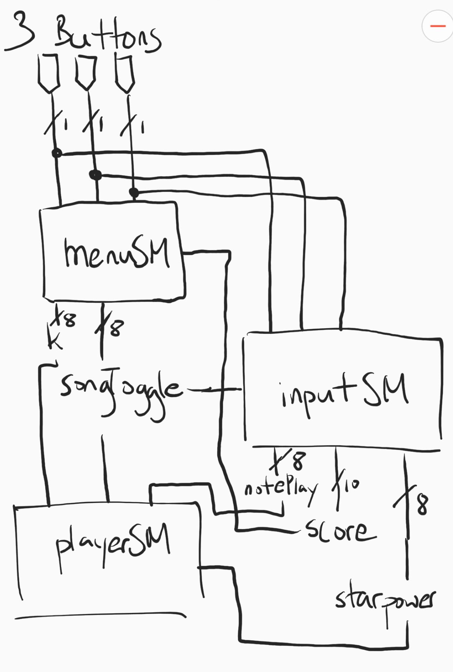

**menuSM**

Controls the LCD Display

Takes in buttons to navigate menu

K tells which song to play

Displays score

**playerSM**

Controls the sound

songToggle controls when to start song

notePlay controls if the note should be

played

Controls when starpower should be turned

off

i**nputSM**

Takes in buttons to hit notes

If button is correct, score increases, and

notePlay turns on

**Functions**:

joyInput() - returns what direction joystick is in

lcdWrite() - converts numbers to char number

and displays on LCD without clearing screen

mMatrix() - prints all stored info to 8x8 Matrix

noteOn() - returns current note

mConvert() - converts note to RGB color

**User Guide**

When games starts, press any button in order to start song selection.

Use the left button to go left, middle button to go right, right button to play song.

Use left button to play red note, middle button to play green note, right button for blue note

First song requires going up or down on the joystick as well as playing the right note.

Left or right on joystick activates starpower and doubles score obtained for each note and notes light up a different color

When the song is over, press left or middle buttons to navigate, or click right button to replay song

**Tips:**

if there are multiple notes of the same color, there is no need to let go of the buttons/joystick.

Starpower has a random activation time that can activate for up to 2.5 seconds. (depends on when you activate starpower. Can become constant 2.5 seconds if ++starpowertime is enclosed in if statement that depends on starpower.)

Activate starpower right when it ends in order to get near full activation time

**Technologies and Components**

AVR Studio 6.2

ATmega 1284  
LCD Module C1602A-V1.2  
Potentiometer  
4x Shift Registers  
Parallax 27800 Joystick

WT-1205  
YwRobot Power MB V2  
32x Resisters  
Lots of Wires

**Complexities:**   
 8x8 RGB  
 Shift Registers  
 Eeprom  
 LCD Display - Special Characters

**Youtube Link**

<https://www.youtube.com/watch?v=A_ItYokcq1E>

**Link to Source Files**

<https://drive.google.com/open?id=1E6MD_MbEPoSGX4_5NBHRcB2U5jXL9hJ3>

Timer.h

Give timer functionality

Obtained from class

Shift.h

Control shift register, and 8x8 RGB Matrix

Wrote myself

Scheduler.h

Controls state machines

Obtained from class

Io.h

Gives LCD Display functionality, and special characters

Obtained from class and slightly altered

Io.c

Initializes io.h functions

Obtained from class

Bit.h

Gives ability to controls bits

Obtained from class

Ayuan003_project.c

Controls everything

Wrote myself except the PWM functions (from class)

