# *User Manual – Incident Management Application*

## 1. Introduction

This application is a simple and intuitive Incident Management System designed for use in a school environment. Its purpose is to facilitate the reporting, monitoring, and resolution of technical or organizational problems within different departments.

The system allows users to create incidents, assign technicians, record actions taken to resolve those incidents, and mark them as completed. There is no login system, which means any user can perform all operations: creating, editing, and managing incidents and related data.

The application is developed in JavaScript, and it uses Sequelize for database interaction.

## 2. Main Functionalities

### 2.1 Incident Creation

Users can report new incidents by providing a title, a brief description of the problem, and selecting the department where the issue has occurred. This helps keep a record of problems as they appear.

### 2.2 Assigning Technicians

Once an incident has been created, a technician can be assigned to it. This makes it easier to track who is responsible for resolving each issue.

### 2.3 Recording Actions

Each step taken to solve the problem can be recorded as an “action”. These actions describe what was done and by whom, allowing for detailed documentation of the resolution process.

### 2.4 Resolving Incidents

When the problem has been solved, the incident can be marked as resolved. This helps distinguish between open and closed incidents and keeps the system organized.

### 2.5 Managing Technicians and Departments

The application also includes options for managing technicians and departments. New entries can be added at any time, ensuring the system stays up to date with the school’s organization.

## 3. How to Use the Application

First of all, you need to acces localhost:3000 to use our web, once you are connected to the server, the main page will show up:

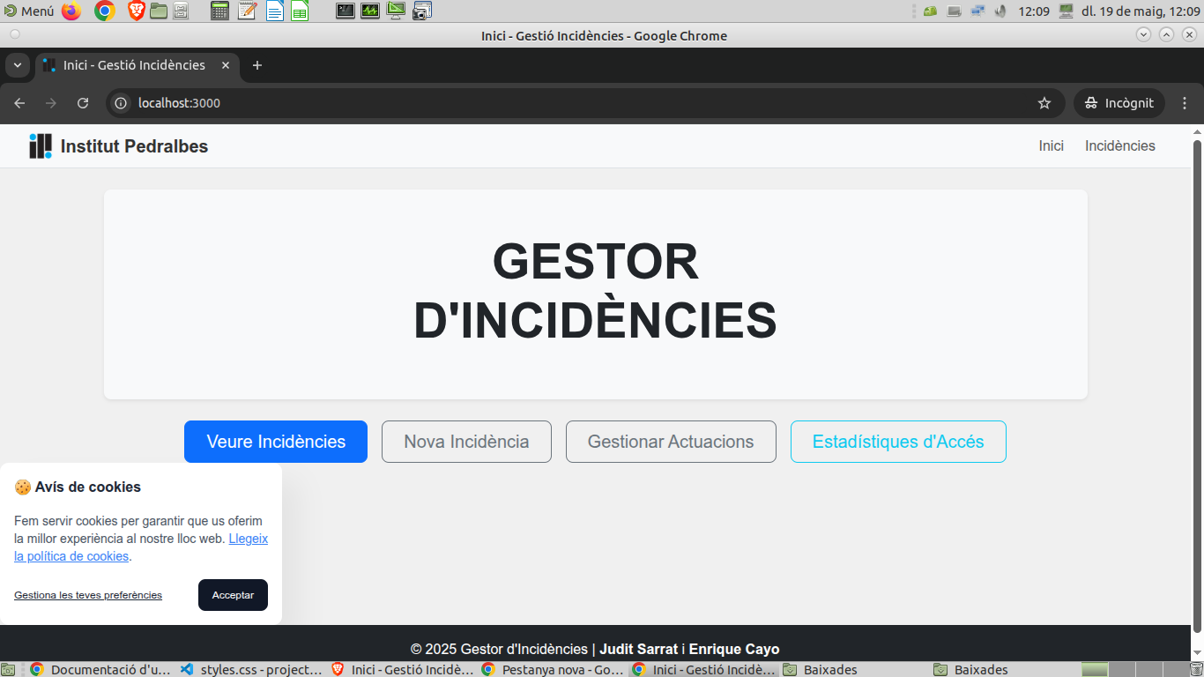

First of all you must accept our cookies in order to use our incident manager.

Now, the main functions you can do is view incidents, as well as edit, delete and update them if you are assigned admin.

### 

### 

### 

### 

### 

### 

### 

### 

### Step 1: View all incidents

* Navigate to the “View Incidents” section.

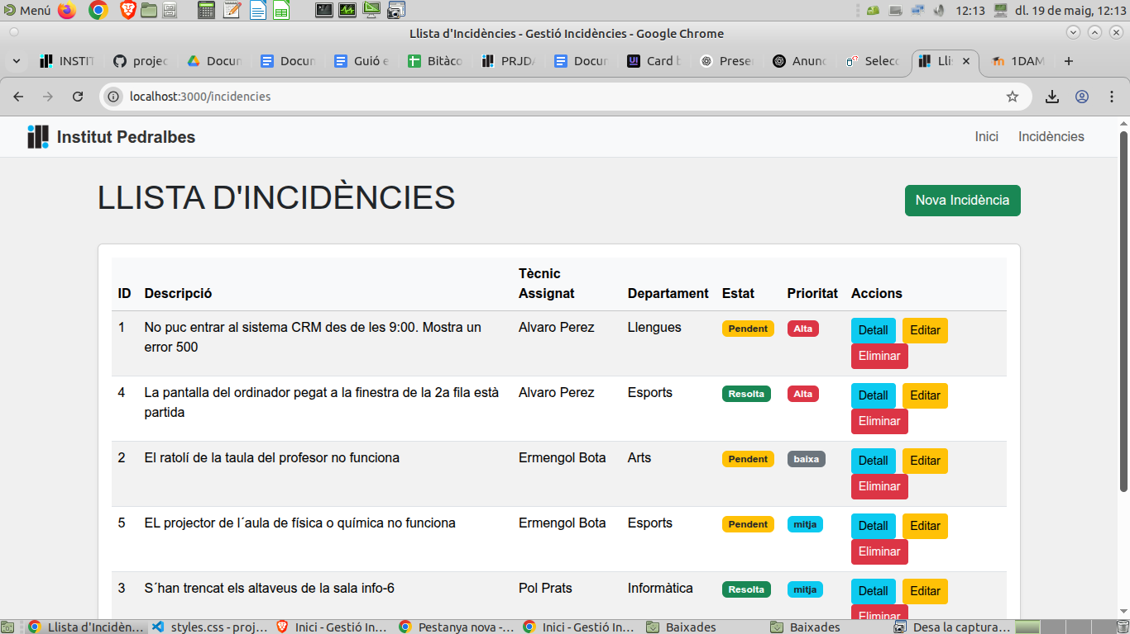

* Here you can see the status of the incidents, as well as its tickets with all information, as well as edit and delete them (in case you are an assigned admin).

### Step 2: Create an Incident

To create a new incident:

* Navigate to the “New Incident” section and click it:

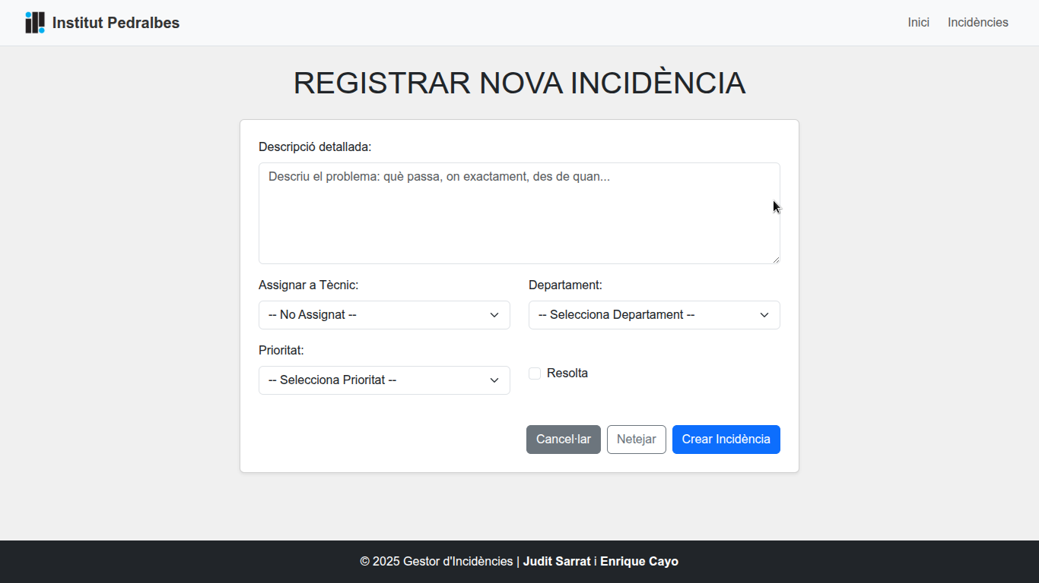

* Enter a detailed description.
* Select the corresponding department and assign a technician.
* Click “Create” to save the new incident o “Clean” if you wish to remake it.

### Step 3: Adding, Viewing and Edit actions.

* Navigate to the “manage actions” section.

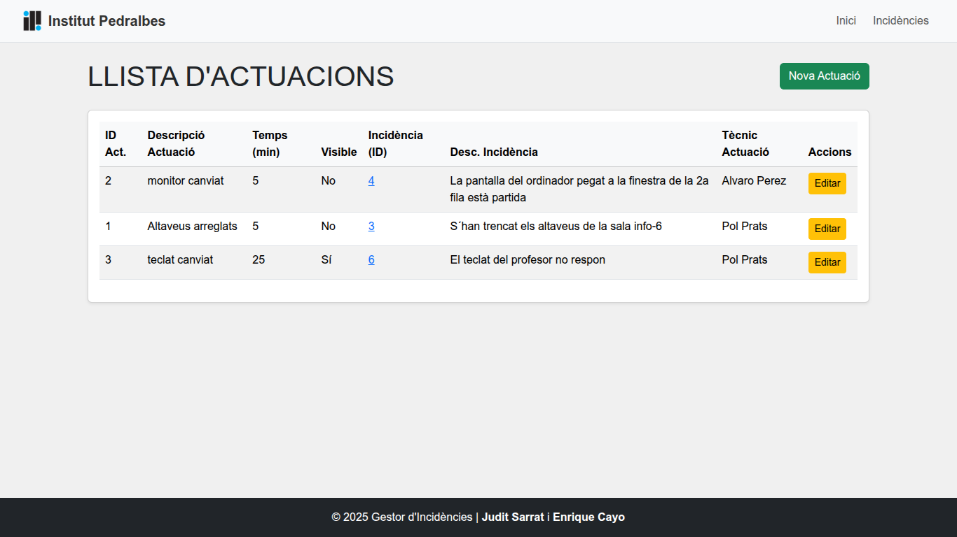

* Here you can see all the public actions.
* Here you can edit the action by clicking the “edit” button in yellow:

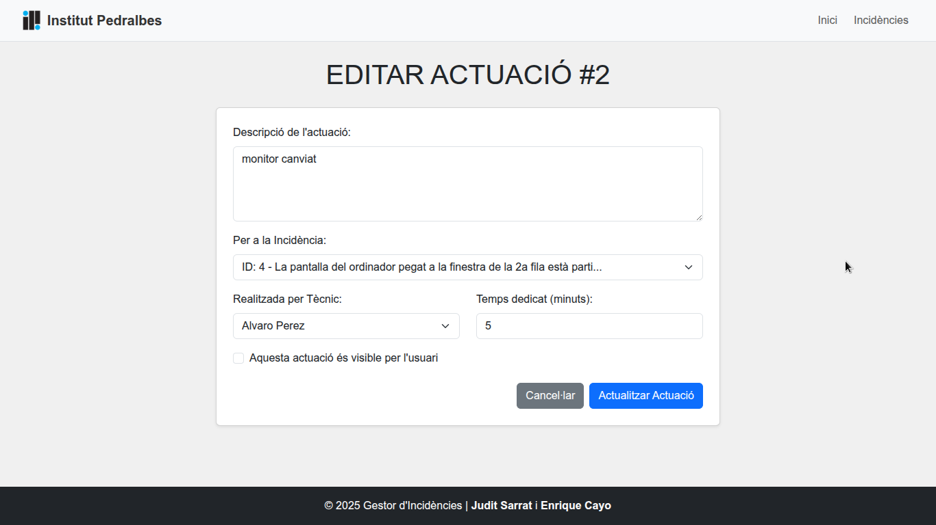

* Here you can modify the action if you must, to save you just click “Update Action” and it will be saved.
* You can also create a new action, by pressing the “New action” Button:

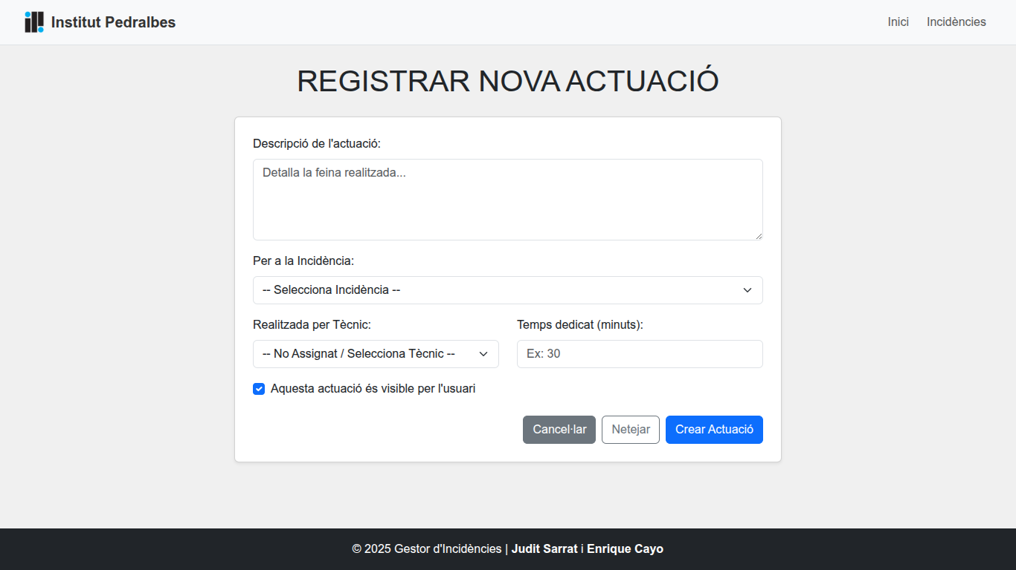

* Here you add the description, the incident the action is referring to, the technician resolving the incident and the amount of time it took.
* To save you just need to create the action.

### Step 4: Statistics

* We have a another option that it’s mainly destined for the admins of the web as well as the technician to compile data referring to the web’s usage, which departments use it more as well as the main visited pages.

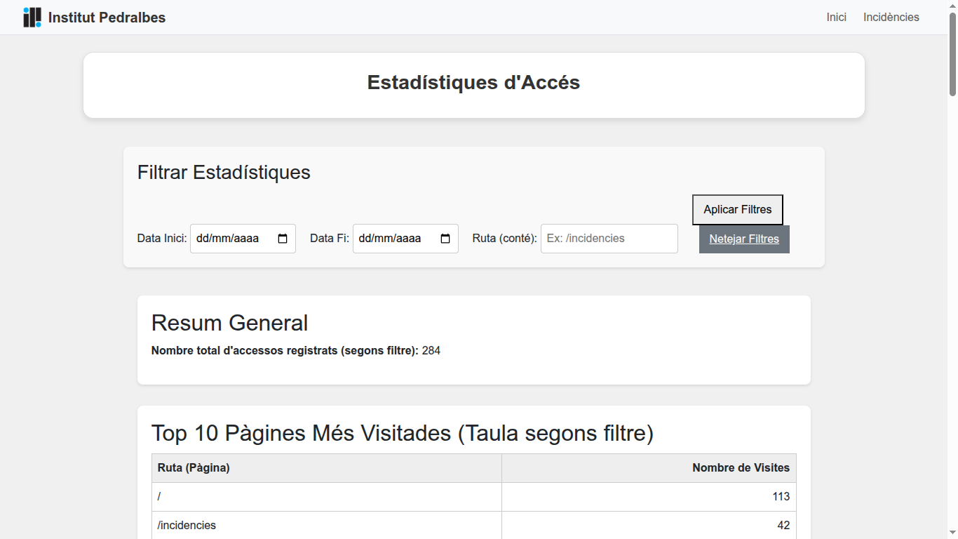

* You can filter by date and route:

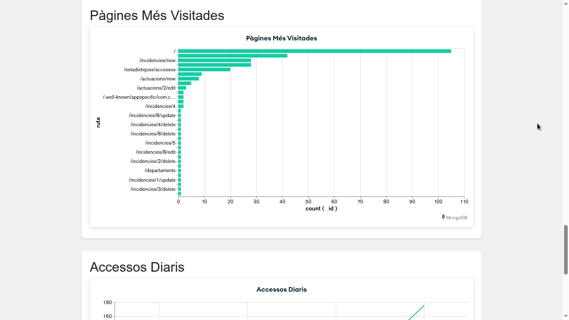

## 4. Additional Information

* No user authentication is required. Every user has full access to all functions in the system.
* The application is structured to be easy to use and fast to navigate.
* All incident data, actions, departments, and technicians are stored using Sequelize models and persisted in the database.

## 5. Example Scenario

Let’s consider a practical example:

A teacher finds that the projector in classroom B2 is not turning on.

1. The issue is reported with the title “Projector not working” and the department is set to “Audiovisual”.
2. The technician Maria López is assigned to handle the issue.
3. Maria adds the following actions:  
    – “Checked cable connections”  
    – “Replaced the HDMI cable”  
    – “Tested the projector successfully”
4. The incident is then marked as resolved.